User’s Guide

This document will explain how to use the project.

1. The user will select row by row the desired part of the sandwich.

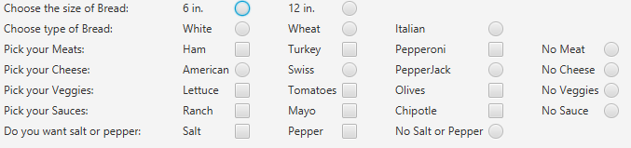

1. There is usually allowed more than one option for each choice.
2. The user can select multiple options for the desired part of the sandwich or they may only have the option of choosing one.



1. For some options, there is a none option to select if that desired part of the sandwich is not wanted.

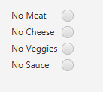

1. Once the user has selected their choices, they can click the show summary button. The summary will appear in the text area.



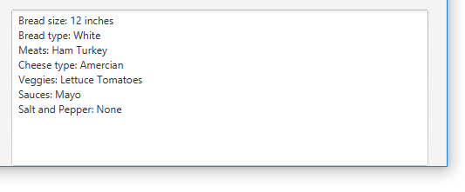

1. A clear button can be used to clear the form.

