**Ellie’s Schedule**

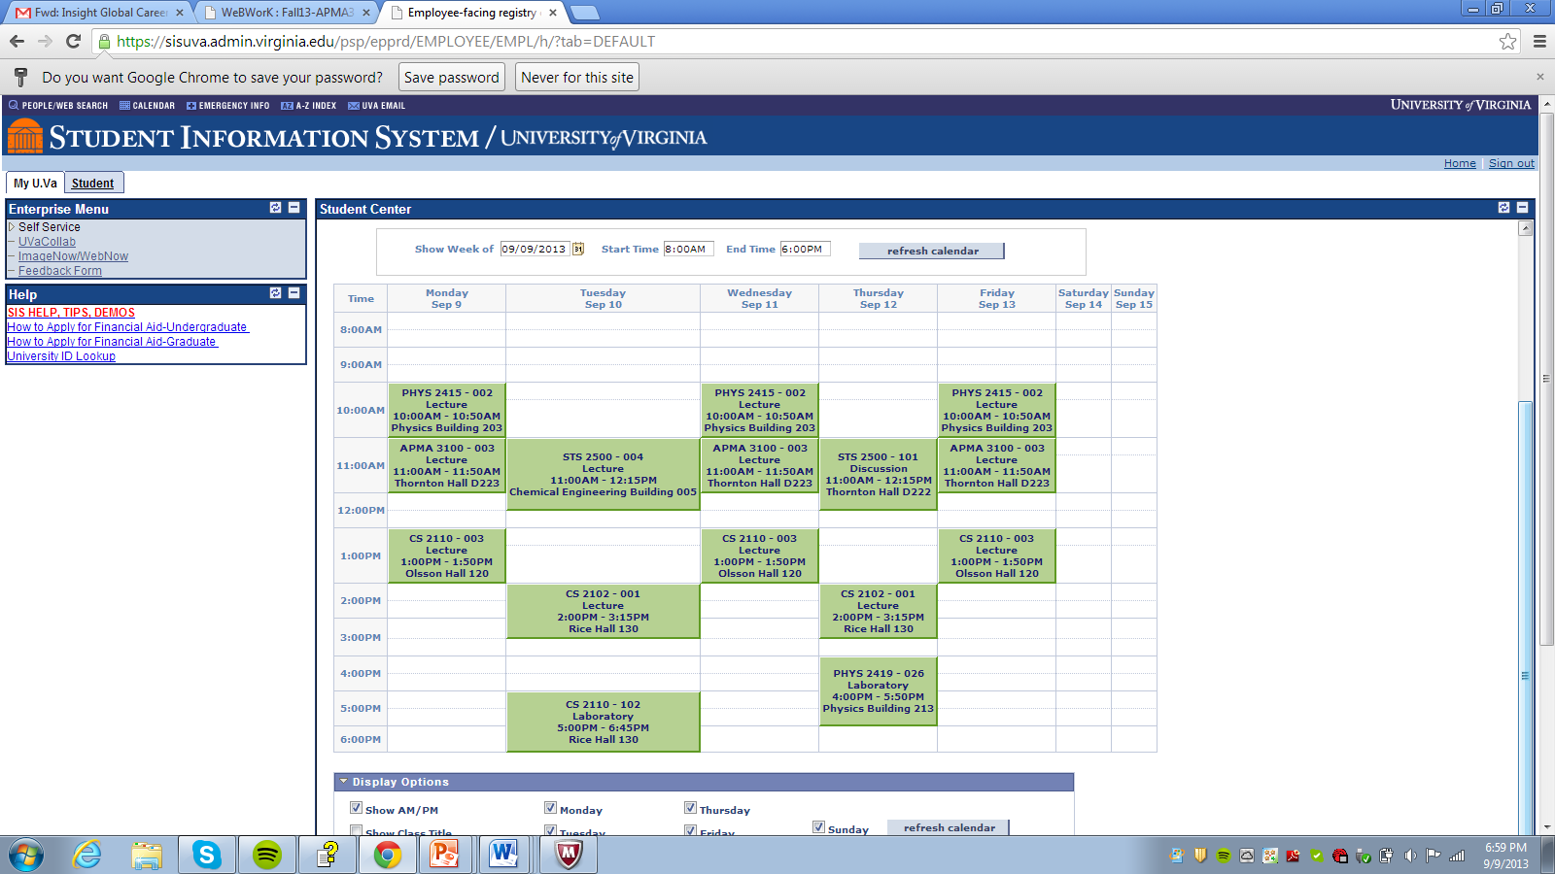

Note: CS 2110 is my Software Design Class and CS 2102 is Discrete Math