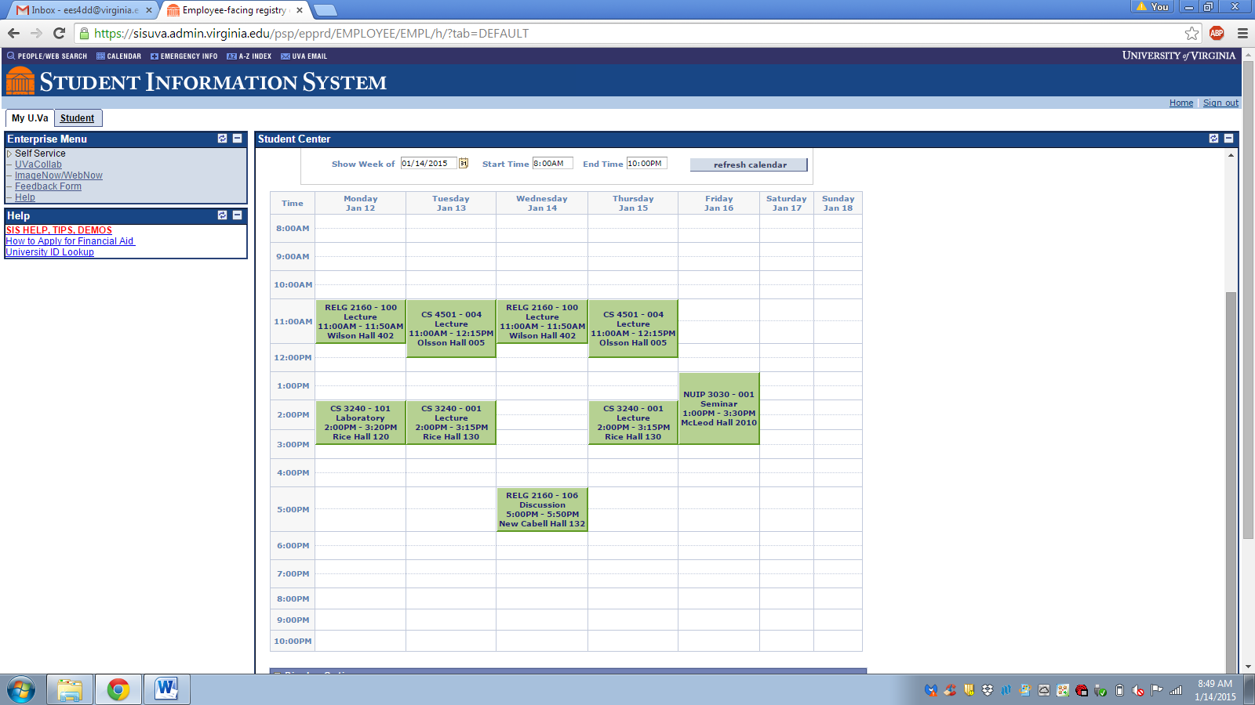

Note: CS 3240 = Advance Software Development Methods

CS 4501 = Programming Languages for Web Applications