**Problem 1)**

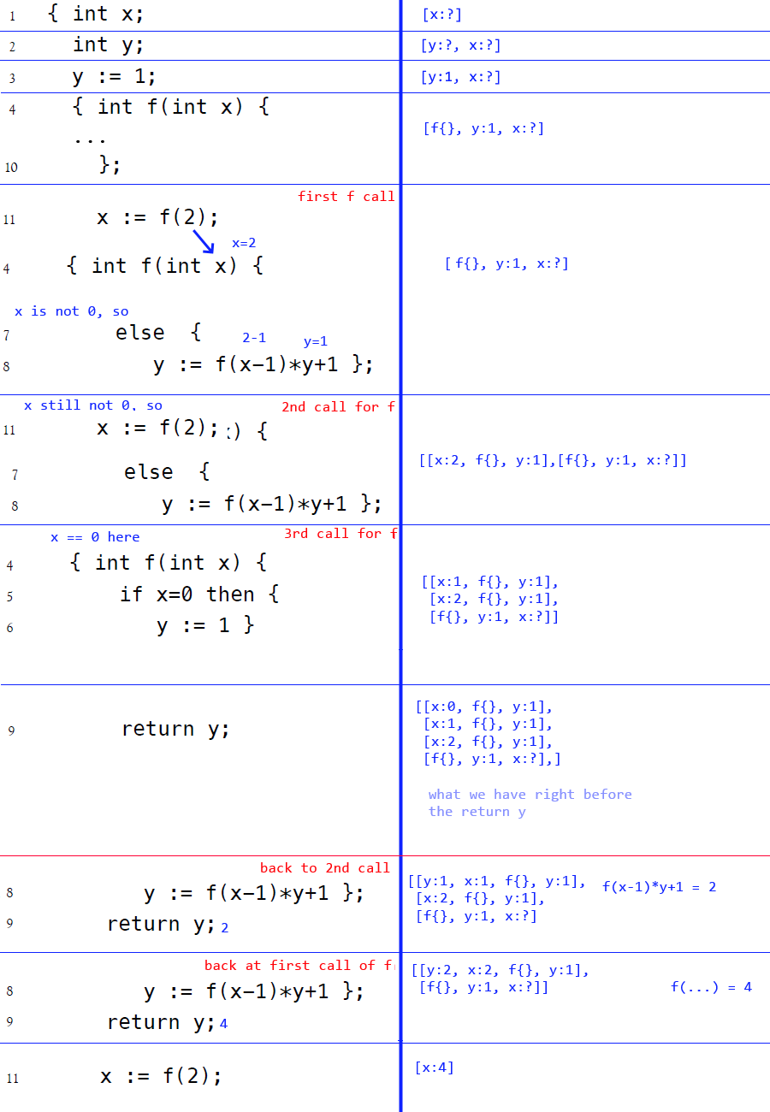

**Problem 2)**

In static scoping, z would be assigned 21. (x*y, 3*7)

The earliest x, 3, would be referred to, as well as the earliest y.

In dynamic scoping, z would be assigned 26. (2*13)

The latest definition of x would be in function g(int x), which a 2 was passed into.

Latest definition of y would be the 13 in where the block of the function g exists.

**Problem 3)**

Call by value:

[x:14, g{}, f{}, z:?, y:7]

[y:16, a:15, x:14, g{}, f{}, z:?, y:7] at first f

[y:32, x:14, g{}, f{}, z:?, y:7] after first function call

[a:-15, y:32, x:14, g{}, f{}, z:?, y:7] in second f

[z:-29, y:32, x:14, g{}, f{}, z:? y:7] after second f

[z:-28, y:7] returned to the first call of z

**Call By Name:**

[g{}, f{}, z:?, y:7], before first function call

[x:(y*2), g{}, f{}, z:g(y*2), y:7], at g

[a:(x+1), x:y*2, g{}, f{}, z:g(y*2), y:7] in first f call

[y:(a+1), a:(x+1), x:y*2, g{}, f{}, z:g(y*2), y:7] in first f call

*y =*

*(a+1)*

*((x+1)+1)*

*(((y*2)+1)+1)*

*(((14)+1)+1) = 16*

*return =*

*16+a*

*16 + x+1*

*16 + ((y*2) + 1)*

*16 + (14 + 1) = 31*

*[y:32, a:(x+1), x:y*2, g{}, f{}, z:g(y*2), y:7] After first f call*

*[a:(x-y+3), y:32, x:y*2, g{}, f{}, z:g(y*2), y:7] in second f call*

*[y:(a+1), a:(x-y+3), x:y*2, g{}, f{}, z:g(y*2), y:7]*

*y = (a+1) = (x-y+3)+1 = (y*2 - 32 + 3) + 1 = (64 - 32 + 3) + 1*

*= 36*

*return = (36+(x-y+3)) = (36+(64-32+3)) = 71*

*[z:71, y:32, x:y*2, g{}, f{}, z:g(y*2), y:7], return z + 1*

*[z: 72, y:32, y:7]*

*Z = 72, newer y = 32, original y = 7*

**Call by Need:**

[g{}, f{}, z:?, y:7], before first function call

[x:y*2, g{}, f{}, z:?, y:7]

[a:x+1, x:y*2, g{}, f{}, z:?, y:7]

[y:(a+1), a:x+1, x:y*2, g{}, f{}, z:?, y:7]

[y:16, a:15, x:14, g{}, f{}, z:?, y:7] evaluated according to call by need

return y+a from first call of f

[y:32, x:14, g{}, f{}, z:?, y:7]

[a:(x-y+3), y:32, x:14, g{}, f{}, z:?, y:7]

[y:(a+1), a:(x-y+3), y:32, x:14, g{}, f{}, z:?, y:7]

[y:-14, a:-15, y:32, x:14, g{}, f{}, z:?, y:7] evaluated according to call by need

y = (x-y+3+1) = (14-32+4) = -14

[z:-29, y:32, x:14, g{}, f{}, z:?, y:7]

z = -28, local y in g = 32, global y = 7