Grazioso Salvare Project Two README
  - Chas Steves | cstevens
CS 340 Client Server Development | October 11, 2026
This project completes the rescue candidate dashboard for Grazioso Salvare. It connects the Austin Animal Center outcomes collection in MongoDB to an interactive Python dashboard so the client can compare rescue profiles, inspect animals, and view their recorded locations. The screenshots in this README show the running application in Codio.

Required functionality
The initial view retrieves the complete collection through AnimalShelter.read({}) from the Project One CRUD module. Four radio options provide Water Rescue, Mountain or Wilderness Rescue, Disaster or Individual Tracking, and Reset. Each rescue option sends a new MongoDB query through the same module; Reset retrieves all animals again.
The table displays six rows per page, supports multiple-column sorting and column filters, and permits one selected row. The breed chart reflects the complete filtered table, rather than only the current page. It groups the eight most frequent breeds and combines the remaining breeds as Other breeds. The Leaflet map displays the selected animal using location_lat and location_long, with breed and animal ID context.
A profile change returns the table to page one, clears its column filters and sort order, and selects the first matching animal. Empty results show informative chart and map messages. Invalid or missing coordinates show an explanation instead of an invalid marker. The header includes the supplied logo and the identifier Chas Steves | cstevens.

Model view and controller
MongoDB is the model. Its document structure preserves the animal outcome fields, and its query operators combine breed membership with sex and numeric age bounds. PyMongo provides MongoClient and dictionary-based queries that integrate naturally with Python. The existing CRUD module centralizes authentication and collection access; dashboard callbacks only use its read method.
Dash components form the view: radio controls, DataTable, Plotly chart, and Leaflet map. Dash callbacks form the controller by connecting changed component properties to Python functions and returning updated data or charts. Pandas removes MongoDB ObjectId values and normalizes missing values for browser serialization. JupyterDash allows the same dashboard to run from the required notebook in the course environment.

Rescue profile criteria
All rescue queries require animal_type equal to Dog. Age bounds are inclusive and use age_upon_outcome_in_weeks. Breed matching includes the listed preferred breeds and their explicit Mix variants; the Water profile uses the specified Labrador Retriever Mix. Slash-separated crossbreeds are not included automatically.
Profile | Preferred breeds | Sex and age
Water Rescue | Labrador Retriever Mix, Chesapeake Bay Retriever, Newfoundland | Intact Female  26–156 weeks
Mountain or Wilderness Rescue | German Shepherd, Alaskan Malamute, Old English Sheepdog, Siberian Husky, Rottweiler | Intact Male  26–156 weeks
Disaster or Individual Tracking | Doberman Pinscher, German Shepherd, Golden Retriever, Bloodhound, Rottweiler | Intact Male  20–300 weeks
Reset | All animals in the collection | No sex or age restriction

Reproducing the project
1. Use the course Codio environment with Python 3.11 and the existing Project One MongoDB service. Extract the submission files together into code_files. Keep ProjectTwoDashboard.ipynb, CRUD_Python_Module.py, dashboard.py, requirements.txt, and Grazioso Salvare Logo.png in the same directory.
2. The application expects MongoDB on localhost:27017, database aac, collection animals, and the aacuser account authenticated against admin. Reuse the database and account created in Project One. The course credential is supplied in the AnimalShelter instantiation as required by the assignment. If working in a fresh environment, create that account with readWrite access to aac and set the notebook credential to match.
3. On a fresh database, import the course CSV using the following command. Enter the aacuser password when prompted. Do not reimport into an already populated course collection, because that creates duplicate records.
mongoimport --db aac --collection animals --type csv --headerline \
--file ../datasets/aac_shelter_outcomes.csv --username aacuser \
--authenticationDatabase admin --password
4. From code_files, install the dependency versions in requirements.txt if they are not already available. The supplied versions match the tested course stack; JupyterDash and Dash 2 are used together.
python3 -m pip install -r requirements.txt

Running and maintaining the dashboard
5. Open ProjectTwoDashboard.ipynb in JupyterLab and run all cells. Open the Codio Box URL on port 8052, for example https://updatewave-anvilagenda-8052.codio.io. Substitute the hostname of your own Box and keep the notebook kernel running. Alternatively, run dashboard.py from the directory containing the CRUD module and logo. Use one server at a time; stop an existing server or change the port if 8052 is occupied.
python3 dashboard.py
6. Choose each profile and verify the table, chart, and map. Select another row to change the map. Test sorting, column filtering, and pagination; choose Reset to restore all animals and clear table settings. The profile count reports MongoDB query results; column filters narrow the table and chart further.

Development and validation
Development reused the Project One CRUD module and completed the supplied notebook structure. The logo was embedded as a data URI, rescue queries were connected to radio controls, and table callbacks supplied the breed chart and map. The completed notebook executed successfully with nbconvert, and the running application was verified in Chrome.
The tested collection returned 10,002 records initially and after Reset, 17 for Water Rescue, 15 for Mountain or Wilderness Rescue, and 21 for Disaster or Individual Tracking. These counts describe the existing course database; a fresh CSV import or later collection changes can produce different totals. Row selection changed the map from Boomer A712291 to the unnamed animal A698931. Empty chart and map results and a missing row selection were also checked.

Challenges and solutions
MongoDB ObjectId values cannot be serialized directly into Dash table data, so _id is removed before conversion. Missing values are converted to None. Sorting and filtering change displayed row positions, so the map uses derived_virtual_data and derived_virtual_selected_rows instead of fixed column numbers or original row indices. Profile changes clear stale selections and table settings. Map tiles load asynchronously, so screenshots were captured after the chart and geographic background finished rendering.
The lab uses a development server. Maintain the pinned dependencies and named fields when extending callbacks. Before public repository distribution, replace the classroom credential with environment-based configuration.

Software resources
MongoDB and PyMongo documentation
Dash callbacks and DataTable
Dash table documentation
Dash Leaflet
Plotly pie charts
Course resources: CS 340 Project Two Guidelines and Rubric, ProjectTwoDashboard starter notebook, Grazioso Salvare logo, and the modified Austin Animal Center Outcomes CSV. Dataset reference: Austin Animal Center (2020), City of Austin, https://doi.org/10.26000/025.000001.

Starting dashboard
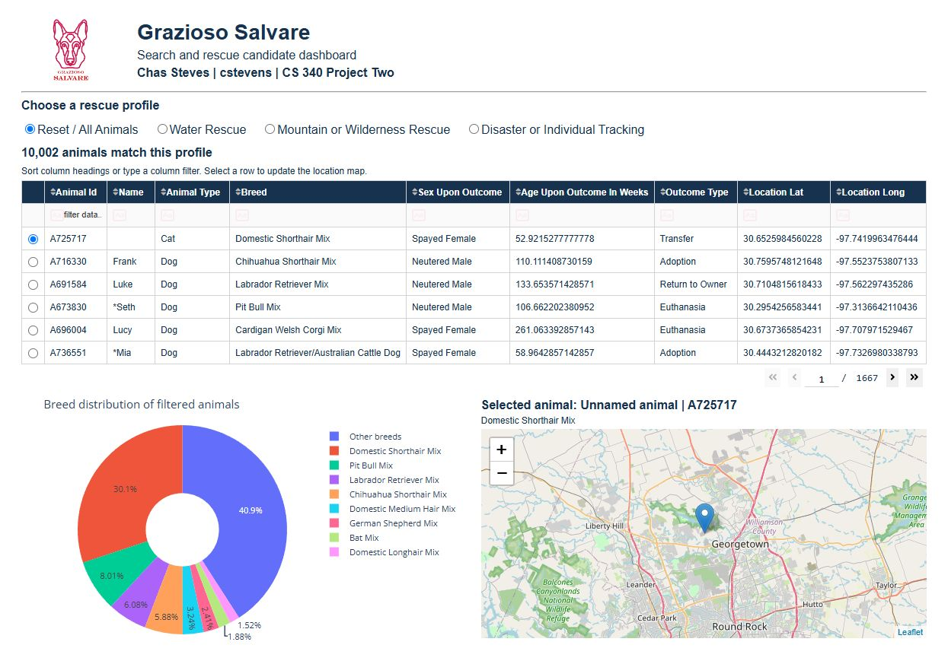
Figure 1. The starting state shows all 10,002 animals, the four profile options, table, breed chart, and selected animal map. The logo and Chas Steves | cstevens identifier remain visible.

Water Rescue
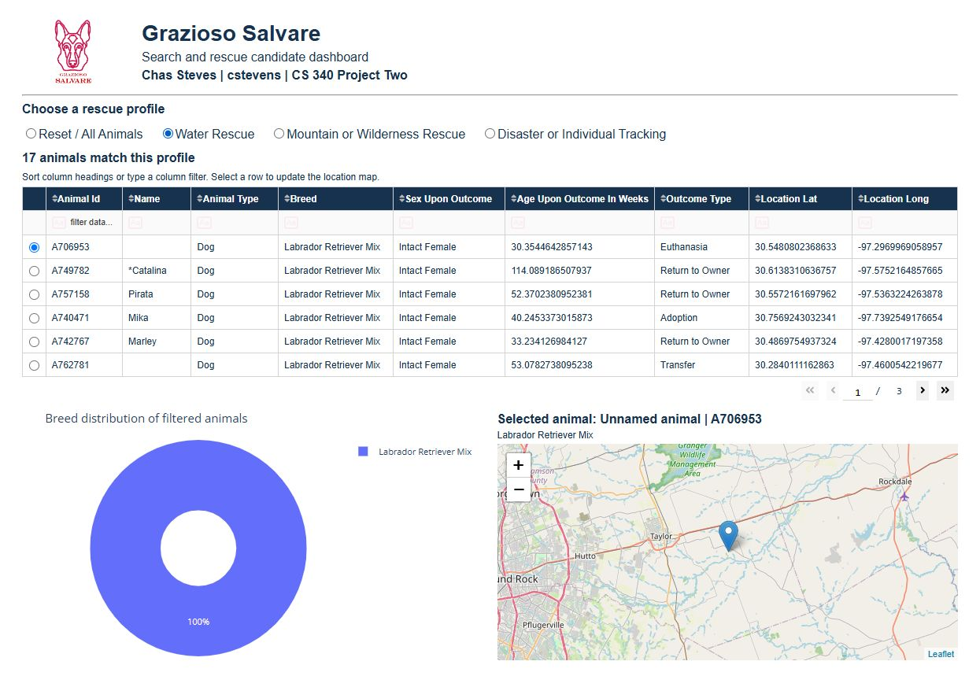
Figure 2. Water Rescue returns 17 animals. The table, 100 percent Labrador Retriever Mix chart, and map display the filtered results. The logo and Chas Steves | cstevens identifier remain visible.

Mountain or Wilderness Rescue
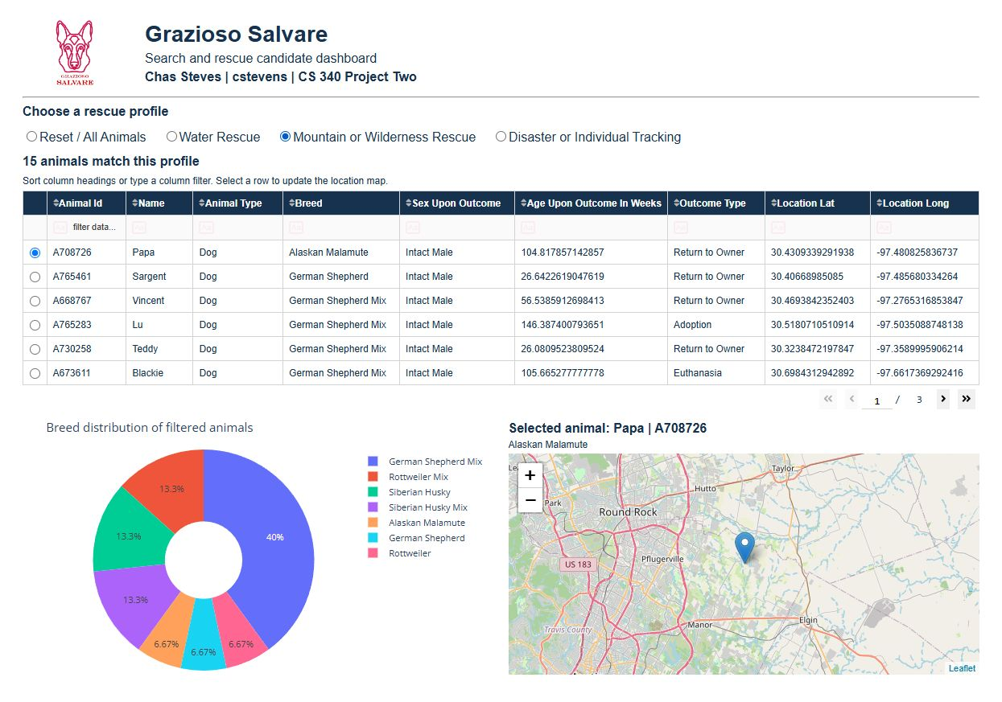
Figure 3. Mountain or Wilderness Rescue returns 15 animals. The breed distribution changes, and the map shows Papa A708726. The logo and Chas Steves | cstevens identifier remain visible.

Disaster or Individual Tracking
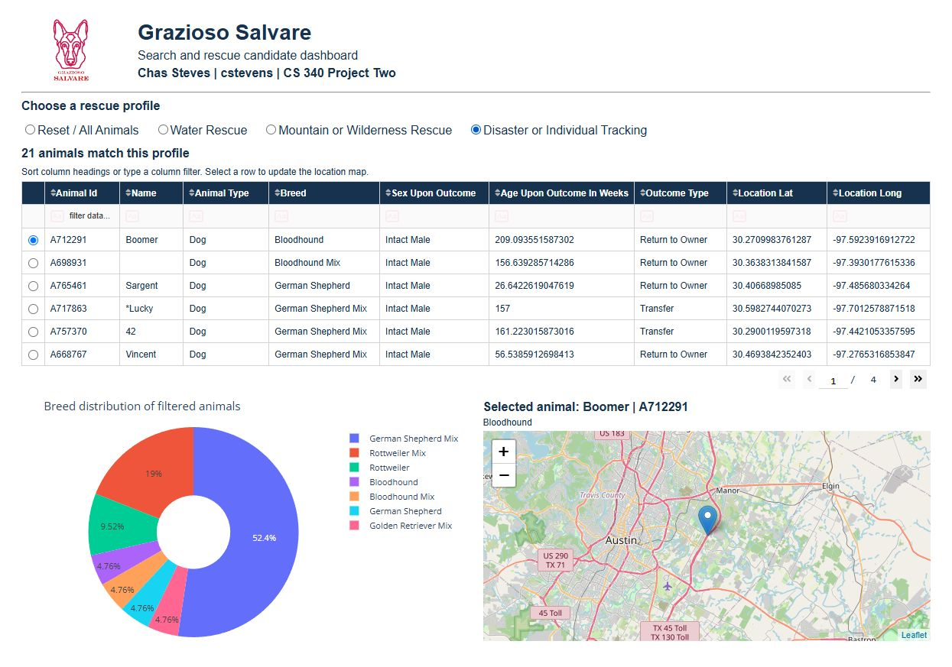
Figure 4. Disaster or Individual Tracking returns 21 animals. The chart updates to this profile and the map shows Boomer A712291. The logo and Chas Steves | cstevens identifier remain visible.

Reset to all animals
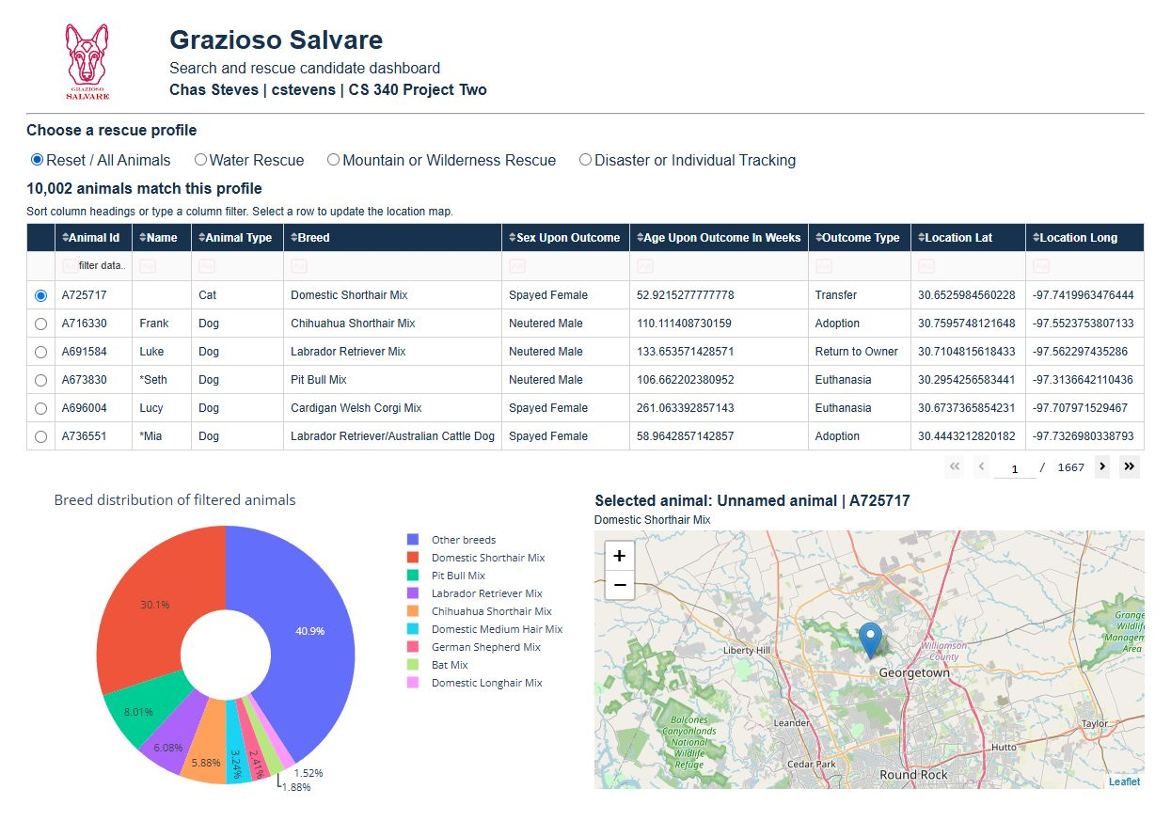
Figure 5. Reset restores all 10,002 animals, the first table page, original breed distribution, and starting map selection. The logo and Chas Steves | cstevens identifier remain visible.

