

Travlr Getaways

CS 465 Project Software Design Document
Version 3.0
Chas
October 11, 2026

Table of Contents

CS 465 Project Software Design Document 1
Table of Contents 2
Document Revision History 2
Executive Summary 3
Design Constraints 3
System Architecture View 4
Component Diagram 4
Sequence Diagram 5
Sign In and Protected Administration 6
Class Diagram 7
Database Schema 8
API Endpoints 9
The User Interface 10
Added Trip 10
Edit Screen 11
Saved Update 12
Angular and Express Structure 13
Testing GET and PUT 13
Customer and Administrator Evidence 14
Customer Management 15

Document Revision History

Version | Date | Author | Comments
1.0 | 09/13/26 | Chas | Milestone One architecture and design constraints.
2.0 | 09/29/26 | Chas | Milestone Two sequence, class, and API documentation.
3.0 | 10/11/26 | Chas | Final application, customer reservations, secured administration, UI evidence, and testing results.

Executive Summary

Travlr Getaways uses the MEAN stack to give customers a public travel website and administrators a separate management interface. MongoDB stores trips, accounts, and reservations. Express handles routes, validation, and authorization on Node.js. Angular runs the administrator single-page application, or SPA, in the browser. Both interfaces use the same API and database, so an administrator's saved trip changes appear on the customer website.
The public website keeps the supplied Travlr layout and uses Express routes, a travel controller, and Handlebars templates. The travel controller retrieves JSON through the REST API and renders the available packages. Customers can search by location or resort and maximum price, create an account, log in, book a package, view their itinerary, and cancel a reservation. Reservation details are stored with the customer account, so they remain available after a page refresh or later login.
The Angular SPA provides trip cards, add and edit forms, deletion confirmation, and customer management. A shared HTTP service handles trip requests, while an authentication service manages the session token. Administrators can maintain trip dates, descriptions, resorts, and prices, and update or remove customer accounts. The API verifies access before processing protected requests. This division keeps presentation in the browser, application rules on the server, and persistent records in MongoDB.

Design Constraints

The main constraints are the MEAN technology stack, the provided customer wireframe, and a shared data contract between two different interfaces. Angular uses TypeScript components and browser routing, while the public website uses server-rendered HTML. Both depend on stable trip codes and consistent JSON fields. Mongoose validates the document structure before storage. The course trip schema keeps price as a formatted string, so price searches convert it to a number for comparison. Departure dates are stored as MongoDB dates and displayed in UTC to avoid shifting the day.
Security must be enforced at the API, because hiding a button does not stop a direct HTTP request. Passwords use salted scrypt hashes, tokens expire after one hour, and public registration cannot create administrators. Customers can access only their own reservations. The SPA requires JavaScript, and both interfaces must handle network or database failures. The current reservation flow records a package booking and its price snapshot; it does not process payments, enforce seat inventory, or integrate with outside travel providers. Those services would require additional models and transaction rules.

System Architecture View

Component Diagram

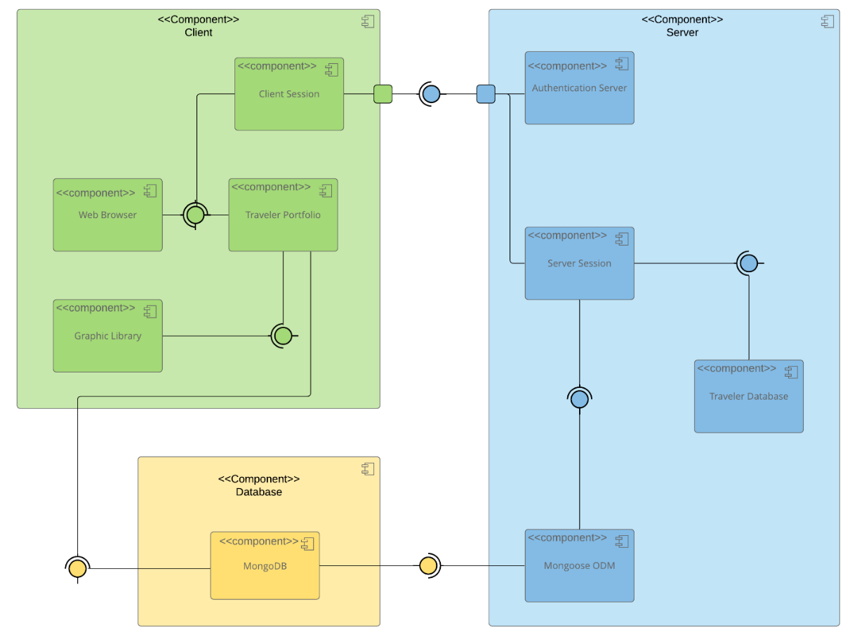

A text version of the component diagram is available: CS 465 Full Stack Component Diagram Text Version.

The supplied component diagram groups the system into Client, Server, and Database tiers. On the client, the browser displays the Traveler Portfolio and graphic assets. In this implementation, that presentation is the public Handlebars website and the Angular admin SPA. Client Session corresponds to the token stored in session storage. CSS and Bootstrap provide the visual layout; Angular components handle administrative interaction.
The Server tier runs Express on Node.js. Authentication Server maps to the login and registration controllers plus token verification middleware. Traveler Database maps to the trip, user, and reservation controllers. Mongoose ODM maps to the schema-backed models that query MongoDB. The diagram's Server Session is represented by a signed token and a current account lookup rather than a separate server session store. The database tier persists the trips, users, and reservations collections.
All database operations pass through the server and Mongoose. The public travel controller calls GET /api/trips and supplies the returned JSON to travel.hbs. Angular and the customer account script send HTTP requests to the API. MongoDB never receives a direct browser connection. This separation allows the interfaces to share records while keeping credentials, authorization, and storage rules on the server.

Sequence Diagram

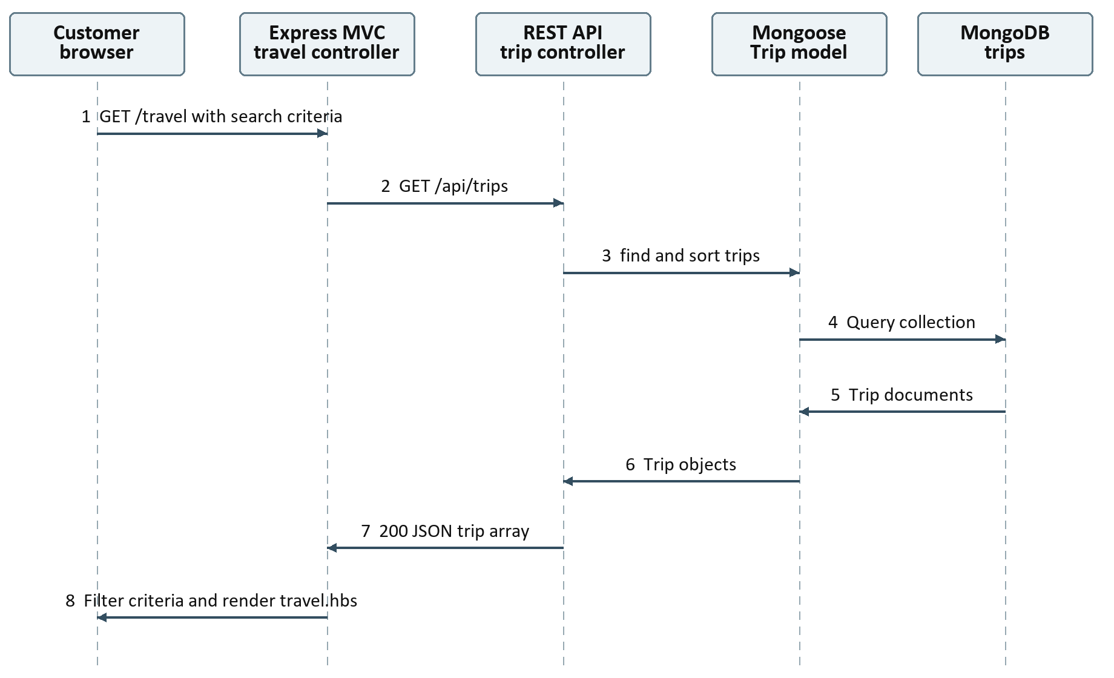
Figure 1 Customer trip retrieval and server rendering

For trip browsing, the customer sends GET /travel with optional location and price criteria. Express routes the request to the travel controller. That controller requests GET /api/trips from the local API. The API controller calls the Trip model, Mongoose queries MongoDB, and the result returns as a JSON array sorted by trip name. The travel controller filters the array, adds a readable departure date, and renders travel.hbs. Handlebars repeats the trip view for each matching record.
An individual trip lookup returns 404 when its code does not exist. Database failures return 500 from the API, and the public controller returns 502 when it cannot retrieve trip data. Search rejects an invalid maximum price with 400. These responses keep a failed request from appearing to return valid trip information.

Sign In and Protected Administration
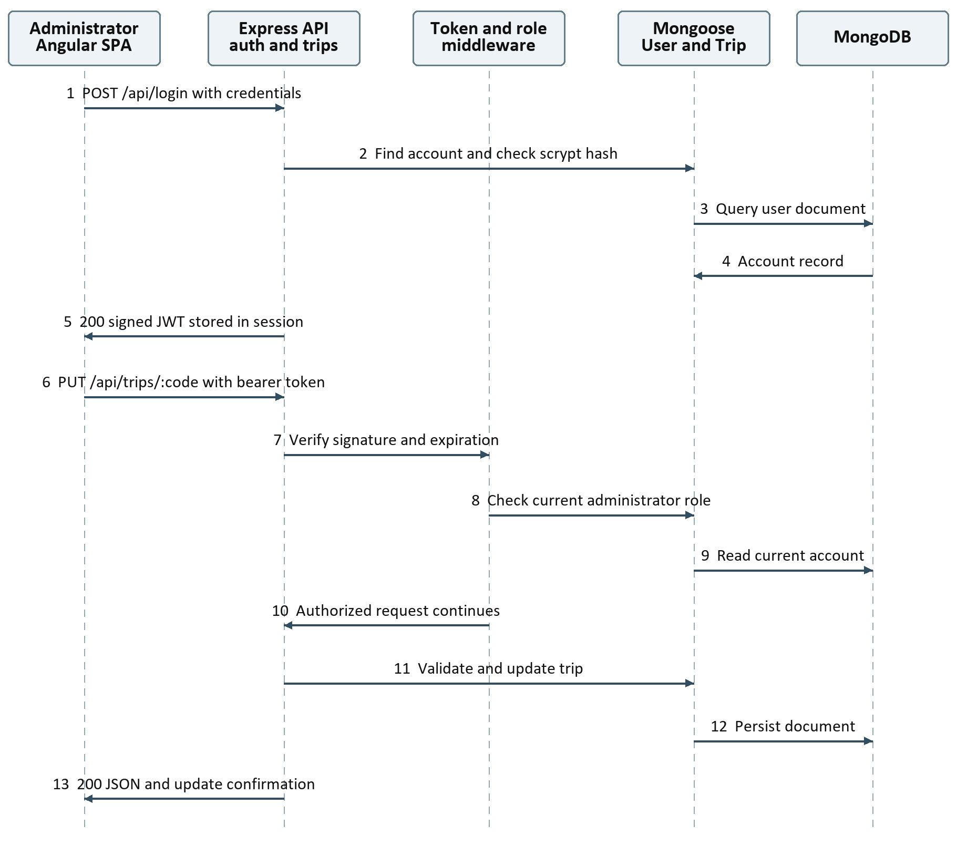
Figure 2 Administrator sign in and an authorized trip update
During sign in, Angular sends an email and password to POST /api/login. The controller loads the account and compares the supplied password with its salted hash. Successful login returns a signed JWT, and Angular stores it for the session. An incorrect password returns 401 and leaves the user on the login form. Public registration uses POST /api/register and always assigns the regular-user role.
For an edit, Angular loads the selected trip with GET /api/trips/:tripCode and preloads the reactive form. Saving sends PUT to that endpoint with the bearer token. Middleware verifies the token and current administrator role before the controller validates the fields and updates MongoDB. The saved object returns as JSON, and the SPA shows a success message. Missing or expired tokens return 401; regular users receive 403. Customer bookings use the same token check, but reservation queries also filter by the authenticated account ID.

Class Diagram

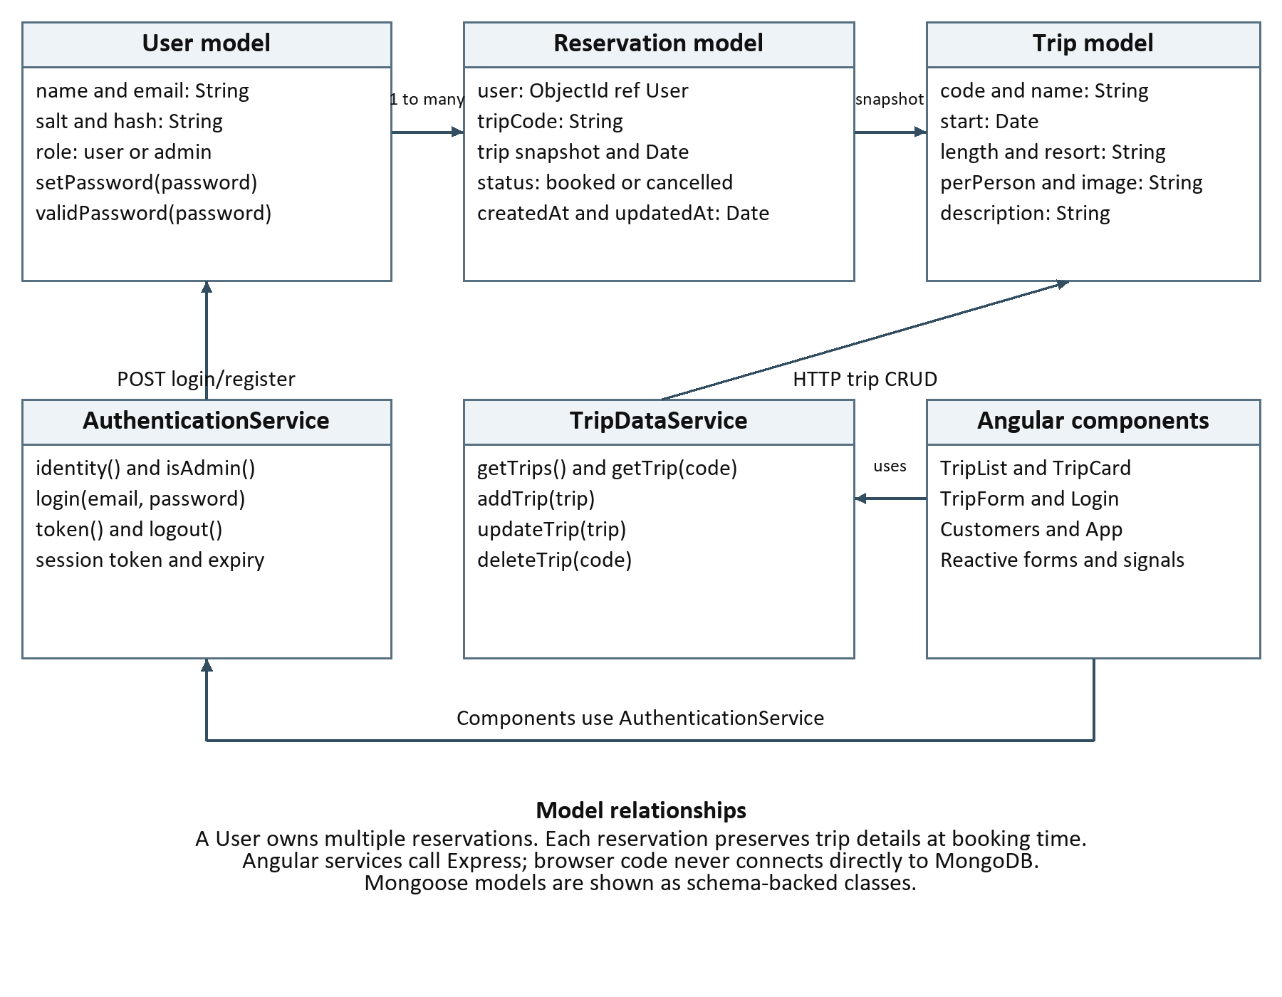
Figure 3 Implemented models and Angular classes
The class diagram shows the implemented schema-backed models and Angular classes. Trip holds package details. User holds account identity, role, salt, and hash, with setPassword and validPassword methods. A User can own multiple Reservation records. Reservation stores the user reference and a snapshot of the selected trip's name, departure, duration, resort, and price. Keeping that snapshot preserves the booked itinerary if the current package changes or is deleted.
TripDataService provides getTrips, getTrip, addTrip, updateTrip, and deleteTrip. AuthenticationService handles login, identity, token expiry, and logout. TripListComponent and TripCardComponent display the collection, TripFormComponent handles add and edit, LoginComponent handles sign in, and CustomersComponent manages customer records. The components use HTTP services and never access database models directly.

Database Schema
Mongoose supplies the metadata schema and validation for three collections. Trip codes and user emails are unique. The reservation index on user and tripCode prevents duplicate bookings of the same package for one account. A cancelled reservation remains in the itinerary as history; rebooking that same package is not supported by the current unique index.
Collection | Fields and types | Storage rules
trips | code, name, length, resort, perPerson, image, description: String  start: Date | All fields required; code unique; code and name indexed. Descriptions accept only the supported simple HTML tags.
users | name, email, salt, hash, role: String | Email unique and normalized. Role is user or admin. Salt and hash are excluded from normal queries and customer API responses.
reservations | user: ObjectId  tripCode, name, length, resort, perPerson, status: String  start, createdAt, updatedAt: Date | user references User. Status is booked or cancelled. Unique user and tripCode pair; timestamps record creation and changes.
The standard seed loads three course trips. The additional demo seed restores Island Escape Adventure with a departure date of September 18, 2027 and a price of $1,499. Seeds update their own trip codes without deleting unrelated records. Integration tests seed separate temporary databases and remove them after verification.

API Endpoints

The REST API returns JSON and uses HTTP status codes to report the result. Public reads support browsing; account tokens protect reservation ownership; administrator tokens protect trip writes and customer management. The API ignores client-supplied role and ownership fields. Table 1 lists the implemented routes.
Table 1 Implemented REST endpoints

Method | Purpose | URL | Notes
GET | List trips | /api/trips | Public. 200 array sorted by name; 500 on database failure.
GET | Read one trip | /api/trips/:tripCode | Public. 200 object or 404.
POST | Create trip | /api/trips | Admin. 201; 400 invalid input; 409 duplicate code.
PUT | Update trip | /api/trips/:tripCode | Admin. 200; code cannot change; 400 invalid input; 404 missing trip.
DELETE | Delete trip | /api/trips/:tripCode | Admin. 204 or 404. Existing booking snapshots remain.
POST | Register account | /api/register | Public. 201 token; 400 invalid fields; 409 duplicate email. Regular-user role only.
POST | Log in | /api/login | Public. 200 token; 400 missing fields; 401 incorrect credentials.
GET | Read own itinerary | /api/reservations | Account token. 200 array filtered by authenticated user.
POST | Book package | /api/reservations | Account token. Send tripCode. 201 snapshot; 404 missing trip; 409 duplicate booking.
DELETE | Cancel own booking | /api/reservations/:id | Account token. 200 cancelled record; 400 invalid ID; 404 missing or other owner.
GET | List customers | /api/users | Admin. 200 regular-user profiles only; no password hashes.
PUT | Update customer | /api/users/:id | Admin. Name and email only. 200; 400 invalid input; 404; 409 duplicate email.
DELETE | Delete customer | /api/users/:id | Admin. 204; removes associated reservations; cannot remove an administrator.

The User Interface

The following screenshots show the completed trip workflow after administrator login. Secure Island Escape is an additional tour created through the SPA, rather than a static page entry. The edit screen loads its stored fields, and the update screen confirms the saved change to Updated Secure Escape.

Added Trip
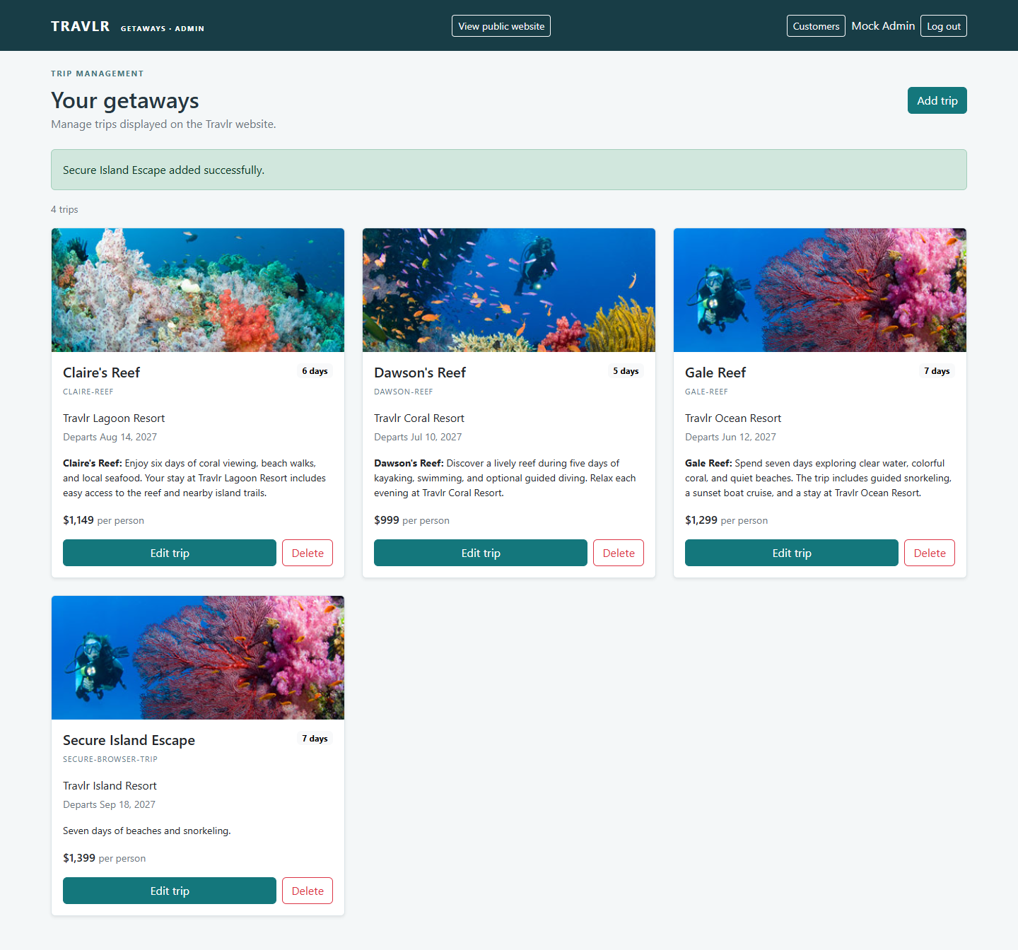
Figure 4 Added trip and authenticated CRUD controls

Edit Screen
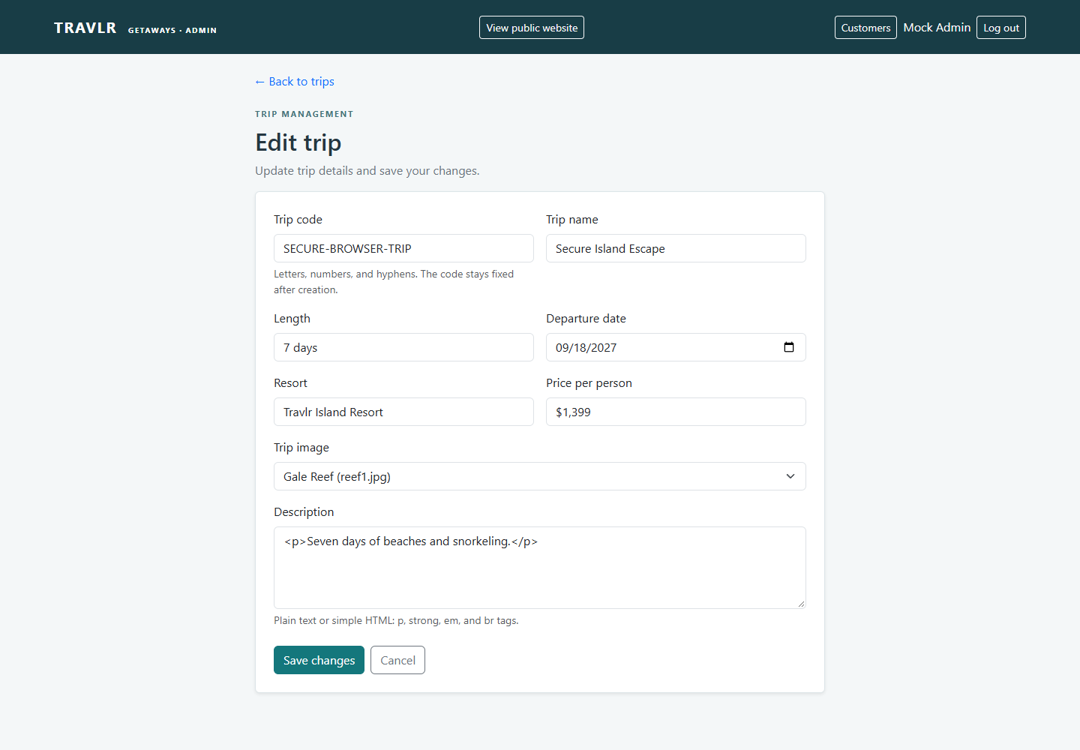
Figure 5 Edit form preloaded from GET /api/trips/:tripCode

Saved Update
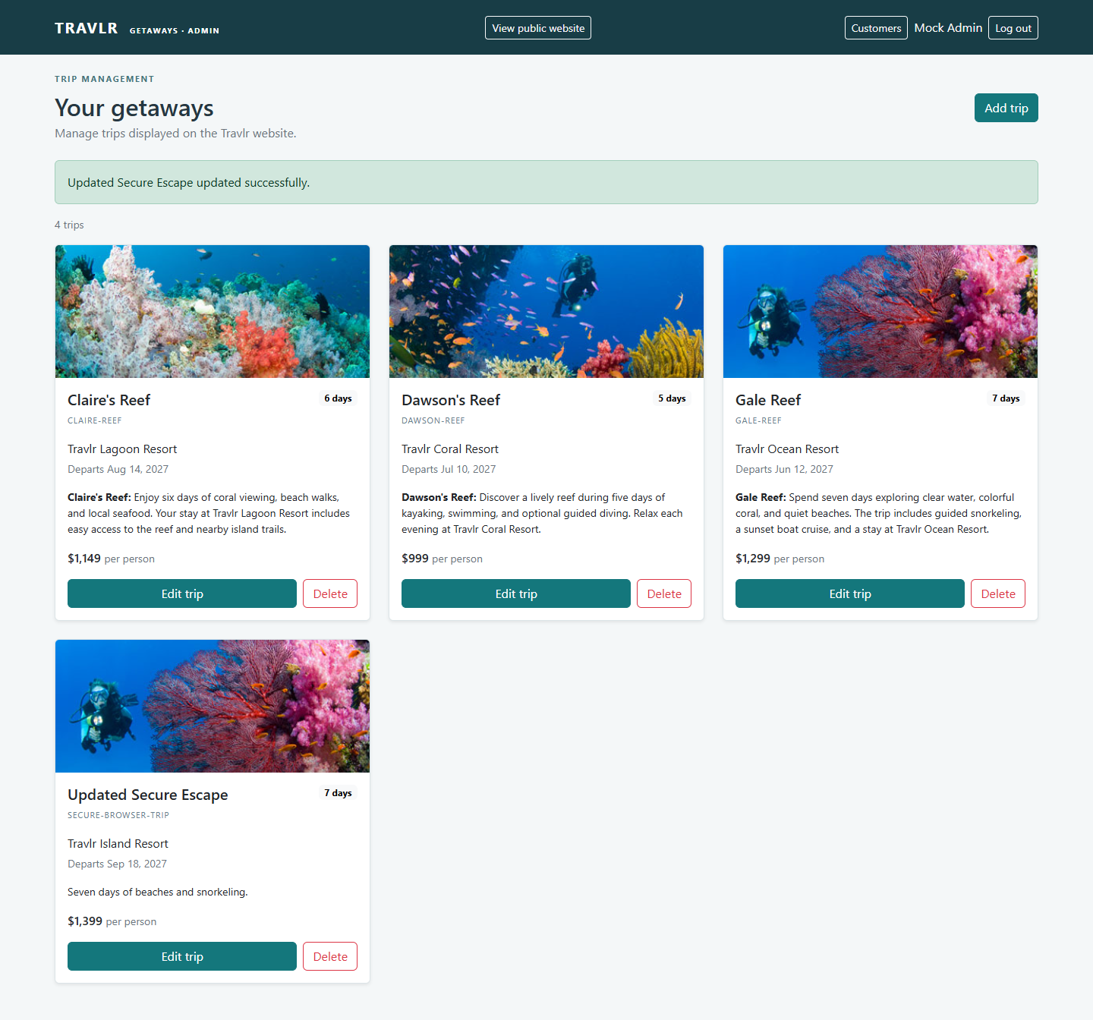
Figure 6 Updated trip retrieved again after a page refresh

Angular and Express Structure
Angular groups the SPA under app_admin/src/app. Each component has a TypeScript class and an HTML template. app.routes.ts maps the trip list, add form, edit form, login page, and customer page. TripDataService centralizes HTTP requests, and AuthenticationService manages the session. Reactive forms provide required-field validation, signals update the view, and reusable trip cards keep list behavior consistent.
Express uses a different structure because it handles requests on the server. app_server contains customer routes, controllers, and Handlebars views. app_api contains REST routes, controllers, and Mongoose models. public contains static pages, images, CSS, and the customer account script. app.js connects those parts and serves the compiled Angular app under /admin. The public travel controller renders a complete HTML document; Angular changes views and updates cards without downloading a new HTML document for each action.
The SPA provides immediate loading, validation, success, and error feedback. It also preloads edit fields, confirms deletion, and updates lists after a saved change. Its tradeoffs are a larger initial JavaScript download and more browser state to manage. Customer account and itinerary pages use a smaller JavaScript script for API interaction while keeping the Express and Handlebars structure.

Testing GET and PUT
GET testing checked the JSON trip collection, the rendered Angular cards, and the selected trip loaded into the edit form. PUT testing changed Secure Island Escape to Updated Secure Escape through that form. The browser check confirmed the API response, the MongoDB record, the updated card after refresh, and the changed name on the public /travel page. This checks the entire path from the interface to storage and back, rather than accepting a success message alone.
Testing also covered missing fields, invalid dates, duplicate codes, missing trips, unsupported description HTML, incorrect passwords, expired or tampered tokens, and direct access to protected endpoints. Regular users cannot change trips or list customers. Reservations are assigned from the verified account instead of a submitted user ID, and another customer cannot read or cancel them. Removing a customer also removes their reservations and invalidates their access.
Final results were 23 passing backend integration tests, 16 passing Angular tests, and 45 passing Postman assertions across 31 requests. Newman ran the Postman collection against an isolated server. Chrome testing verified trip CRUD, customer registration and login, location and price search, booking persistence, cancellation, customer editing and deletion, guarded URLs, logout, and the mobile login layout. No browser script errors occurred. Screenshots and machine-readable results are included in the application ZIP.

Customer and Administrator Evidence
The customer itinerary stores the selected package with its departure date, resort, duration, price, and reservation status. The administrator customer page updates names and email addresses without exposing password material. The complete search, booking, and customer-management screenshots are included in test/evidence/final-project.
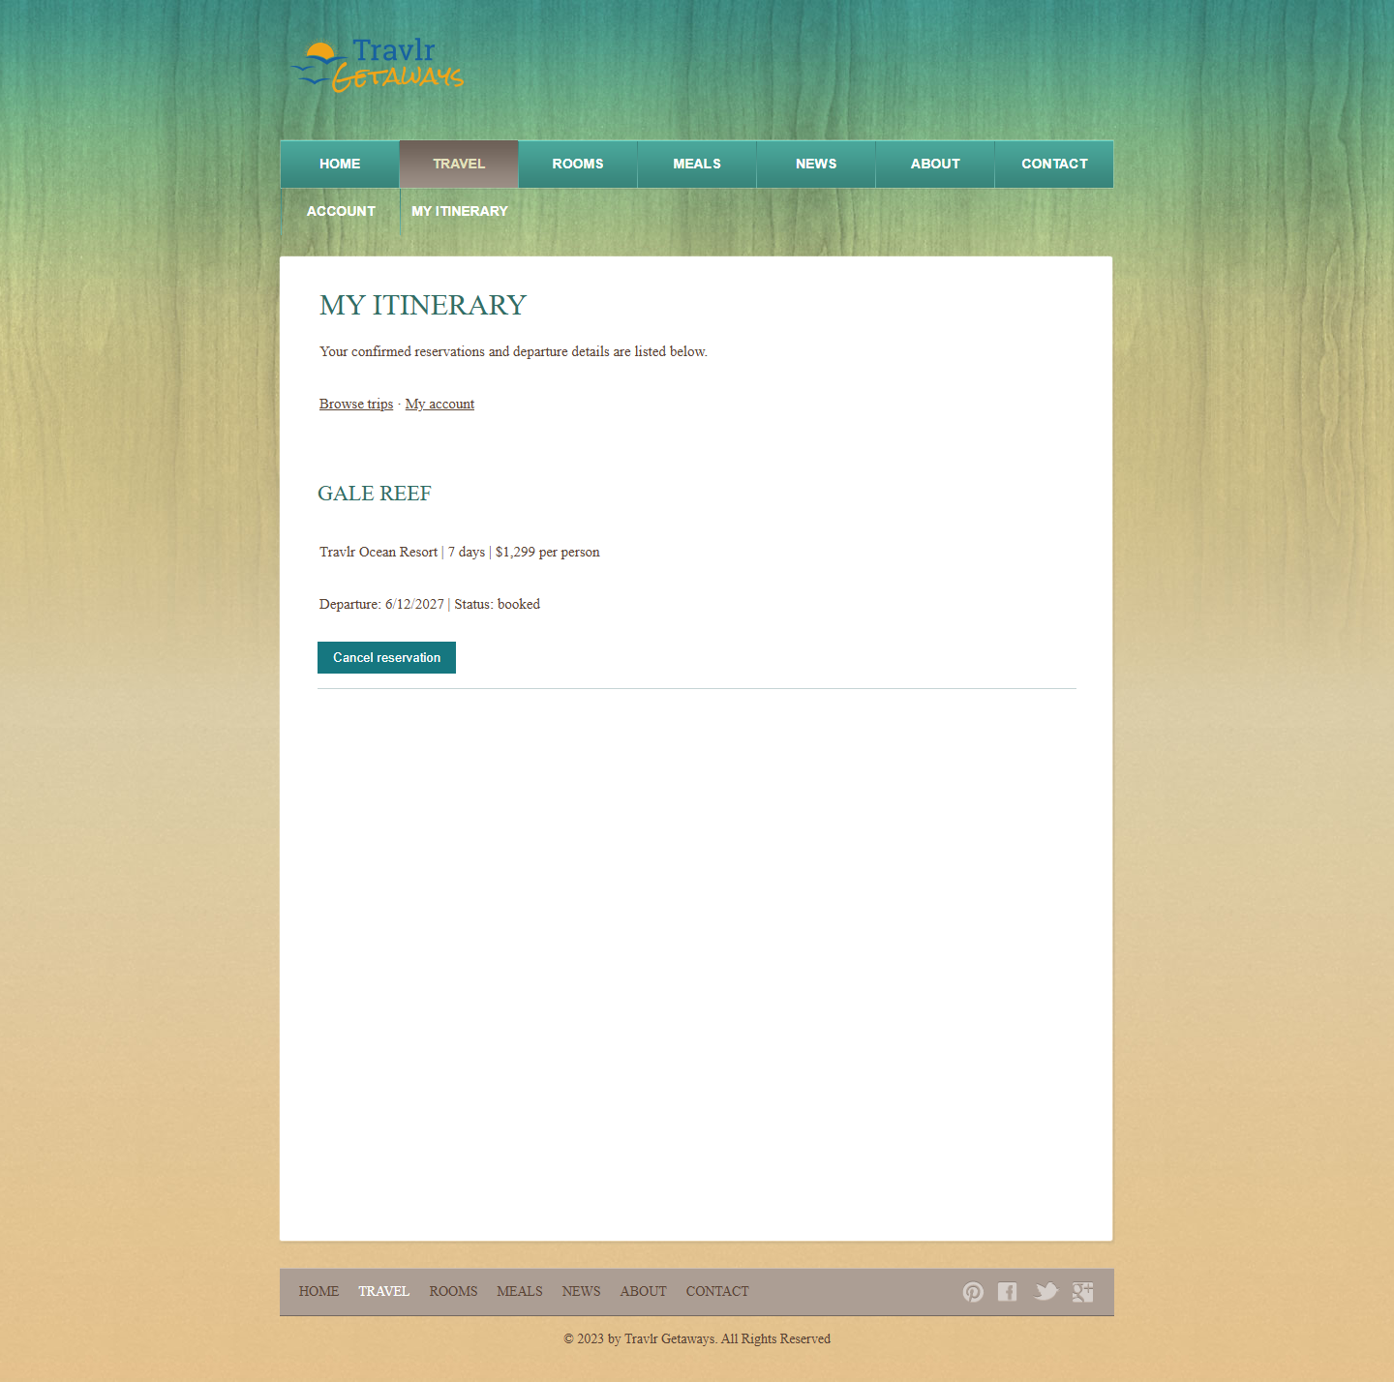
Figure 7 Customer itinerary retrieved after booking and refresh

Customer Management
The customer list shows the saved name and email after an authorized update. Deleting the account requires a second confirmation and removes its reservations. The browser test verified both operations and confirmed that the deleted account was no longer present in MongoDB.
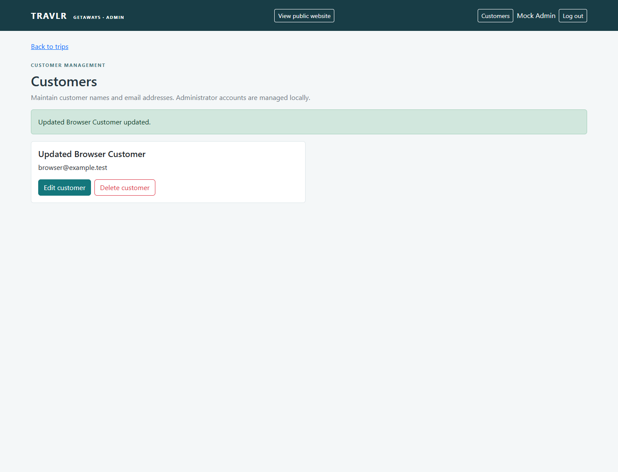
Figure 8 Administrator customer management after a saved update

