Software Architecture and Design Specification
Project: Chat Application (Socket Programming)
Version: 1.0
Authors: S Kishore, Prajwal G N, Harivasan, Shreyas
Date: 02-10-2026
Status: Draft
Institution: PES University, Bangalore - Department of Computer Science and Engineering

Revision History
Version | Date | Author | Change Summary
1.0 | 02-10-2026 | S Kishore | Initial architecture and design specification, derived from SRS v1.0 (08/09/2026) and the Test Plan (REQ-01 to REQ-15).
1.1 | 2-10-2026 | Harivasan R | - Updated system architecture diagrams  - Refined module descriptions for authentication, message broker, and persistence layer  -Revised non-functional requirements and overall architecture

Approval
Role | Name | Signature/Date
Author | Prajwal G N
Author | Harivasan
Author | Shreyas
Author | S Kishore
Faculty/Reviewer

Role | Name | Signature/Date
Author | S Kishore
Author | Prajwal G N
Author | Harivasan R
Author | Shreyas

1. Introduction

1.1 Purpose
This document specifies the architecture and design of the Real-Time Chat Application (Socket Programming), version 1.0. It translates the requirements in the Software Requirements Specification (SRS) and the Test Plan into a structure that developers can implement and testers can verify. Content follows IEEE Std 1016-2009 (software design descriptions) and the viewpoint/stakeholder approach of ISO/IEC/IEEE 42010.

1.2 Scope
Covers the end-user chat services of v1.0: connecting to the server over WebSocket, joining and leaving a chat room, sending and receiving text messages in real time, join/leave notifications, optional presence and typing indicators, and handling of connection failure with reconnection. Both the browser client and the WebSocket server are in scope.
Out of scope for v1.0, consistent with the SRS: chat history persistence or any database, user authentication, file or image sharing, native mobile apps and horizontal scaling. Section 4.6 records how the design can grow to include them.

1.3 Audience
Developers, QA engineers, security reviewers, instructors and faculty, project managers, and the administrator or maintenance team who will deploy and monitor the server.

1.4 Definitions
Term | Definition
WebSocket (WS / WSS) | Full-duplex protocol over one TCP connection (RFC 6455). WSS is WebSocket over TLS.
Socket.IO / Flask-SocketIO | Event-based real-time library on top of WebSocket; Flask-SocketIO is its Python server.
Room | Logical group of connected clients that receive each other's broadcasts. The Test Plan calls this a chat session.
Session (sid) | Server-side record of one connected client, keyed by a unique session id.
Handshake | HTTP Upgrade exchange that turns an HTTP connection into a WebSocket.
Event / Broadcast | A named JSON message exchanged over the socket / delivery of one event to every session in a room.
ADR | Architecture Decision Record (Section 3.5).
STRIDE | Threat model: Spoofing, Tampering, Repudiation, Information disclosure, Denial of service, Elevation of privilege.
XSS / CSWSH | Cross-Site Scripting / Cross-Site WebSocket Hijacking.
TLS | Transport Layer Security, used by wss://.
SRS / STP / RTM | Software Requirements Specification / Software Test Plan / Requirement Traceability Matrix.

2. Document Overview

2.1 How to use this document
The document provides the architectural deliverables (goals, component diagram, pattern rationale with ADRs, technology stack, risks, traceability and security architecture in Section 3) and the design deliverables (UML sequence diagrams, API design, error handling, logging, monitoring and UX in Section 4).
If you are a... | Start with
Developer | 3.3 and 3.4 (components), 4.1 (design model), 4.3 (API), 4.4 (errors)
Tester | 3.8 (traceability), 4.2 (sequence diagrams), 4.4 (error catalogue)
Security reviewer | 3.9 (security architecture), 4.3.5 (validation rules)
Administrator | 3.6 (deployment), 4.4 (logging and monitoring)
Faculty / manager | 3.1, 3.5, 3.7, 4.6

2.2 Related Documents
Document | Relationship
SRS: Chat Application (Socket Programming), v1.0, 08/09/2026 | Source of requirements REQ-1 to REQ-9, non-functional requirements, business rules and message field layout (Appendix B).
SRS and Test Plan Details, September 2026 | Source of requirements REQ-01 to REQ-15 and test cases UT/IT/ST (3 unit, 3 integration, 2 system per requirement).
RTM (SRS Appendix C) | This document fills its Architecture Reference and Design Reference columns (Section 3.8).
Requirement baseline. The two inputs number requirements differently: the SRS uses REQ-1 to REQ-9 (with rooms, server timestamps and optional presence/typing) and the Test Plan uses REQ-01 to REQ-15. This document uses REQ-01 to REQ-15 as the baseline because test cases are already defined against it, and Section 3.8.3 maps REQ-1 to REQ-9 onto it so that no requirement is left unallocated.

3. Architecture

3.1 Goals & Constraints
Goals: low-latency two-way messaging (delivery within 1 second for up to 100 concurrent users), reliable behaviour under network failure (no client crash, clear notification, reconnection), safe handling of user input (no script injection), modular and portable code, and a design simple enough to test thoroughly.
Constraints:
- WebSocket protocol is mandatory for real-time messaging; long polling is not the primary transport (SRS 2.5).
- Backend in either Node.js 18+ (ws or Socket.IO) or Python 3.9+ (Flask-SocketIO), not both (SRS 2.5).
- No persistent database in v1.0; messages are not stored after the session ends (SRS 2.5, 7).
- Single-server deployment; no load balancing or horizontal scaling (SRS 2.5).
- Browser client only (Chrome, Firefox, Edge, Safari); no native mobile app (SRS 2.6).
- TLS-secured wss:// in production; input sanitisation against XSS (SRS 5.3).
- Business rules: only connected users may send or receive; a user is in at most one room at a time (SRS 5.5).
Table 1: Quality targets that drive the architecture
ID | Target | Source | Architectural consequence
NFR-P1 | Delivery latency at most 1 s with 100 concurrent users | SRS 5.1 | Persistent push channel; in-memory state; no I/O on delivery path
NFR-P2 | At least 100 simultaneous connections | SRS 5.1 | Non-blocking server; configured capacity 200
NFR-S1 | wss:// (TLS) in production | SRS 5.3 | TLS at server or reverse proxy
NFR-S2 | Sanitise input against XSS | SRS 5.3 | Validator/Sanitizer plus safe rendering
NFR-R1 | Auto-reconnect dropped clients | SRS 5.4 | Heartbeat, back-off reconnect, rejoin
NFR-M1 | Modular: separate connection, room, broadcast logic | SRS 5.4 | Component decomposition (3.4)
NFR-PO1 | Runs on any OS with Node.js or Python | SRS 5.4 | Technology-neutral design (3.6)
NFR-U1 | Usable without instructions | SRS 5.4 | Always-visible status; plain errors (4.5)
No availability percentage is specified in the SRS. A single instance is accepted for v1.0; recovery relies on client reconnection (Section 3.7).

3.2 Stakeholders & Concerns
Stakeholder | Concerns | Addressed in
End User (Chat User) | Instant delivery, clear connection status, no page refresh, messages shown safely | 3.5, 4.2, 4.4, 4.5
Administrator | Capacity, monitoring, logging, secure deployment over TLS | 3.6, 3.9, 4.4
Developer | Modularity, clear event contract, Node.js or Python portability | 3.4, 4.1, 4.3
Tester | Traceability, observable states, predictable error behaviour | 3.8, 4.4
Faculty / Project manager | Scope control, requirement coverage, risk visibility | 3.7, 3.8, 4.6

3.3 Component (UML) Diagram
Figure 1 shows the logical component view. The client tier runs in the browser. The server tier is a single process. The only network connector between tiers is the WebSocket connection (red). Server components share an in-memory Session and Room Store. Dashed arrows are supporting dependencies (S5 is also used by S1 and S4; S6 is read by all server components).
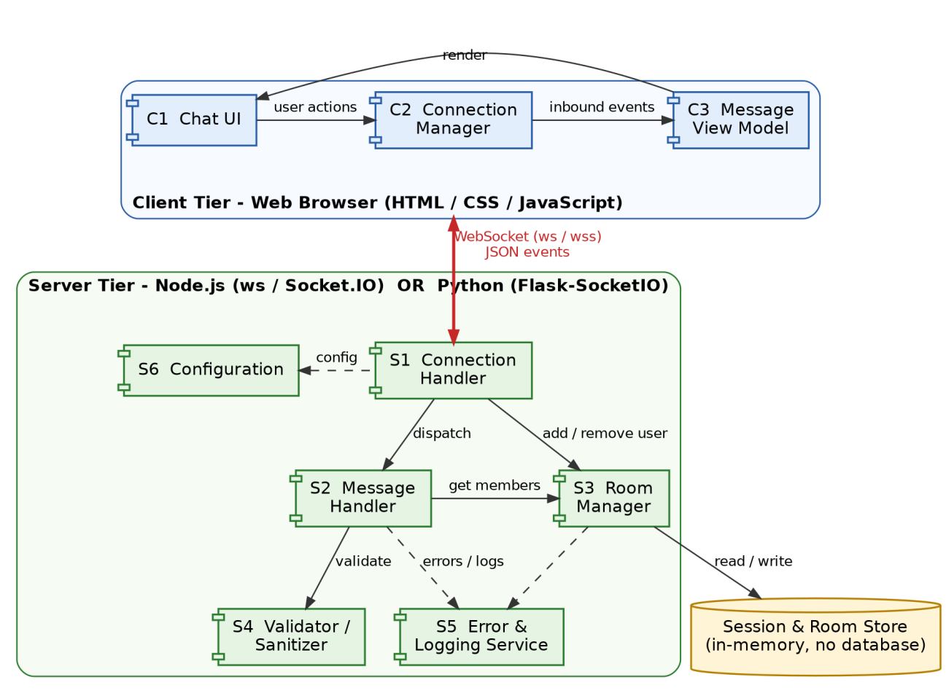
Figure 1: UML component diagram: client tier, server tier and in-memory store

3.4 Component Descriptions
Table 2: Component catalogue
ID | Component | Responsibility | Key operations | Planned file
C1 | Chat UI | Connection area (username, room, Connect, Leave), message list, input box, Send, status and error banner. Blocks empty input locally. | showStatus(), showError(), renderMessage(), setMembers() | index.html, ui.js
C2 | Connection Manager | Owns the socket: connect, emit, receive, heartbeat monitoring, back-off reconnection and automatic rejoin. Publishes status changes to C1. | connect(), joinRoom(), leaveRoom(), sendMessage(), onStatus() | client.js
C3 | Message View Model | Keeps received messages ordered by server seq, formats timestamps, escapes text, removes duplicates. | addMessage(), getOrdered(), clear() | messages.js
S1 | Connection Handler | Accepts handshakes, checks origin and capacity, creates and removes sessions, runs heartbeat, dispatches events, cleans up on disconnect. | onConnection(), onDisconnect(), dispatch() | Server.js / app.py
S2 | Message Handler | Handles message and typing: validates through S4, adds UTC timestamp and room sequence number, finds recipients through S3, broadcasts. | handleMessage(), handleTyping(), broadcast() | Server.js / app.py
S3 | Room Manager | Room membership, one room per session, join/leave system events, presence list, deletes empty rooms. | addUser(), removeUser(), getMembers(), roomOf() | Rooms.js / rooms.py
S4 | Validator / Sanitizer | Type, length and pattern checks; HTML-escapes text; returns structured validation errors. | validateJoin(), validateMessage(), sanitize() | validator.js / validator.py
S5 | Error & Logging Service | Maps failures to error codes, builds error events, writes structured logs, exposes counters. | buildError(), log(), counters | errors.*, logger.*
S6 | Configuration | Loads port, limits, timeouts, TLS and allowed origins from environment. | config | config.js / config.py
ST | Session & Room Store | In-memory maps sessions and rooms (Section 4.1.3). Lost on restart by design. | internal to S1, S3 | inside Rooms.*
Table 3: Connectors between components
From | To | Mechanism | Content
C1 | C2 | Function call / callback | User actions; status and error callbacks
C2 | C3, C3 to C1 | Function call | Inbound events, then ordered escaped messages for rendering
C2 | S1 | WebSocket (ws / wss), JSON events | All events in Section 4.3 (the only network connector)
S1 | S2, S3 | In-process call | Dispatch of events; add/remove user
S2 | S4, S3 | In-process call | Validation; recipient lookup
S1-S4 | S5 | In-process call | Error mapping, logging
S3, S1 | ST | In-process read/write | Session and room records
S6 | S1, S2 | Read-only | Limits, timeouts, origins

3.5 Chosen Architecture Pattern and Rationale
Chosen pattern: client-server architecture with an event-driven publish/subscribe interaction over persistent WebSocket connections. The server is internally layered (transport, application handlers, validation and state), with the Mediator pattern in the Room Manager and the Observer pattern in the client. The server owns identity, ordering and rooms; clients stay thin.
Table 4: Patterns applied
Pattern | Where | Rationale
Client-Server | Browser (C1-C3) and server (S1-S6) | Central authority for rooms, ordering and validation; matches SRS product perspective.
Event-driven publish/subscribe | WebSocket events; room = topic, sessions = subscribers | Server pushes when events occur, so no polling or page refresh (REQ-11); meets the 1 s target.
Layered (server) | S1 transport; S2/S3 handlers; S4 and ST below | Replacing the library in S1 does not touch room logic (NFR-M1, NFR-PO1).
Mediator | S3 Room Manager | Sessions never reference each other; low coupling and easy unit tests.
Observer | C2 status callbacks to C1; events to C3 | UI reacts to state without C2 knowing UI details.
Gatekeeper validation | S4 before S2/S3 | Invalid input never changes state or reaches other users (NFR-S2).
Table 5: Alternatives considered
Alternative | Why not / decision
HTTP short or long polling | High latency and wasted requests; violates the WebSocket constraint. Rejected (Socket.IO may fall back internally).
Server-Sent Events plus HTTP POST | Needs two channels; weaker for typing and presence. Rejected.
Peer-to-peer (WebRTC) | Signalling complexity; rooms, ordering and validation are hard without a server. Rejected.
Message broker with microservices | Over-engineered for 100 users and contradicts the single-server constraint. Deferred to future work (4.6).
Single-process WebSocket server with in-memory rooms | Selected: meets latency and capacity with the fewest moving parts and is easy to test.
Table 6: Architecture decision records
ID | Decision | Rationale and consequence
ADR-1 | WebSocket is the only real-time transport | Mandated by SRS; lowest overhead. Clients need WebSocket support (all listed browsers have it).
ADR-2 | Server derives sender, room, timestamp; client sends only content | Prevents spoofing and clock tampering; satisfies the server-side timestamp requirement (SRS REQ-4).
ADR-3 | Server assigns a per-room sequence number seq | One total order for all receivers (REQ-12); C3 orders by seq.
ADR-4 | All state in memory | SRS excludes persistence. Restart clears rooms; clients rejoin automatically.
ADR-5 | Validate on client and on server | Client check gives instant feedback (REQ-09); the server check is the authority.
ADR-6 | One room per session at a time | SRS business rule; second join_room returns E204.
ADR-7 | TLS terminated at a reverse proxy in production | Keeps certificates out of app code; development uses plain ws on localhost.
ADR-8 | Technology-neutral design with two realisations | SRS allows Node.js or Python, not both; team chooses one in sprint 1.

3.6 Technology Stack & Data Stores
The component model is technology-neutral. The team selects one option; both conform to this architecture.
Table 7: Technology options
Concern | Option A: Node.js 18+ | Option B: Python 3.9+
Server library | ws (raw) or socket.io | Flask with Flask-SocketIO
Concurrency | Single-threaded event loop; no locks for shared maps | eventlet or gevent mode recommended; use a lock if threading mode
Rooms (S3) | Own Map, or socket.join() | Own dict, or join_room() / leave_room()
Heartbeat | pingInterval / pingTimeout (or ws ping/pong) | ping_interval / ping_timeout
Payload limit | maxPayload / maxHttpBufferSize | max_http_buffer_size
Client | Browser WebSocket API or Socket.IO client | Socket.IO client
Source files | Server.js, Rooms.js, validator.js, config.js | app.py, rooms.py, validator.py, config.py
Client: HTML5, CSS and vanilla JavaScript, no build tool required. Data stores: none persistent. The in-memory Session and Room Store holds sessions and rooms (Section 4.1.3). A future repository for chat history (MongoDB or SQLite, SRS 3.2) attaches behind S2.
Deployment. In development the browser connects to ws://localhost:5000. In production a reverse proxy terminates TLS so clients use wss:// on port 443 and the application port stays internal.
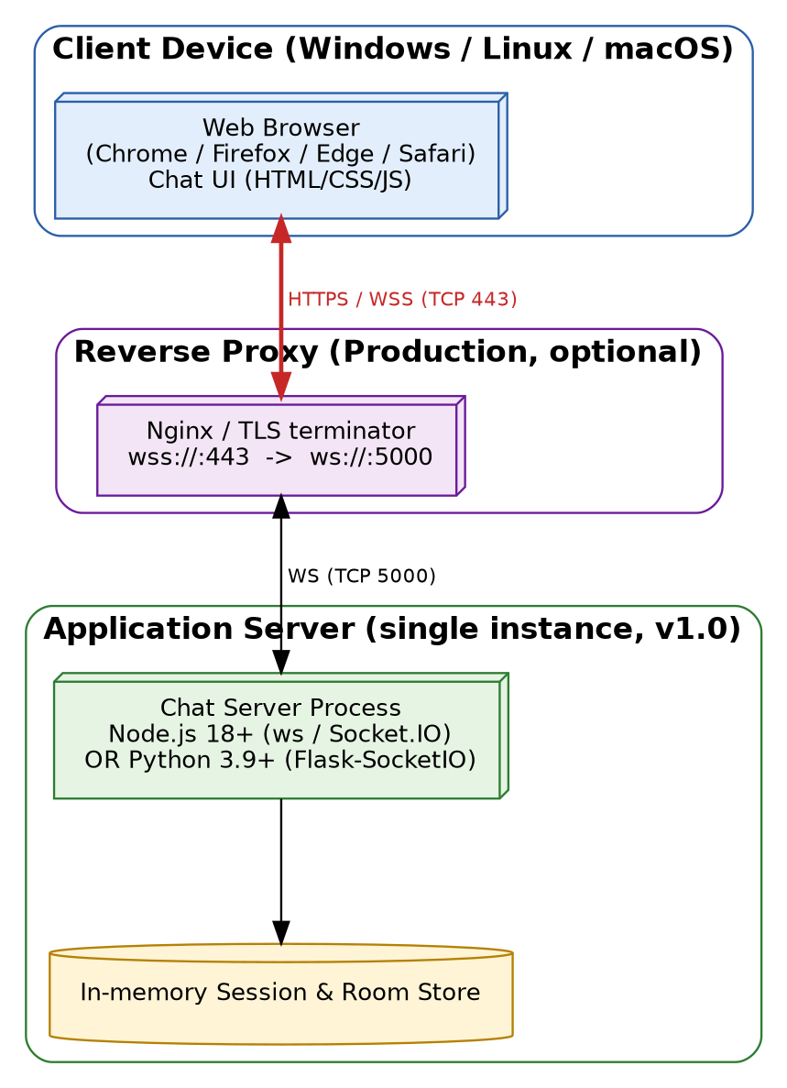
Figure 2: Deployment view (single instance, v1.0)

3.7 Risks & Mitigations
ID | Risk | Mitigation
R1 | Server or network failure interrupts chat (all sessions drop) | Heartbeat detects within 45 s; client back-off reconnect with automatic rejoin; clear status banner (REQ-03, 13-15).
R2 | Team mixes Node.js and Python code | ADR-8: choose one stack in sprint 1.
R3 | Library and runtime version incompatibility (SRS 2.6) | Pin versions, commit lock file, document in README.
R4 | Message ordering anomalies under concurrency | ADR-3; assign seq inside the single handler; two-client integration tests (IT-12B).
R5 | Latency target missed under load | Capacity estimate in 4.1.5; rate limiting; load test with 100 simulated clients.
R6 | XSS via message text or username | Server escaping (S4) plus client rendering with textContent and CSP (3.9).
R7 | Reconnect storm after a server restart | Exponential back-off with random jitter (4.4.4).
R8 | Two requirement numbering schemes cause untested requirements | Crosswalk in 3.8.3; add test cases if optional REQ-8/9 are implemented.

3.8 Traceability to Requirements

3.8.1 Requirement to architecture and design
Req ID | Requirement | Components | Architecture | Design
REQ-01 | Connect to the chat server | C1, C2, S1, S6 | 3.4, ADR-1 | SD-1; 4.3.2
REQ-02 | Display connection status | C1, C2 | 3.4 | SD-1; Fig. 3 (state)
REQ-03 | Notify when server connection is lost | C2, C1, S1 | 3.4, 3.7 R1 | SD-3; 4.4.3
REQ-04 | Join a chat session (room) | C1, C2, S1, S3 | 3.4, ADR-6 | SD-1; join_room
REQ-05 | Leave the chat session | C1, C2, S1, S3 | 3.4 | SD-4; leave_room
REQ-06 | Update session on join/leave | S3, S2, C3 | 3.5 (Mediator) | SD-1, SD-4; system, presence
REQ-07 | Enter and send a text message | C1, C2, S2 | 3.4 | SD-2; message
REQ-08 | Transmit message through WebSocket | C2, S1, S2 | 3.4, ADR-1 | SD-2; 4.3.1
REQ-09 | Prevent empty message | C1, S4 | ADR-5, 3.5 | SD-2; 4.3.5; E304, C04
REQ-10 | Display received messages | C3, C1 | 3.4 | SD-2; message
REQ-11 | Display without manual refresh | C2, C3 | 3.5 (event-driven) | SD-2
REQ-12 | Maintain message order | S2 (seq), C3 | ADR-3 | SD-2; 4.1.3
REQ-13 | Handle unavailable server without crash | C2, C1 | 3.7 R1 | SD-1 (alt); 4.4.3; C01
REQ-14 | Notify when connection is interrupted | C2, C1 | 3.7 R1 | SD-3; 4.4.3; C02
REQ-15 | Allow reconnect after failure | C2, S1, S3 | 3.7 R7 | SD-3; 4.4.4; C03

3.8.2 Requirement to code and test cases
File names are planned names (Section 3.4) and follow the SRS RTM naming (Server.js/app.py, Rooms.js/rooms.py). Test IDs are from the Test Plan: three unit (A-C), three integration (A-C) and two system (A-B) cases per requirement.
Req ID | Code file reference | Unit IDs | Integration IDs | System IDs
REQ-10 | messages.js; ui.js | UT-10A-C | IT-10A-C | ST-10A-B
REQ-11 | client.js; messages.js | UT-11A-C | IT-11A-C | ST-11A-B
REQ-12 | Server.js / app.py; messages.js | UT-12A-C | IT-12A-C | ST-12A-B
REQ-13 | client.js; ui.js | UT-13A-C | IT-13A-C | ST-13A-B
REQ-14 | client.js; ui.js | UT-14A-C | IT-14A-C | ST-14A-B
REQ-15 | client.js | UT-15A-C | IT-15A-C | ST-15A-B
REQ-01 | client.js; Server.js / app.py | UT-01A-C | IT-01A-C | ST-01A-B
REQ-02 | client.js; ui.js | UT-02A-C | IT-02A-C | ST-02A-B
REQ-03 | client.js; ui.js; Server.js / app.py | UT-03A-C | IT-03A-C | ST-03A-B
REQ-04 | client.js; Server.js / app.py; Rooms.js / rooms.py | UT-04A-C | IT-04A-C | ST-04A-B
REQ-05 | client.js; Rooms.js / rooms.py | UT-05A-C | IT-05A-C | ST-05A-B
REQ-06 | Rooms.js / rooms.py; messages.js | UT-06A-C | IT-06A-C | ST-06A-B
REQ-07 | ui.js; client.js; Server.js / app.py | UT-07A-C | IT-07A-C | ST-07A-B
REQ-08 | client.js; Server.js / app.py | UT-08A-C | IT-08A-C | ST-08A-B
REQ-09 | ui.js; validator.js / validator.py | UT-09A-C | IT-09A-C | ST-09A-B

3.8.3 Crosswalk to SRS requirements REQ-1 to REQ-9
SRS ID | SRS requirement | SRS test | Baseline REQ | Allocation
REQ-1 | WebSocket connection on page load | TC-01 | REQ-01, 02 | C2, S1; SD-1
REQ-2 | Reject failed handshake, show error | TC-04 | REQ-13, 02 | S1 (E101), C2, C1
REQ-3 | Broadcast to room within 1 s | TC-02 | REQ-08, 10, 11 | S2, S3, C3; SD-2
REQ-4 | Server-side timestamp | TC-05 | REQ-12 (support) | S2; ADR-2
REQ-5 | Reject empty message | - | REQ-09 | C1, S4; SD-2
REQ-6 | Join a named room | TC-03 | REQ-04 | S3; SD-1
REQ-7 | Notify on join/leave | - | REQ-06 | S3, S2; SD-1, SD-4
REQ-8 | List of connected users (optional) | - | none in Test Plan | presence event
REQ-9 | Typing indicator (optional) | - | none in Test Plan | typing event
REQ-8 and REQ-9 are priority Low. They are designed in the API and enabled by the flags FEATURE_PRESENCE and FEATURE_TYPING. If implemented, matching test cases should be added to the Test Plan.

3.8.4 Non-functional requirements
ID | Requirement | Realised by | Verified by
NFR-P1/P2 | 1 s latency; 100 connections | 3.5; 4.1.5; S6 MAX_CONNECTIONS=200 | Load test with 100 clients
NFR-S1 | wss:// in production | ADR-7; control SC-1 | Deployment check
NFR-S2 | Sanitise against XSS | S4; C3 textContent; SC-3, SC-4 | S4 unit tests with script payloads
NFR-R1 | Auto-reconnect | C2 back-off (4.4.4); SD-3 | REQ-15 tests
NFR-M1 | Modular code | 3.4; layered server | Code review against 3.4
NFR-PO1 | Cross-platform | 3.6 | Run on Windows, Linux, macOS
BR-1 / BR-2 | Only connected users; one room per user | S1 (E203); S3 invariant (E204) | Integration and unit tests

3.9 Security Architecture
The SRS requires TLS transport and protection against script injection, with authentication optional for later. The product stores no data on disk, but live messages, usernames and server availability still need protection.
Trust boundaries. (1) Browser to network to server: everything crossing it is untrusted; entry points are the handshake, each WebSocket event, GET /health and GET /admin/stats. (2) Reverse proxy to application (production): the internal port is reachable only from the proxy. Inside the process, components trust each other because validation happens once at the boundary (S1, S4). The client likewise treats every received string as untrusted text.
Table 8: Threat model (STRIDE) and mitigations
STRIDE | Threat | Mitigation | Control
Spoofing | Client forges sender or room | Server ignores client identity and uses the session record (ADR-2) | SC-5
Spoofing | Username already in use in a room | Unique per room (E302); real authentication planned (4.6) | SC-6
Spoofing / Tampering | Cross-Site WebSocket Hijacking | Origin allow-list at handshake; reject with E101 (close 1008) | SC-2
Tampering | Script/HTML injected in message or username (XSS) | Server escaping (S4); client renders with textContent, never innerHTML; CSP header | SC-3, SC-4
Tampering | Malformed JSON, unknown events, oversized frames | Strict schema (E201, E202); 4 KB payload cap (E402, close 1009) | SC-7
Repudiation | No record of actions | Structured logs with session id, event, time; message bodies never logged | SC-10
Information disclosure | Eavesdropping on ws:// | TLS 1.2+ via wss://; HSTS at proxy | SC-1
Information disclosure | Stack traces leaked in errors | Clients get only code and fixed text; details stay in logs (E500) | SC-9
Denial of service | Connection flood | Global cap 200, per-IP cap 20; idle timeout (E102) | SC-8
Denial of service | Message flood or slow consumer | Token bucket 5 msg/s, burst 10 (E401); bounded send buffer; disconnect slow consumers | SC-8
Elevation of privilege | Send before joining; call admin endpoint | State check (E203); bearer token on /admin/stats | SC-5, SC-11
Supply chain | Vulnerable dependency | Pinned versions; npm audit / pip-audit; run as non-root | SC-12
Table 9: Security controls
Control | Description | Component
SC-1 Transport | wss:// with TLS 1.2+ in production; REQUIRE_TLS rejects plain connections. | Proxy, S1
SC-2 Origin check | Origin header compared with ALLOWED_ORIGINS before a session is created. | S1
SC-3 Validation | Type, length and pattern checks (4.3.5); text HTML-escaped before broadcast. | S4
SC-4 Safe rendering | DOM built with textContent; header Content-Security-Policy: default-src 'self'; script-src 'self'; connect-src 'self' wss:. | C3, C1, S1
SC-5 Server authority | Sender, room and timestamp come from server state; only join_room is accepted before joining (E203). | S1, S2
SC-6 Username policy | Pattern ^[A-Za-z0-9_ -]{1,50}$, unique per room; hook point in onConnection() for future token check. | S3, S4
SC-7 Protocol hardening | Only events in 4.3 accepted; unknown fields dropped; payload limit 4096 bytes. | S1, S4
SC-8 Abuse limits | Connection caps, rate limit, heartbeat and idle timeouts, bounded buffers. | S1, S6
SC-9 Safe errors | Code and fixed message only to clients; internal exception logged with correlation id. | S5
SC-10 Audit log | Connect, join, leave, disconnect, validation failure and rate-limit events logged without message content. | S5
SC-11 Admin access | /admin/stats needs Authorization: Bearer ADMIN_TOKEN; disabled if unset. | S1, S6
SC-12 Dependencies | Exact versions, advisory review before release, non-root service user. | Build
Residual risks (accepted for v1.0): no authentication (anyone may pick a free username), no end-to-end encryption (server can read messages in memory), no moderation tooling for the Administrator role, and a single server as a single point of failure.

4. Design

4.1 Design Overview

4.1.1 Design approach
The application is designed as layered modules with one responsibility each, so connection handling, room logic, validation and broadcasting can be built and tested separately (NFR-M1). Event handlers are thin: they validate, call the Room Manager, and emit. The server holds all authoritative state; the client only renders what the server sends. Every network interaction is a named JSON event (Section 4.3).

4.1.2 Client state model
The Connection Manager (C2) is a small state machine. The Chat UI shows the current state at all times (REQ-02) and offers only the actions that are valid in it.
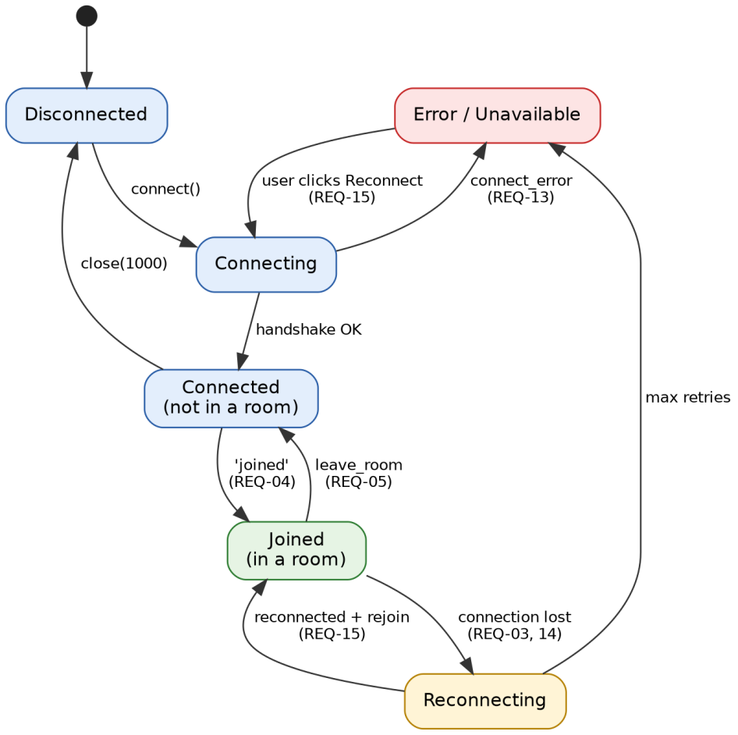
Figure 3: Client connection state diagram (C2)

4.1.3 Data design
No database is used in v1.0. The server keeps two in-memory maps; the message object is transient and is never stored.
Table 10: In-memory structures (Session & Room Store)
Structure | Key | Fields
sessions | sid (string) | username, room (or null), ip, connectedAt, lastSeen, rate-limit tokens
rooms | room name (string) | members (set of sid), seq counter (integer, starts at 0), createdAt
Invariants enforced by S3: a sid appears in at most one room (BR-2); a username is unique within a room; a room with no members is deleted; seq only increases.
Table 11: Message object field layout (extends SRS Appendix B)
Field | Length | Type | Description | Mandatory | Set by
id | 36 | String (UUID) | Unique message id for de-duplication (added in this design) | Y | Server
type | 20 | String | Event type: message / join / leave / typing | Y | Server
sender | 50 | String | Username of the sender | Y | Server (from session)
room | 30 | String | Room identifier | Y | Server (from session)
content | 500 | String | Message text (sanitised); empty for join/leave/typing | Y | Client text, server sanitises
timestamp | - | DateTime | UTC time, RFC 3339 (REQ-4 in SRS) | Y | Server
seq | - | Integer | Per-room sequence number for ordering (REQ-12; added in this design) | Y | Server

4.1.4 Configuration parameters
Parameter | Default | Purpose
PORT | 5000 | Application listening port
MAX_CONNECTIONS / MAX_CONN_PER_IP | 200 / 20 | Capacity limits (design capacity is 2x the 100-user requirement)
HEARTBEAT_INTERVAL / HEARTBEAT_TIMEOUT | 25 s / 20 s | Detect silent connection loss within 45 s
MAX_PAYLOAD_BYTES / MAX_CONTENT_LEN | 4096 / 500 | Frame and message text limits
RATE_LIMIT | 5 msg/s, burst 10 | Per-session token bucket
ALLOWED_ORIGINS / REQUIRE_TLS | localhost / false (true in production) | Origin allow-list; refuse plain ws
ADMIN_TOKEN | unset | Enables /admin/stats when set
FEATURE_PRESENCE / FEATURE_TYPING | true / true | Optional REQ-8 and REQ-9
DEFAULT_ROOM, LOG_LEVEL | global, info | Room used when none given; log verbosity

4.1.5 Performance and capacity estimate
Worst realistic case: all users in one room, each sending one message every 5 seconds.
Parameter | Value
Concurrent users | 100 (design capacity 200)
Messages into server | 100 / 5 s = 20 msg/s
Deliveries (fan-out to 100) | 20 x 100 = 2,000 per second
Stress case (1 message/s each) | 100 msg/s, 10,000 deliveries/s
Message size | At most 500 characters plus about 150 bytes of metadata
A single event-loop server doing only in-memory lookups and socket writes should handle this comfortably. Latency budget: network 100-200 ms round trip, validation and routing under 5 ms, queueing under 50 ms. This is an estimate and must be confirmed by the load test.

4.2 UML Sequence Diagrams
Four sequence diagrams cover the main flows of this project. Participants are the components of Section 3.4. Numbers in the diagrams are message order; REQ tags show where each requirement is realised.

SD-1: Connect to server and join a room (REQ-01, 02, 04, 06, 13)
The user opens the page, the client performs the WebSocket handshake, and on success joins a room. The server adds the user to the room and broadcasts a join notice. If the handshake fails or the server is down, the client shows an error and stays usable.
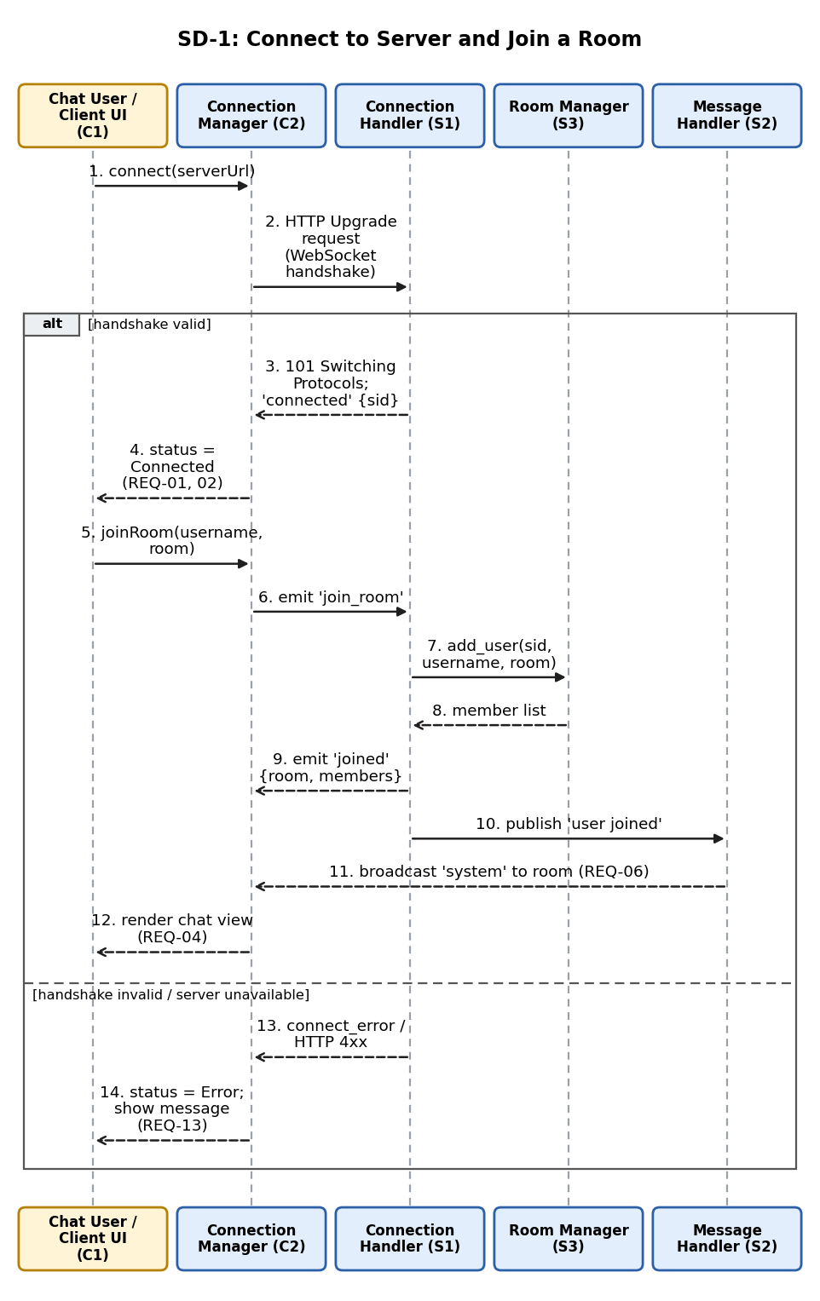
Figure 4: SD-1: connect and join (includes the failure alternative)

SD-2: Send a message and broadcast (REQ-07 to 12)
The client blocks empty text. Valid text is sent to the server, which validates and sanitises it, adds a server UTC timestamp and a per-room sequence number, and delivers it to every member including the sender. Receivers render it without a refresh.
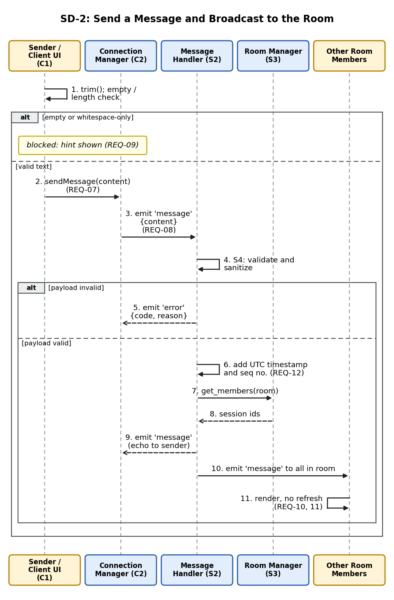
Figure 5: SD-2: send message, validate, stamp, broadcast

SD-3: Connection loss and reconnection (REQ-03, 14, 15)
A dropped connection is detected through a close event or heartbeat timeout. The user is notified, the server removes the session and tells the room, and the client retries with exponential back-off, then rejoins the room automatically.
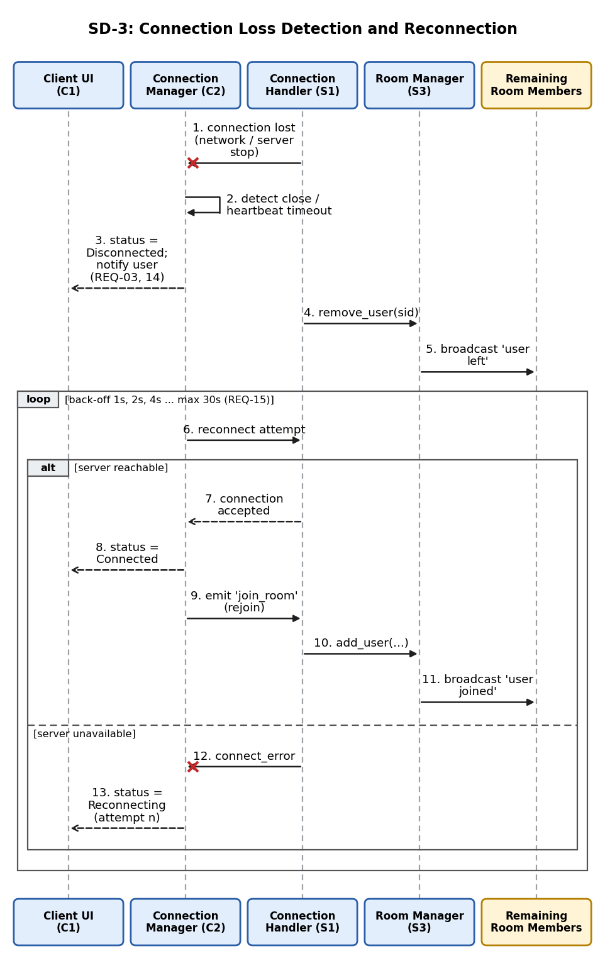
Figure 6: SD-3: connection loss detection and reconnection

SD-4: Leave a room (REQ-05, 06)
The user leaves explicitly. The server removes the member, deletes the room if empty, acknowledges, and notifies the remaining members; the client then closes the socket normally.
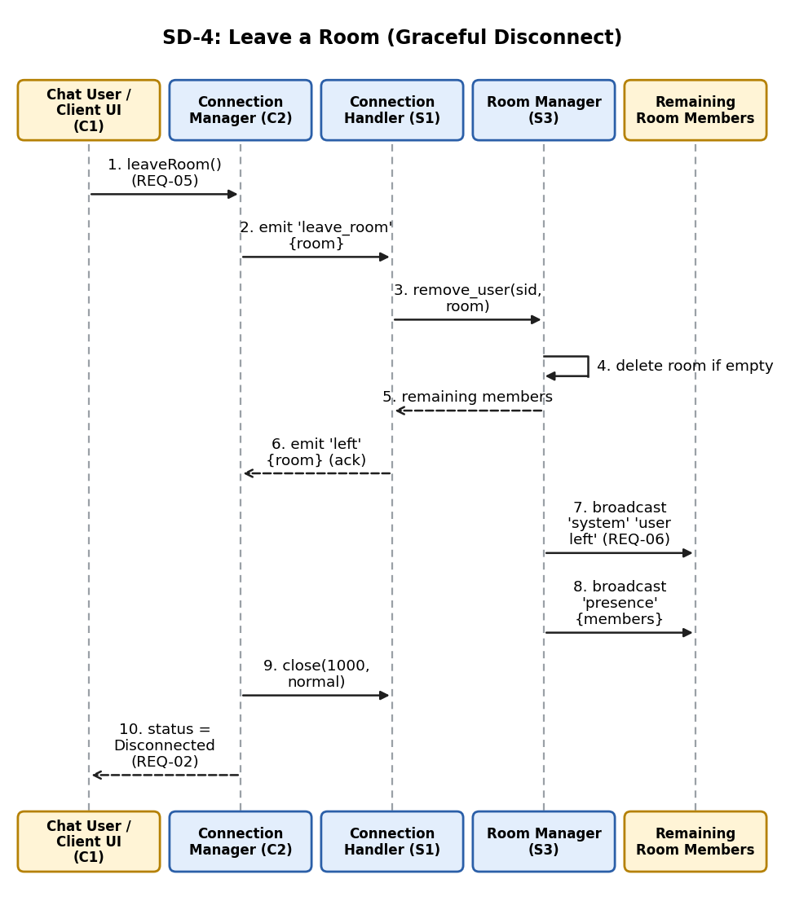
Figure 7: SD-4: leave room and graceful disconnect

4.3 API Design

4.3.1 Interface overview
The system exposes one real-time interface (JSON events over WebSocket) and two small HTTP endpoints. With Socket.IO or Flask-SocketIO the event name is the Socket.IO event. With the raw ws library each frame is the envelope {"event": "<name>", "data": { ... }}. Payloads are UTF-8 JSON (RFC 8259) of at most 4096 bytes. Timestamps are RFC 3339 UTC. The interface is defined for three components below: Connection Handler (S1), Room Manager (S3) and Message Handler (S2).

4.3.2 Connection Handler (S1) interface
Table 12: Handshake and HTTP endpoints
Item | Definition
Endpoint | GET /socket with Upgrade: websocket (path /socket.io/ for Socket.IO). Production: wss://host/socket.
Request | Standard WebSocket handshake headers including Origin.
Response (success) | 101 Switching Protocols, then server event connected {sid, serverTime, limits}.
Errors | 403 origin not allowed (E101); 503 at capacity (E102); WebSocket close codes 1008 (policy), 1009 (too large), 1001 (server going away), 1000 (normal).
GET /health | No auth. Response 200 {"status":"ok","uptimeSec":n,"connections":n,"rooms":n}.
GET /admin/stats | Header Authorization: Bearer <ADMIN_TOKEN>. Response 200 with counters (4.4.7). Errors: 401 missing/invalid token, 404 if disabled.

4.3.3 Room Manager (S3) and Message Handler (S2): client to server events
Table 13: Client to server events
Event | Request payload | Success response | Errors
join_room (REQ-04) | {username, room} | To sender: joined {room, username, members}. To room: system (type join) and presence. | E201, E301, E302, E303, E204
leave_room (REQ-05) | {} (room from session) | To sender: left {room}. To room: system (type leave) and presence. | E203
message (REQ-07, 08) | {content} | To all in room including sender: message {id, type, sender, room, content, timestamp, seq}. | E203, E304, E305, E401, E402
typing (optional, REQ-9) | {isTyping: boolean} | To others in room: typing {sender, room, isTyping}. No ack. | E203, E401 (silently dropped)

4.3.4 Server to client events
Event | Payload | Sent when
connected | {sid, serverTime, limits:{maxContent, heartbeat}} | After successful handshake (REQ-01)
joined / left | {room, username, members} / {room} | Acknowledge join / leave
message | {id, type:"message", sender, room, content, timestamp, seq} | A valid message is accepted
system | {type:"join"|"leave", sender, room, timestamp, seq} | A member joins or leaves, or disconnects (REQ-06)
presence | {room, members:[username]} | Membership changes (optional REQ-8)
typing | {type:"typing", sender, room, isTyping} | Another member is typing (optional REQ-9)
error | {code, message, event} | Any rejected request (Section 4.4)
Example: sending a message (SD-2).
Client -> Server event: message
{ "content": "Hello everyone" }

Server -> all clients in room event: message
{ "id": "5b1f0c9e-3d0a-4b7e-9a39-0d6a2f7e41aa", "type": "message",
"sender": "kishore", "room": "global", "content": "Hello everyone",
"timestamp": "2026-10-02T10:41:22.418Z", "seq": 17 }

Server -> sender only (rejected) event: error
{ "code": "E304", "message": "Message cannot be empty.", "event": "message" }

4.3.5 Validation rules
Field | Rule | Error
username | Trim; pattern ^[A-Za-z0-9_ -]{1,50}$; unique within the room | E301, E302
room | Pattern ^[A-Za-z0-9_-]{1,30}$; default global if omitted | E303
content | Trim; must not be empty (REQ-09); at most 500 characters; control characters removed; HTML-escaped on the server | E304, E305
payload | Valid JSON object; only known fields (others dropped); at most 4096 bytes | E201, E402
event name | Must be one of the client events in 4.3.3 | E202
session state | message, typing, leave_room require a joined session; join_room requires none | E203, E204

4.4 Error Handling, Logging & Monitoring

4.4.1 Principles
- Every rejected request returns a standard error event {code, message, event}. The message is fixed, user-readable text; no stack traces or internals (SC-9).
- Validation happens before any state change; a rejected request changes nothing and reaches no other user.
- An error affects only the offending session. No handler exception may stop the server or other sessions.
- The client never crashes on server errors or an unavailable server (REQ-13); it shows a message and stays usable.
- Logs and error texts never contain message bodies or secrets.

4.4.2 Error code catalogue
Table 14: Server error codes (sent to clients)
Code | Condition | User-visible message | Action
E101 | Origin not allowed / handshake rejected | Connection refused. | Close 1008
E102 | Server at connection capacity | Server is busy. Try again shortly. | Refuse; client may retry
E201 | Malformed JSON or schema violation | Invalid request. | Reject event
E202 | Unknown event name | Unsupported request. | Reject event
E203 | Not joined to a room (BR-1) | Join a room first. | Reject event
E204 | Already in a room (BR-2) | Leave your current room first. | Reject event
E301 | Invalid username | Use 1-50 letters, digits, spaces, _ or -. | Reject join
E302 | Username in use in room | That name is taken in this room. | Reject join
E303 | Invalid room name | Use 1-30 letters, digits, _ or -. | Reject join
E304 | Empty or whitespace-only message (REQ-09) | Message cannot be empty. | Reject message
E305 | Message longer than 500 characters | Message is too long (max 500). | Reject message
E401 | Rate limit exceeded | You are sending too fast. | Drop; close after repeated hits
E402 | Payload larger than 4096 bytes | Message too large. | Close 1009
E500 | Unexpected server error | Something went wrong. Please retry. | Log with correlation id
E503 | Server shutting down | Server is restarting. | Close 1001; client reconnects
Table 15: Client-local errors (never sent over the network)
Code | Condition | Message shown | Requirement
C01 | Server unavailable on connect | Cannot reach the server. Retrying... | REQ-13
C02 | Connection lost while connected | Connection lost. Reconnecting... | REQ-03, 14
C03 | Reconnect failed after maximum attempts | Could not reconnect. Click Reconnect to try again. | REQ-15
C04 | Empty input blocked before sending | Type a message first. | REQ-09
C05 | Send attempted while not connected | You are not connected. | BR-1

4.4.3 Client handling of connection failure (REQ-13, 14)
- On connect_error or an unreachable server, C2 sets state Error/Unavailable, C1 shows C01, and no exception reaches the page.
- On a close event or heartbeat timeout while connected, C2 sets state Reconnecting, C1 shows C02, and the Send control is disabled (C05 if forced).
- Messages typed while disconnected are not queued in v1.0; the input is kept so the user can resend after reconnecting.
- All socket callbacks are wrapped in try/catch so a bad event cannot break the UI.

4.4.4 Reconnection algorithm (REQ-15)
Delay before attempt n (n starting at 0) = min(30 s, 1 s x 2^n) plus random jitter of up to 20 percent, to avoid a reconnect storm after a server restart. After 10 failed attempts C2 stops, sets state Error and shows C03 with a Reconnect button; the button restarts the sequence (ERR to Connecting in Figure 3). When a reconnect succeeds, C2 re-emits join_room with the stored username and room, so the user returns to the same room without action.

4.4.5 Server-side exception handling
- Each event handler runs inside a guard. An exception is logged with a correlation id, the sender receives E500, and the process continues.
- A process-level handler for uncaught exceptions and unhandled rejections logs the failure; an external supervisor (for example systemd or a process manager) restarts the process if it exits.
- On SIGTERM the server sends E503, closes sockets with code 1001 and exits cleanly.
- Disconnect cleanup is idempotent: the same path handles explicit leave, close event, heartbeat timeout and error, so no stale session remains (business rule: disconnected users are not active).

4.4.6 Logging
Structured JSON log lines to standard output. Fields: ts, level (debug, info, warn, error), event, sid, ip, room, code, msgId, durationMs, corrId. Never logged: message content, tokens, full request bodies.
Level | Examples
info | connect, join, leave, disconnect, server start and stop
warn | validation failure (E3xx), rate-limit hit (E401), origin refused (E101), capacity reached (E102)
error | unhandled exception (E500), socket write failure, heartbeat subsystem failure
debug | event dispatch trace (disabled in production)

4.4.7 Monitoring
Metric | Source | Alert threshold (suggested)
Active connections, active rooms | /health, /admin/stats | Connections above 160 (80 percent of capacity)
Messages per second, deliveries per second | S2 counters | Sustained above 100 msg/s
Server processing time per message (p95) | S2 timer (receive to last send) | Above 200 ms for 1 minute (NFR-P1 at risk)
Errors by code | S5 counters | E500 above 0 in 5 minutes; E401 spike
Disconnects and reconnects per minute | S1 counters | Sudden spike (network or restart problem)
Uptime and memory | /health, OS | Memory growth over time (leak)

4.5 UX Design
A single-page interface with five areas: connection area, status/error banner, message list, optional online list and message input. No instructions should be needed (NFR-U1).
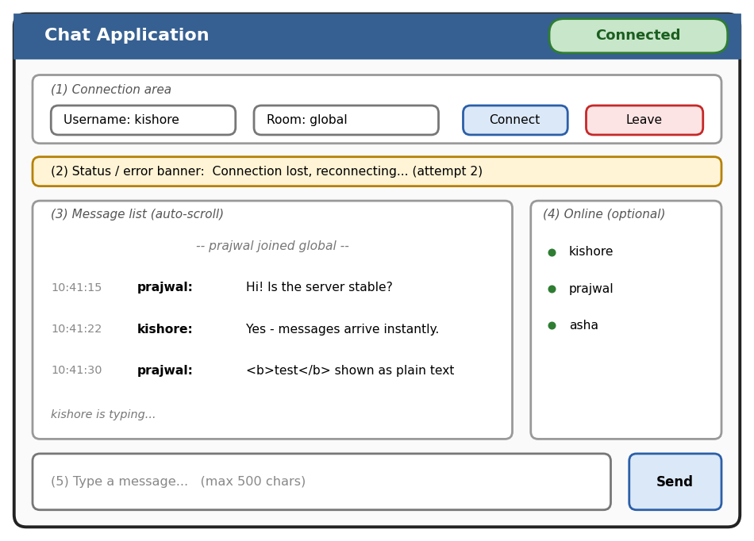
Figure 8: Wireframe of the chat page (the banner is shown only when a problem occurs)
Table 16: Interface elements and requirements
Element | Behaviour | Requirement
Connection area | Username and room fields, Connect button, Leave button. Leave is enabled only when joined; Connect only when disconnected. | REQ-01, 04, 05
Status chip | Always visible: Disconnected, Connecting, Connected, Reconnecting, Error (text plus colour). | REQ-02
Banner | Shows C01 to C05 and server errors in plain language; clears when resolved. | REQ-03, 13, 14
Message list | Sender, text and server time; system lines for join/leave in a distinct style; auto-scroll to newest unless the user scrolled up; text only, never HTML. | REQ-06, 10, 11, 12
Online list (optional) | Members of the current room. | SRS REQ-8
Typing line (optional) | "name is typing..." below the list, cleared after 3 s without typing. | SRS REQ-9
Input and Send | Enter sends, Shift+Enter inserts a new line; empty text blocked with C04; counter near the 500 limit; disabled when not joined. | REQ-07, 09
Accessibility. Body text at least 16 px with contrast of at least 4.5:1; status never relies on colour alone; every control has a visible label and keyboard focus; the message list and banner use aria-live="polite" so screen readers announce new messages and status changes; the layout adapts to narrow screens. The v1.0 interface is English only.

4.6 Open Issues & Next Steps
Table 17: Open issues
# | Issue | Proposed resolution
1 | Select the backend stack (Node.js or Python) and raw WebSocket versus Socket.IO | Decide in sprint 1 (ADR-8); update file names in 3.8.2.
2 | SRS (REQ-1 to 9) and Test Plan (REQ-01 to 15) numbering differ | Adopt REQ-01 to 15 and revise the SRS RTM (Appendix C) to match.
3 | Optional presence and typing (SRS REQ-8/9) have no test cases | Decide scope for v1.0; add UT/IT/ST cases if included.
4 | Messages typed while offline are not queued | Accepted for v1.0; consider an outbox with retry.
5 | Room-name creation policy (any user can create a room by joining) | Confirm with faculty; add maximum rooms limit if needed.
6 | Capacity figures are estimates | Confirm with a 100-client load test (for example Artillery or Locust).
Next steps: (1) fix the stack and repository layout; (2) implement S4 and S3 first, since they are pure logic and fully unit-testable; (3) implement S1/S2 and C2; (4) implement C1/C3; (5) execute the Test Plan and fill the Actual Result and Test Result columns; (6) run the load test.
Future enhancements (SRS Other Requirements): chat history persistence through a repository behind S2; user authentication through the hook in S1; horizontal scaling through a shared pub/sub adapter and sticky sessions; file and image sharing as a new event with size and type limits; moderation tools such as an admin kick; native mobile client reusing the event contract.

5. Appendices

5.1 Glossary
Core terms are in Section 1.4. Additional terms used in the design:
Term | Meaning
Heartbeat (ping/pong) | Periodic small frames used to detect a silent connection loss.
Back-off / jitter | Increasing delay between reconnect attempts, with a random addition to spread clients out.
Sequence number (seq) | Per-room counter assigned by the server to define one message order for everyone.
Presence | Information about who is currently in a room.
Token bucket | Rate-limiting method allowing a steady rate with a short burst.
CSP / HSTS | Browser security headers: Content-Security-Policy / HTTP Strict-Transport-Security.
Origin | Header identifying the web page that started the request; used to stop cross-site hijacking.

5.2 References
- SRS: Chat Application (Socket Programming), v1.0, PES University CSE, 08/09/2026.
- SRS and Test Plan Details (REQ-01 to REQ-15, UT/IT/ST cases), PES University CSE, September 2026.
- IEEE Std 1016-2009, Systems Design: Software Design Descriptions.
- ISO/IEC/IEEE 42010:2022, Architecture description.
- IETF RFC 6455 (WebSocket), RFC 8259 (JSON), RFC 3339 (timestamps).
- Socket.IO documentation (socket.io/docs); Flask-SocketIO documentation (flask-socketio.readthedocs.io); Node.js ws library (github.com/websockets/ws).
- OWASP WebSocket Security Cheat Sheet; OWASP Application Security Verification Standard.
- Microsoft STRIDE threat modelling method.

5.3 Tools
Purpose | Tool
Diagrams in this document (component, deployment, state, sequence, wireframe) | Graphviz and Matplotlib (generated from scripts)
Editable UML if diagrams need changes | PlantUML or draw.io (recreate from the descriptions in 3.3 and 4.2)
Manual API testing | wscat or browser developer tools (WebSocket frames); Postman for HTTP endpoints
Automated tests | Jest (Node.js) or pytest (Python); python-socketio or socket.io-client as test clients
Load test (100 clients) | Artillery or Locust
Dependency and security checks | npm audit or pip-audit

