## 

## 

## 

## 

## **ChatMaps Deliverable 2**

Software Requirements Specification

Stephen Goodridge, Clark LaChance, Nicholas Pease, Joseph Gallant, Aidan Bradley

COS420

3 March 2024

Github: <https://github.com/ChatMaps/ChatMaps>

Kanban: <https://trello.com/b/TaygvBv7/chatmaps>

**SRS Document**

**Functional**

1. The system must allow users to register with a username and password
2. The system must allow users to sign in using their credentials
3. The system shall allow users to upload profile pictures.
4. The system shall allow users to customize their profile with interests.
5. The system shall show users a local map of their area.
6. The system shall only show the general location of the user's friends on the map.
7. The system shall have a separate tab, showing unfriended users in their current chat room.
8. The system shall allow the user to add friends via their username.
9. The system shall let users invite friends to chat rooms that they’re currently connected to.
10. The system shall have a friends list to show who is currently online.
11. The system shall have the option to create private chat rooms to only be accessed by invitation.
12. The system shall have default chat rooms with specific topics, including COS420, Food, and Coding.
13. The system shall allow users to create chat rooms with a specific topic for other users in the area to join.
14. The system shall have a topic filter to find specific chat rooms the user would want to join.
15. The system shall support multiple languages.

**Non-functional**

1. The system shall provide users real-time location updates every 5 minutes 95% of the time.
2. The system shall send notifications to users for chats 95% of the time.
3. The system shall be available at all hours of the day 99% of the time.
4. The system shall be capable of handling up to 100 concurrent users connected to chat rooms 95% of the time.
5. The system shall be capable of keeping users’ information private 99% of the time.
6. The system shall be capable of recommending chat rooms in the user’s area based on their interests 90% of the time.
7. The system shall comply with relevant laws and regulations, such as data protection regulations 99% of the time.
8. The system shall load chat rooms for users within 2 seconds 90% of the time.
9. The system shall handle sending messages within 5 seconds 95% of the time.
10. The system shall not exceed 1 hour for any scheduled maintenance period 99% of the time.

**Updated UI Mockups**

*Home Page*

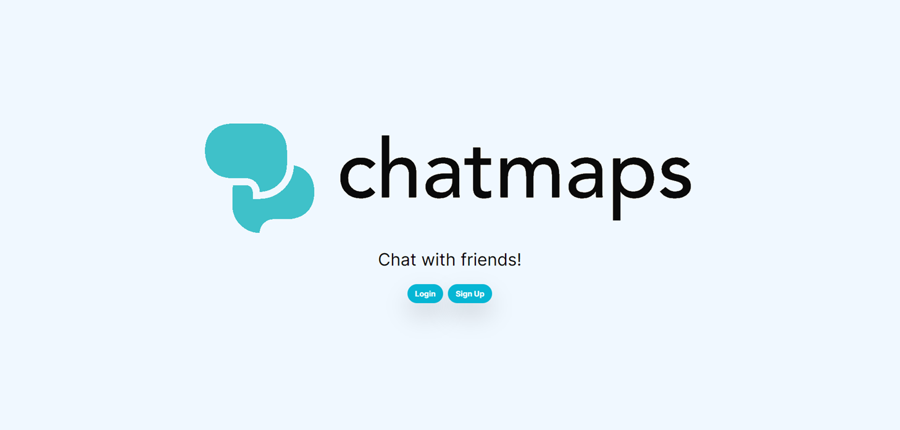

*Register Page*

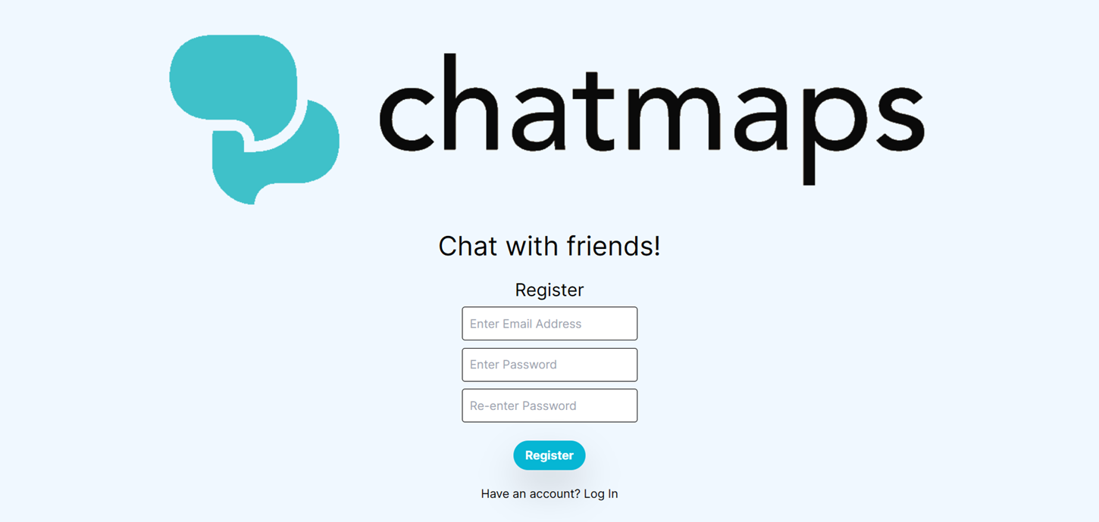

*Login Page*

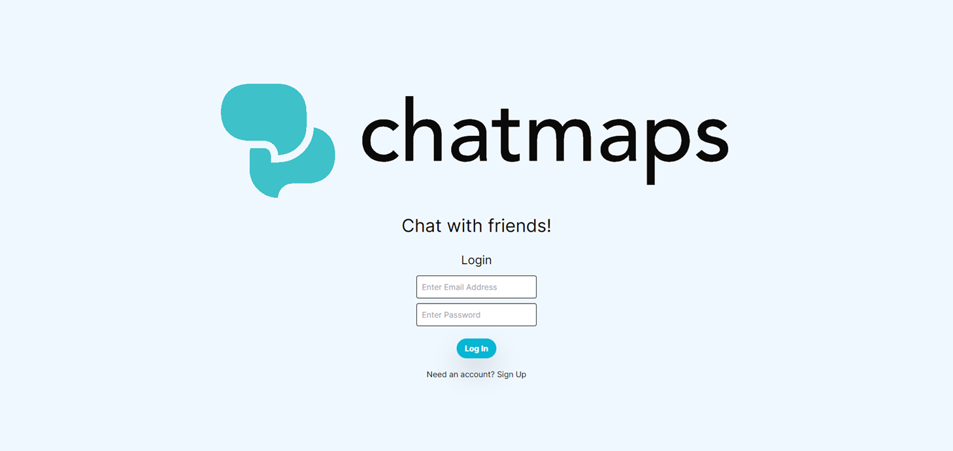

*Onboarding Page*

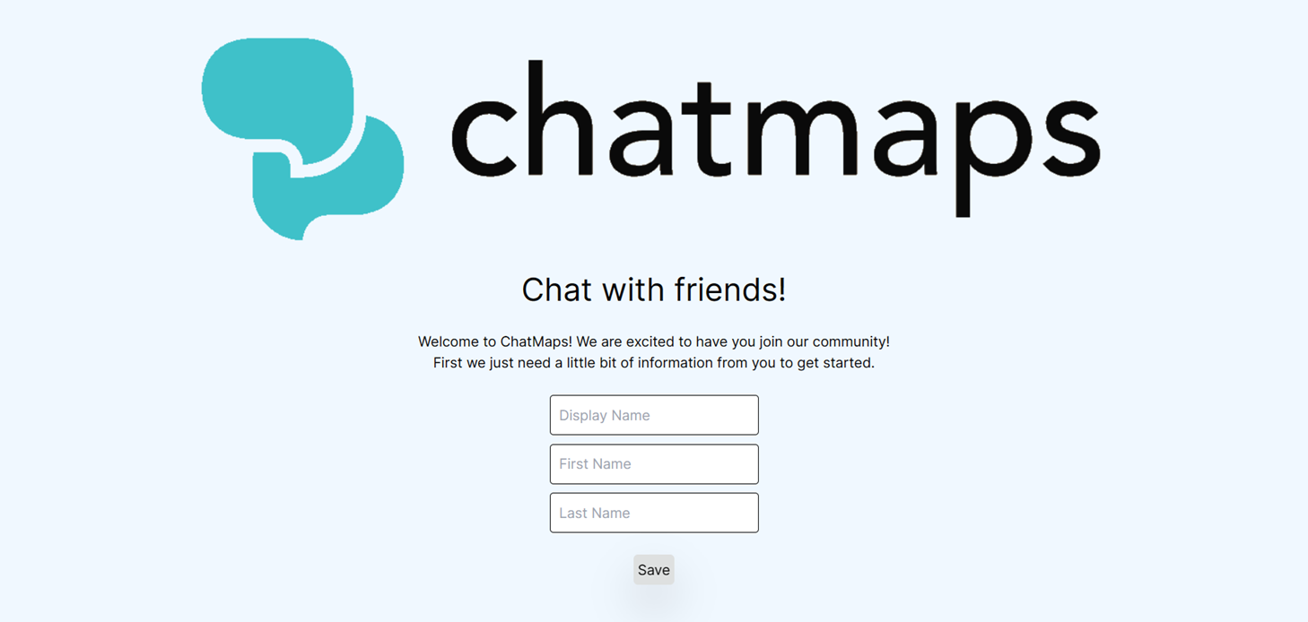

*Main App Page*

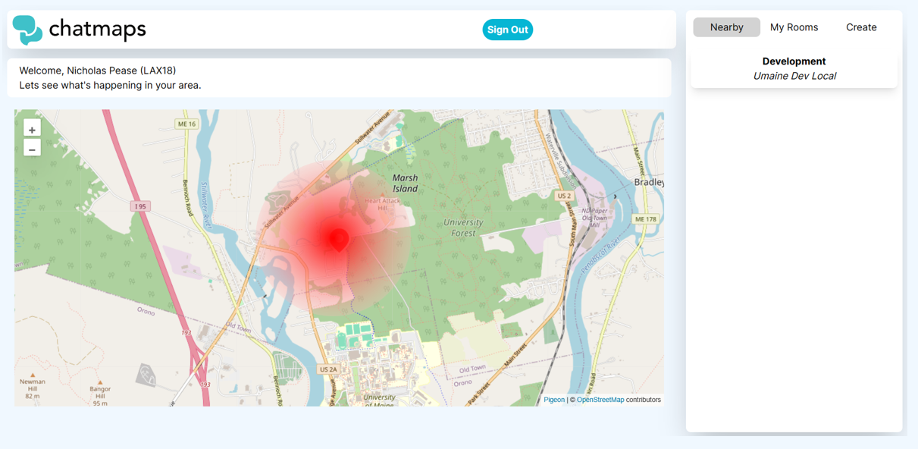

*Chat Page*

