## 

## 

## 

## 

## **ChatMaps Deliverable 3**

Domain Model

Stephen Goodridge, Clark LaChance, Nicholas Pease, Joseph Gallant, Aidan Bradley

COS420

24 March 2024

Github: <https://github.com/ChatMaps/ChatMaps>

Kanban: <https://trello.com/b/TaygvBv7/chatmaps>

**Domain Model**

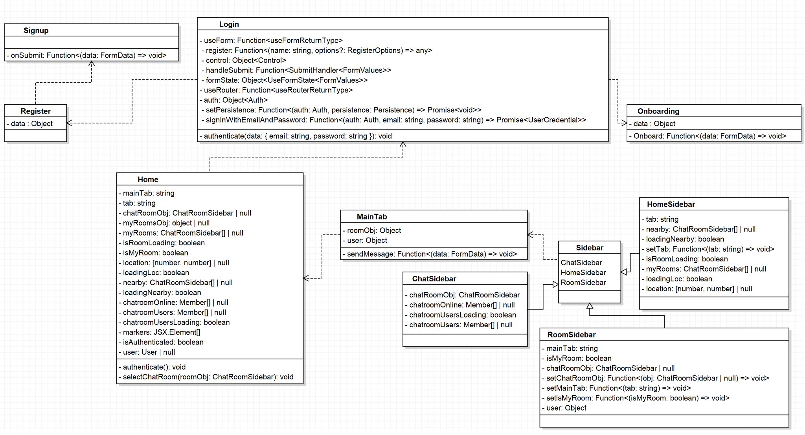

**Description:**

The ChatMaps system aims to provide the users with the ability to :

* Create chat rooms
* Invite friends
* See nearby users

ChatMaps uses a login page, a sidebar for several functions, and a home page.

Users must register an account before they can use ChatMaps features.

The Sidebar class will house two sidebar classes, the Chatroom sidebar and the Room sidebar. These classes are responsible for creating the chatroom and having the users enter it.

The Home class will contain the functions of the home page, a page containing an updated map with the user location and nearby users, and a sidebar with different tabs to navigate for different purposes. It depends on the Login class to be able to gather user information.

The Login class will use the entered information to authenticate the user and sign them in, and

will depend on the Signup / Login and Onboarding classes to successfully log the user into their account.