## 

## 

## 

## 

## **ChatMaps Deliverable 3**

Sequence Diagram

Stephen Goodridge, Clark LaChance, Nicholas Pease, Joseph Gallant, Aidan Bradley

COS420

24 March 2024

Github: <https://github.com/ChatMaps/ChatMaps>

Kanban: <https://trello.com/b/TaygvBv7/chatmaps>

**Sequence Diagram**

Login

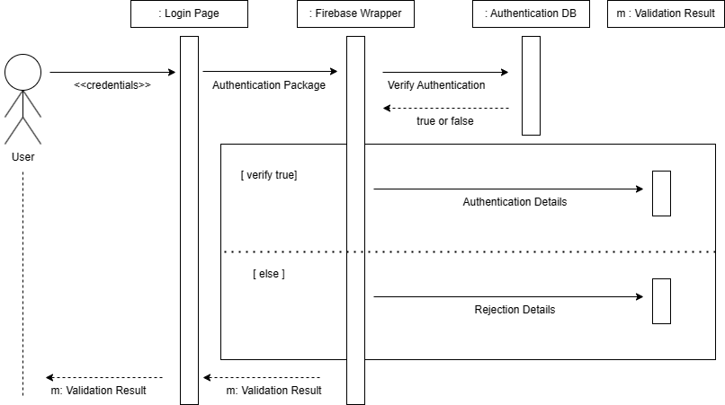

| # | Subject | Subject Action | Parameters | Object Acted Upon |
| --- | --- | --- | --- | --- |
| 1 | User | enters | Credentials | Login Page |
| 1.1 | Login Page | dispenses | Authentication Package | Firebase Wrapper |
| 1.2 | Firebase Wrapper | verifies | Authentication Package | Authentication DB |
| 1.3 | Authentication DB | returns | True or false to | Firebase Wrapper |
| 1.4 | If true is returned |  |  |  |
| 1.4.1 | Firebase Wrapper | dispenses | Authentication Details | Validation Result |
| 1.5 | else |  |  |  |
| 1.5.1 | Firebase Wrapper | dispenses | Rejection Details | Validation Result |
| 1.6 | Firebase Wrapper | returns | Validation Result | Login Page |
| 1.7 | Login Page | returns | Validation Result | User |

1 User enters login details on the login page

1.1 The login page packages those details and sends the package to the Firebase Wrapper

1.2 The Firebase wrapper then verifies the login details against the authentication database

1.3 The authentication database returns a Firebase auth object, along with a true/false determination of login success

1.4 If the authentication returns a true

1.4.1 The Firebase wrapper returns the authenticated user object

1.5 else

1.5.1 The firebase wrapper returns the rejection message object

1.6 The Firebase wrapper returns the given object to the login page

1.7 The login page returns the object to the user with a message

Register

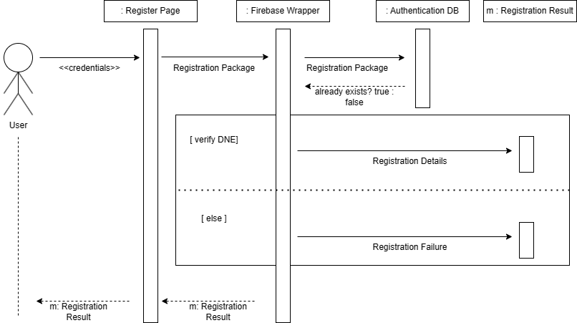

| # | Subject | Subject Action | Parameters | Object Acted Upon |
| --- | --- | --- | --- | --- |
| 1 | User | enters | Credentials | Register Page |
| 1.1 | Register Page | dispenses | Registration Package | Firebase Wrapper |
| 1.2 | Firebase Wrapper | verifies | Registration Package | Authentication DB |
| 1.3 | Authentication DB | returns | Account already exists true or false | Firebase Wrapper |
| 1.4 | If true is returned |  |  |  |
| 1.4.1 | Firebase Wrapper | dispenses | Registration Details | Registration Result |
| 1.5 | else |  |  |  |
| 1.5.1 | Firebase Wrapper | dispenses | Registration Failure | Registration Result |
| 1.6 | Firebase Wrapper | returns | Registration Result | Register Page |
| 1.7 | Register Page | returns | Registration Result | User |

1 User enters registration details on the register page

1.1 The register page packages those details and sends the package to the Firebase Wrapper

1.2 The Firebase wrapper then verifies the account does not exist against the Authentication DB

1.3 The authentication database returns a true or false result depending on if the account exists

1.4 If the account does not exist

1.4.1 The Firebase wrapper returns the registration result

1.5 else

1.5.1 The firebase wrapper returns registration failure

1.6 The Firebase wrapper returns the given object to register page

1.7 The login page returns the object to the user with a message

Onboarding

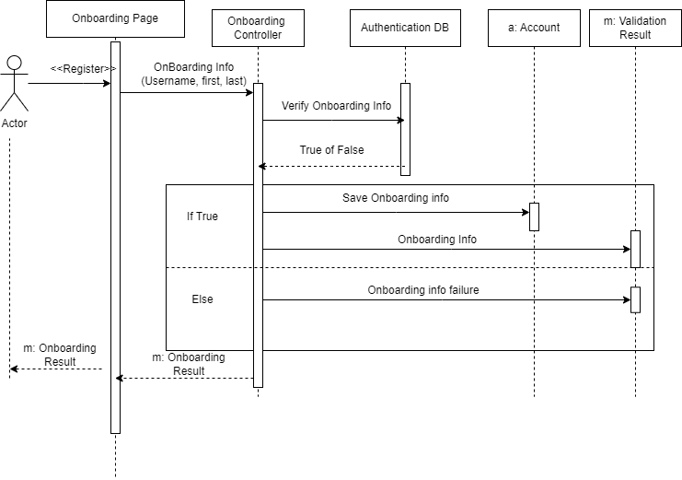

| # | Subject | Subject Action | Parameters | Object acted upon |
| --- | --- | --- | --- | --- |
| 1 | User | Register | credentials | Onboarding Page |
| 1.1 | Onboarding Page | dispenses | Onboarding info | Onboarding controller |
| 1.2 | Onboarding controller | verify | Onboarding info | Authentication database |
| 1.3 | If True is returned |  |  |  |
| 1.3.1 | Onboarding controller | saves | Onboarding info | account |
| 1.3.2 | Onboarding controller | dispenses | Onboarding info | Validation Result |
| 1.4 | If False is returned |  |  |  |
| 1.4.1 | Onboarding controller | dispenses | Onboarding info failure | Validation result |
| 1.5 | Onboarding controller | Returns | Onboarding result | Onboarding Page |
| 1.6 | Onboarding page | Returns | onBoarding result | User |

1: User registers an account and is brought to the Onboarding page

1.1: Onboarding information is taken to onboarding controller

1.2: Verify Username, first, and last name with authentication database

1.3: If true is returned

1.3.1: Save onboarding information to account

1.3.2: Return valid validation result

1.4 : If false is returned

1.4.1: Return invalid validation result

1.5: Returns validation result to Onboarding page

1.6 Returns validation result to User

Creating a Room

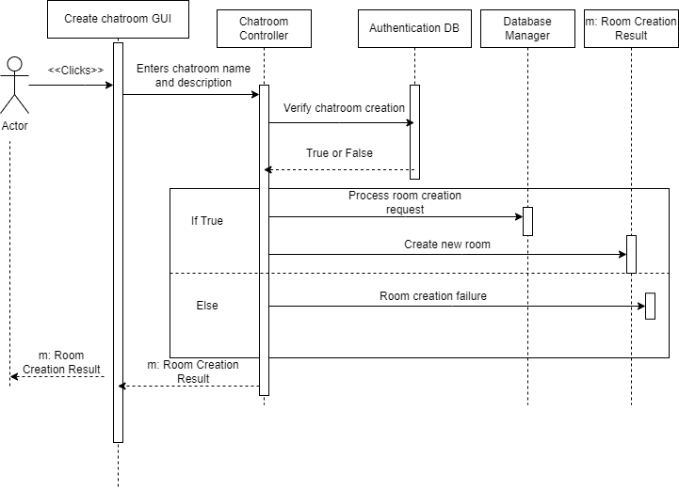

| # | Subject | Subject Action | Parameters | Object Acted Upon |
| --- | --- | --- | --- | --- |
| 1 | User | clicks | Create chat room | Create chat room GUI |
| 1.1 | Create Chat Room GUI | dispenses | Chat room name/description | Chat room controller |
| 1.2 | Chat room controller | verify | Chat room creation | Authentication database |
| 1.3 | If True is returned |  |  |  |
| 1.3.1 | Chat room controller | dispenses | Room Creation | Database Manager |
| 1.3.2 | Chat room controller | creates | Chat room | Room creation result |
| 1.4 | If False is returned |  |  |  |
| 1.4.1 | Chat room controller | dispenses | Room Creation Failure | Room creation result |
| 1.5 | Chat room controller | Returns | Room Creation Result | Create chat room GUI |
| 1.6 | Create chat room GUI | Returns | Room Creation Result | User |

1: User clicks create chat room button

1.1: User enters chat room details such as room name/description

1.2: Authentication database verifies the name and description of the chat room

1.3: If True is returned

1.3.1: Database manager process the new room being created

1.3.2: Validate room creation

1.4: If False is returned

1.4.1: Reject room creation

1.5: Return room validation to Chat room GUI

1.6: Return room validation to User

Design Sequence Diagram:

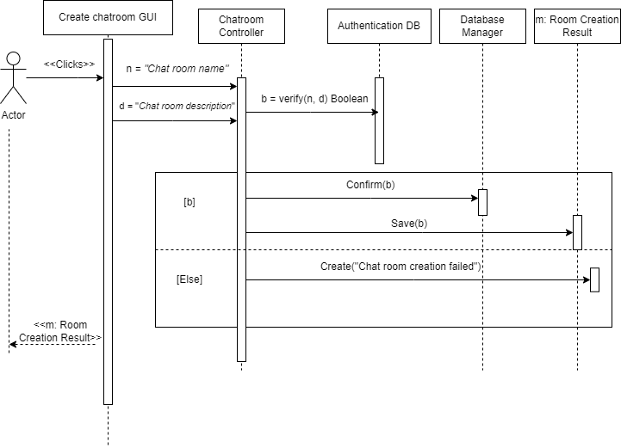

| # | Subject | Subject Action | Parameters | Object Acted Upon |
| --- | --- | --- | --- | --- |
| 1 | User | clicks | Create chat room | Create chat room GUI |
| 1.1 | Create Chat Room GUI | dispenses | n,d | Chat room controller |
| 1.2 | Chat room controller | verify() | n,d | Authentication database |
| 1.3 | If True is returned |  |  |  |
| 1.3.1 | Chat room controller | confirm() | b | Database Manager |
| 1.3.2 | Chat room controller | m = save() | b | Room creation result |
| 1.4 | If False is returned |  |  |  |
| 1.4.1 | Chat room controller | m = create() | Room Creation Failure | Room creation result |
| 1.5 | Chat room controller | Returns | m | Create chat room GUI |
| 1.6 | Create chat room GUI | Returns | m | User |

Room List Retrieval

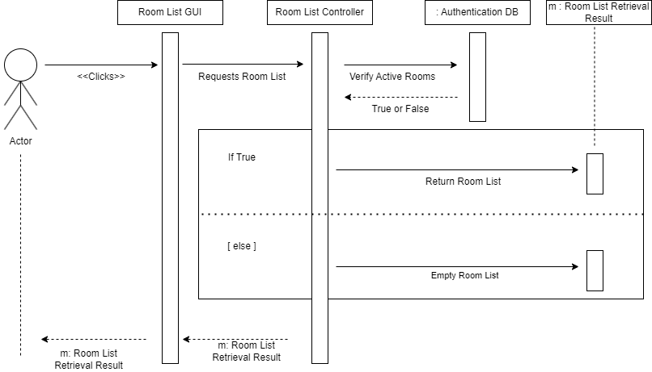

| # | Subject | Subject Action | Parameters | Object Acted Upon |
| --- | --- | --- | --- | --- |
| 1 | User | Clicks | Request Room List | Room List GUI |
| 1.1 | Room List GUI | request | Room List | Room List Controller |
| 1.2 | Room List Controller | verify | Active Rooms | Authentication DB |
| 1.3 | If True is returned |  |  |  |
| 1.3.1 | Room List Controller | return | Room List | User |
| 1.4 | If False is returned |  |  |  |
| 1.4.1 | Room List Controller | return | Empty Room List | User |

1: User clicks “Rooms” to get the list of rooms.

1.1: The request gets sent to the Room List Controller for processing.

1.2: The Room List Controller verifies that there’s Active Rooms by checking the database.

1.3: If True

1.3.1: Return a list that contains active rooms.

1.4: If False

1.4.1: Return an empty list that contains no rooms.

Sending a message

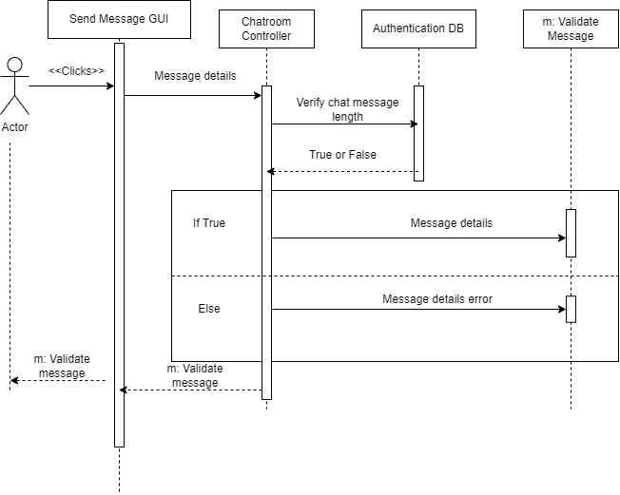

| # | Subject | Subject Action | Parameters | Object Acted Upon |
| --- | --- | --- | --- | --- |
| 1 | User | Clicks | Send | Send Message GUI |
| 1.1 | Send Message GUI | dispenses | Message details | Chatroom controller |
| 1.2 | Chat room controller | verify | Chat length | Authentication DB |
| 1.3 | If True is returned |  |  |  |
| 1.3.1 | Chat room controller | dispenses | Message details | Validate Message |
| 1.4 | If False is returned |  |  |  |
| 1.4.1 | Chat room controller | dispenses | Message details error | Validate Message |
| 1.5 | Chat room controller | Return | Validate message | Send Message GUI |
| 1.6 | Send Message GUI | Return | Validate message | User |

1: User clicks “send” to send message

1.1: The users typed message is processed to the chat room controller

1.2: Chatroom controller verifies the message isn’t to long

1.3: If True

1.3.1: Validate the message

1.4: If False

1.4.1: Message will fail and won’t send

1.5: Return validation that the message sent to the chat room controller

1.6: Return validation that the message sent to the user

Design Sequence Diagram:

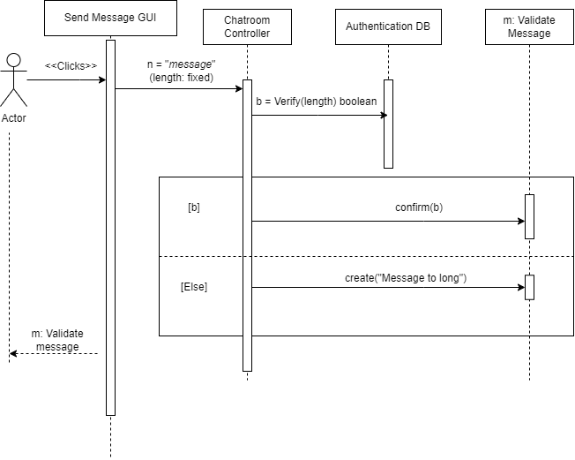

| # | Subject | Subject Action | Parameters | Object Acted Upon |
| --- | --- | --- | --- | --- |
| 1 | User | Clicks | Send | Send Message GUI |
| 1.1 | Send Message GUI | dispenses | n | Chatroom controller |
| 1.2 | Chat room controller | b = verify() | n | Authentication DB |
| 1.3 | If True is returned |  |  |  |
| 1.3.1 | Chat room controller | confirm() | b | Validate Message |
| 1.4 | If False is returned |  |  |  |
| 1.4.1 | Chat room controller | create() | Message details error | Validate Message |
| 1.5 | Chat room controller | Return | m | Send Message GUI |
| 1.6 | Send Message GUI | Return | m | User |

Saving a Room

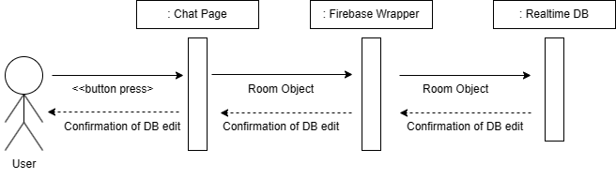

| # | Subject | Subject Action | Parameters | Object Acted Upon |
| --- | --- | --- | --- | --- |
| 1 | User | presses | Button | Chat Page |
| 1.1 | Chat Page | sends | Room Object | Firebase Wrapper |
| 1.2 | Firebase Wrapper | sends | Room Object | Realtime DB |
| 1.3 | Realtime DB | sends | Confirmation | Firebase Wrapper |
| 1.4 | Firebase Wrapper | sends | Confirmation | Chat Page |
| 1.5 | Chat Page | sends | confirmation | User |

1 User presses the save room button

1.1 The chat page sends the room object to the Firebase wrapper for packaging

1.2 The firebase wrapper sends the room object to the real-time DB

1.3 The real-time DB sends a confirmation to the Firebase wrapper

1.4 The firebase wrapper sends confirmation to the chatpage

1.5 The chat page sends a confirmation to the user via a message

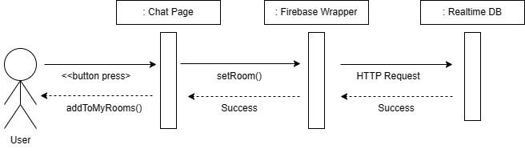

| # | Subject | Subject Action | Parameters | Object Acted Upon |
| --- | --- | --- | --- | --- |
| 1 | User | presses | Button | Chat Page |
| 1.1 | Chat Page | sends | Room Object via setRoom() | Firebase Wrapper |
| 1.2 | Firebase Wrapper | sends | Room Object via HTTP | Realtime DB |
| 1.3 | Realtime DB | sends | Success | Firebase Wrapper |
| 1.4 | Firebase Wrapper | sends | Success | Chat Page |
| 1.5 | Chat Page | sends | Success via addToMyRooms() | User |

1 User presses the save room button

1.1 The chat page sends the room object to the Firebase wrapper for packaging

1.2 The firebase wrapper sends the room object to the real-time DB

1.3 The real-time DB sends a confirmation to the Firebase wrapper

1.4 The firebase wrapper sends confirmation to the chatpage

1.5 The chat page sends a confirmation to the user via a message