## 

## 

## 

## 

## **ChatMaps Deliverable 4**

Software Requirements Specification

Stephen Goodridge, Clark LaChance, Nicholas Pease, Joseph Gallant, Aidan Bradley

COS420

7 April 2024

Github: <https://github.com/ChatMaps/ChatMaps>

Kanban: <https://trello.com/b/TaygvBv7/chatmaps>

**SRS Document**

**Project Description**

ChatMaps is a web-based social networking service that allows users to connect to others in their local geographic area. It will implement an interactable mapping utility to show general user locations relative to other users, as well as a chat room feature that allows users to start public conversations based on a specified topic. ChatMaps is primarily intended for use in densely populated areas, such as college campuses or metropolitan areas, so people of similar interests can start conversations. The goal of this project is to create a web app that plots locations, gives a radius of the local area, and connects users into different topic-based chat rooms.

This service will implement user login and profiles, allowing users to add each other as friends and start private conversations. There will be several default chat rooms of varying topics, but users will also have the ability to create their own topics that will be viewable by other users. For example, a user at the University of Maine could create a joinable chat room titled “COS420”, which would be visible to others near this campus.

This app shares some similarities to other social networks that implement location-based content. ChatMaps’ novel approach is to utilize user location to facilitate real-time communication with others within a given radius.

**Functional Requirements**

1. The system must allow users to register with a username and password
2. The system must allow users to sign in using their credentials
3. The system shall allow users to upload profile pictures.
4. The system shall allow users to customize their profile with interests.
5. The system shall show users a local map of their area.
6. The system shall only show the general location of the user's friends on the map.
7. The system shall have a separate tab, showing unfriended users in their current chat room.
8. The system shall allow the user to add friends via their username.
9. The system shall let users invite friends to chat rooms that they’re currently connected to.
10. The system shall have a friends list to show who is currently online.
11. The system shall have the option to create private chat rooms to only be accessed by invitation.
12. The system shall have default chat rooms with specific topics, including COS420, Food, and Coding.
13. The system shall allow users to create chat rooms with a specific topic for other users in the area to join.
14. The system shall have a topic filter to find specific chat rooms the user would want to join.
15. The system shall support multiple languages.

**Non-functional Requirements**

1. The system shall provide users real-time location updates every 5 minutes 95% of the time.
2. The system shall send notifications to users for chats 95% of the time.
3. The system shall be available at all hours of the day 99% of the time.
4. The system shall be capable of handling up to 100 concurrent users connected to chat rooms 95% of the time.
5. The system shall be capable of keeping users’ information private 99% of the time.
6. The system shall be capable of recommending chat rooms in the user’s area based on their interests 90% of the time.
7. The system shall comply with relevant laws and regulations, such as data protection regulations 99% of the time.
8. The system shall load chat rooms for users within 2 seconds 90% of the time.
9. The system shall handle sending messages within 5 seconds 95% of the time.
10. The system shall not exceed 1 hour for any scheduled maintenance period 99% of the time.

**Constraints**

Several constraints are in effect both during the development and full deployment of this web application. Compliance with industry standards will be vital when this product is publicly available, specifically GDPR if ChatMaps chooses to expand into the EU market. Operating system restrictions are also a factor, as the website will not function properly without the ability to run JavaScript in the browser.

A key aspect of this web app is communicating data between users, causing data security, integrity, and availability to be key constraints for ChatMaps. User’s data must be handled securely both within the database and as it is communicated to other users of the platform, where applicable. Likewise, data must be accurate to prevent communication issues between users and bugs within the platform. The availability of the website, defined in non-functional requirement #3, is also extremely important, as the key purpose of the product, chatting with others, is not possible without a stable connection to the platform. These key constraints define much of the development process to ensure ChatMaps is a stable, reliable, and safe product.

**Assumptions**

The requirements listed in this document make several assumptions. To use this program, users must have access to a stable internet connection. Additionally, a computer with a modern web browser is needed in order to properly load all of the JavaScript code on the site. If it is decided that ChatMaps needs to support older platforms, many requirements may be changed to a limited form in order to ensure basic functionality within the capabilities of older browsers. ChatMaps also assumes that current regulations surrounding the handling of user data will remain stable. If these requirements change, then features within the product and requirements in this document will need to be updated.

**Updated UI Mockups**

*Home Page*

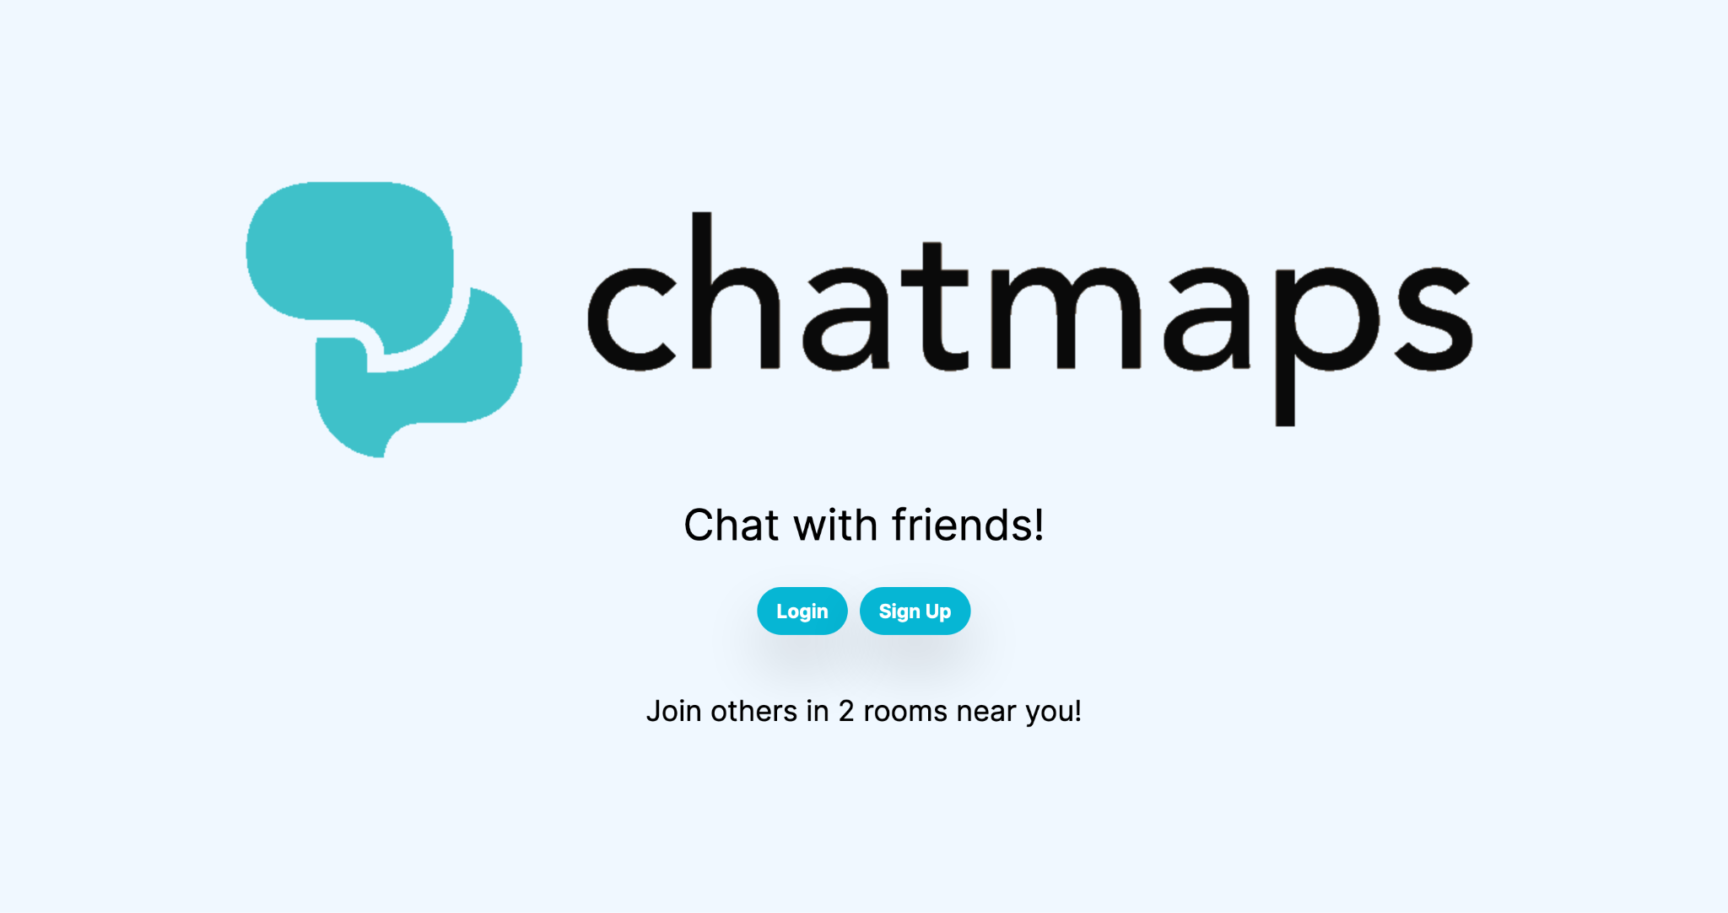

*Register Page*

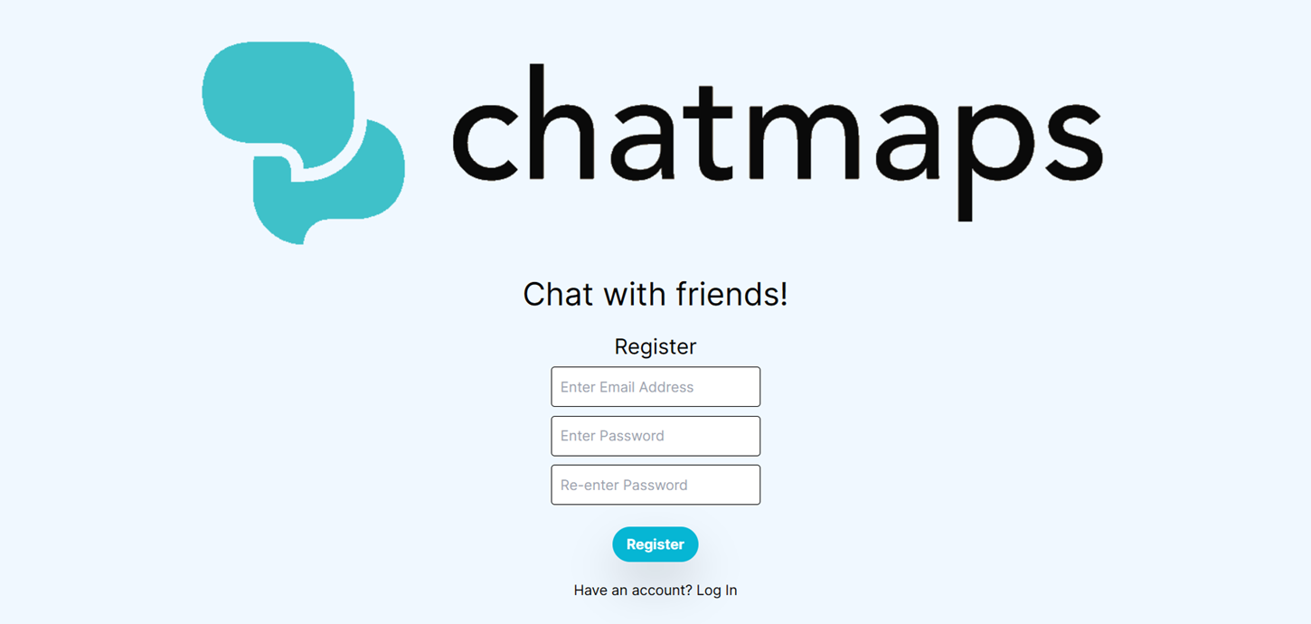

*Login Page*

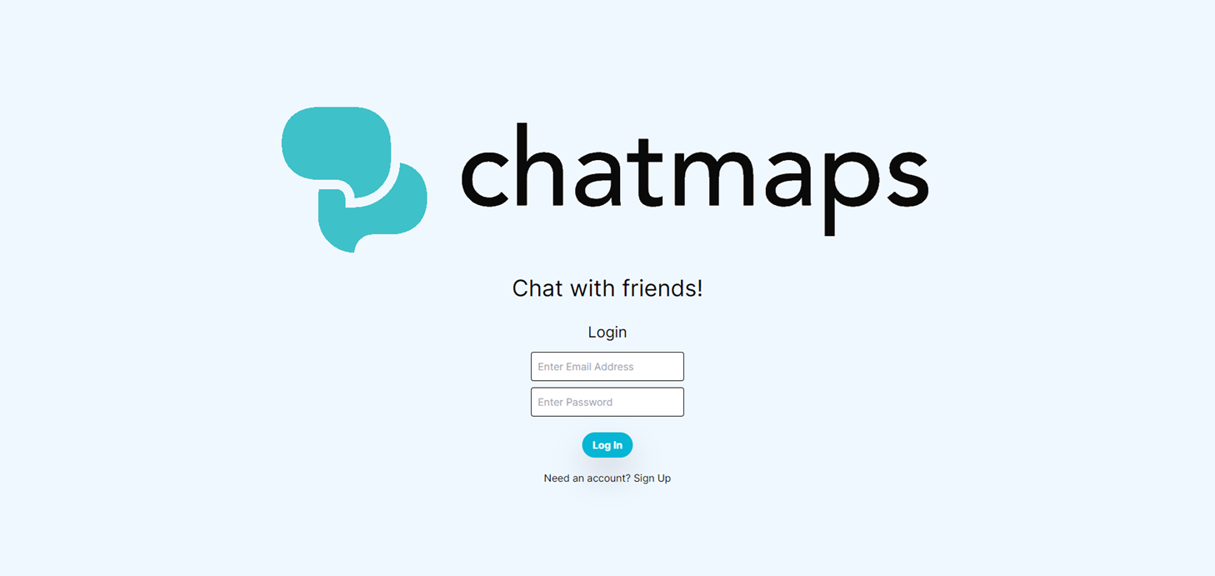

*Onboarding Page*

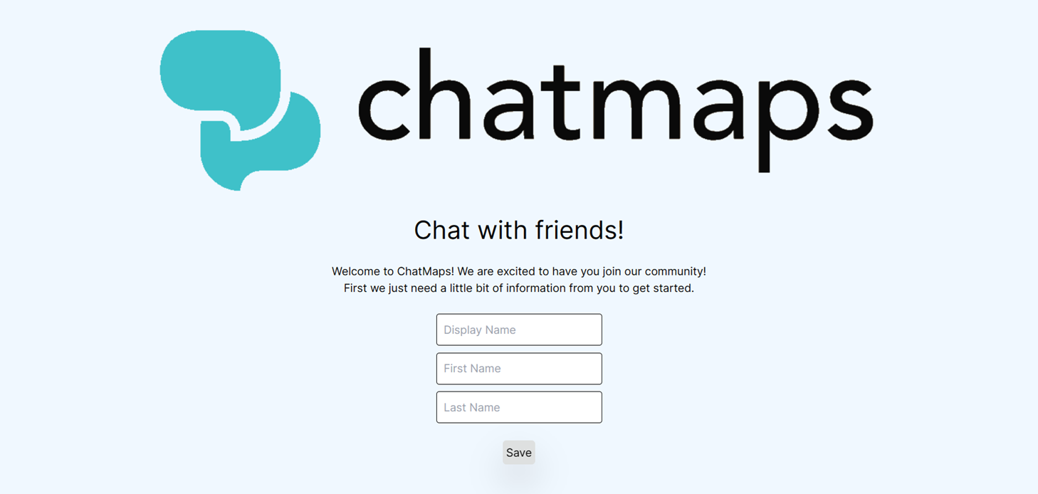

*Main App Page (updated)*

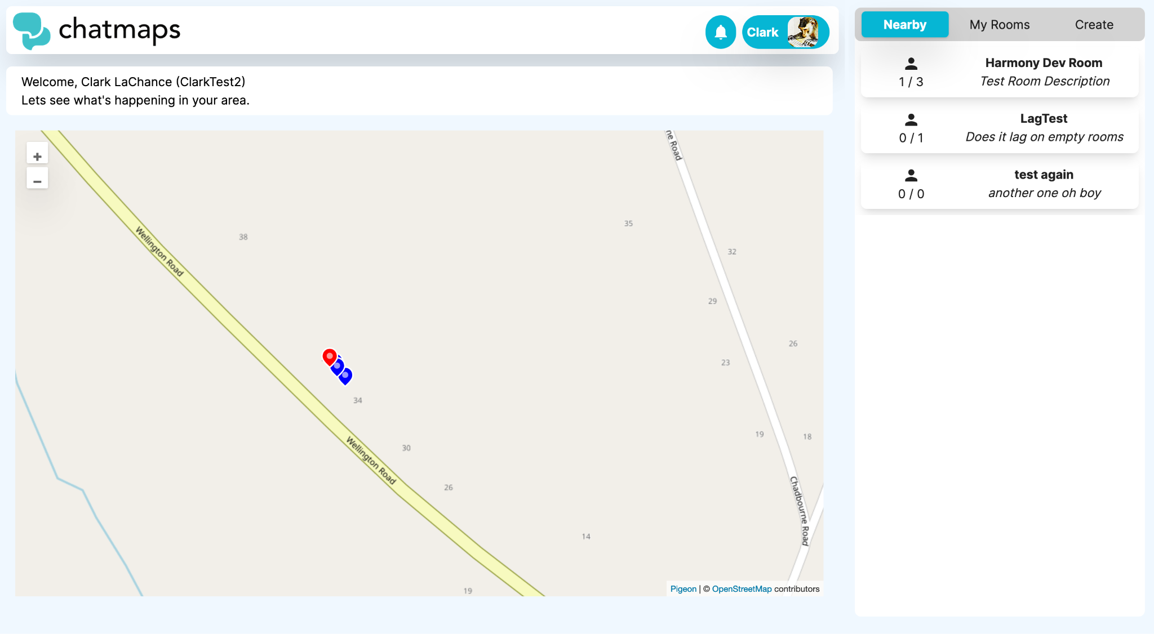

*Chat Page*

