Week-5
Q1: What are the key limitations of traditional MapReduce that make Spark a preferred choice for modern big data processing?
Answer:
Traditional MapReduce processes data by reading and writing to disk after every step, which makes it slower, especially when working with large datasets. It is not suitable for iterative tasks like machine learning because the data has to be loaded from disk repeatedly. Writing MapReduce programs is also more complex and requires more code.
Apache Spark overcomes these limitations by processing data in memory, which makes execution much faster. It provides simple APIs for Python, Java, Scala, and R, making development easier. Spark also supports SQL queries, streaming, machine learning, and graph processing within the same framework. Because of its speed, ease of use, and support for multiple data processing tasks, Spark is the preferred choice for modern big data applications.

Q2: Explain how Spark uses In-Memory Computing to speed up iterative machine learning algorithms compared to disk-based systems.
Answer:
Spark uses in-memory computing, which means it stores intermediate data in RAM instead of writing it to disk after every operation. This allows Spark to reuse the same data multiple times without reading it again from storage.
In machine learning algorithms, the same dataset is processed repeatedly during training. In traditional disk-based systems like MapReduce, the data is read from and written to disk in every iteration, which increases execution time. Spark avoids this overhead by keeping the data in memory, making iterative algorithms much faster and more efficient. This is one of the main reasons why Spark is widely used for machine learning and big data analytics.

Q3: Write a code snippet to remove all duplicate rows from a DataFrame based on a specific set of columns: user_id and transaction_date.
Answer:

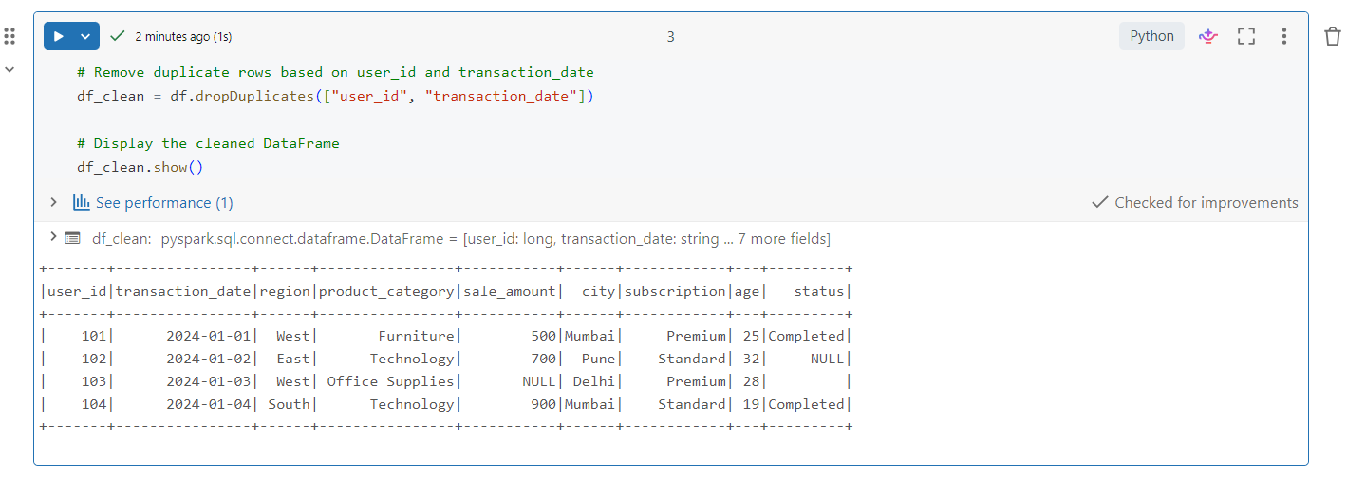
Q4: Given a DataFrame df_sales, write a query to filter for rows where the region is 'West' and then group by product_category to find the average sale_amount.
Answer:
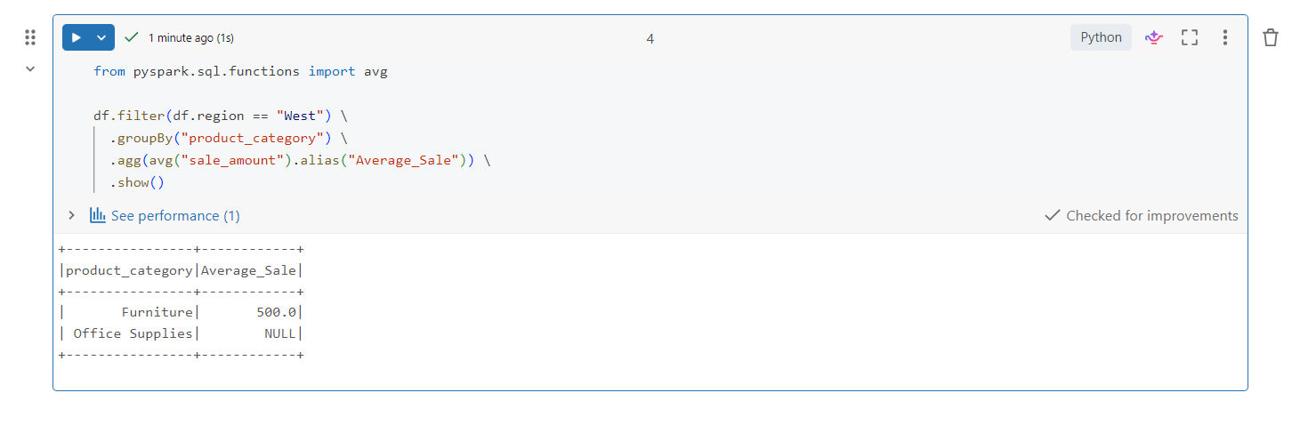
Q5: What is the difference between .na.drop() and .na.fill()? Provide a code example of filling null values in a status column with the string 'Unknown'.
Answer:

The .na.drop() function removes rows that contain null values, whereas .na.fill() replaces null values with a specified value. In this example, all null values in the status column are replaced with "Unknown" instead of removing the records.
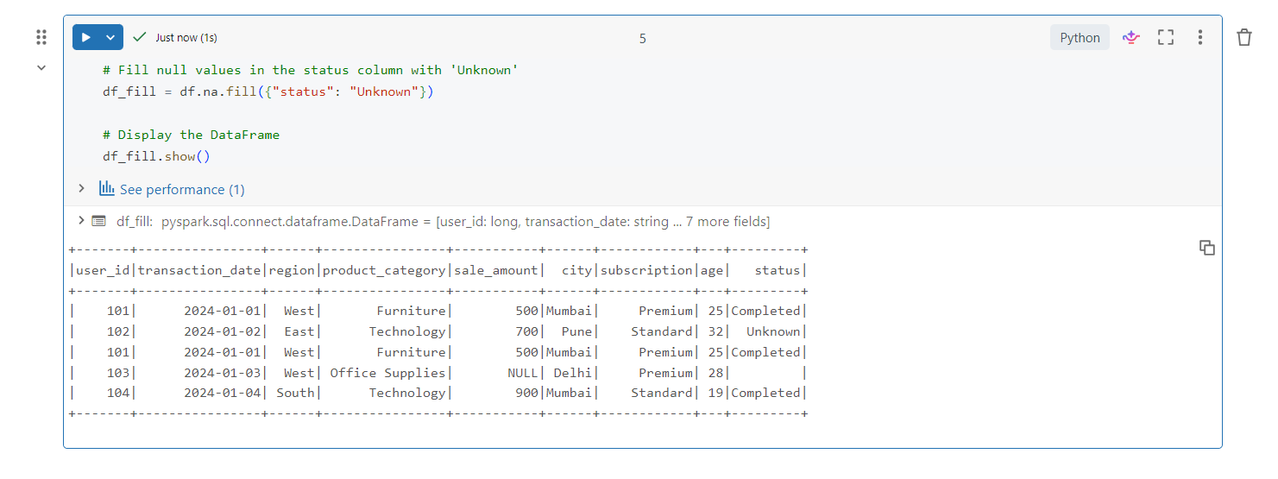
Q6: Write a query to find the total count of records for each city in a DataFrame, but only for cities where the count is greater than 100.
Answer:
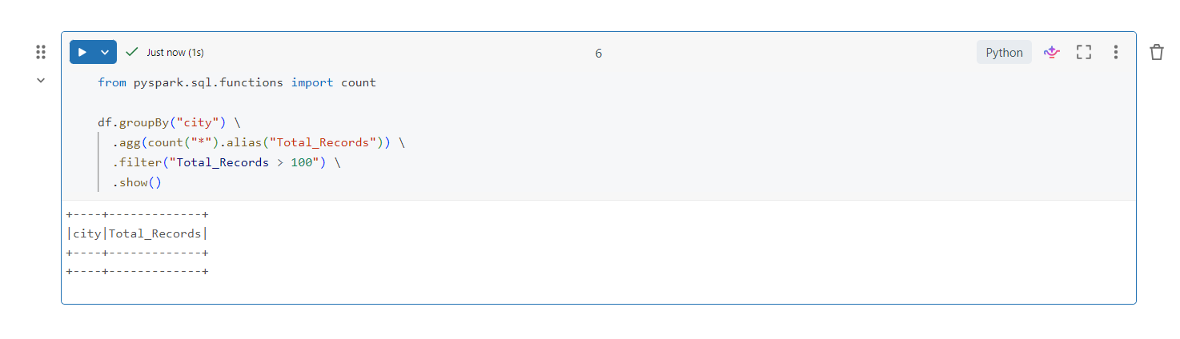
Q7: How does the immutability of Spark DataFrames affect how you perform "data cleaning" steps like dropping columns or renaming them?
Answer:

Spark DataFrames are immutable, which means the original DataFrame cannot be changed after it is created. Whenever we perform operations like dropping a column, renaming a column, or filtering data, Spark creates a new DataFrame instead of modifying the existing one. Therefore, we usually assign the result to a new DataFrame or overwrite the existing variable with the transformed DataFrame.

Q8: Write a Spark command to filter a dataset for rows where the age is between 18 and 30 (inclusive) and the subscription is 'Premium'.
Answer:
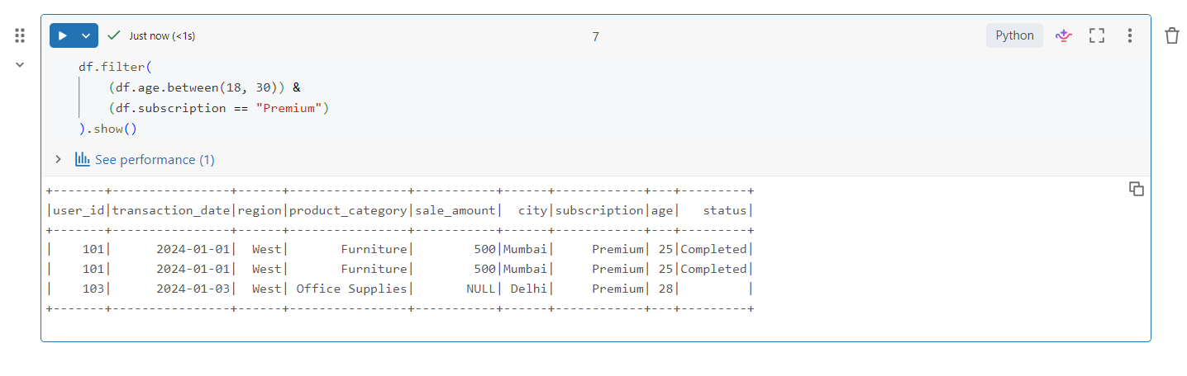
Q9: When cleaning a dataset, why is it often better to handle null values before performing mathematical aggregations like sum() or avg()?
Answer:

Null values can affect the accuracy of mathematical calculations such as sum() and avg(). If null values are not handled properly, the results may be incorrect or incomplete. Replacing or removing null values before performing aggregations helps produce more reliable and meaningful results.

Q10: Write the code to revise a column named raw_timestamp by casting it to a TimestampType and renaming it to event_time.
Answer:

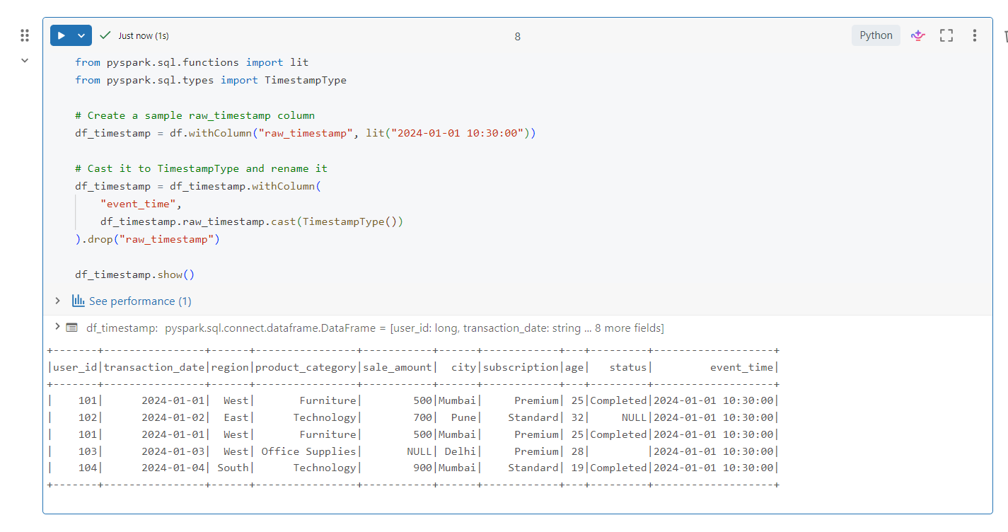
Q11: Explain the "Shuffle" process that occurs during a grouping operation. Why is it considered a wide transformation?
Answer:

A shuffle is the process of redistributing data across different partitions so that records with the same key are grouped together. During operations like groupBy(), Spark moves data between executors, which increases network communication and execution time. Since data is transferred across partitions, groupBy() is considered a wide transformation.

Q12: Write a code snippet that identifies and removes rows where the email column contains null values OR the username is an empty string.
Answer:

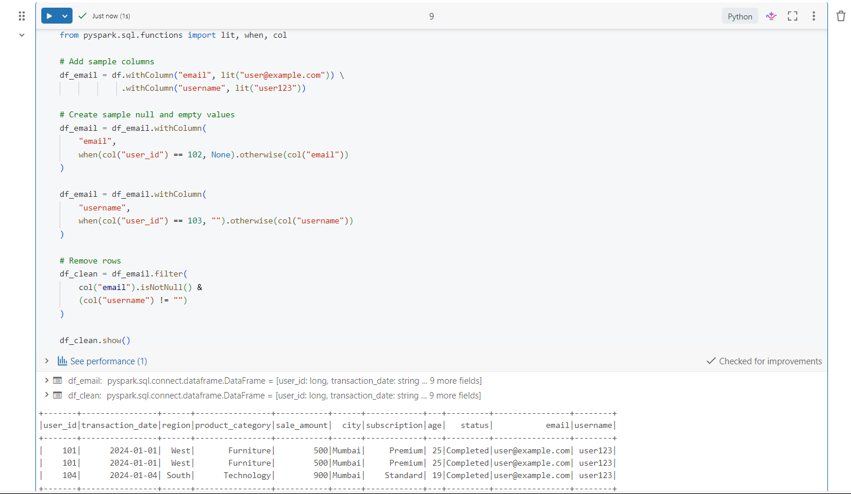
Q13: How do you use the .agg() function to calculate multiple statistics at once, such as the min, max, and mean of the price column?
Answer:

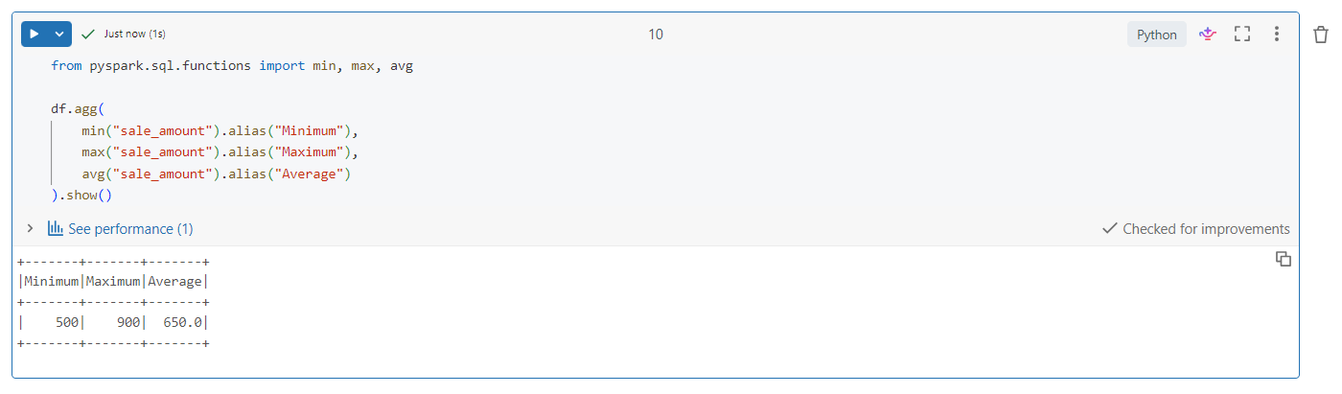

Q14: In the context of cleaning a dataset, what is the risk of using inferSchema=true when your source data contains messy or inconsistent date formats?
Answer:

When inferSchema=true is used, Spark automatically determines the data type of each column. If a date column contains inconsistent or invalid date formats, Spark may assign the wrong data type or treat the column as a string. This can lead to incorrect results, errors during processing, or problems while performing date-related operations. Therefore, it is important to validate and clean the data before relying on schema inference.

Q15: Write a final processing pipeline that:
- Filters out duplicates.
- Fills null prices with 0.
- Groups by store_id to calculate total revenue.
Answer:

