Week-6
Q1: Explain the roles of the Driver, Cluster Manager, and Executor in a Spark application.
Answer:
- Driver: The Driver controls the Spark application. It creates the SparkSession, divides the job into tasks, and sends those tasks to the executors.
- Cluster Manager: The Cluster Manager manages the available resources in the cluster and allocates resources to the Spark application.
- Executor: Executors run on worker nodes. They execute the tasks assigned by the Driver and store/cache data during processing.

Q2: How does Spark’s Lazy Evaluation strategy improve performance when chain-processing large datasets?
Answer:
- Spark does not execute transformations immediately.
- It waits until an action like show() or count() is called.
- This gives Spark time to optimize the operations before executing them.
- It avoids unnecessary processing and improves performance on large datasets.

Q3: Write a Spark command to read a CSV file located at "data/source.csv", ensuring the first row is treated as a header and inferSchema is enabled.
Answer:
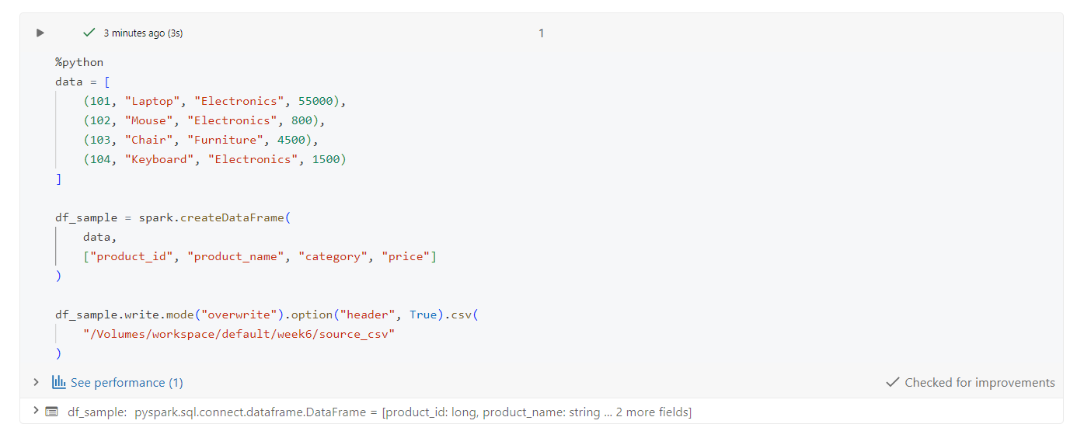
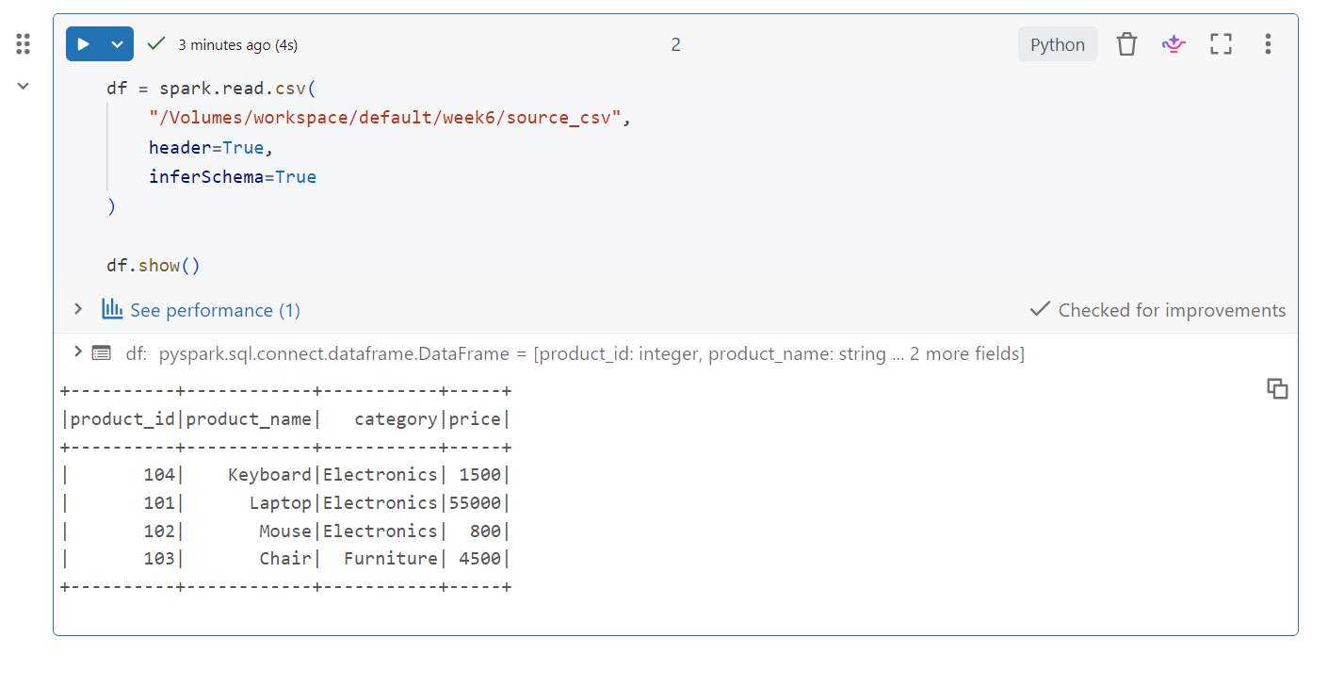
Q4: What is the difference between CSV and Parquet in terms of storage (row-based vs. columnar) and why does it matter for performance?
Answer:
- CSV stores data in a row-based format and takes more space.
- Parquet stores data in a columnar format and provides better compression.
- Parquet is faster when we need only specific columns from a large dataset.
- Therefore, Parquet is generally better for large-scale Spark processing.

Q5: Given a DataFrame df, write a query to select the columns product_id and price where the category is 'Electronics'.
Answer:
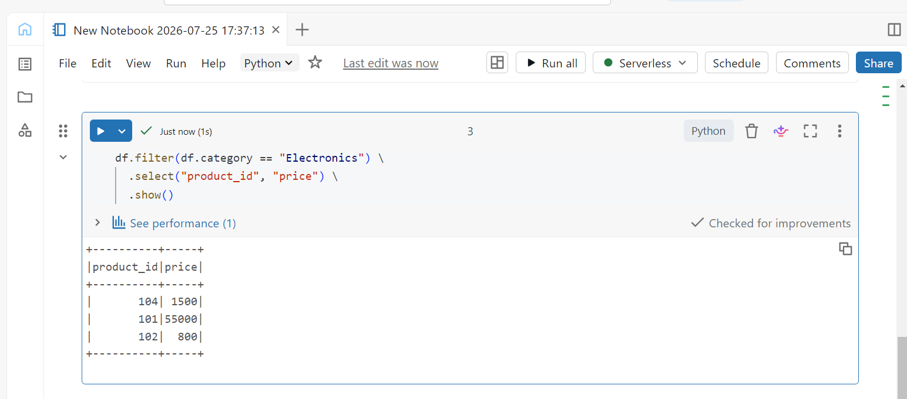
Q6: Write the code to "revise" a DataFrame by renaming the column old_name to new_name and casting the price column from a String to a Double.
Answer:
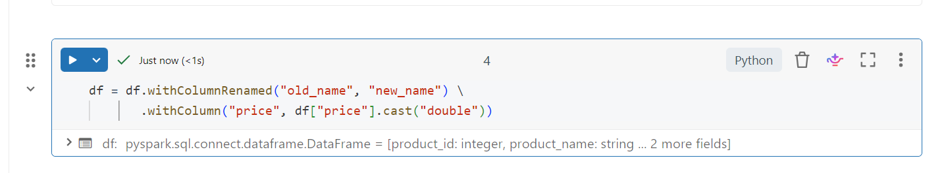
Since our current DataFrame doesn't have an old_name column, we'll create a small DataFrame

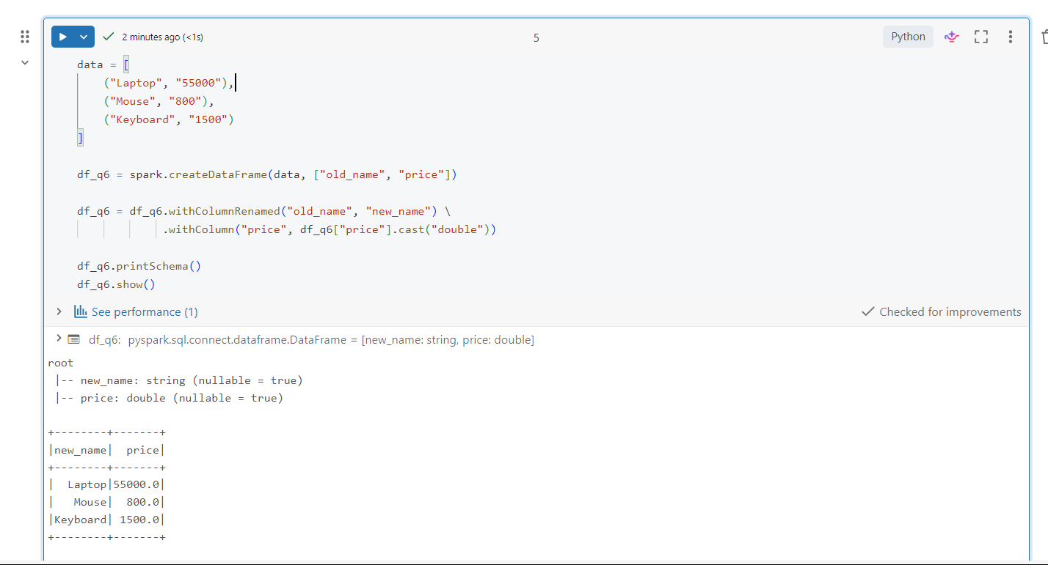

Q7: How does Spark use the Lineage Graph (DAG) to provide fault tolerance if a worker node fails?
Answer:
- Spark keeps track of all transformations using a Lineage Graph (DAG).
- If a worker node fails, Spark knows how the lost data was created.
- It re-executes the required transformations to recreate that data.
- This provides fault tolerance without restarting the whole job.

Q8: Write a query to filter a DataFrame df_orders for rows where the status is 'Completed' AND the amount is greater than 1000.
Answer:
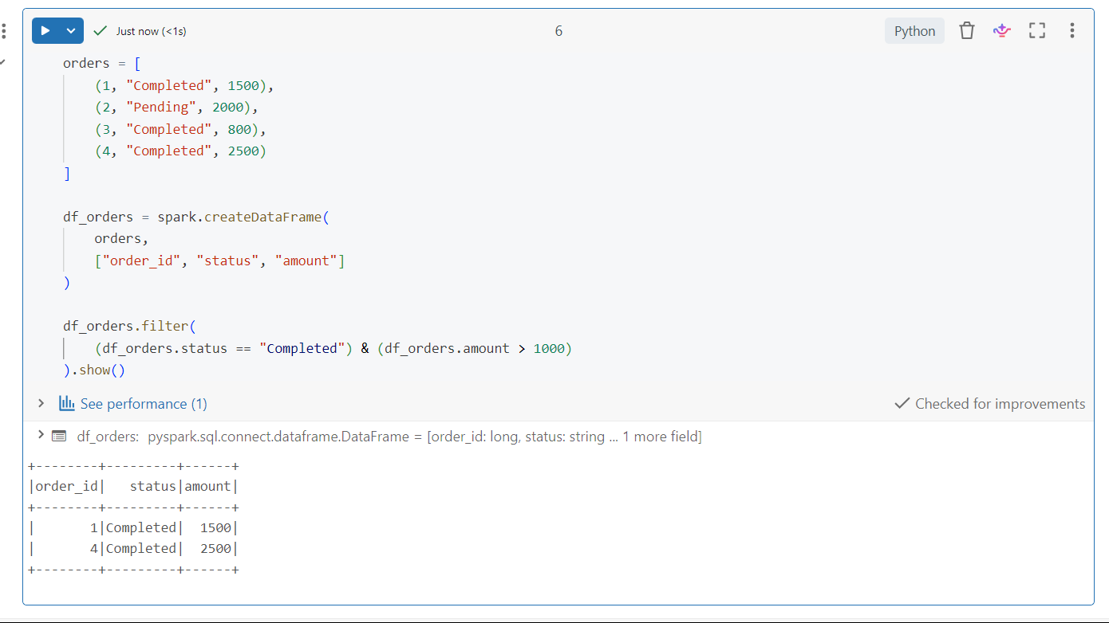

Q9: Explain the concept of Predicate Pushdown in Parquet and how it affects the amount of data loaded into memory.
Answer:
- Predicate Pushdown allows Spark to apply filters while reading the Parquet file.
- Only the required data is read instead of loading the complete dataset.
- This reduces memory usage and makes processing faster.

Q10: Write a code snippet to add a new column final_price which is the base_price multiplied by 1.18 (18% tax).
Answer:
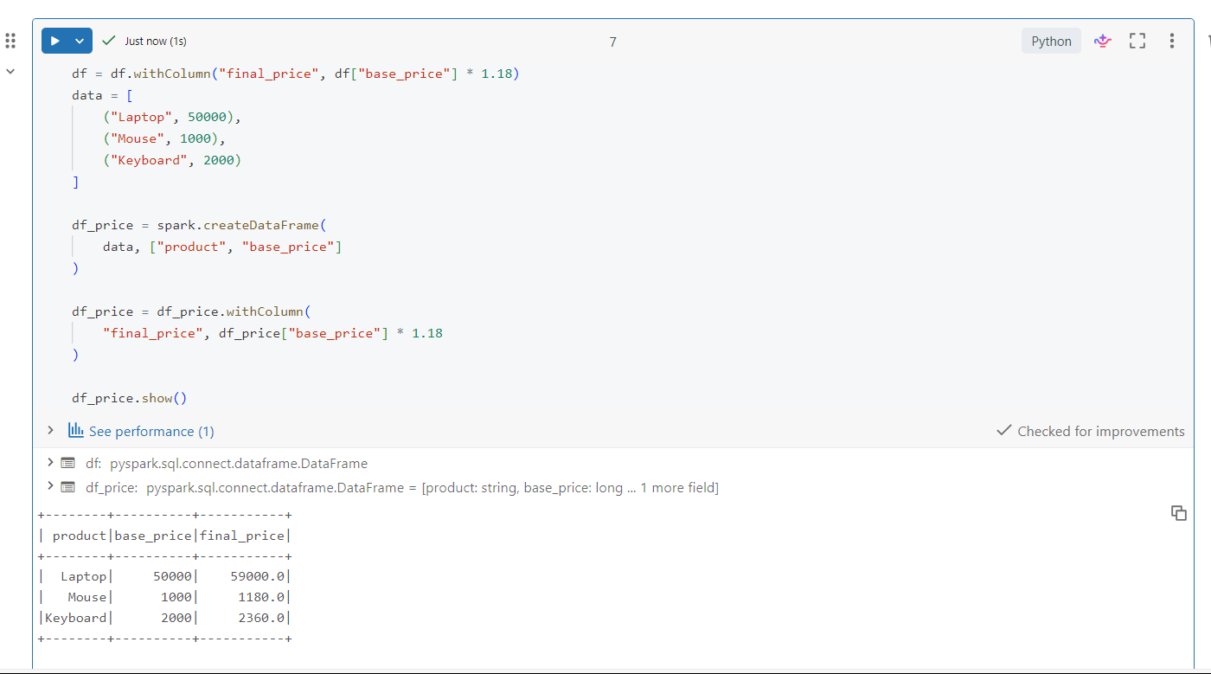

Q11: What is the difference between Transformations and Actions? Provide two examples of each.
Answer:
- Transformations: They create a new DataFrame from existing data but are not executed immediately due to lazy evaluation.
Examples: filter(), select()
- Actions: They trigger the actual execution of the transformations and return/display the result.
Examples: show(), count()

Q12: Write the Spark command to load a Parquet file from "path/to/input", filter out any rows where user_id is null, and save the result as a CSV at "path/to/output".
Answer:
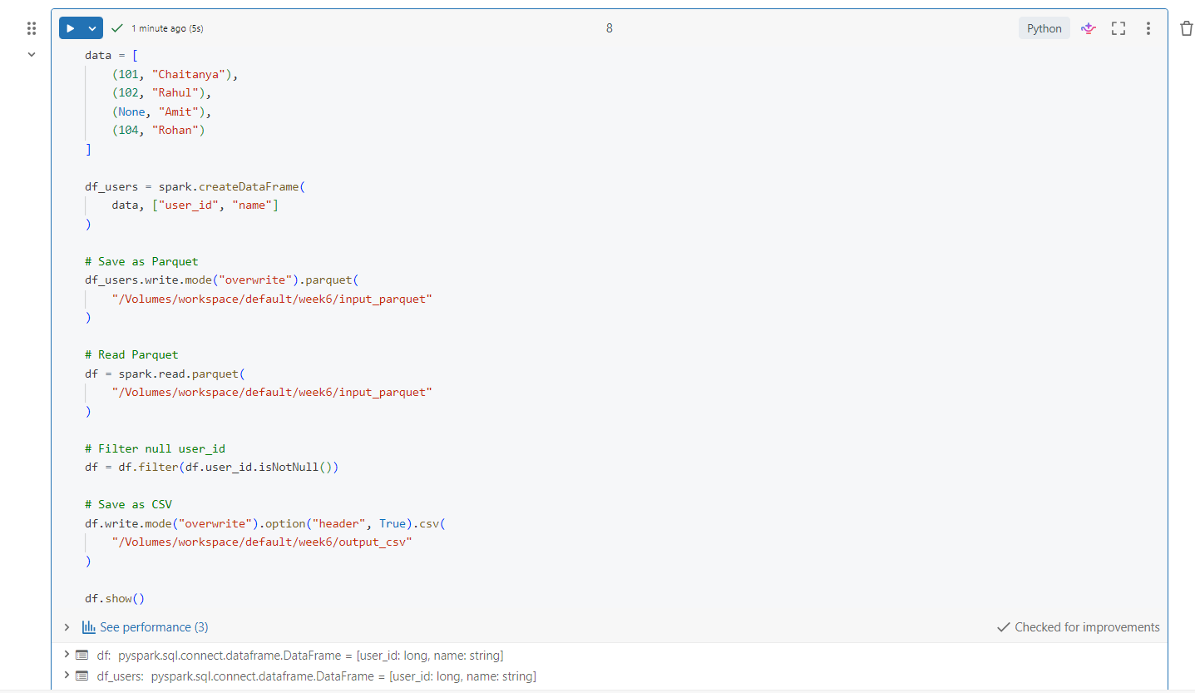

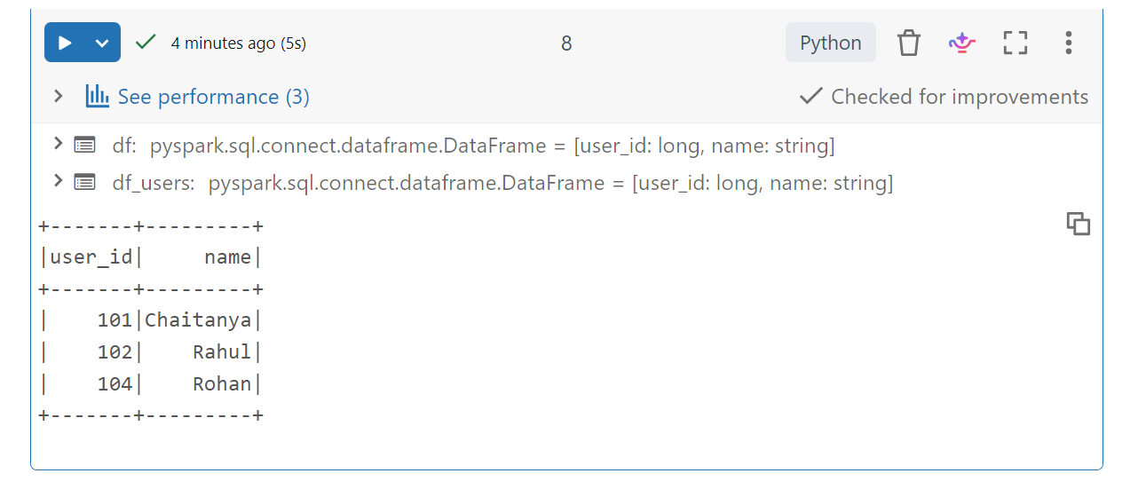

Q13: In Spark Architecture, what is the difference between Client Mode and Cluster Mode?
Answer:
- Client Mode: The Driver runs on the machine from where the Spark application is submitted.
- Cluster Mode: The Driver runs inside the cluster on one of the worker nodes.
- Client Mode is useful for testing and debugging, while Cluster Mode is generally preferred for production jobs.

Q14: Write a query to filter a dataset for rows where the region is 'North' OR the priority is 'High'.
Answer:
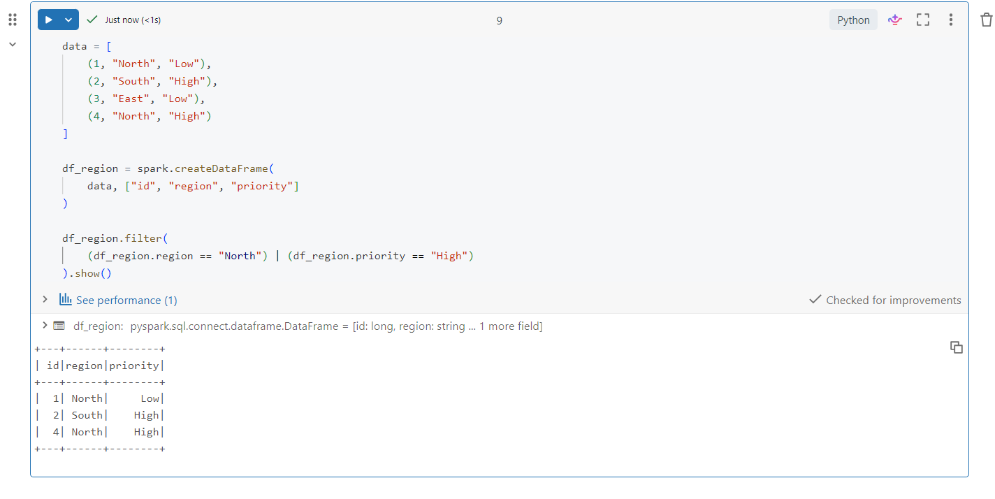

Q15: When exploring a dataset, why is it safer to use .show(5) instead of .collect() on a multi-terabyte dataset?
Answer:
- .show(5) displays only the first 5 rows of the dataset.
- .collect() brings the entire dataset to the Driver machine.
- For very large datasets, .collect() can cause memory issues or even crash the Driver.
- So, .show(5) is safer for checking large datasets.

Databricks Notebook
The practical Spark tasks in this assignment were executed using PySpark in Databricks.
Databricks Notebook Link:
Week 6 Spark Assignment – Databricks Notebook

