I’m passionate about biotechnology and its applications, mainly on forensic biotechnology. I am interested in using biotechnology to help solve crimes and make the society safer. Not only that, I’m fascinated by how biotechnology can be used to solve crimes, such as identifying evidence through DNA. By working in this field, I hope to make a positive impact on the world, improving how we solve criminal cases.

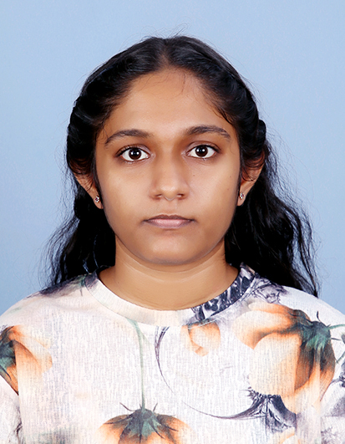

Educational Qualifications

Secondary education

Grade 01 - 13 WP/KE/ Vishaka Balika Vidyalaya – Sapugaskanda

Passed GCE. Ordinary Level (O/L) Examination

* 4 A’s - Sinhala Language, English, Business & Accounting, Music
* 3 B’s - Mathematics, Buddhism, History
* 2 C’s - Science, Information & Communication Technology

Higher education

Participated GCE. Advanced Level (A/L) Examination 23/24 in science stream

* Biology - C
* Physics - S
* Chemistry – S

Currently a biotechnology undergraduate in SLIIT in Malabe (2024 onwards)

Other educational Qualifications

British Council - Sri Lanka

* Completed Myclass upper-intermediate course in 2024
* Completed Upper-secondary language course in 2021

Bhatkhande Sangit Vidyapith Lucknow - Music course

* Completed Prathma - instrumental in 2020
* Completed Praveshika - instrumental in 2020

Awards and Certifications

* Participated “ITN Band the Band” competition in 2018
* Winner of Kelaniya Educational Zone band competition in 2019
* Runners-up of Eloge Jubliante International band competition in 2019

Other skills

* Communication skills
* Leadership Skills
* Creativity
* Time Management

Hobbies

* Drawing
* Singing
* Playing guitar
* Writing fictions
* Cooking and baking

Link to my downloadable resume

* <https://acrobat.adobe.com/id/urn:aaid:sc:AP:f093d301-84c9-429f-8536-c1077eb35ff0>

contact details

* email address – chathudewage07@gmail.com