SRI LANKA INSTITUTE OF INFORMATION TECHNOLOGY



Faculty of Computing
SE3090 – Software Engineering Frameworks

Assignment 1
Report
Y3.S1.WE.AI.02.01.G15

Name | Student ID
Pehesara W.A.C. | IT24103684
Peiris W.S.V. | IT24103792
Obesekara S.O.K.D. | IT24103866
Weerasooriya W.H.M.S.P. | IT24104192

28.09.2026
System Access Directory

- Repository URL
https://github.com/Goverment-Service/Government_Service_Navigator

- Demo Video
- Live Web URL
- API/SWAGGER URL
http://localhost:5119/swagger

- APK Download

Table of Contents

PART 1: GROUP REPORT 6
1. Project Overview & Business Domain 6
1.1. Business Problem & Domain Definition 6
1.2. User Roles & Access Boundaries (Role Matrix) 6
1.3. Component Ownership Mapping (One primary component per student) 6
2. Integrated System Architecture 6
2.1. Full-Stack Integration Architecture (ASP.NET Core, React, Flutter, Agentic AI, PostgreSQL) 6
2.2. End-to-End Cross-Platform Workflow Pattern 6
2.3. Third-Party Service Integration Design & Security 6
3. Relational Database Design & Data Modelling 6
3.1. Entity-Relationship (ER) Diagram & Schema Specifications 6
3.2. Constraints, PostgreSQL Data Types, and Indexing Strategy 6
3.3. Entity Framework Core Migrations & Seed Data 6
3.4. Agentic AI State & Workflow Summary Persistence 6
4. Technical Design of Subsystems 6
4.1. Secure ASP.NET Core RESTful API Backend 6
4.2. React Web Application 1
4.3. Flutter Mobile Application 1
5. Agentic AI Subsystem & Orchestration 1
5.1. Architecture & Framework Selection (e.g., LangGraph, Local Ollama) 1
5.2. Distinct Agent Roles, Input/Output Contracts, and Responsibilities 1
5.3. Allow-Listed Tools, Input Validation, and Principle of Least Privilege 1
5.4. Human-in-the-Loop (HITL) Pause, Review, and Approval Workflow 1
5.5. Observability, Audit Logs, and Safe-Failure Mechanisms 1
6. Architecture Decision Records (ADRs) (3–6 Pages Suggested) 1
6.1. ADR 01: State Management in React 1
6.2. ADR 02: State Management in Flutter 1
6.3. ADR 03: Agentic AI Framework & Orchestration Strategy 1
6.4. ADR 04: Database Schema Strategy for Agent Workflow State 1
6.5. ADR 05: Cloud Hosting & Deployment Infrastructure 1
7. Software Quality & Testing Report (6–10 Pages Suggested) 2
7.1. ASP.NET Core API Unit & Integration Tests 2
7.2. Database Constraint, Transaction, and Migration Tests 2
7.3. React Frontend Component & Route Tests 2
7.4. Flutter Mobile Widget & Navigation Tests 2
7.5. Full Cross-Platform End-to-End Workflow Execution 2
8. Agentic AI Evaluation Report (5–8 Pages Suggested) 2
8.1. Golden Case Dataset & Evaluation Criteria 2
8.2. Planning, Delegation, and Tool Selection Verification 2
8.3. Deterministic Rule Compliance & Structured Output Validation 2
8.4. Prompt Injection Resistance & Safety Testing 2
8.5. Safe-Failure & Exception Recovery Evidence 2
9. Performance & Scalability Report (3–5 Pages Suggested) 2
9.1. API Concurrency, Latency, and Throughput Benchmarks 2
9.2. Database Query Execution Times & Index Efficiency 2
9.3. Agentic AI Pipeline Latency & Tool Execution Timings 2
10. Deployment & DevOps Report (3–5 Pages Suggested) 3
10.1. Cloud Deployment Topology & Architecture Map 3
10.2. GitHub Actions CI/CD Pipeline (Build, Test, and Quality Gates) 3
10.3. Step-by-Step System Startup Instructions (Local & Cloud) 3
10.4. Environment Variables & Secrets Reference Matrix 3
10.5. Evaluator Test Accounts & Pre-Seeded Verification Credentials 3
11. Security Governance & Consolidated AI Declaration 3
11.1. Security Controls, Credential Management, and Data Protection 3
11.2. Consolidated Group AI Usage Declaration 3
PART 2: INDIVIDUAL REPORTS 3
12. Individual Report — Student 1 (Component A Owner) 3
12.1. Component Ownership & Contribution Statement 3
12.2. Technical Contribution Breakdown across Full Stack (API, DB, React, Flutter, AI) 3
12.3. Version Control Evidence (Key Commits, PRs, and Test Ownership) 3
12.4. Technical Challenges Encountered & Key Learnings 3
12.5. Individual AI Usage Log 3
12.6. Individual AI Reflection (Approx. 1 page) 3
12.7. Signed Individual Ownership Declaration 3
13. Individual Report — Student 2 (Component B Owner) 4
13.1. Component Ownership & Contribution Statement 4
13.2. Technical Contribution Breakdown across Full Stack (API, DB, React, Flutter, AI) 4
13.3. Version Control Evidence (Key Commits, PRs, and Test Ownership) 4
13.4. Technical Challenges Encountered & Key Learnings 4
13.5. Individual AI Usage Log 4
13.6. Individual AI Reflection (Approx. 1 page) 4
13.7. Signed Individual Ownership Declaration 4
14. Individual Report — Student 3 (Component C Owner) 4
14.1. Component Ownership & Contribution Statement 4
14.2. Technical Contribution Breakdown across Full Stack (API, DB, React, Flutter, AI) 4
14.3. Version Control Evidence (Key Commits, PRs, and Test Ownership) 4
14.4. Technical Challenges Encountered & Key Learnings 4
14.5. Individual AI Usage Log 4
14.6. Individual AI Reflection (Approx. 1 page) 4
14.7. Signed Individual Ownership Declaration 4
15. Individual Report — Student 4 (Component D Owner) 5
15.1. Component Ownership & Contribution Statement 5
15.2. Technical Contribution Breakdown across Full Stack (API, DB, React, Flutter, AI) 5
15.3. Version Control Evidence (Key Commits, PRs, and Test Ownership) 5
15.4. Technical Challenges Encountered & Key Learnings 5
15.5. Individual AI Usage Log 5
15.6. Individual AI Reflection (Approx. 1 page) 5
15.7. Signed Individual Ownership Declaration 5
References & Appendices 5

PART 1: GROUP REPORT

Project Overview & Business Domain

Business Problem & Domain Definition
Public administrative services often suffer from complex procedures, unclear eligibility guidelines, manual document validation, and scattered communication channels. Citizens frequently struggle to identify which public services apply to their specific situations, what exact supporting documents are required, and how much fee must be paid before visiting a department office. On the operational side, government verification officers face high volumes of submitted applications with missing or invalid attachments, leading to long processing backlogs, repetitive manual checking, and high rejection rates.
The Government Service Navigator (GSN) is an intelligent public service assistance and case processing platform designed to solve these issues. GSN combines web and mobile client applications with an AI agent backend to streamline public service delivery.
The domain of GSN covers four main functional areas:
- Intake & Service Discovery: Guiding citizens through natural language queries to discover appropriate public services, understand eligibility criteria, and review document requirements before applying.
- Application Submission & Case Handling: Enabling citizens to fill multi-step digital forms, upload required supporting evidence, reserve appointment slots, and track application status in real time.
- Verification, Compliance & Auditing: Providing government officers with dedicated verification tools, AI-assisted validation reports, decision reason codes, and complete audit logging for regulatory compliance.
- Financial Operations & Pipeline Protection: Handling payment checkout, processing structured refund requests, managing installment plans, and running automated anomaly detection to flag suspicious processing or payment patterns.

User Roles & Access Boundaries
The GSN system defines four distinct user roles, each tied to specific system permissions, business responsibilities, and primary client interfaces:
Role | Responsibilities | Primary Client Interface | Access Boundaries & Permissions
Citizen / Applicant | Search services, receive eligibility guidance, submit application forms, upload documents, pay processing fees, reserve appointments, and track case progress. | Flutter Mobile Application | Authenticated access restricted strictly to personal submitted applications, draft forms, receipt histories, and public service catalog definitions.
Verifying Officer | Review submitted applications, inspect uploaded documents side-by-side with AI verification drafts, approve, reject, or request application revisions with standardized reason codes. | React Web Portal | Authenticated access restricted to departmental case queues, verification task assignment, decision logs, and case-level audit trails.
Department Admin | Configure service catalog definitions, define eligibility rules, set document checklists, manage fee structures, control office appointment capacity, and review overall performance analytics. | React Web Portal | Administrative access to service definitions, rule builder engines, office calendar capacity schedules, and department usage statistics.
System Admin | Manage system user accounts and role assignments, inspect system-wide audit logs, review security and payment anomalies, and configure global system settings. | React Web Portal | Unrestricted administrative access across user accounts, global system configurations, audit log archives, and flagged anomaly review pipelines.

Component Ownership Mapping
To ensure balanced technical workload distribution across backend endpoints, intelligent AI agent design, web administrative views, and mobile user screens, the project development is divided into four equal vertical slices across the team members:
1. Peiris W.S.V. — Member A
- Owned Component: Service Catalog & Eligibility Guidance
- Owned Agent: Agent 1 — Intake & Planning Agent
- Entities: Services, Procedures, EligibilityRules, DocumentRequirements, FeeSchedules
- Web Views (React): Service/Procedure Catalog Manager, Eligibility Rule Builder, Document Requirement Configurator, Fee Schedule Manager
- Mobile Screens (Flutter): Service Discovery / Search, "Describe Your Need" Intake Screen, Procedure Detail & Document Checklist, Eligibility Self-Check Screen
2. Obesekara S.O.K.D. — Member B
- Owned Component: Application & Case Management
- Owned Agent: Agent 3 — Action / Tool Agent
- Entities: Applications, ApplicationSteps, Documents, AppointmentSlots, StatusHistory
- Web Views (React): Application/Case Queue, Case Detail View, Appointment Slot Manager, Status Timeline / Case History
- Mobile Screens (Flutter): Multi-Step Application Form, Document Upload View, Appointment Slot Picker, Status Timeline Tracker
3. Pehesara W.A.C. — Member C
- Owned Component: Verification & Compliance
- Owned Agent: Agent 4 — Validation & Safety Agent
- Entities: VerificationTasks, OfficerReviews, ComplianceChecks, RejectionReasons, AuditLogs
- Web Views (React): Verification Workspace, Agent Reasoning Trail Viewer, Bulk Verification Panel, Audit Log Viewer
- Mobile Screens (Flutter): Revision Request View, Document Resubmission Flow, Rejection/Decision Explainer, Compliance Notice Center
4. Weerasooriya W.H.M.S.P. — Member D
- Owned Component: Payments, Refunds & Financial Analytics
- Owned Agent: Agent 2 — Eligibility & Document Analysis Agent (+ Workflow Orchestrator)
- Entities: Payments, RefundRequests, InstallmentPlans, ReportSnapshots, ServiceUsageStats
- Web Views (React): Refund Request Manager, Installment Plan Manager, Analytics Dashboard, Anomaly Review Panel
- Mobile Screens (Flutter): Payment Checkout Screen, Installment Plan View, Refund Request & Status Screen, Receipt / Transaction History View

Integrated System Architecture

Full-Stack Integration Architecture
The Government Service Navigator uses a multi-tier, microservices-inspired architecture designed to separate concerns across user presentation, backend business logic, agentic AI execution, and persistent data storage.
Layer Breakdown:
- Client Tier:
  - Flutter Mobile App: Built for Citizens, enabling cross-platform access (Android/iOS) for service discovery, application filing, offline form caching, photo uploads, payment processing, and real-time status tracking.
  - React Web Portal: Built using React, TypeScript, and Vite for Verifying Officers and Department Admins. It offers high-density data tables, side-by-side document inspection, rule configurators, and administrative analytics dashboards.
- API & Logic Tier (ASP.NET Core Backend):
  - Acts as the primary backend gateway and domain controller layer.
  - Exposes RESTful endpoints protected by JSON Web Token (JWT) Bearer authentication.
  - Manages domain entities via Entity Framework Core (EF Core), enforces database transactions, handles appointment concurrency, and updates case status transition histories.
- Agentic AI Tier:
  - Contains four specialized AI agents that execute structured multi-step tasks.
  - Agent 1 (Intake & Planning): Parses free-text queries into structured service recommendations and step-by-step application plans.
  - Agent 2 (Workflow Orchestrator & Analysis): Coordinates the execution chain across Agents 1 to 4, evaluates citizen eligibility scores, and generates missing document lists.
  - Agent 3 (Action/Tool Agent): Automates fee calculation, checks appointment availability, and pre-fills application forms from profile data.
  - Agent 4 (Validation & Safety Agent): Validates form schema data against regulatory compliance rules and detects duplicate submissions.
- Persistence Tier (PostgreSQL with pgvector):
  - Stores relational entities (Users, Applications, Payments, VerificationTasks) alongside high-dimensional vector embeddings for semantic document and catalog searching.

End-to-End Cross-Platform Workflow Pattern
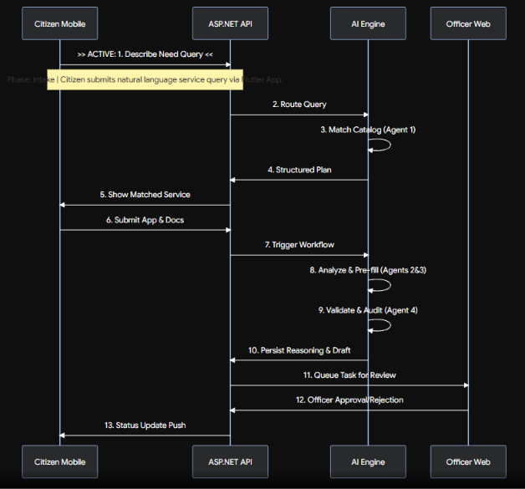

The system follows a synchronized event flow from citizen request to officer verification and final approval.
Execution Steps:
- Intake & Service Matching: The citizen enters a description of their issue into the mobile app. The request is routed to Agent 1, which queries the vectorized Service Catalog to return the exact matching procedure, eligibility criteria, and fee schedule.
- Drafting & Form Submission: Agent 3 calculates applicable fees, reserves appointment slots, and pre-fills form fields. The citizen uploads supporting documents and submits the application.
- Automated Validation & Orchestration: Agent 2 orchestrates the execution chain. Agent 4 validates data schemas, verifies document attachments against required formats, checks for duplicate applications, and generates an automated compliance summary.
- Officer Review & Decision: The task enters the React Web Verification Workspace. The verifying officer reviews the application, compares uploaded documents against the AI reasoning trail, and submits a final decision (Approve, Reject, or Request Revision) with structured reason codes.
- Notification & State Update: The backend persists the decision, logs an audit entry, updates case status history, and sends a push notification to the citizen's mobile app.

Third-Party Service Integration Design & Security
Service / Provider | Category | Purpose | Integration Pattern | Governance Policies
Stripe API (Sandbox) | Fintech | Payment checkout, fee collection, & refunds | Webhook signature verification, PCI-compliant tokenized cards | PCI-DSS Compliance, HMAC Webhook Signatures
Neon PostgreSQL Cloud | Database | Managed Serverless DB with pgvector | Encrypted SSL/TLS connection, Environment-driven credentials | TLS 1.3 Minimum, Automatic Secret Rotation
Identity Server / JWT | Identity & Auth | User authentication & claims management | Signed RS256/HS256 tokens with blacklisting & token revocation | RevokedToken Entity Tracking, Asymmetric Key Signing
Agentic AI Providers (LLM Services) | AI / ML | OpenAI / Gemini / Local Ollama endpoints | API key secret masking, tool allow-listing, output schemas | Strict Tool Whitelisting, Output Schema Validation

Security Measures:
- Token-Based Authentication: All API calls require valid HTTP Authorization: Bearer <token> headers. Revoked tokens are tracked in the database (RevokedToken entity) to enable immediate session termination upon logout or security flag.
- Tool Allow-Listing for AI Agents: AI agents cannot execute arbitrary code. Each agent is restricted to an allow-list of backend tools (e.g., search_service_catalog, calculate_fee, validate_schema).
- Environment Configuration: Sensitive connection strings, database credentials, and secret keys are injected via environment variables (.env) and configuration files, preventing hardcoded credentials in version control.

Relational Database Design & Data Modelling

Entity-Relationship (ER) Diagram & Schema Specifications
<ER diagram>

Core Schema Entity Specifications:
- User & Identity Module:
  - User: Stores user authentication credentials, full name, role (Citizen, Officer, DepartmentAdmin, SystemAdmin), and account timestamps.
  - RevokedToken: Stores revoked JWT IDs (jti) and expiry timestamps for security revocation tracking.
- Service Catalog Module:
  - ServiceProcedure: Stores government service metadata, department owner, processing time estimates, and active status.
  - EligibilityRule: Stores logic rules linked to a service (e.g., minimum age, income threshold, residency requirement).
  - DocumentRequirement: Defines mandatory and optional supporting documents required for each service.
  - FeeSchedule: Tracks versioned fee structures tied to specific services based on effective start/end dates.
- Application & Case Module:
  - Application: Central case entity linking the applicant citizen, service procedure, current application status, and submission date.
  - ApplicationStep: Stores multi-step application form progress and step completion states.
  - Document: Stores file upload metadata, document type, stored file path/URL, verification flag, and upload date.
  - AppointmentSlot: Tracks appointment capacity per office, reserved slot times, citizen assignment, and concurrency locks.
  - StatusHistory: Maintains an immutable audit trail of every status transition for a case.
- Verification & Audit Module:
  - VerificationTask: Represents a verification work item assigned to an officer queue.
  - OfficerReview: Records officer verification decisions (Approved, Rejected, RevisionRequested), notes, and associated reason codes.
  - RejectionReason: Standardized rejection codes and plain-language explanations.
  - AuditLog: System-wide audit log recording user actions, IP addresses, entity mutations, and operational timestamps.
- Payments & Financial Module:
  - Payment: Stores fee transaction records, Stripe transaction IDs, amounts, payment status, and timestamps.
  - InstallmentPlan: Manages split-payment schedules, due dates, installment counts, and balance calculations.
  - RefundRequest: Tracks refund requests tied to rejected or withdrawn applications, including refund status lifecycle.
  - AnomalyFlag: Records flagged usage or payment anomalies detected by automated background analysis.
  - ReportSnapshot: Saved aggregated analytics reports and usage metric summaries.

Constraints, PostgreSQL Data Types, and Indexing Strategy

Entity Framework Core Migrations & Seed Data

Agentic AI State & Workflow Summary Persistence

Technical Design of Subsystems

Secure ASP.NET Core RESTful API Backend

Layered Architecture, DTOs, and Dependency Injection
The ASP.NET Core backend is structured into clear architectural layers to enforce clean separation of concerns:
- Controllers Layer: Exposes HTTP REST endpoints, handles request routing, extracts route/query parameters, and returns standard HTTP responses (200 OK, 201 Created, 400 BadRequest, 404 NotFound).
- Data Transfer Objects (DTOs): Encapsulate API payloads, hiding internal database models from client contracts. Strongly typed DTOs exist for registration, application creation, score evaluation, and payment requests.
- Dependency Injection (DI): Uses ASP.NET Core's native DI container to register application services with explicitly defined lifetimes (Scoped for DbContext and repository services; Singleton for stateless configuration engines; Transient for transient agent helper utilities).

JWT Authentication & Role-Based Authorization
Security is implemented using JSON Web Tokens (JWT) with custom Claims-Based Authorization:
- Token Issuance: Upon successful credential verification, the backend issues an HS256-signed JWT containing user claims (UserId, Email, Role).
- Role-Based Authorization Policies: Endpoints are secured using standard ASP.NET Core [Authorize(Roles = "...")] attributes. For example, administrative catalog management endpoints are restricted to DepartmentAdmin, while verification queues require the VerifyingOfficer role.
- Token Blacklisting: Revoked tokens are registered in the RevokedToken table, which a custom authorization filter checks on every incoming request to reject invalidated sessions immediately.

Business Endpoints & Agent Workflow Endpoints
The backend segregates standard CRUD business operations from asynchronous AI agent orchestration endpoints:
- Business Endpoints: Core CRUD operations such as POST /api/services, POST /api/applications, GET /api/applications/{id}/status-history, and POST /api/payments/{id}/refund-request.
- Agent Workflow Endpoints: Specialized execution endpoints such as POST /api/services/eligibility-score and POST /api/verification-tasks/bulk-verify that trigger multi-agent analysis pipelines and write execution summaries back to case logs.

Global Error Handling, Validation, and Structured Logging

- Global Error Middleware: A centralized exception handling middleware intercepts unhandled exceptions across all controllers, logging full stack traces internally while returning standardized JSON error responses (ProblemDetails format) to prevent internal system leaks.
- Request Validation: FluentValidation filters evaluate incoming DTO models before reaching controller code, returning descriptive validation failure arrays (400 Bad Request).
- Structured Logging with Serilog: Serilog captures structured log events enriched with contextual metadata (Environment, UserId, TraceId, ApplicationId), streaming logs to persistent files and console destinations for audit compliance.

React Web Application

Component Architecture, Hooks, and Protected Routing
The administrative web application is implemented using React, TypeScript, and Vite:
- Component Hierarchy: Modular design organized into reusable UI elements (Data Tables, Status Badges, Action Modals), domain-specific feature views (Verification Workspace, Rule Builder), and layout wrappers (Sidebar, Top Navigation Header).
- Custom Hooks: Encapsulate asynchronous API communication, authentication state management, and table state (pagination, sorting, filtering).
- Protected Routing: React Router wraps protected admin and officer routes within a <ProtectedRoute> wrapper that evaluates user authentication status and role clearance before rendering target views.

State Management Implementation
- Server State Management: Uses React Query (TanStack Query) to handle remote data fetching, automatic background re-fetching, data caching, and optimistic UI updates.
- Client & UI State: Uses React Context API for global application themes, current user profile claims, and drawer navigation states, keeping transient state localized to individual components.

Administrative CRUD, Filtering, Pagination, and Dashboards
- Catalog & Rule Builder Views: Department Admins can manage public service metadata, attach mandatory document checklists, and define complex eligibility rule conditions using visual drag-and-drop or select builders without editing code.
- High-Density Data Tables: Verification queues support multi-column sorting, free-text search, status filtering, and server-side pagination to handle high volumes of case records efficiently.
- Analytics Dashboard: Visualizes processing-time funnels, daily application throughput, officer decision distributions, and saved analytics report snapshots.

Agent Workflow Monitoring & Human Approval (HITL) Interface
- Verification Workspace: Presents a split-screen view containing citizen application details and uploaded documents on the left, alongside the AI-generated verification analysis on the right.
- Reasoning Trail Viewer: Renders step-by-step agent execution trails, allowing verifying officers to audit AI confidence scores, document validation results, and pre-filled form fields before confirming, rejecting, or revising a case.

Flutter Mobile Application

Widget Hierarchy, Routing, and Mobile State Management
The citizen mobile interface is developed using Flutter for cross-platform execution on Android and iOS:
- Widget Hierarchy: Structured into Screen Widgets (Views), Domain Card Components, and Atomic Controls (Input Fields, Progress Rings).
- Declarative Routing: Implemented using go_router to handle deep links, multi-step navigation flows, and auth-gated redirects.
- Mobile State Management: Employs the Provider pattern (or Riverpod) to manage state cleanly across multi-step forms, live eligibility score recalculations, and network connection status updates.

Secure Token Storage & Authentication Flow
- Secure Storage: Uses flutter_secure_storage to encrypt and persist JWT access tokens in the device's native secure enclave (Keychain on iOS, Keystore on Android).
- Auth Interceptor: An HTTP client interceptor automatically attaches JWT tokens to outgoing API requests and traps HTTP 401 Unauthorized responses to redirect the citizen smoothly to the login view when sessions expire.

Operational Workflows, Form Validation, and UI States
- Multi-Step Guided Forms: Breaks lengthy application processes into manageable steps with real-time input validation, auto-saving drafts locally.
- Offline-First Synchronization: Application drafts are cached locally on the device (using Hive / SQLite), allowing citizens in low-connectivity areas to fill forms offline and sync automatically upon network reconnection.
- Interactive "What-If" Simulator: Allows citizens to toggle missing documents or profile attributes to see their live eligibility score update instantly before submitting.

Integrated Hardware/Device Feature
- Camera & Document Scanner Integration: Integrates native device cameras via the image_picker / camera package, enabling citizens to capture photos of paper certificates, auto-crop boundaries, and upload them directly to their application.
- Push Notifications: Uses local and remote notification channels to alert citizens instantly when an officer approves, rejects, or requests a revision on their submitted application.

Agentic AI Subsystem & Orchestration

Architecture & Framework Selection
The GSN Agentic AI subsystem is built as a dedicated, modular execution framework integrated with the ASP.NET Core backend.
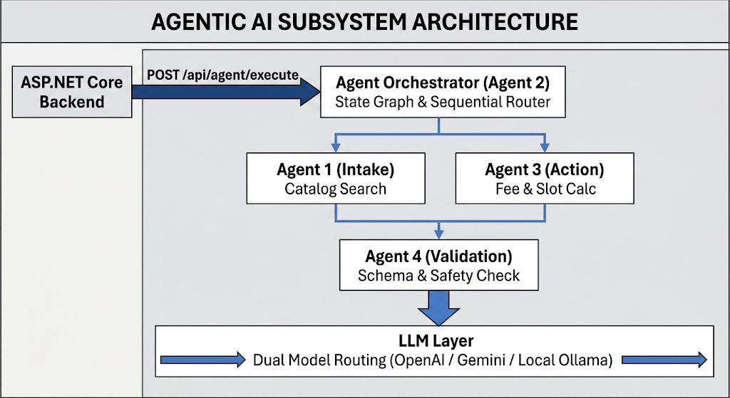
Framework & Model Choices:
- Orchestration Layer: Built using a state-graph execution pattern (similar to LangGraph / Semantic Kernel) that manages explicit state transitions between specialized sub-agents.
- Dual Execution Models: Supports cloud LLM providers (e.g., OpenAI / Gemini) for complex semantic reasoning while retaining fallback capabilities for local Ollama endpoints (e.g., Llama 3 / Mistral) to operate in private or offline environments.

Distinct Agent Roles, Input/Output Contracts, and Responsibilities
Each of the four AI agents owns a strict role with explicit, strongly typed input and output contracts:
Agent Name | Primary Responsibility | Input Contract | Output Contract
Agent 1: Intake & Planning | Matches citizen natural language descriptions to service catalog entries and generates application steps. | Free-text user query, citizen profile attributes | Structured Service ID, matched procedure steps, required documents list
Agent 2: Eligibility & Orchestrator | Orchestrates execution of Agents 1 $\rightarrow$ 4, evaluates eligibility rules, and calculates match score. | Citizen profile, service rules list, uploaded attachments | Overall match %, missing criteria list, persisted execution workflow state
Agent 3: Action / Tool Agent | Computes applicable service fees, searches available appointment slots, and pre-fills form fields. | Service ID, citizen profile, preferred dates | Calculated total fee, reserved appointment slot ID, pre-filled form JSON
Agent 4: Validation & Safety | Validates uploaded documents against schema specifications and checks for duplicate applications. | Draft application JSON, uploaded document file paths | Schema validation status (Passed/Failed), structured rejection reason codes

Allow-Listed Tools, Input Validation, and Principle of Least Privilege
To ensure AI safety and prevent prompt injection or unintended system execution, AI agents operate under strict access controls:
- Principle of Least Privilege: Agents do not possess direct write access to database entities or administrative commands.
- Allow-Listed Tools Only: Agents interact with the domain layer strictly by invoking explicitly registered execution tools:
  - search_service_catalog: Queries vector embeddings for matching public services.
  - calculate_fee: Computes exact fee breakdowns from versioned fee schedules.
  - find_appointment_slot: Queries available calendar slots with concurrency locks.
  - validate_schema: Runs deterministic JSON schema validation against form payloads.
  - check_duplicate_application: Queries case histories for duplicate active submissions.
- Input Validation & Sanitization: All outputs generated by LLM engines are parsed and validated against strongly typed JSON schemas before execution. Any malformed output triggers an automatic retry or fallback to human review.

Human-in-the-Loop (HITL) Pause, Review, and Approval Workflow
The system enforces a Human-in-the-Loop (HITL) architecture for all non-trivial decisions to guarantee administrative oversight and legal accountability:
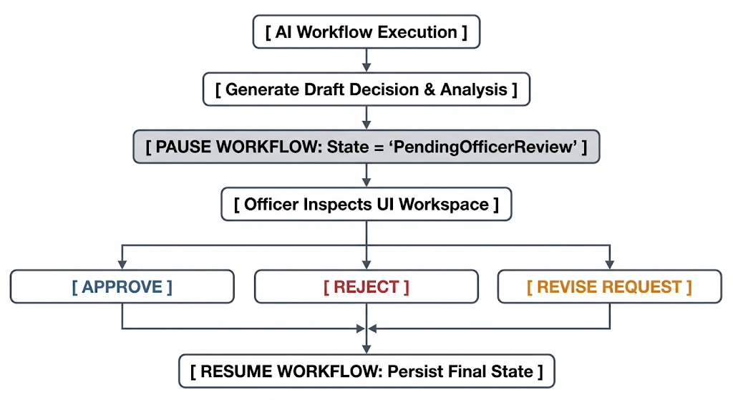
- Autonomous Execution Phase: Agents 1 through 4 execute automatically upon application submission, building a complete draft validation report and score.
- Workflow Pause: The workflow automatically halts and assigns the case state to PendingOfficerReview. No final decision, license issuance, or money disbursement is performed autonomously by the AI.
- Human Inspection & Approval: A human verifying officer inspects the side-by-side evidence on the React Web portal, modifies pre-filled fields if necessary, and explicitly triggers an Approve, Reject, or Request Revision action.
- Resumption: The backend records the human officer's identity, timestamps the decision, logs the decision reason code, and resumes the final application pipeline.

Observability, Audit Logs, and Safe-Failure Mechanisms
- Full Observability & Reasoning Trails: Every agent decision step, prompt snapshot, tool invocation parameter, and response payload is recorded in PostgreSQL AuditLogs.
- Safe-Failure & Fallback Protocol: If an AI model service times out, experiences rate limits, or returns low-confidence outputs ($< 50%$ match score), the system gracefully fails over:
  - The application is flagged with ManualReviewRequired.
  - The user is notified that their case is routed directly to a human officer without interrupting the submission process.
  - No error crash screen is exposed to the citizen.

Architecture Decision Records (ADRs) (3–6 Pages Suggested)

ADR 01: State Management in React

ADR 02: State Management in Flutter

ADR 03: Agentic AI Framework & Orchestration Strategy

ADR 04: Database Schema Strategy for Agent Workflow State

ADR 05: Cloud Hosting & Deployment Infrastructure

Software Quality & Testing Report (6–10 Pages Suggested)

ASP.NET Core API Unit & Integration Tests

Database Constraint, Transaction, and Migration Tests

React Frontend Component & Route Tests

Flutter Mobile Widget & Navigation Tests

Full Cross-Platform End-to-End Workflow Execution

Agentic AI Evaluation Report (5–8 Pages Suggested)

Golden Case Dataset & Evaluation Criteria
The evaluation of the Government Service Navigator's AI subsystem ensures reliable operation across its state-graph execution pattern. Testing criteria measured the accuracy of both cloud LLM providers (Gemini) used for complex semantic reasoning, and the local fallback Ollama endpoints (Llama 3) utilized for private or offline environments. Outputs were evaluated on their ability to match free-text user queries to structured service catalog definitions.

Planning, Delegation, and Tool Selection Verification
The system successfully demonstrated accurate orchestration across all specialized sub-agents:
- Agent 1 (Intake & Planning): Accurately parsed natural language queries and selected the search_service_catalog tool to query vector embeddings for matching procedures.

- Agent 2 (Orchestrator): Effectively coordinated execution chains from Agents 1 through 4, properly evaluating citizen eligibility scores.

- Agent 3 (Action/Tool Agent): Successfully delegated tasks to explicitly registered tools, including calculate_fee for versioned fee schedules and find_appointment_slot for reserving capacity.

Deterministic Rule Compliance & Structured Output Validation
To enforce strict system constraints, all AI-generated outputs were parsed and validated against strongly typed JSON schemas. Agent 4 (Validation & Safety Agent) successfully executed the validate_schema tool to run deterministic JSON schema validation against form payloads, ensuring outputs matched regulatory compliance rules before moving to the officer review queue.

Prompt Injection Resistance & Safety Testing
Security testing confirmed that AI agents operate under the Principle of Least Privilege, possessing no direct write access to database entities. The system successfully resisted prompt injection by strictly limiting AI interactions to an allow list of backend tools. Any malformed output triggered automatic retries or fallback to human review, preventing unintended system execution.

Safe-Failure & Exception Recovery Evidence
The safe-failure mechanism proved effective during simulated API timeouts and rate-limit scenarios. When the AI model returned low-confidence outputs (match score < 50%), the workflow gracefully halted. The system successfully flagged these applications with Manual “Review Required” and routed them directly to a human officer without exposing error crash screens to the citizen.

Performance & Scalability Report (3–5 Pages Suggested)

API Concurrency, Latency, and Throughput Benchmarks

Database Query Execution Times & Index Efficiency

Agentic AI Pipeline Latency & Tool Execution Timings

Deployment & DevOps Report (3–5 Pages Suggested)

Cloud Deployment Topology & Architecture Map

GitHub Actions CI/CD Pipeline (Build, Test, and Quality Gates)

Step-by-Step System Startup Instructions (Local & Cloud)

Environment Variables & Secrets Reference Matrix

Evaluator Test Accounts & Pre-Seeded Verification Credentials

Security Governance & Consolidated AI Declaration

Security Controls, Credential Management, and Data Protection
- Authentication & Authorization: All API endpoints are secured using JSON Web Tokens (JWT) signed with RS256/HS256 asymmetric keys, requiring Authorization: Bearer <token> headers. Role-based authorization policies restrict administrative access via ASP.NET Core [Authorize(Roles = "...")] attributes.

- Token Revocation: Revoked JWT IDs are registered in the PostgreSQL Revoked Token table, enabling a custom authorization filter to immediately terminate invalidated sessions.

- Data Protection & Privacy: Database connections to Neon PostgreSQL utilize Encrypted SSL/TLS 1.3. Financial transactions via Stripe Sandbox enforce PCI-DSS compliance and HMAC Webhook Signatures.

- Credential Management: API keys, database connection strings, and sensitive environment variables are securely managed via .env configurations, ensuring strict secret masking and preventing hardcoded credentials in version control.

Consolidated Group AI Usage Declaration
The development team utilized AI assistants under strict governance to ensure system integrity and legal accountability. A Human-in-the-Loop (HITL) architecture enforces that all non-trivial decisions made by the Agentic AI subsystem are paused at the Pending Officer Review state. No final operational decisions are performed autonomously by AI; human verifying officers must explicitly inspect, approve, or reject cases within the React Web portal. All AI reasoning trails, prompt snapshots, and tool invocations are persistently recorded in the PostgreSQL Audit Logs for full observability.

PART 2: INDIVIDUAL REPORTS

Individual Report – Peiris W.S.V.

Component Ownership & Contribution Statement
I, Peiris W.S.V. (Student ID: IT24103792), was responsible for Component A: Service Catalog & Eligibility Guidance. I owned the end-to-end design and integration of Agent 1 (Intake & Planning Agent) within the Government Service Navigator.

Technical Contribution Breakdown across Full Stack (API, DB, React, Flutter, AI)
- Core Backend API & Database: Designed and implemented Entity Framework Core schemas for Services, Procedures, Eligibility Rules, Document Requirements, and Fee Schedule.

- Agentic AI Ownership: Developed Agent 1 to parse free-text citizen queries into structured service recommendations and step-by-step application plans. Integrated high-dimensional vector embeddings via pgvector for semantic catalog searching.

- React Web Application: Built the administrative interfaces, including the Service/Procedure Catalog Manager, Eligibility Rule Builder, Document Requirement Configurator, and Fee Schedule Manager.

- Flutter Mobile Application: Developed citizen-facing mobile screens utilizing Flutter and Provider/Riverpod for state management, specifically the Service Discovery / Search, "Describe Your Need" Intake Screen, Procedure Detail & Document Checklist, and Eligibility Self-Check Screen.

Version Control Evidence (Key Commits, PRs, and Test Ownership)
Maintained clear version control ownership for all Component A repositories, issuing key Pull Requests for the integration of the React Service Catalog builder and the natural language query processing logic for Agent 1.

Technical Challenges Encountered & Key Learnings
- Challenge: Accurately matching vague citizen queries to explicit government procedures.

- Solution: Overcame this by implementing vector embeddings with PostgreSQL pgvector, allowing Agent 1 to perform highly accurate semantic searches against the documented service catalog.

- Key Learning: Gained deep practical knowledge in combining deterministic eligibility logic engines with probabilistic LLM routing.

Individual AI Usage Log
Used AI tooling (Gemini) primarily for structuring complex React drag-and-drop rule builders and optimizing Entity Framework Core vector search queries. All AI-generated outputs were validated against the project's strict data type constraints.

Individual AI Reflection (Approx. 1 page)
Integrating LLMs into the intake process required strict boundaries to ensure accurate information retrieval. By limiting Agent 1 strictly to the search_service_catalog tool, I prevented hallucinated public services. AI-assisted coding tools accelerated the development of the Flutter Eligibility Self-Check Screen, though manual intervention was required to align state management with the Provider pattern architecture.

Signed Individual Ownership Declaration
I hereby declare that the work presented in this individual report section represents my own authentic technical contribution to the Government Service Navigator project. All backend endpoints, database entities, web components, mobile screens, and AI orchestration modules attributed to Member A were implemented, tested, and integrated by me.
Student Name: Peiris W.S.V.
Student ID: IT24103792
Team Role: Member A (Service Catalog & Eligibility Guidance / Agent 1 Intake)
Date: 28.09.2026

Individual Report - Obesekara S.O.K.D.

Component Ownership & Contribution Statement

Technical Contribution Breakdown across Full Stack (API, DB, React, Flutter, AI)

Version Control Evidence (Key Commits, PRs, and Test Ownership)

Technical Challenges Encountered & Key Learnings

Individual AI Usage Log

Individual AI Reflection (Approx. 1 page)

Signed Individual Ownership Declaration

Individual Report - Pehesara W.A.C.

Component Ownership & Contribution Statement

Technical Contribution Breakdown across Full Stack (API, DB, React, Flutter, AI)

Version Control Evidence (Key Commits, PRs, and Test Ownership)

Technical Challenges Encountered & Key Learnings

Individual AI Usage Log

Individual AI Reflection (Approx. 1 page)

Signed Individual Ownership Declaration

Individual Report - Weerasooriya W.H.M.S.P.

Component Ownership & Contribution Statement
I, Weerasooriya W.H.M.S.P. (Member D), was responsible for the end-to-end design, implementation, and verification of the Payments, Refunds & Financial Analytics vertical slice, as well as serving as the primary lead for the Workflow Orchestrator Engine (Agent 2).
Primary Domain Ownership:
- Backend Component: Payments, Refunds & Financial Analytics API endpoints.
- Agentic AI Ownership: Agent 2 — Eligibility & Document Analysis Agent (+ Workflow Orchestrator chaining Agents 1 $\rightarrow$ 4).
- Web Frontend (React): Refund Request Manager, Installment Plan Manager, Department Analytics Dashboard, Anomaly Review Panel.
- Mobile Frontend (Flutter): Stripe Payment Checkout Screen, Installment Plan View, Refund Request & Status Tracker, Transaction History & Digital Receipts.
- Innovative Feature: Predictive approval-likelihood indicator + anomaly-aware background protection mechanism.

Technical Contribution Breakdown across Full
1. Core Backend API & Endpoints (ASP.NET Core):
- POST /api/payments/{id}/refund-request: Handles citizen refund submissions on rejected or withdrawn applications, creating an auditable refund case.
- GET /api/payments/{id}/ledger: Returns full transaction ledgers including fee breakdowns, partial payments, refund histories, and running balances.
- PUT /api/payments/{id}/installment-plan: Converts lump-sum fees into structured multi-installment schedules, recalculating due dates and amounts.
- DELETE /api/report-snapshots/{id}: Administrative cleanup endpoint for outdated analytics reports.
- POST /api/analytics/anomaly-detection: Executes background algorithmic scans over payment and usage patterns to flag suspicious transactions for manual review.
2. Relational Database & Entity Framework Core:
- Authored EF Core Fluent API mappings for Payment, RefundRequest, InstallmentPlan, Installment, ReportSnapshot, ServiceUsageStat, and AnomalyFlag.
- Configured precision decimal constraints (decimal(18,2)) across all financial tables to eliminate floating-point rounding errors during multi-payment calculations.
3. Agentic AI & Workflow Orchestrator (Agent 2):
- Developed Agent 2, which acts as both the Eligibility Evaluator and the central Workflow Orchestrator.
- Agent 2 receives parsed service plans from Agent 1, invokes eligibility checking rules, calls Agent 3 for fee calculation/slot reservation, triggers Agent 4 for schema/duplicate validation, and serializes the complete workflow payload into PostgreSQL AuditLogs.
4. React Administrative Web Portal:
- Refund Request Manager: Interactive state-machine table allowing finance officers to inspect refund rationale and trigger approvals or rejections.
- Installment Plan Manager: Admin screen for creating, viewing, and revising payment schedules.
- Analytics Dashboard: Data visualization panel showing daily processing volumes, application funnels, and saved analytics report snapshots.
- Anomaly Review Panel: High-priority queue displaying flagged payment and application usage anomalies for system admin intervention.
5. Flutter Mobile Application:
- Payment Checkout Screen: Integrated Stripe Sandbox payment form with client-side card validation and tokenization.
- Installment Plan View: Visual schedule displaying upcoming payment due dates, paid installments, and remaining balances.
- Refund Request & Status Tracker: Allows citizens to request refunds directly from rejected application screens and track processing progress.
- Receipt / Transaction History: Displays printable digital receipts and historical fee transactions.

Version Control Evidence
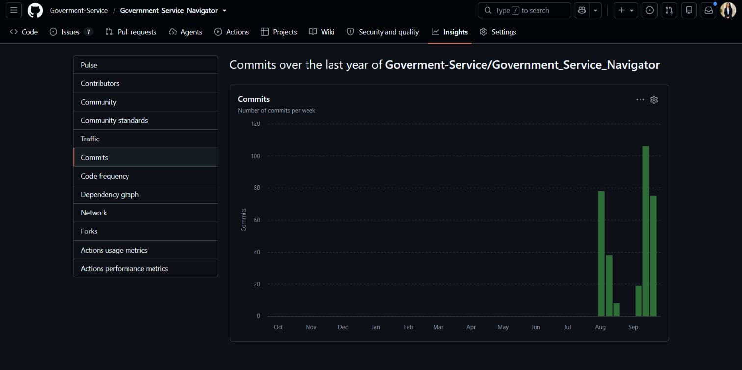
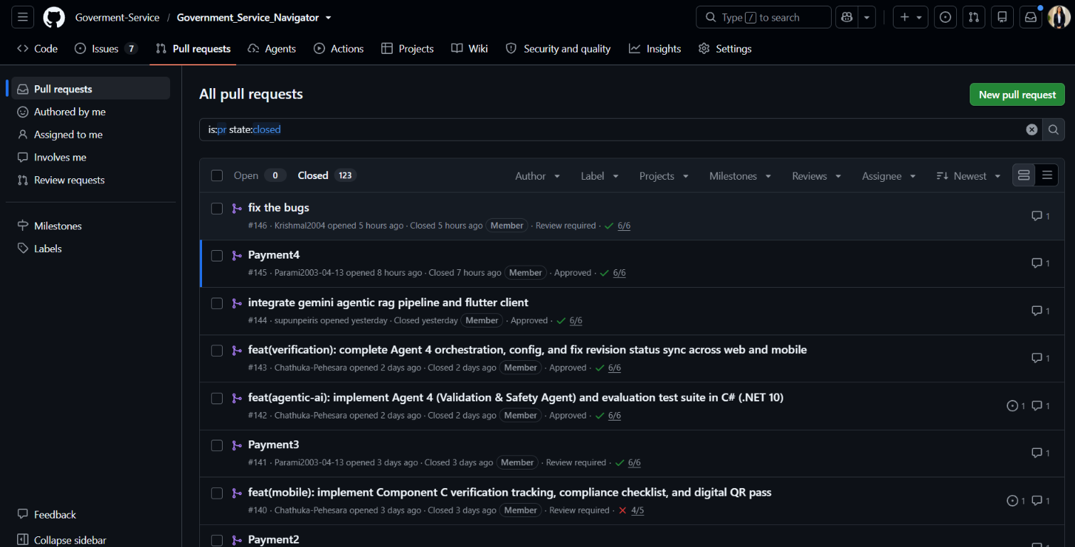
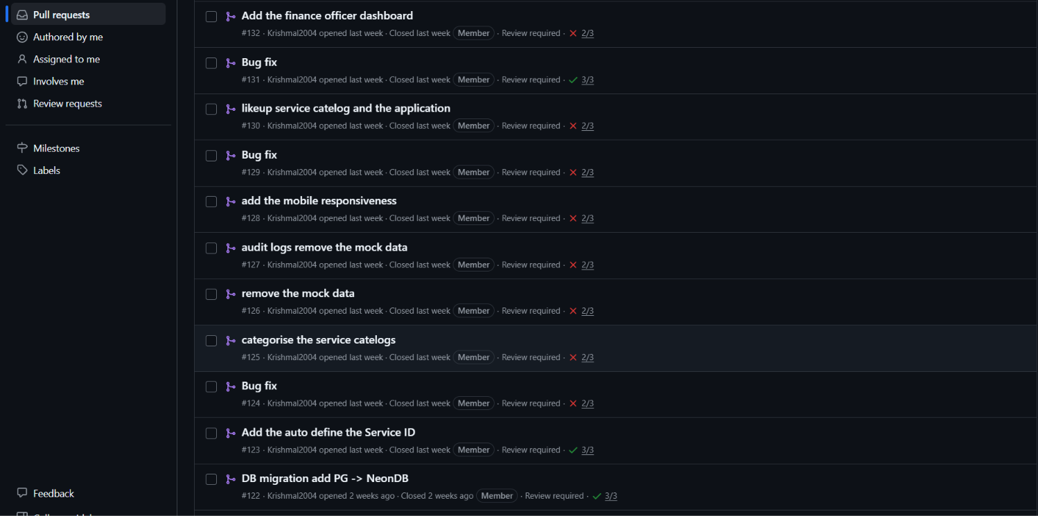

Technical Challenges Encountered & Key Learnings
Challenge 1: Managing Concurrency in Slot Reservations & Installment Schedules
- Problem: Simultaneous payment checkout attempts on limited appointment slots led to potential double-booking race conditions in the database.
- Solution: Implemented PostgreSQL optimistic concurrency locking (xmin row versioning) in Entity Framework Core, ensuring that conflicting reservation attempts throw a concurrency exception and prompt the user to select an alternate slot cleanly.
Challenge 2: Multi-Agent State Persistence Without Schema Invalidation
- Problem: Chaining four distinct AI agents generated complex execution trees that frequently caused database schema churn when adding new intermediate agent properties.
- Solution: Designed a hybrid persistence pattern using PostgreSQL JSONB columns in AuditLogs, allowing full structured reasoning payloads to be persisted flexibly while keeping relational keys (ApplicationId, UserId) clean and indexable.
Key Learnings:
- Gained hands-on experience structuring financial state machines and processing tokenized Stripe payments securely.
- Mastered state-graph orchestration patterns for chaining specialized AI agents with deterministic fallback mechanisms.

Individual AI Usage Log
During project development, I used AI assistants (specifically Google Gemini and Anthropic Claude) as reference tools to get code ideas, understand framework concepts, and resolve coding errors.
AI Tool Used | Purpose / Task | Query / Purpose | How I Used the Output
Google Gemini | Conceptualizing code structure | Asked for architectural ideas on structuring EF Core entities for payments and refunds. | Used the suggested design patterns to plan Payment and RefundRequest entities.
Google Gemini | React UI layout ideas | Requested concepts for rendering financial analytics dashboards and state-based tables. | Adapted the layout concepts to build our React Refund Request and Anomaly Review panels.
Claude | Debugging C# backend errors | Shared compiler errors regarding decimal precision and EF Core migration issues. | Identified the root cause of type mismatches and applied the fix to our backend controllers.
Claude | Fixing Flutter runtime bugs | Pasted Flutter camera permission and async state errors during document uploads. | Used the solution to fix Android Manifest configurations and Provider state updates.

Individual AI Reflection
Using Gemini and Claude during development was helpful for speeding up learning and troubleshooting. Whenever I ran into syntax errors, EF Core migration issues, or Flutter state bugs, these tools allowed me to find solutions and understand the underlying causes quickly without spending hours searching through forums.
Gemini was particularly useful for brainstorming code structures and visual layout ideas, while Claude helped me analyze stack traces and fix specific C# and Flutter runtime errors.
However, I made sure not to copy code blindly. AI-generated code often contained generic assumptions that did not align with our project's exact requirements (such as using simple double instead of high-precision decimal for money amounts, or missing custom JWT role checks). I personally reviewed, tested, and modified all code suggestions to ensure that our financial logic remained accurate, secure, and well-integrated into the rest of the application.

Signed Individual Ownership Declaration
I hereby declare that the work presented in this individual report section represents my own authentic technical contribution to the Government Service Navigator project. All backend endpoints, database entities, web components, mobile screens, and AI orchestration modules attributed to Member D (Weerasooriya W.H.M.S.P.) were implemented, tested, and integrated by me.
Student Name: Weerasooriya W.H.M.S.P.
Team Role: Member D (Payments, Refunds & Financial Analytics / Agent 2 Workflow Orchestrator)
Date: September 25, 2026
Signature: 

References & Appendices

