**Online Employee Management System**

**Group Number: SE/OOP/B10/G12**

**Batch: Y2.S1.10.1**

**Group Details:**

|  |  |  |
| --- | --- | --- |
|  | **Student Registration Number** | **Student Name** |
| **1** | **Sanduni Madara P.G** | **IT19392172** |
| **2** | **Nimsara S.J.J.C** | **IT19365374** |
| **3** | **Alaharuwan S.S** | **IT19754826** |

**Individual contribution: -**

|  |  |  |  |
| --- | --- | --- | --- |
|  | **Student Registration Number** | **Student Name** | **Individual contribution** |
| **1** | **Sanduni Madara P.G** | **IT19392172** |  |
| **2** | **Nimsara S.J.J.C** | **IT19365374** |  |
| **3** | **Alaharuwan S.S** | **IT19754826** |  |

**Nimsara S.J.J.C - IT19365374**

Use case scenario: -

|  |  |  |
| --- | --- | --- |
| **Use case ID** |  | |
| **Name** | Collect materials for the event | |
| **Priority** | 5 | |
| **Primary Actor(s)** | Designer | |
| **Pre-Conditions** | * Designer should be logged into the system. * Customer and the required event details should be added to the main system. | |
| **Post-Conditions** | * Customers should be able to process with their event they selected. | |
| **Secondary Actor(s)** | Store, organizer | |
| **Main Success Scenario** | **Step** | **Action** |
|  | 1 | Designer enters login credentials to the system. |
|  | 2 | System validate login credentials. |
|  | 3 | Enter to the designer Section and Click display confirmed event sent by the organizer. |
|  | 4 | System shows confirmed events to be designed. |
|  | 5 | Go to the design Management tab. |
|  | 6 | Create the Needed materials form by using event details. |
|  | 7 | System generates a re-check option to check the event details and needed materials form. |
|  | 8 | System asks administrative permissions to confirm for sending email to the store. |
|  | 9 | Send an email with the attachment of needed materials and customer details to the store. |
|  | 10 | Verified store Report is submitted to the system with needed payments mentioned. |
|  | 12 | Send the report to the organizer to get the approval and the payment from the customer for materials needed. |
|  | 13 | Get the payment from the organizer and send it to the store. |
|  | 14 | Receive items from the store. |
|  | 15 | Exit from the system. |
| **Extensions** | 1.a | If the designer enters incorrect username or password system shows error message and prompt re-enter credentials. |
|  | 7.a | If event details are correct, system will move on to the confirmation process. |
|  | 7.b | If event details are incorrect, need to provide details again. |
|  | 8.a | If the designer does not confirm the email as an administrative permission, System will cancel the process. |
|  | 8.b | System shows the needed materials detail form in the designer Interface. |
|  | 10.a | Store checks and verify the needed materials details form. |
|  | 10.b | Verified event report send to the designer with payment details needed to be processed. |
|  | 12.a | System will send a message to all employees to inform about notice. |

Sequence diagram: -

Communication diagram: -

**Sanduni Madara P.G - IT19392172**

Use case scenario: -

|  |  |
| --- | --- |
| Use case ID: | 02 |
| Use case Name: | Apply leave |
| Summary | Employee gives a leave request |
| Actors: | Employee |
| Priority |  |
| Pre-conditions | The employee must be a member and must be logged in to the system. |
| Post condition | The leave request is recorded in the database. |
| Main Scenario | 1. Employee logged in to the employee interface. 2. System displays the employee interface. 3. The leave request menu displayed on the system. 4. Checks the available leave details. 5. Checks the kinds of leave details. 6. The employee applies for leave and the form is displayed. 7. The employee first enters the leave apply date. 8. Then the reason for the leave will be entered. 9. The number of leave days are also being entered. 10. Then the employee assigns a member to his/her duty on that day. 11. Employee asks for the approval of the leave from the Head of the Department (HOD). 12. Click send button. 13. The leave request is sent successfully message is displayed. |
| Extensions | 4a) Employee must exist in the system.  6a) If the employee has already taken all the leaves for a month, the system informs that he/she can’t take a leave.  8a) If the HOD has not given the leave approval, leave is cancelled.  9a) If the employee does not fill the correct information in the form, an error message is displayed. |

Sequence diagram: -

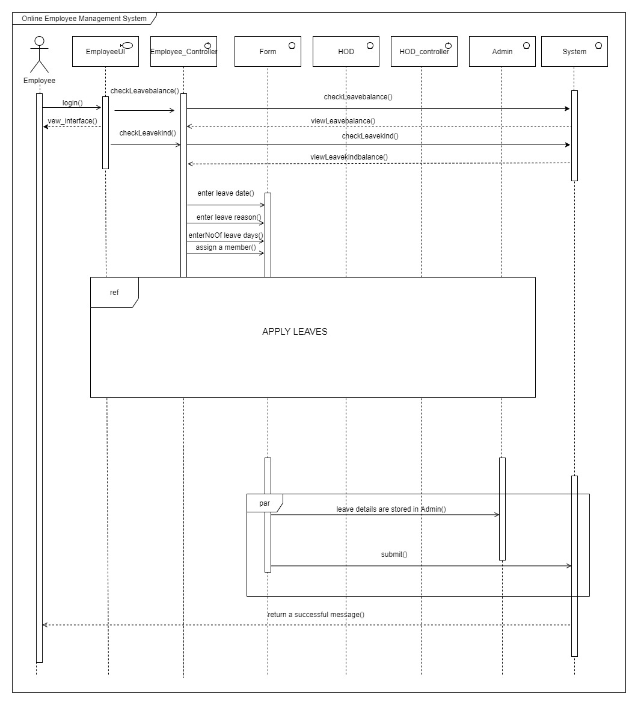

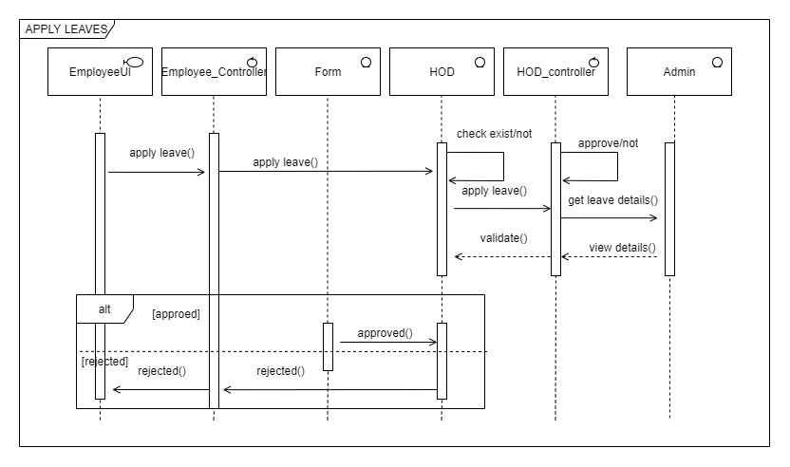

Communication diagram: -

Note: the ref part communication diagram is below

**Alaharuwan S.S - IT19754826**

Use case scenario: -

Sequence diagram: -

Communication diagram: -