//IT20133672

//C.D.Adhihetty

//Mid Assignment

“SATHNAAD20” musical show Organized by LEO CLUB of Mahanama College at College Main Auditorium. The main purpose of this show to earn **Profit** to the Leo Club to do next year Projects. (so, they didn’t care about count of attendance crowed and the seats of the auditorium)

All the costs of the Show recovered by “Show Tickets” and all the tickets are sold at the show night in Auditorium. The Seat types and Their ticket Prices are given in the following table

|  |  |  |
| --- | --- | --- |
| **Seat Type** | **Seat Name** | **Ticket Price (RS.)** |
| 1 | Front Seats | 2,000 |
| 2 | Back Seats | 1,500 |
| 3 | Balcony Seats | 1,000 |

Write a C program to get Income of the Musical Show by Entering Ticket Prices according to Seat Types. When the seat type is invalid, the program should display an error message.

Your program should display **Total Income** and if total income gets more than 10,000(RS.) display

“**WE MADE A PROFIT AS** **WE EXPECTED**”

#include <stdio.h>//include header file

int main(void)//begins main function

{

//declare variables

int totalIncome=0;

int seatType,qty;

int price,ticketPrice;

char ch ='Y';

while(ch=='Y'||ch=='y')//loop

{

printf("PLEASE ENTER THE SEAT TYPE(only 1,2,3):");

scanf(" %d", &seatType);//read a decimal integer

if(seatType==1|| seatType==2|| seatType==3)

{

//inputs and calculations

printf("PLEASE ENTER THE QUANTITY:");

scanf(" %d", &qty);//read a decimal integer

if(seatType==1)

ticketPrice=2000;

else if(seatType==2)

ticketPrice=1500;

else

ticketPrice=1000;

price =ticketPrice * qty;//calculation

printf("SEAT TYPE QUANTITY PRICE\n");

printf("%d %d %d\n",seatType,qty,price);

totalIncome =totalIncome + price;//calculation

}

else

printf("INVALID SEAT TYPE\n");

printf("Do YOU WANT MORE ENTIRES(Y/N):");

scanf("%*c%c", &ch);//read a character

}

printf("TOTAL INCOME EARN FROM THE SHOW = RS%d\n",totalIncome);//print total

if(totalIncome>10000)

printf("WE HAVE MADE A PROFIT AS WE EXPECTED\n");

else

printf("WE HAVEN'T MADE A PROFIT AS WE EXPECTED\n");

return 0;//end of main function

}

TEST CASE 1: When the Income gets More than RS 10,000

PLEASE ENTER THE SEAT TYPE(only 1,2,3):1

PLEASE ENTER THE QUANTITY:3

Do YOU WANT MORE ENTIRES(Y/N):y

PLEASE ENTER THE SEAT TYPE(only 1,2,3):2

PLEASE ENTER THE QUANTITY:2

Do YOU WANT MORE ENTIRES(Y/N):y

PLEASE ENTER THE SEAT TYPE(only 1,2,3):3

PLEASE ENTER THE QUANTITY:2

Do YOU WANT MORE ENTIRES(Y/N):n

TEST CASE 2: When the Income gets Less than RS 10,000

PLEASE ENTER THE SEAT TYPE(only 1,2,3):2

PLEASE ENTER THE QUANTITY:2

Do YOU WANT MORE ENTIRES(Y/N):y

PLEASE ENTER THE SEAT TYPE(only 1,2,3):1

PLEASE ENTER THE QUANTITY:2

Do YOU WANT MORE ENTIRES(Y/N):y

PLEASE ENTER THE SEAT TYPE(only 1,2,3):5

INVALID SEAT TYPE

PLEASE ENTER THE SEAT TYPE(only 1,2,3):n

Program output (Screen shot of the program output)

TEST CASE 1:

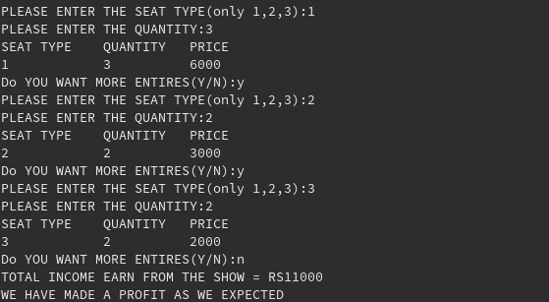

TEST CASE 2:

