Methodology

1.Dataset Description

This research uses a structured Sri Lankan flood risk dataset consisting of 25,000 records and 32 attributes. Each record represents a geographic location and includes environmental factors (rainfall, elevation, vegetation indices), geographic variables (latitude, longitude, distance to river), and infrastructure-related indicators (road quality, evacuation access, hospital distance, water/electricity availability). The dataset also contains a flood risk score and a measured inundation area, which were used as core variables for building the prediction and prioritization models.

The goal of using this dataset was to build a system that is realistic and applicable to Sri Lanka, where floods frequently affect both urban and rural communities.

2 Data Cleaning and Preprocessing

Before training any machine learning models, the dataset needed to be cleaned because real-world datasets often contain missing values and inconsistent entries. If missing values are not handled properly, machine learning models can make incorrect assumptions or fail during training.

Therefore, missing values were handled using two main approaches:

For numerical features (such as rainfall, elevation, population density), missing values were replaced using the median, because the median is more stable than the mean and is less affected by outliers.

For categorical features (such as district, soil type, electricity availability), missing values were replaced using the most frequent category (mode).

After filling missing values, the categorical features were converted into numerical form using one-hot encoding. This step is necessary because machine learning models cannot directly interpret text categories.

For models like Logistic Regression, the numerical values were scaled because Logistic Regression performs better when features are on similar ranges (for example rainfall values vs distance values).

Finally, the dataset was divided into training and testing sets using an 80:20 split, and stratification was used to ensure the flood and non-flood cases remained balanced in both sets. This ensures that evaluation results are fair and realistic.

3 Feature Engineering

Although the original dataset already contained many useful attributes, additional engineered features were created to make the prediction system more realistic and stronger. Feature engineering helps improve model accuracy and allows the system to capture deeper patterns.

The following engineered features were created:

Rain Ratio
This measures the intensity of recent rainfall compared to monthly rainfall. If a location experiences very high rainfall in a short time compared to average monthly rainfall, the flood risk increases.

River Risk
Flood risk increases when a location is closer to a river. Therefore, the inverse of distance to river was used so that closer areas automatically receive higher risk weight.

Exposure Index
Flood impact becomes worse in areas where there are more people and more built-up regions. So population density and built-up percentage were combined to represent exposure.

Vulnerability Index
Communities that are far from hospitals, far from evacuation centers, and have weak infrastructure tend to suffer more in floods. This combined factor was created to represent the vulnerability of the community.

These engineered features were important because floods are not caused by one factor alone. Instead, flood severity depends on a combination of natural conditions (rainfall, river distance) and social/infrastructure conditions (population, accessibility, infrastructure).

4 Flood Probability Classification

The first prediction task in this project is flood probability prediction. Here, the aim is to predict whether a flood is likely to occur in a location based on the input conditions.

This was modeled as a binary classification problem:

1 = Flood Occurred

0 = No Flood

Two machine learning classifiers were trained and compared:

Logistic Regression
Random Forest Classifier

Multiple evaluation metrics were used:

Accuracy
Precision
Recall
F1-score
ROC-AUC

Among these, Recall is especially important in flood prediction. This is because missing a real flood case (false negative) could delay warning and relief operations, putting communities at risk. Therefore, the best classifier was chosen not only based on accuracy but also on recall and ROC performance.

5 Inundation Area Prediction (Regression)

Flood occurrence alone is not enough to support relief planning. Authorities also need to understand how large and severe the flood impact might be. To support this, the second task predicts inundation area, which represents the flood magnitude.

This was treated as a regression problem, and two models were tested:

Linear Regression
Random Forest Regressor

Since inundation values vary widely (some floods affect small areas while others cover large areas), the target values were trained in log-space. Log transformation reduces the effect of very large outliers and improves prediction stability.

Regression evaluation was performed using:

MAE (Mean Absolute Error)
RMSE (Root Mean Squared Error)
R² score

This regression output is later used as an input when calculating relief priority.

6 Relief Priority Recommendation System

The most important contribution of this research is the Relief Priority Recommendation module. The goal is not only to predict floods, but also to support the question:

“Which areas should receive help first?”

This module calculates a relief priority score for each location based on:

flood probability (from classification model)
predicted inundation magnitude (from regression model)

exposure and vulnerability indicators such as population density, infrastructure readiness, hospital distance, and evacuation access.

The score assigns each location into:

High priority
Medium priority
Low priority

This makes the system practically useful because disaster response teams often have limited resources, so they must prioritize high-urgency areas first.

In addition, location scores were aggregated at the district level to generate a district-level ranking. This is more useful for government planning since most relief decisions are done at district-scale.

7 Explainability

In real-world disaster management, simply giving predictions is not enough. Decision makers need to understand why a location is predicted as high-risk. For this reason, explainability was included through feature importance analysis.

Logistic Regression coefficients were extracted and ranked to identify which variables have the strongest influence on the model’s prediction. This makes the system more transparent and improves trust because authorities can understand whether the model is focusing on realistic factors such as rainfall patterns, flood risk score, infrastructure quality, and geographic characteristics.

Results and Discussion

This section presents the results obtained from the flood probability classification model, inundation area regression model, explainability analysis, and relief priority recommendation module. The main objective of the system is not only to predict flood risk but also to support decision-making by identifying which districts and locations should receive relief first.

1: Confusion Matrix of Flood Occurrence Classification Model
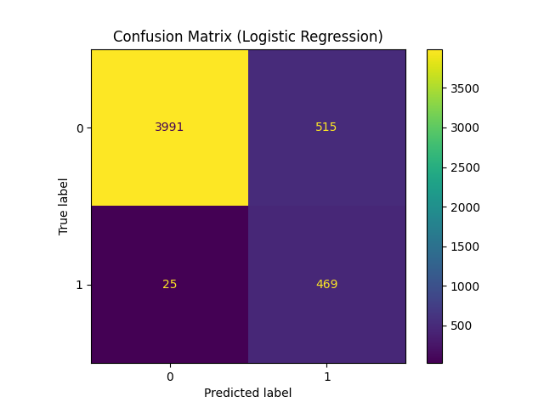
Figure 1 shows the confusion matrix of the selected flood occurrence classifier (Logistic Regression). The matrix indicates that the model correctly predicted a high number of non-flood cases (true negatives) and flood cases (true positives), meaning that it learned clear distinctions between flood-prone and non-flood conditions. A moderate number of false positives were observed, which means the model sometimes predicts flood risk even when a flood may not occur. However, in disaster management, false positives are generally acceptable because giving extra warnings is safer than failing to detect an actual flood event. More importantly, the model produced a low number of false negatives, meaning it rarely misses true flood cases. This makes the classifier reliable for early warning and relief planning, where the cost of missing a flood event can be high.

2: ROC Curve and AUC Score for Flood Occurrence Prediction

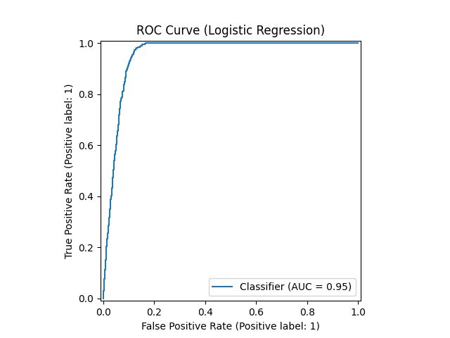
Figure 2 presents the ROC curve of the flood occurrence prediction model and shows a high AUC value (approximately 0.95), which reflects strong classification performance. AUC measures how well the model separates flood and non-flood conditions across different thresholds. The high AUC indicates that the model can consistently distinguish flood-prone areas from safer areas using the provided environmental and infrastructure indicators. This supports the practical use of the system because it shows that the classifier does not depend only on one variable such as rainfall, but successfully combines multiple real-world inputs to estimate flood probability. In an emergency decision-support context, a strong ROC-AUC result increases confidence that flood alerts and priority recommendations are based on meaningful predictions.

3: Actual vs Predicted Inundation Area (Regression Module)
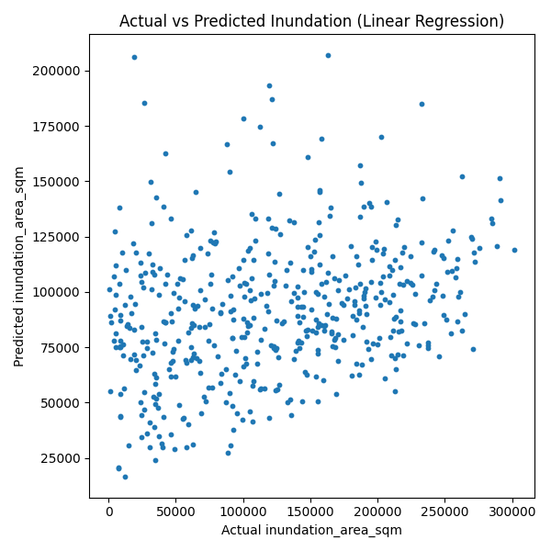

Figure 3 compares the predicted inundation area values against the actual observed inundation area values. The scatter plot demonstrates that while predictions generally follow the trend of the actual values, there is visible dispersion, especially at high inundation ranges. This suggests that predicting the exact flood impact area is more challenging than predicting flood occurrence. Flood inundation is influenced by complex factors that are difficult to fully capture, such as real-time river overflow dynamics, local drainage patterns, and unrecorded infrastructure variations. Although the regression performance shows limitations (low R²), the predictions still provide useful approximate estimates for ranking areas by expected impact. In this system, the regression output is not used alone; instead it is combined with flood probability and vulnerability indicators, which allows the prioritization module to remain meaningful even when inundation estimates contain uncertainty.

4: Top 15 Coefficients / Feature Importance (Model Explainability)
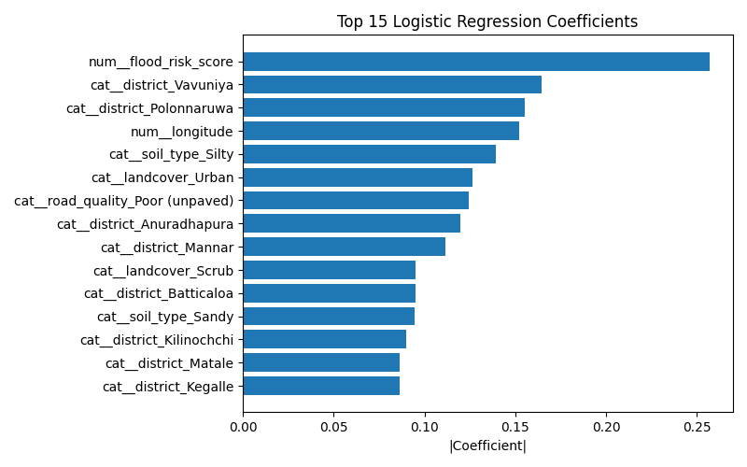

Figure 4 highlights the most influential features in the flood occurrence model using coefficient-based explainability. The results indicate that flood risk score and location-related features (such as district and longitude indicators) contribute strongly to prediction outcomes. Environmental factors such as landcover type and soil conditions also appear important, suggesting that flood vulnerability is influenced by ground-level features and not only rainfall. Infrastructure-related factors like road quality also contribute, reflecting the real-world impact of human development on flood conditions. This explainability output is valuable because it increases trust in the system: authorities and stakeholders can understand why a location is classified as flood-prone, rather than receiving only a black-box prediction. In real disaster response planning, interpretability improves the credibility and acceptability of machine learning systems.

5: Relief Priority Score Distribution Map (Sri Lanka)
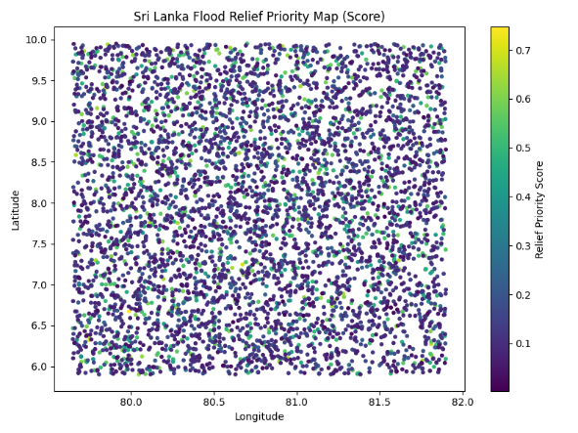

Figure 5 visualizes relief priority scores across Sri Lanka by plotting locations geographically and coloring them based on urgency. Locations with higher scores represent areas predicted to experience floods with higher probability and greater expected impact, combined with exposure and vulnerability. This map is one of the most important research outputs because it provides a clear visual representation of “where help is needed first.” Instead of reading long tables, decision-makers can identify high-risk clusters and focus on urgent zones quickly. The visualization supports real-world emergency usage because relief planning often depends on fast interpretation, especially during extreme rainfall periods. The map demonstrates that the system can translate machine learning predictions into actionable spatial insights.

6: Top 10 Districts by Average Relief Priority Score

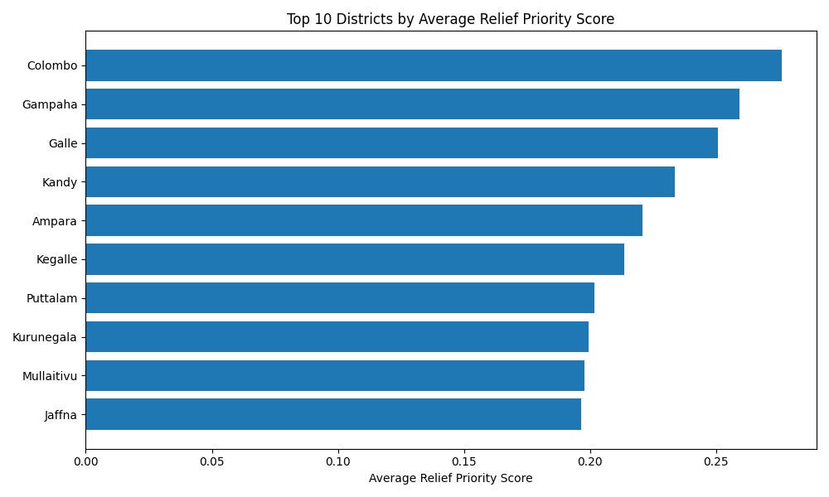

Figure 6 presents the top 10 districts ranked by their average relief priority score. This result is important because in real disaster response, resource allocation is usually planned at district level rather than individual points. The ranking highlights districts such as Colombo, Gampaha, and Galle as highly urgent, which aligns with expectations because these districts contain dense populations and significant infrastructure exposure. At the same time, districts such as Ampara also appear frequently, suggesting that both high-exposure urban zones and flood-prone regions require urgent attention. This district-level ranking improves the practical value of the system because it can directly support government and disaster-management agencies in allocating limited shelters, medical teams, and relief supplies.

7: District-wise Flood Relief Priority Map (Average Score)

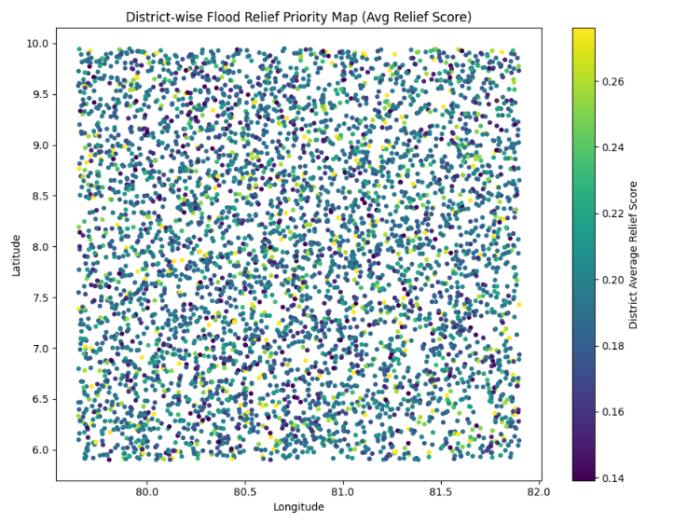
Figure 7 shows the district-wise relief priority map based on average relief score values. Compared to point-level maps, this visualization provides a simplified national summary that is easier for policy-makers to interpret. It highlights how flood urgency varies geographically across Sri Lanka and helps identify which regions are consistently at higher risk. This is particularly useful when planning preparedness strategies before the monsoon season. The district map emphasizes that flood risk is not evenly distributed and that national planning should prioritize districts with high average relief scores. This output strengthens the contribution of the research by providing a clearer decision-support tool rather than only a prediction model.

8: District Priority Category Map (Low / Medium / High)
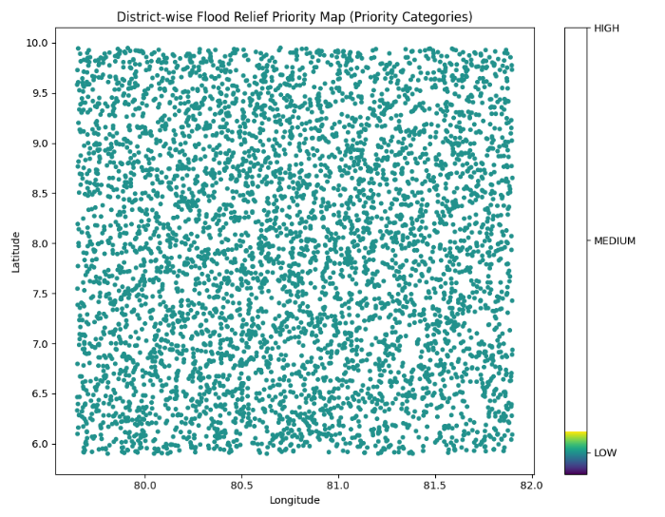

Figure 8 categorizes districts into low, medium, and high priority groups using relief priority score thresholds. This figure improves interpretability because categories such as “High Priority” are easier to understand than numerical scores alone, especially for non-technical stakeholders. The categorization allows authorities to quickly identify where emergency response must be immediate and where monitoring may be sufficient. This also supports realistic resource planning, where relief teams can assign shelters and medical teams to “High Priority” zones first, while medium and low priority districts receive follow-up support. Therefore, the category map directly supports the goal of this research: improving decision-making and reducing delay in flood relief distribution.

Overall, the results demonstrate that the proposed system successfully combines flood probability prediction, impact magnitude estimation, explainability, and relief prioritization into a single decision-support framework. The classification model provides reliable flood detection capability, the regression model contributes approximate flood impact estimation, and the relief scoring mechanism converts these predictions into a meaningful priority ranking for disaster response. The maps and district summaries make the system practically usable for Sri Lankan authorities by showing where relief must be directed first, which supports faster recovery and reduced flood-related suffering.

Conclusion

Floods remain one of the most frequent and damaging natural disasters in Sri Lanka, often causing major disruption to communities and creating challenges in relief distribution. A key issue during flood events is that authorities often struggle to identify which areas should receive assistance first, especially when resources such as shelters, medical teams, and food supplies are limited. This research addressed that problem by proposing a machine learning–based flood impact prediction and relief priority recommendation system.

The developed system successfully integrates multiple components into a single decision-support framework. First, a flood occurrence prediction model was trained to estimate the probability of flooding using environmental, geographic, and infrastructure-related features. Evaluation results showed strong performance, with high recall and ROC-AUC, indicating that the model is highly sensitive in identifying flood-prone locations. This is particularly important for disaster management because missing a true flood event can result in delayed response and increased human suffering.

Secondly, a regression-based module was developed to estimate flood impact magnitude by predicting inundation area. Although inundation prediction remains challenging due to the complex and uncertain nature of flood behaviour, the model still provided useful approximate estimates that support impact ranking. Most importantly, the regression output was not used alone; instead, it was combined with flood probability and vulnerability indicators to strengthen prioritization decisions.

The major contribution of this research is the relief priority recommendation module. By combining predicted flood probability, predicted inundation impact, population exposure, and infrastructure vulnerability, the system generated relief priority scores for locations and districts. The final outputs—including ranked district lists and spatial maps—demonstrated that the system can effectively highlight urgent zones requiring immediate relief support. These results show that machine learning can be transformed into practical decision-making tools, rather than remaining as only prediction models. Therefore, the proposed approach can assist disaster response teams in Sri Lanka to allocate resources more efficiently and reduce delays in recovery and relief distribution.

Future Work

While the proposed system achieved strong results and demonstrates real-world potential, several improvements can further enhance reliability and practical usability.

Integration of Real-Time Data Sources
In future work, the system can be enhanced by integrating real-time rainfall and weather forecasts using APIs (such as OpenWeatherMap, Meteostat, or satellite rainfall datasets). This would allow the model to provide live flood risk predictions rather than relying only on historical dataset values.

Use of High-Resolution Geographic and Hydrological Data
Flood behavior is strongly influenced by terrain slope, river networks, drainage flow, and soil absorption capacity. Future versions of the system can include higher-resolution digital elevation models (DEMs), river basin boundaries, and land gradient features, which may improve inundation prediction accuracy.

Improved Regression Impact Modeling
Since inundation prediction showed lower R² values due to complex flood dynamics, future work could test advanced regression models such as Gradient Boosting Regression, XGBoost, or deep learning methods. Additionally, integrating satellite-derived flood extent data could improve target label accuracy.

More Realistic Relief Allocation under Constraints
Although this research already includes relief ranking, future versions can incorporate full optimization strategies, such as using linear programming or reinforcement learning to allocate limited shelters, medical teams, and food supplies more efficiently across districts.

Field Validation with Historical Flood Records
The system can be strengthened by validating results against real flood events in Sri Lanka (e.g., disasters in Colombo, Ratnapura, Ampara, and Kalutara). Comparing predicted priority zones with actual affected areas would increase the trustworthiness of the model and demonstrate practical performance.

Deployment for Government Use and Mobile Accessibility
Future development could include a fully deployed web dashboard connected to GIS systems, along with a mobile-friendly interface for disaster response officers. Alerts and notifications (SMS/email) could also be integrated so that high-risk predictions automatically trigger warning systems.

Streamlit Dashboard Implementation

To ensure the proposed flood prediction and relief prioritization system can be used in real-world disaster response settings, the final models were deployed using an interactive web-based dashboard developed with the Streamlit framework. The dashboard acts as a decision-support tool where users can upload a new dataset containing location-level flood-related attributes.

After uploading the dataset, the system automatically preprocesses the data by handling missing values and ensuring compatibility with the trained models. First, a classification model predicts the probability of flood occurrence for each location. Next, for locations that exceed a selected flood probability threshold, the regression model estimates the expected inundation area.

Using flood probability, predicted inundation impact, and vulnerability indicators such as population density, infrastructure score, hospital distance, and evacuation access, the dashboard calculates a relief priority score. Each location is then categorized into low, medium, or high priority.

The dashboard also provides district-level summaries, top priority location rankings, and visual maps showing relief urgency distribution across Sri Lanka. Finally, users can download the full predicted results as a CSV file for reporting and relief planning purposes. This deployment demonstrates that the proposed system goes beyond prediction and provides an actionable tool for prioritizing relief distribution under resource constraints.

