CO223 : LABORATORY SESSION 4

GAMAGE C.T.N.

E/13/107

GROUP 05

SEMESTER 3

18/04/2016

**Layered Architectures: Addressing, Encapsulation, and Layers Working Together II**

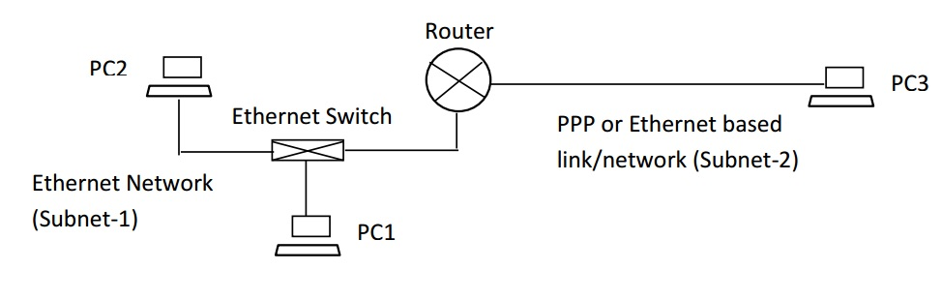

The IP and MAC addresses were determined and the connection was checked using the commands ipconfig , tracert,ipconfig/all , arp –a . The below table contains the obtained data.

|  |  |
| --- | --- |
| PC 1 | IP : 192.168.2.2 |
| MAC : 00-16-35-66-70-DE |
| PC 2 | IP : 192.168.2.3 |
| MAC : 00-16-35-66-56-05 |
| PC 3 | IP : 192.168.3.2 |
| MAC : 00-16-35-66-72-31 |
| Router | IP : 192.168.2.1 ( Router-NIC-1) |
| MAC : D0-7E-28-DE-71-81 |
| IP : 192.168.3.1 (Router-NIC-2) |
| MAC : 33-33-00-00-00-0C |

Then the routing table of the PC 2 was obtained by the command netstat –r. The result is shown below.

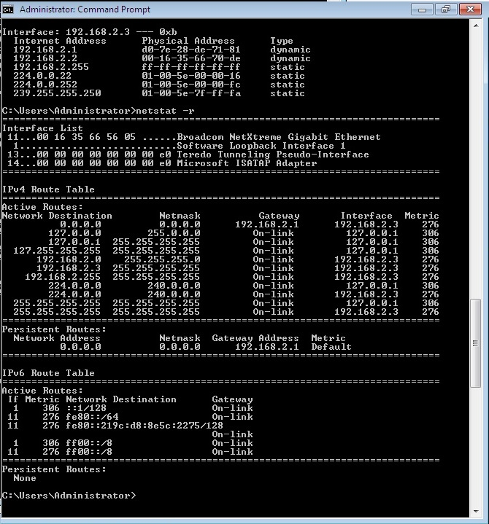

The routing table of the router was obtained by the PC which the console is connected (PC2) using the “Tera-Term” software and the command “display ip routing-table”.

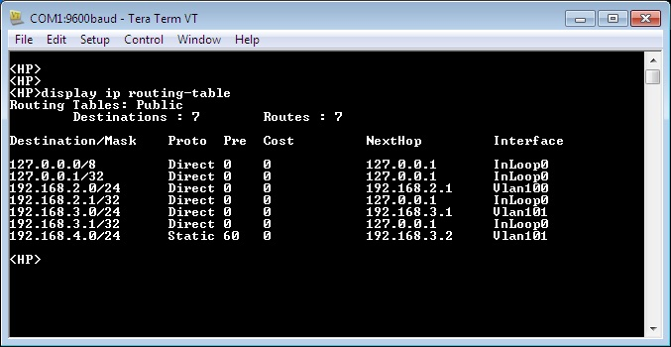

**Part-1: Transmission through different/many physical networks: Layers working together**

**Sending a packet from PC2 to PC3**

a.

1. Using the ping tool the frames were sent from PC2 to PC3. Using the Wireshark at PC2 and PC3 the frames sent and received were captured.

**At PC 2**

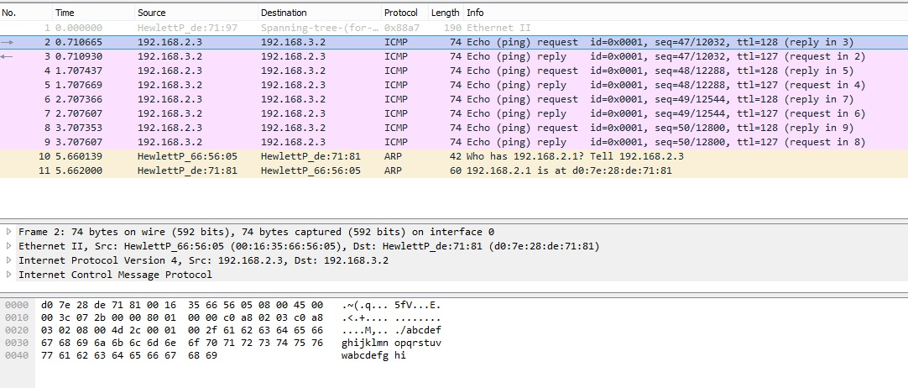

**AT PC 3**

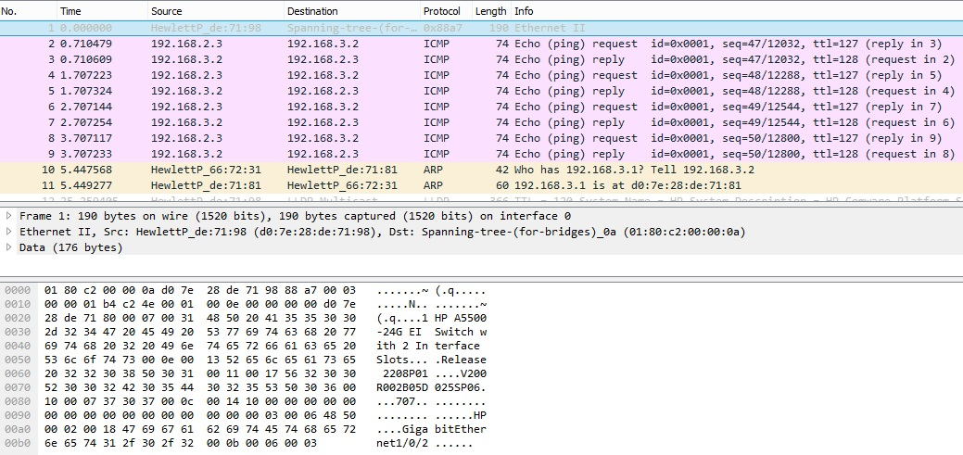

By analyzing the above records it is clear that PC2 has sent 4 requests and it has received 4reply’s from the PC 3.

2. Let’s select the frame number 4 in the Wireshark records in PC 2 which is sent as a request to the PC 3

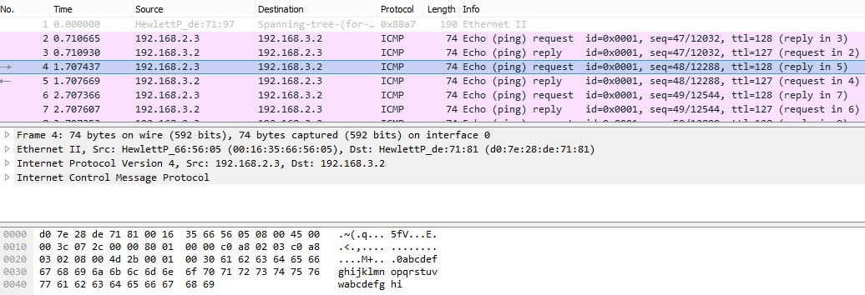

b.

1. Source IP :192.168.2.3

Destination IP : 192.168.3.2

2. The packets formed have the IP addresses of the source and destination. The routing table at the PC2 indicates that the packet should be sent to the router, hence it is encapsulated in the Ethernet frame with the MAC addresses of the source and destination. Then the Ethernet frame is broadcasted by the PC 2’s NIC and it is captured by the routers NIC.

3. Source MAC : 00-16-35-66-56-05

Destination MAC : D0-7E-28-DE-71-81

4.

|  |  |
| --- | --- |
| IP addresses | MAC addresses |
| Source IP address: PC 2  Destination IP address: PC3 | Source MAC address : PC2  Destination MAC address : Router-NIC-1 |

5.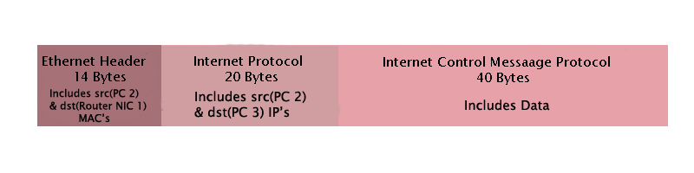

C .When the frame is sent by PC2 and received by the router the Router-NIC-1 examines the protocol type field and passes the packet to router’s IP layer. There the IP layer analyzes the packet and obtain the data of the destination address and finds that the packet should be routed to the PC 3

D. When a packet is received by the router it checks all the destination entries of the routing table of the router to find the destination IP address. Here after it examines the ip packets destination address it finds that PC 3 is directly connected via Ethernet link. The IP packet is encapsulated with Ethernet frame and sent to the PC 3.

E. 1.

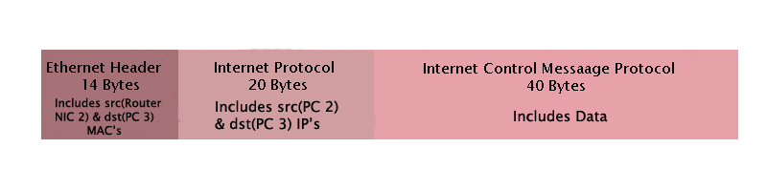

2.

|  |  |
| --- | --- |
| IP addresses | MAC addresses |
| Source IP address: PC 2  Destination IP address: PC3 | Source MAC address : Router-NIC-1  Destination MAC address : PC 3 |

F. The corresponding frame to which was sent from PC 2 to PC 3 is the frame number 4 in the trace file of PC3. The selected frame is shown below.

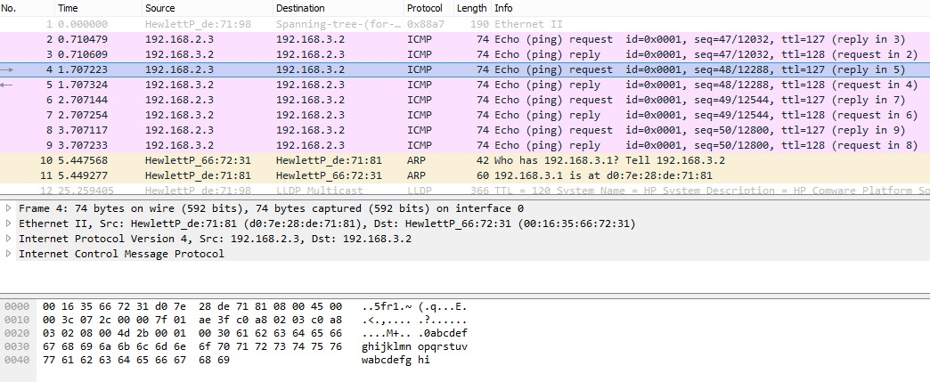

2. The IP addresses and MAC address are same as the ones which are mentioned in the above table. Therefore it is confirmed that the packet sent from the PC2 is correctly received by the PC 3

G.

When we compare the two tables above we can see that the same source and destination IP address are there. Hence the packet is sending from the PC2 to PC3 it the source and destination addresses are stored in the packets accordingly irrespective of the router in between. Hence the router is acting as the connecting device between the 2 physical layers the 2 MAC addresses of the router gateways are used for the routing of the packets.

The Ethernet layer, the internet protocol layer, internet control message protocol layer are working together in this PC 2 to PC 3 transmission. The IP packet has the source and destination address and it is encapsulated with the Ethernet frame with those addresses. It is broadcasted by the PC 2’s NIC and then captured by the routers NIC. After processing the NIC submits the packet for its IP layer. There it determines that the packet should be routed to the PC 3. Then it is encapsulated in the Ethernet frame and sent to the PC3 with the help of the routing tables and there it is accepted by the IP layer of the PC 3.

H. The data transmission in the internet is also done through the TCP/IP protocols following the layered architectures. Emails, web pages media and everything passes in the internet in the form of packets as seen above. There are layers as application, transport, internet and network interface in which a packet exchanges in the internet passes through. In this model every layer provides its service providing specific tasks in that layer with the help of the layer below it. In those layers they follow different protocols and different encapsulations.

**Part-2: Application processes**

**Web surfing: PC2 (Web-client) and PC3 (Web-server)**

A.

A web request is sent from PC2 to PC3 and the web contents were downloaded from PC3 (server). Using the Wireshark at PC2 and PC3 the frames sent and received were captured.

**At PC 2**

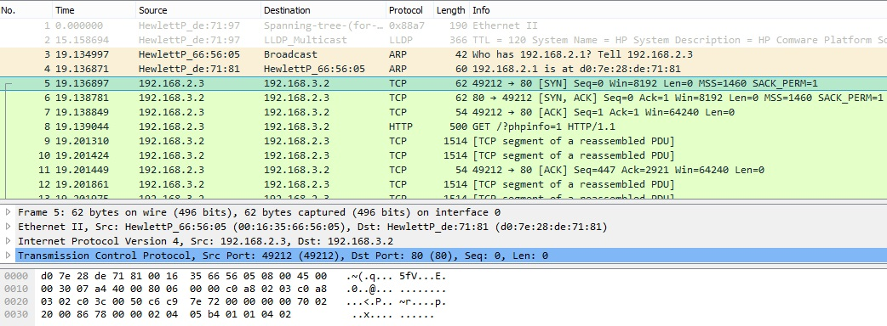

**At PC 3**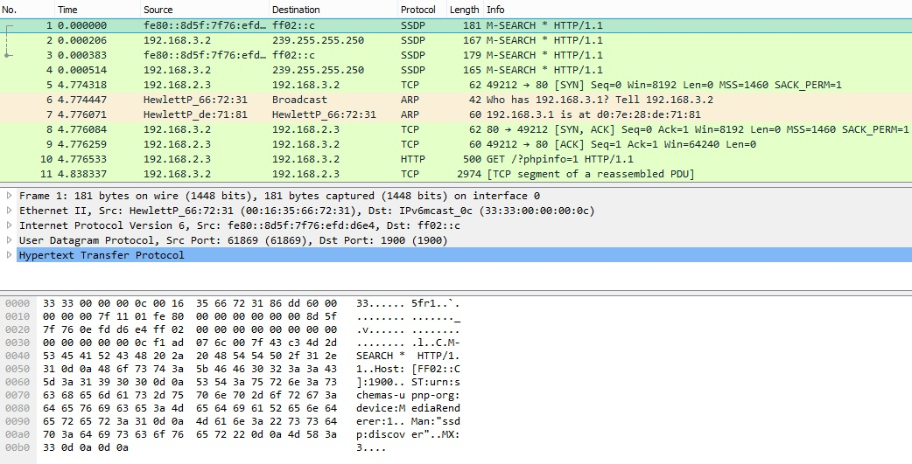

B.

From the trace file ‘CO223_Lab4_2a _PC3’, the frame associated with the ‘HTTP request’ received from PC2 is shown below.

1. 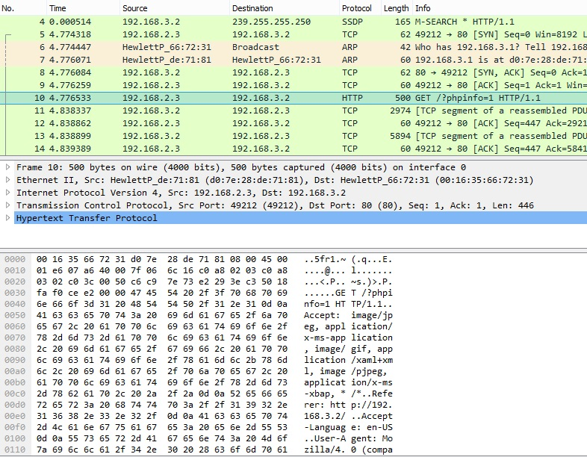

The http request can be specified from the http encapsulation seen from the frame selected.

2. The transport layer (transmission control protocol) header information.

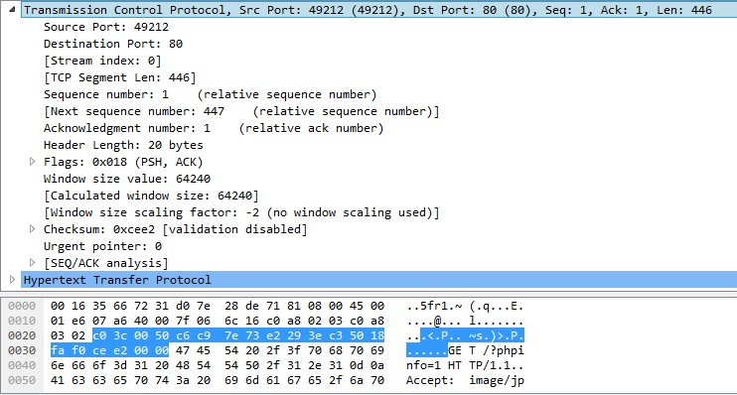

Transport Layer protocol is the TCP protocol.

The source port number is : 49212 . The source port is helping to keep data about the new incoming connections and existing connections by identifying the specific process, and also it is used to reply to the correct session started by the 2nd side.

The destination port number is : 80. From this port number the host identify the socket to which the service should supplied . This port number 80 uses the http protocol.

3. The Network layer header information

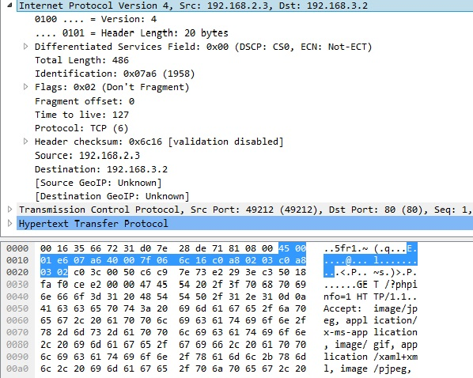 Network layer protocol: Internet Protocol

Protocol type: Internet Protocol Version 4

Source IP address: PC 2’s IP address

Destination IP address: PC 3’s IP address

4. Link layer header information: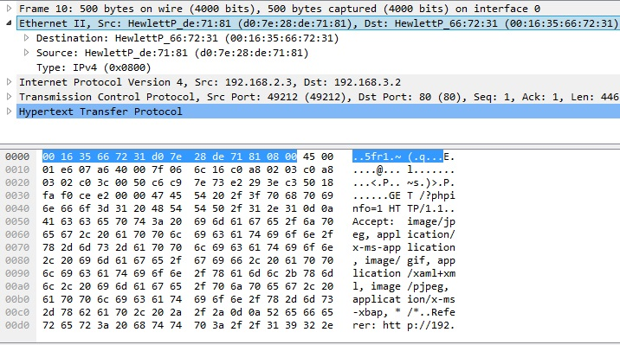

Link layer protocol: Ethernet protocol

Protocol Type: IPv4 (0x0800) It says that the frame has Ipv4 packets with the internet protocol

Source MAC address: Router-NIC-2

Destination MAC address: PC 3’s MAC address

C.

Frame size= 500 Bytes

Full control message size(headers)= 54 Bytes

Full control message size to the frame size ratio = 54:500=1 : 9.26

D. The following packet shown includes the data of the web content that were shown in the web browser. We can that it contains body, headers and links which we were able to see in the browser.

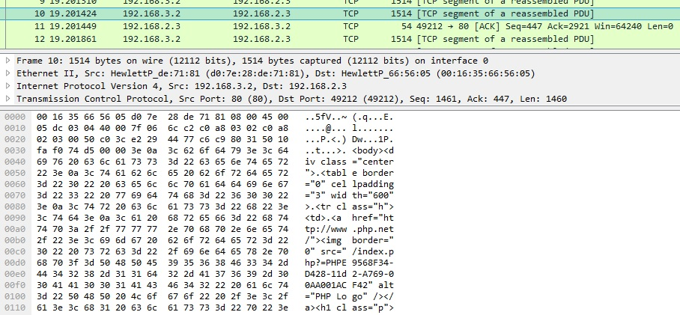

End of the report.