# Install Python

<https://www.python.org/ftp/python/3.12.3/python-3.12.3-amd64.exe>

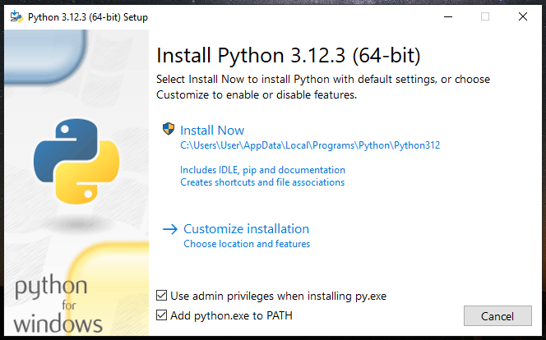

Tick: Use admin privileges when installing py.exe

Tick: Add python.exe to PATH

Install Now

Python installation location:

C:\Users\User\AppData\Local\Programs\Python\Python312

**Add Python to the system environment variables**

Add Python Path:

In the Edit Environment Variable window, click "New" and add the path to your Python installation directory (C:\Users\User\AppData\Local\Programs\Python\Python312).

Also, add the path to the Scripts directory (C:\Users\User\AppData\Local\Programs\Python\Python312\Scripts) if you want to run Python scripts and tools installed via pip.

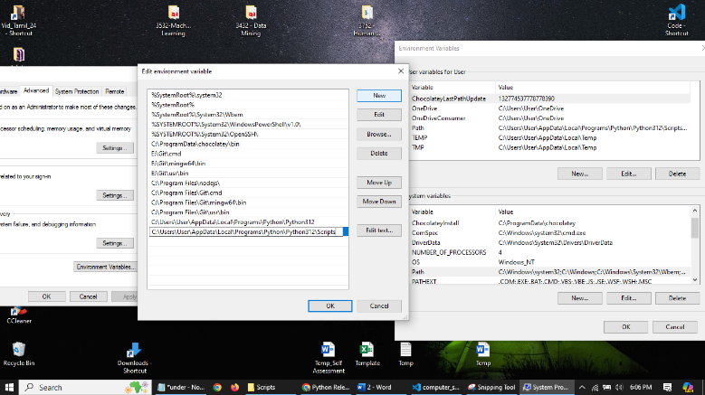

# Install Xampp

<https://sourceforge.net/projects/xampp/files/XAMPP%20Windows/8.0.30/xampp-windows-x64-8.0.30-0-VS16-installer.exe>

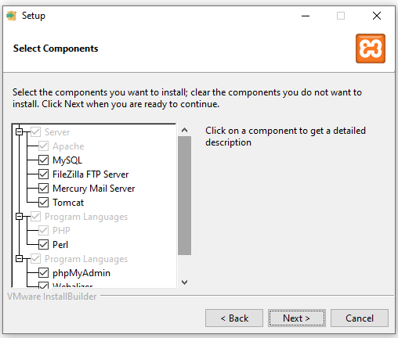

With Xampp we get below Components of XAMPP:

**Apache:** The web server that handles HTTP requests and serves web pages.

**MySQL:** The database management system used for storing and managing databases.

**phpMyAdmin:** A web-based tool included in XAMPP for managing MySQL/MariaDB databases through a graphical interface.

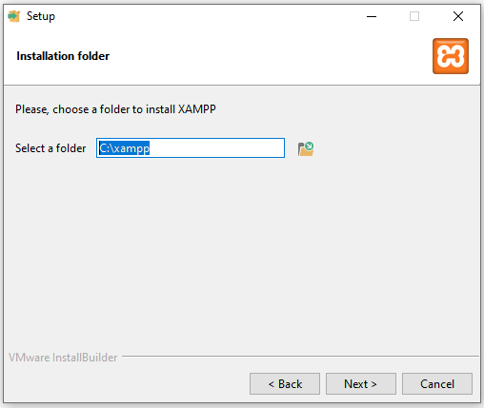

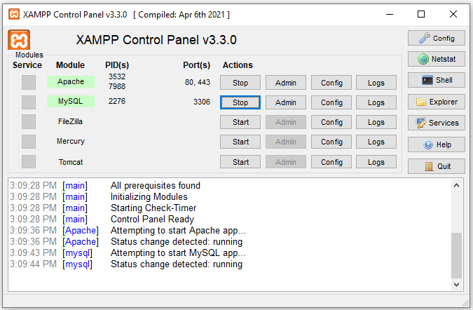

http://localhost/phpmyadmin/

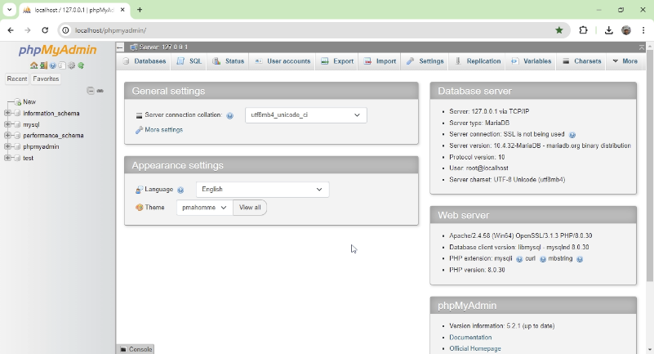

# Create database

CREATE DATABASE IF NOT EXISTS computer_shop;

CREATE USER 'techtriad'@'localhost' IDENTIFIED BY 'ITE-2952';

GRANT ALL PRIVILEGES ON computer_shop.* TO 'techtriad'@'localhost';

FLUSH PRIVILEGES;

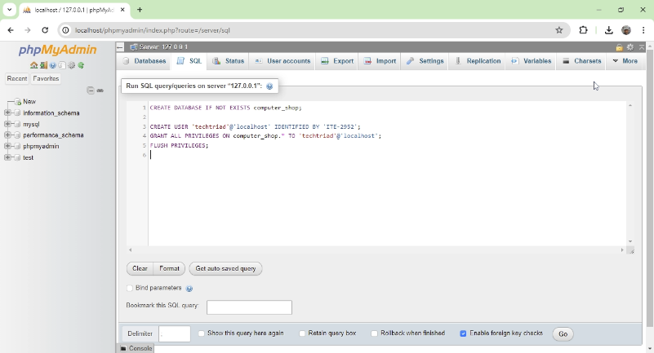

# Install Node

<https://nodejs.org/dist/v20.13.1/node-v20.13.1-x64.msi>

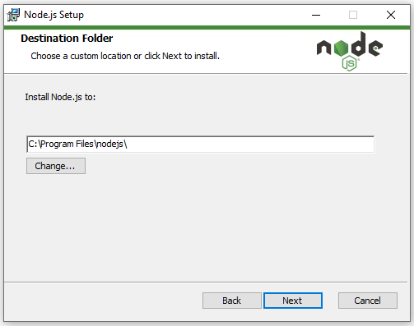

C:\Program Files\nodejs\

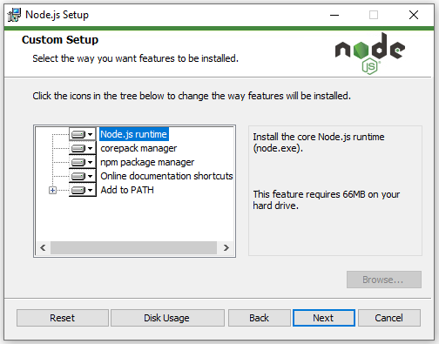

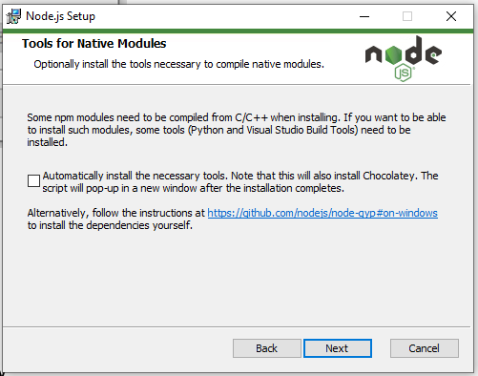

# Run Python backend

**Step 01**

PS C:\Users\User\ITE-2952\computer_shop> python -m venv env

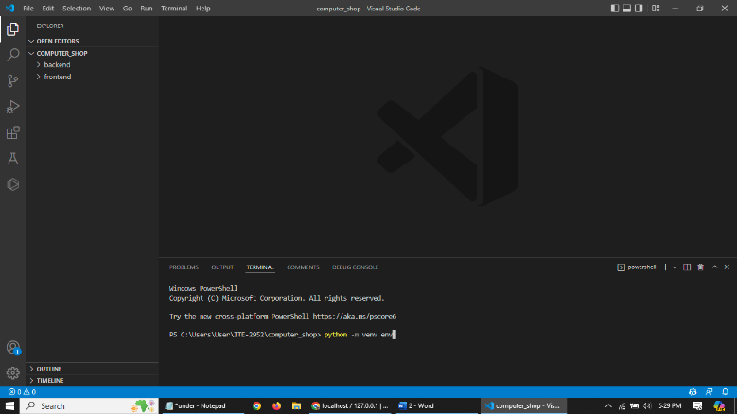

**Step 02**

PS C:\Users\User\ITE-2952\computer_shop> .\env\Scripts\activate

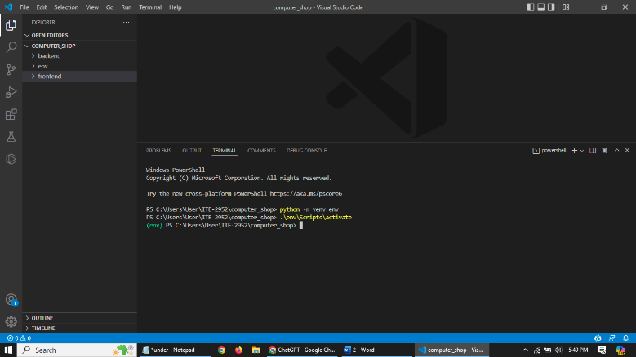

**Step 03**

(env) PS C:\Users\User\ITE-2952\computer_shop> pip install django djangorestframework djangorestframework-simplejwt django-cors-headers mysqlclient pandas mysql-connector-python

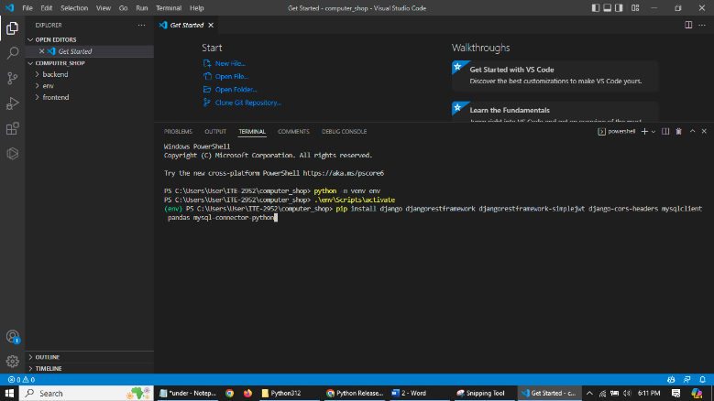

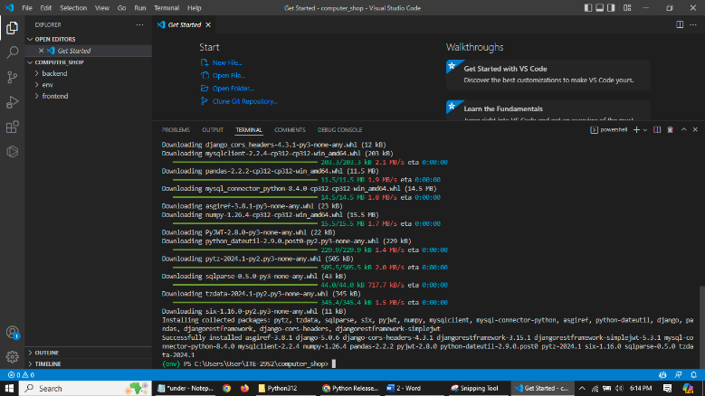

**Step 03**

(env) PS C:\Users\User\ITE-2952\computer_shop> cd backend

(env) PS C:\Users\User\ITE-2952\computer_shop\backend> python manage.py makemigrations

(env) PS C:\Users\User\ITE-2952\computer_shop\backend> python manage.py migrate

(env) PS C:\Users\User\ITE-2952\computer_shop\backend> python manage.py runserver

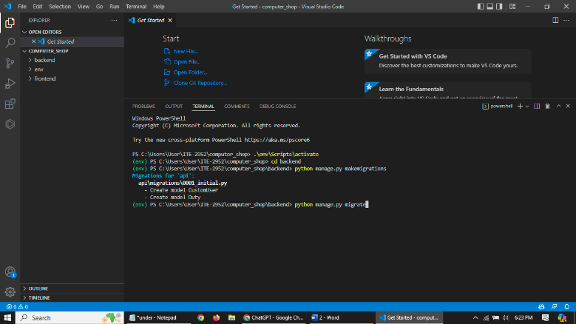

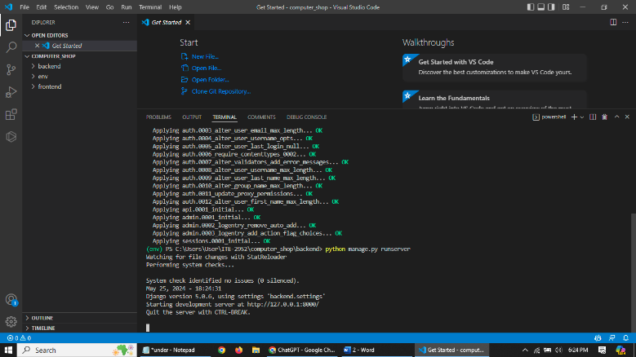

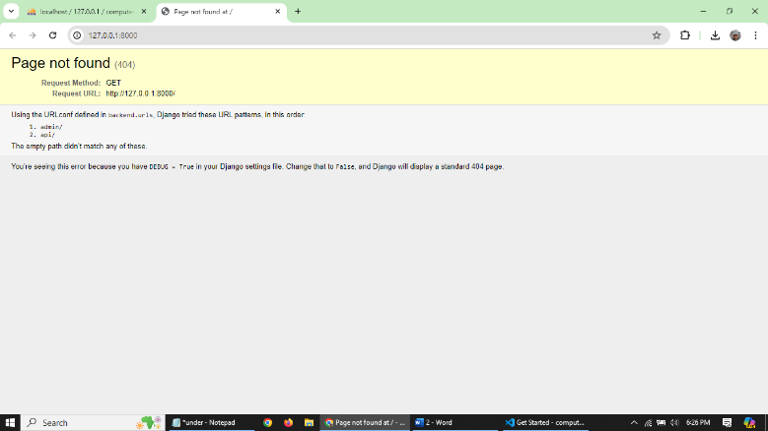

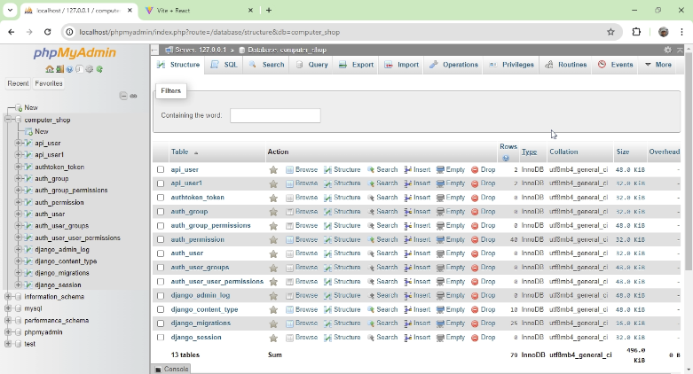

# Run React frontend

PS C:\Users\User\ITE-2952\computer_shop> cd frontend

PS C:\Users\User\ITE-2952\computer_shop\frontend> npm run dev

