

**Sri Lanka Institute of Information Technology**

**OAuth related assignment document.**

**Module Name: SSD.**

**SSD Assignment 2**

**Group Members Details**

|  |  |
| --- | --- |
| **Registration No** | **Name** |
| **IT17166720** | **WICKRAMAARACHCHI W.P.C.K** |
| **IT17171298** | **KATHRIARACHCHI A.D** |

**SSD Assignment 2 OAuth2**

This application is about share google sheets with outside of organization and access sheets using a local application. You must create google oauth2 credentials and service account. The process as follow:

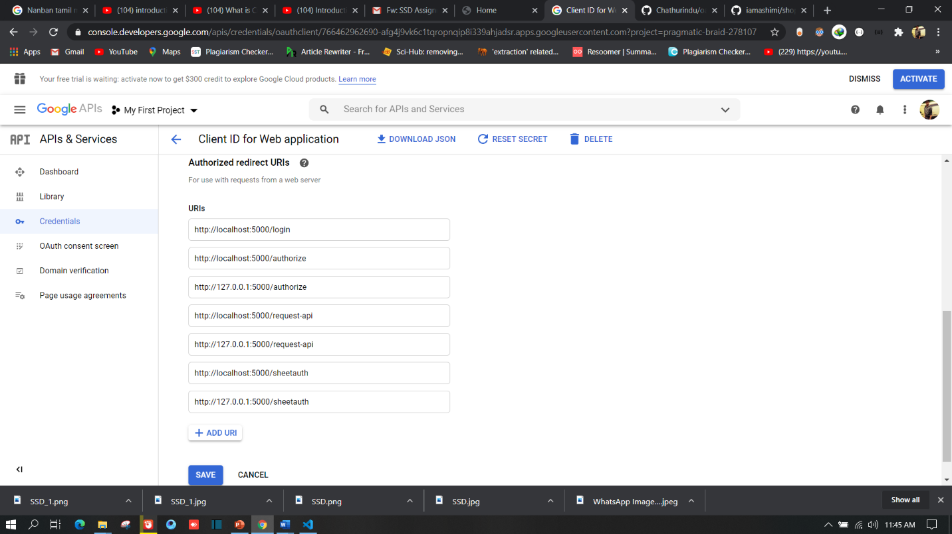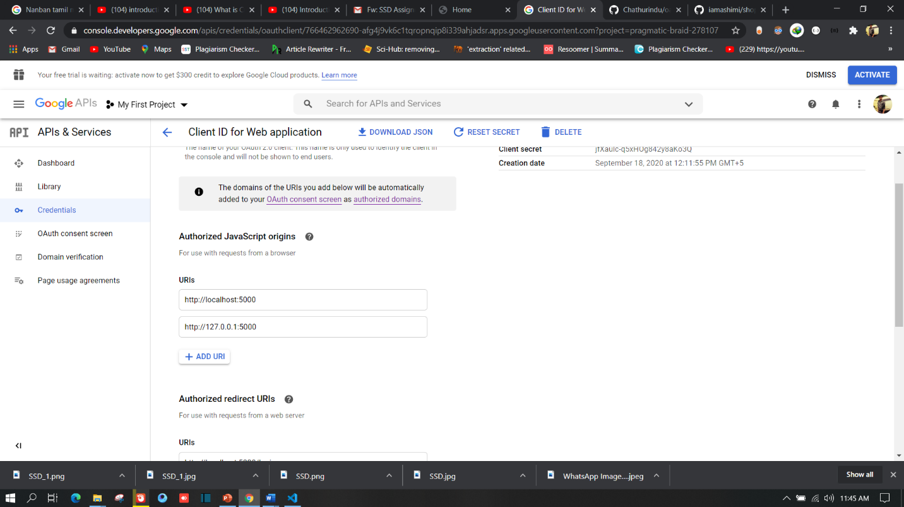

Then copy client id and secret id and add it creating .env file.

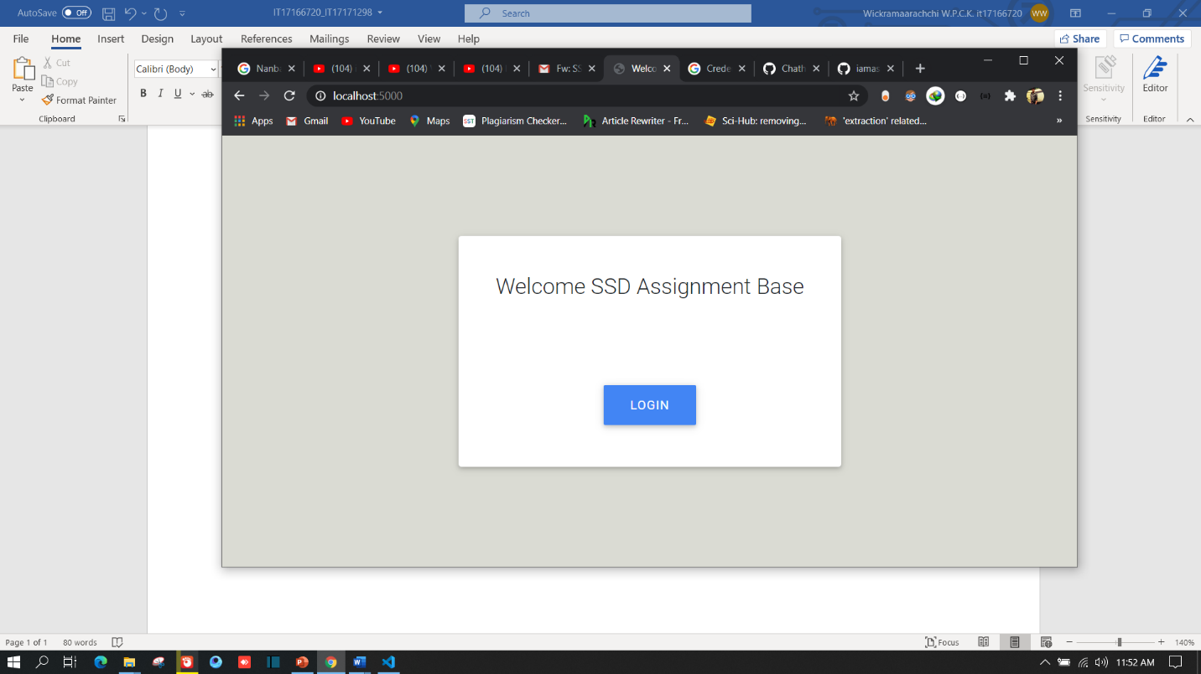In the application you can simply run the development mode in locally using ‘flask run’ command and open the application in <http://127.0.0.1:5000/> . Then you will display the welcome page as follow:

Then you have login to the system, and you will redirect to google authentication page as follow:

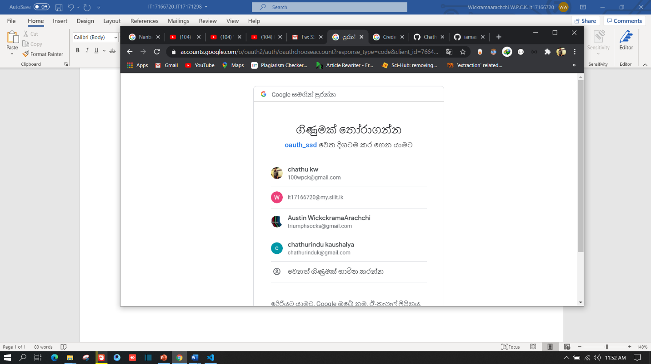

Then you will redirect to home page after authenticated successfully.

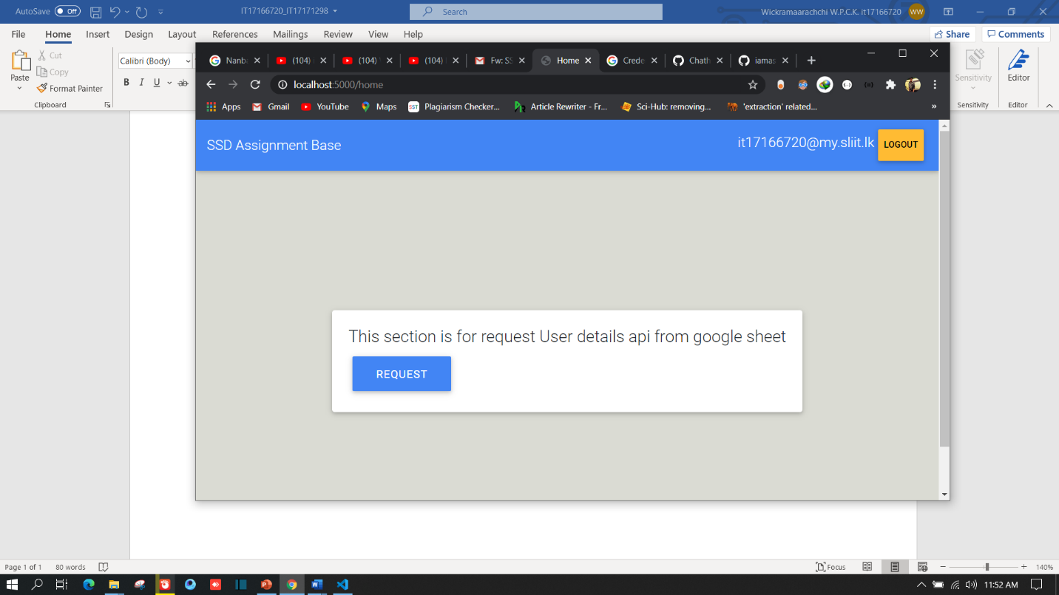

Then you need to request for google sheet. In this phase this application is only developed for access a one sheet. Further this application can be developed to access multiple sheets which can be edit or with limited access. For this step we used google service account and get a email which is used for giving share access via email.

Finally, you will be display sheet data in local application using data tables representation.

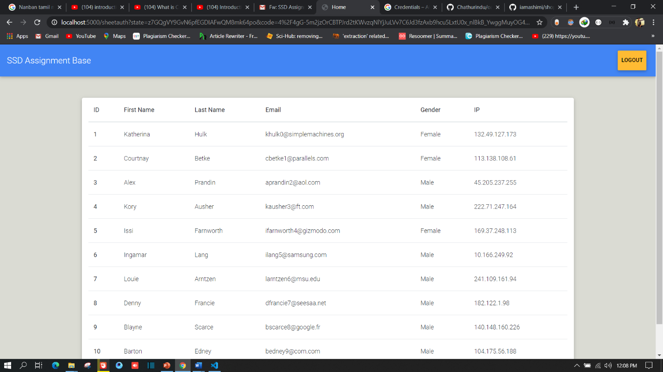

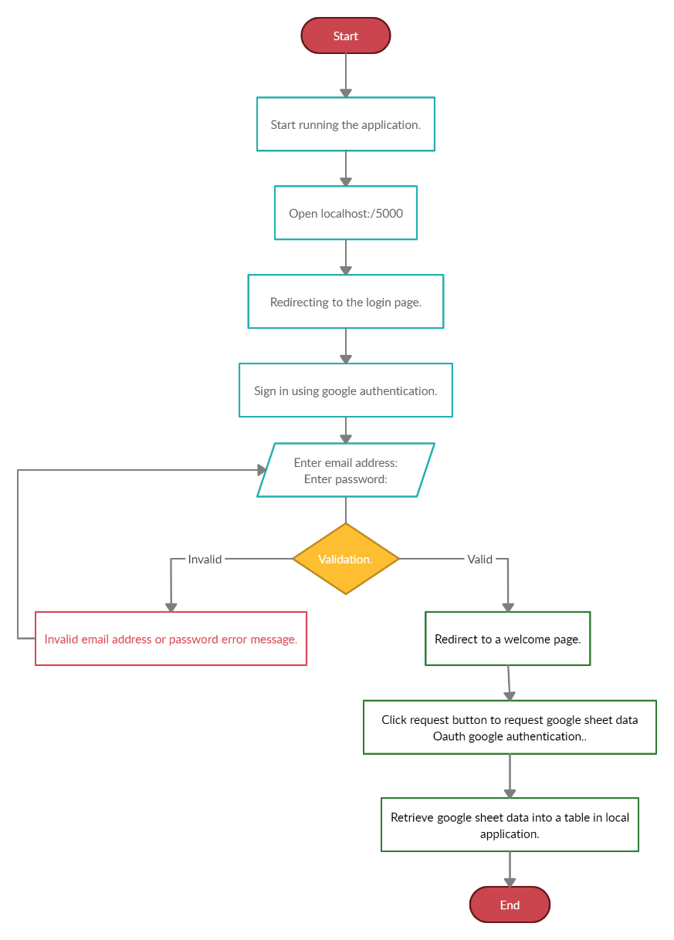We have presented our workflow using chart as follow: