**SRI LANKA INSTITUTE OF INFORMATION TECHNOLOGY**

**Enterprise Standards and Best Practices for IT Infrastructure**

4 th Year 2nd Semester 2016

Name: Chathumali E.J.A.P.C.

SLIIT ID: IT13084714

Practical Session: WD Wednesday

Practical Number: 4

Date of Submission: Friday 9th September 2016

**What is Vmotion?**

VMware has many powerful feature to provide virtual infrastructures high availability with zero down time.in this document will discuss about the one of the main feature provide in VMware. VMotion provides the VMware admins to manage their virtual machine with high availability and zero down time. And VMotion provide the live migration of virtual machine of transfer the running live virtual machine from one physical service to another physical service

**How it works**

First, the entire state of a virtual machine is encapsulated by a set of files stored on shared storage. VMware’s clustered Virtual Machine FileSystem (VMFS) allows multiple installations of ESX Server to access the same virtual machine files concurrently.

Second, the active memory and precise execution state of the virtual machine is rapidly transferred over a high speed network. This allows the virtual machine to instantaneously switch from running on the source ESX Server to the destination ESX Server. VMotion keeps the transfer period imperceptible to users by keeping track of on-going memory transactions in a bitmap. Once the entire memory and system state has been copied over to the target ESX Server, VMotion suspends the source virtual machine, copies the bitmap to the target ESX Server, and resumes the virtual machine on the target ESX Server. This entire process takes less than two seconds on a Gigabit Ethernet network.

Third, the networks used by the virtual machine are also virtualized by the underlying ESX Server. This ensures that even after the migration, the virtual machine network identity and network connections are preserved. VMotion manages the virtual MAC address as part of the process. Once the destination machine is activated, VMotion pings the network router to ensure that it is aware of the new physical location of the virtual MAC address. Since the migration of a virtual machine with VMotion preserves the precise execution state, the network identity, and the active network connections, the result is zero downtime and no disruption to users.

**What are the Limitations of VMware vMotion?**

* Virtual machines configured with the Raw Device Mapping(RDM) for clustering features using vMotion
* VM cannot be connected to a CD-ROM or floppy drive that is using an ISO or floppy image stored on a drive that is local to the host server. The device should be disconnected before initiating the vMotion.
* Virtual Machine cannot be migrated with VMotion unless the destination swap file location is the same as the source swap file location. As a best practice, Place the virtual machine swap files with the virtual machine configuration file.
* Virtual Machine affinity must not be set (aka, bound to physical CPUs).

1. **Configure the Networking adapter**

**[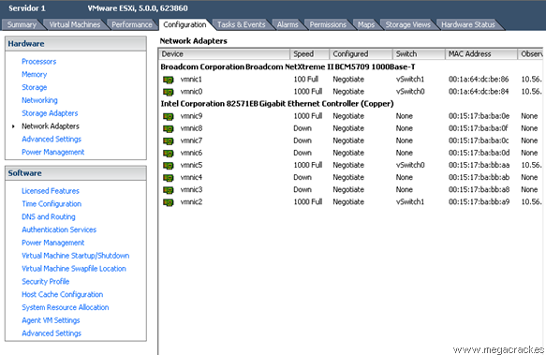](http://en.megacrack.es/wp-content/uploads/2012/10/Vmotion-ESXi-0.png)**

1. **create the vSphere standard switch.**

**[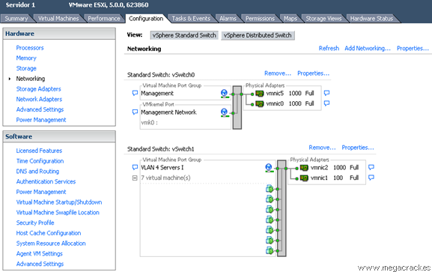](http://en.megacrack.es/wp-content/uploads/2012/10/Vmotion-ESXi-1.png)**

1. **add network wizard and VMKernal**

**[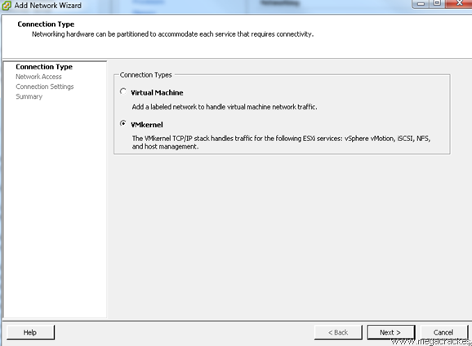](http://en.megacrack.es/wp-content/uploads/2012/10/Vmotion-ESXi-2.png)**

1. **add network wizard [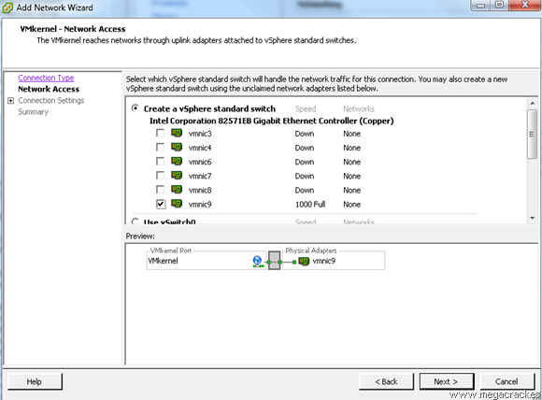](http://en.megacrack.es/wp-content/uploads/2012/10/Vmotion-ESXi-3.png)and get network access**
2. **VMKernal – connection settings.**

* **Use network label to identify**

**[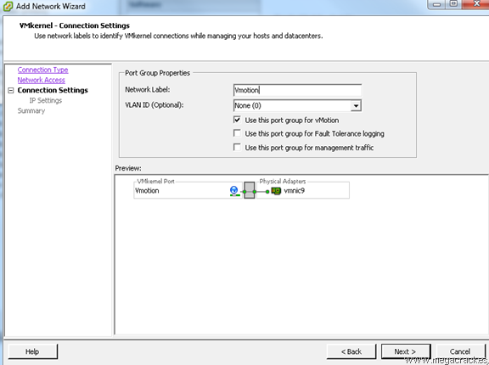](http://en.megacrack.es/wp-content/uploads/2012/10/Vmotion-ESXi-4.png)**

1. **Specify VMKernal IP**

* **IP Address: 50.50.50.1**

**[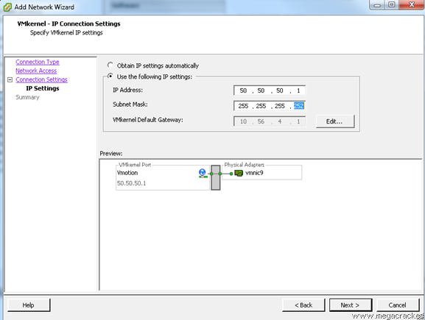](http://en.megacrack.es/wp-content/uploads/2012/10/Vmotion-ESXi-5.png)**

1. **Verify vSphere standard switch are configured appropriately**

**[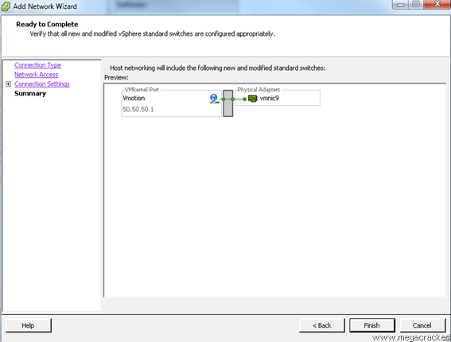](http://en.megacrack.es/wp-content/uploads/2012/10/Vmotion-ESXi-6.png)**

1. **visibility of the new connections.**

**[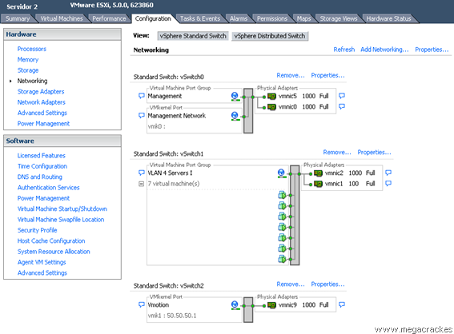](http://en.megacrack.es/wp-content/uploads/2012/10/Vmotion-ESXi-7.png)**

1. **Configured and available network**

**[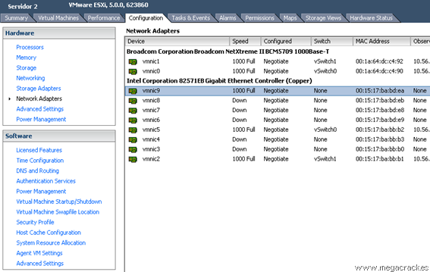](http://en.megacrack.es/wp-content/uploads/2012/10/Vmotion-ESXi-8.png)**

1. **Check available Networking** **and** **create the vSwitch.**

**[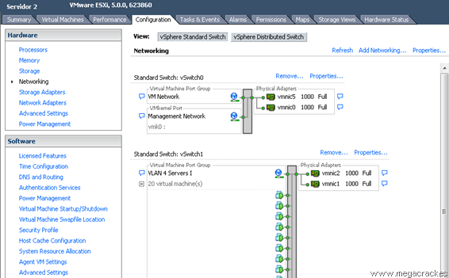](http://en.megacrack.es/wp-content/uploads/2012/10/Vmotion-ESXi-9.png)**

1. **Select** **VMKernel** **connection type**

**[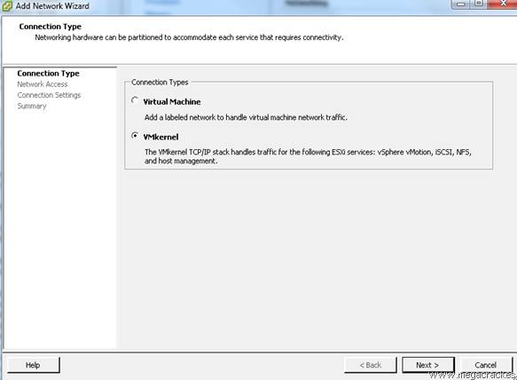](http://en.megacrack.es/wp-content/uploads/2012/10/Vmotion-ESXi-21.png)**

1. **Use this port group for VMotion.**

**[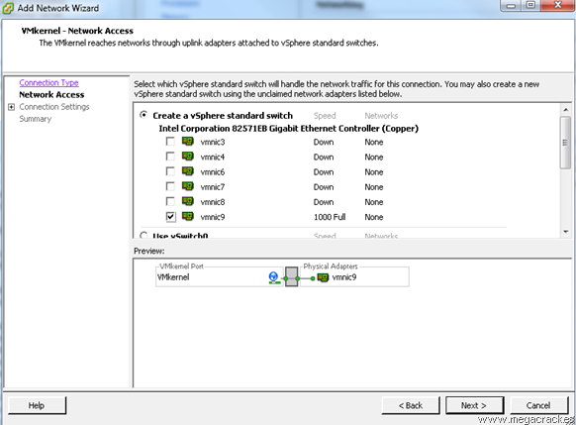](http://en.megacrack.es/wp-content/uploads/2012/10/Vmotion-ESXi-31.png)**

**[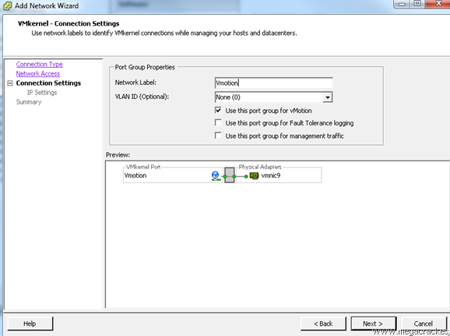](http://en.megacrack.es/wp-content/uploads/2012/10/Vmotion-ESXi-41.png)**

1. **VMKernal - ip connection settings**

* **IP Address: 50.50.50.2**

**[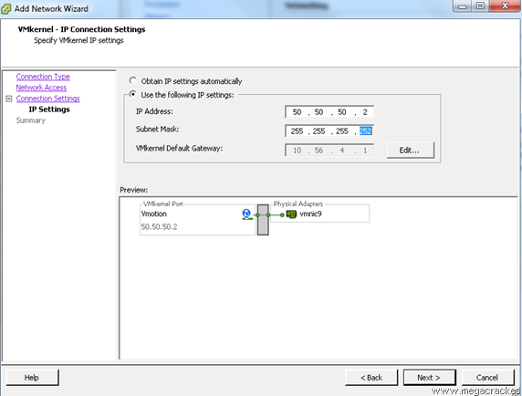](http://en.megacrack.es/wp-content/uploads/2012/10/Vmotion-ESXi-10.png)**

1. **Complete the creation VM**

**[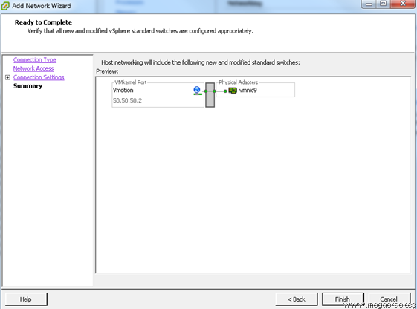](http://en.megacrack.es/wp-content/uploads/2012/10/Vmotion-ESXi-11.png)**

Now what we will do to ensure that the entire system is working properly migrate a VM from one ESXi to the other using Vmotion functionality you just configured.

1. **Edit the settings**

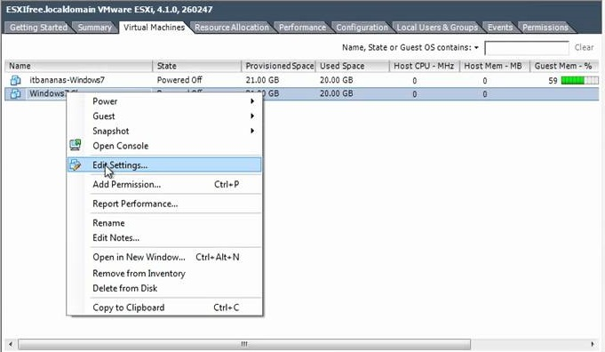

1. **Change the virtual machine host**

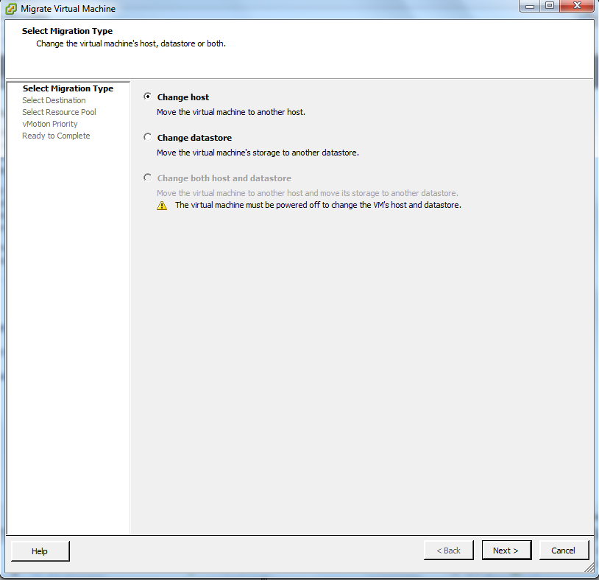

1. **Select the destination or cluster**

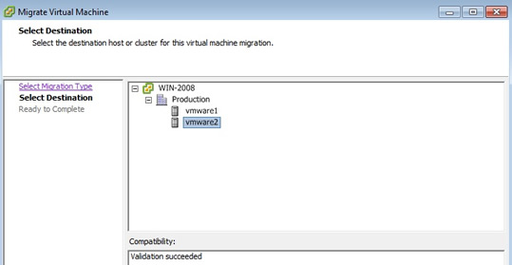

1. **Give the vMotion priority**

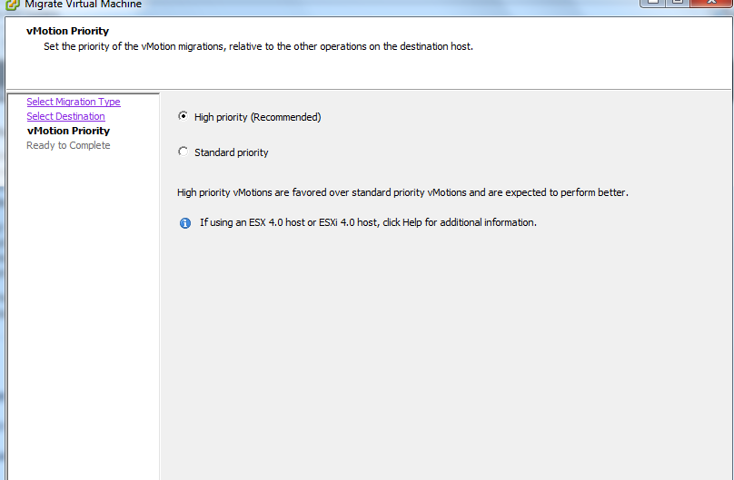

1. **Complete the vMotion process**

