Table of Contents

Diagrams 2

JSP 2

Data Dictionary 2

Global 2

Local 2

Pseudocode 3

Load Customer First Name 3

Load Customer Surname 3

Load Animal Name 3

Load Animal Gender 3

Load Animal Type 3

Load Animal Age 3

Load Animal Castration Info 3

Load Animal Accident Info 3

Calculate Animal Insurance 3

Check Continue 4

Print Result 4

Finite-State Machine 4

# Diagrams

## JSP

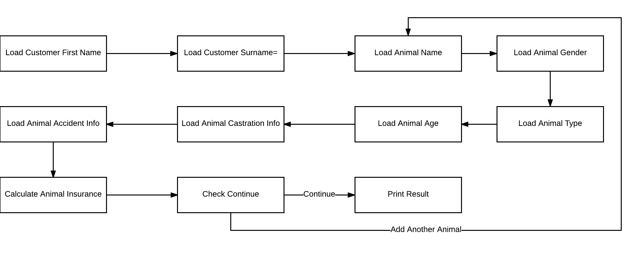

## Data Dictionary

### Global

|  |  |  |  |  |
| --- | --- | --- | --- | --- |
| Load  Pos. | Name | Type | Default | Purpose |
| 1 | curr_state | int | 0 | Number identifying the current state of program |
| 2 | owner_first_name | char array[20] | \0 | The pet owner first name |
| 3 | owner_surname | char array[20] | \0 | The pet owner surname |
| 4 | pet_names | char array[10][20] | \0 | The pets names |
| 5 | pet_gender | int array[10] | -1 | The pets genders |
| 6 | pet_type | char array[10] | U | The pets types encoded as single characters |
| 7 | pet_type_price | float array[5] | 50, 80, 40, 60, 10 | The pets insurance prices |
| 8 | pet_age | int char[10] | -1 | The pets ages |
| 9 | pet_is_neutered | int char[10] | -1 | The pets castration data |
| 10 | pet_had_accident | int char[10] | -1 | The pets accident data |
| 11 | insurance_cost | float char[10] | 0 | The array of insurance total costs |
| 12 | insurance_base_price | float char[10] | 0 | The array of insurance base prices |
| 13 | insurance_mod_old | float char[10] | 0 | The arrays of insurance modifiers |
| 14 | insurance_mod_young_male | float char[10] | 0 |
| 15 | insurance_mod_accident | float char[10] | 0 |
| 16 | quote | float | 0 | The final insurance quote |
| 17 | idx_curr_pet | int | 0 | The current index of processed pet |
| 18 | tmp | char array[20] | \0 | Any temporary variable that needs to be stored |

### Local

|  |  |  |  |  |
| --- | --- | --- | --- | --- |
| Load  Pos. | Name | Type | Default | Purpose |
| 1 | i | int | \0 | Used exclusively within iterative for loops |

# Pseudocode

## Load Customer First Name

|  |
| --- |
| Print “Customer First Name:”  Scan first_name  IF first_name IS ?  Print help  ELSE  nextState |

## Load Customer Surname

|  |
| --- |
| Print “Customer Surname:”  Scan surname  IF surname IS ?  Print help  ELSE  nextState |

## Load Animal Name

|  |
| --- |
| Print “Animal Name:”  Scan animal_name  IF animal_name IS ?  Print help  ELSE  nextState |

## Load Animal Gender

|  |
| --- |
| Print “Animal Gender:”  Scan animal_gender  IF animal_gender IS ?  Print help  ELSE  nextState |

## Load Animal Type

|  |
| --- |
| Print “Animal Type:”  Scan animal_type  IF animal_type IS ?  Print help  ELSE  nextState |

## Load Animal Age

|  |
| --- |
| Print “Animal Age:”  Scan animal_age  IF animal_age IS ?  Print help  ELSE  nextState |

## Load Animal Castration Info

|  |
| --- |
| Print “Animal Castration Status:”  Scan animal_castration  IF animal_castration IS ?  Print help  ELSE  nextState |

## Load Animal Accident Info

|  |
| --- |
| Print “Animal Accident Status:”  Scan animal_accident  IF animal_accident IS ?  {  Print help  }  ELSE  {  nextState  } |

## Calculate Animal Insurance

|  |
| --- |
| Switch animal_type {  Case Dog  IF animal_castration IS 1  {  cost = pet_price[0]  }  ELSE  {  cost = pet_price[1]  }  Case Cat  IF animal_castration IS 1  {  cost = pet_price[3]  }  ELSE  {  cost = pet_price[4]  }  Case Other  cost = pet_price[5]  }  IF animal_age IS GREATER THAN 5  {  cost = mod_old -> cost  }  ELSE IF animal_age IS LESS THAN 2 AND animal_gender IS male  {  cost = mod_young_male -> cost  }  IF animal_accident IS true  {  cost = mod_accident -> cost  }  nextState |

## Check Continue

|  |
| --- |
| Print “Add Another Animal?”  Scan choice  IF choice IS yes  State0 //Add an animal  ELSE  nextState |

## Print Result

|  |
| --- |
| for ;count IS LESS THAN total_pets;  {  Print animal_name  Print cost  Print insurance_mods  }  Print total  nextState //Ends Program |

## Finite-State Machine

|  |
| --- |
| While state IS NOT 11  {  Switch curr_state  { case 0:  load_customer_first_name()  case 1  load_customer_surname()  Case 2  load_animal_name()  Case 3  load_animal_gender()  Case 4  load_animal_type()  Case 5  load_animal_age()  Case 6  load_animal_castration_info()  Case 7  load_animal_accident_info()  Case 8  calculate_animal_insurance()  Case 9  check_continue()  Case 10  print_result()  }  } |