 | SARALA BIRLA UNIVERSITY | 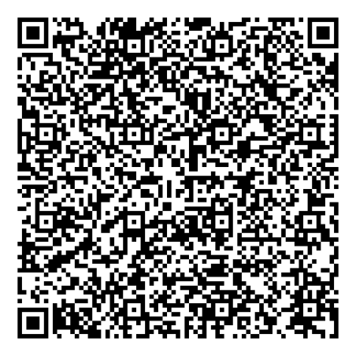
 | ODD 2025-26 MID SEM
ADMIT CARD
Registration No. |  | Year of Registrati |  | on |  |  |  |  |  | Program Code
SBU221026  Department Name |  |  |  |  |  |  |  |  |  |  |  | Sem Gen
 |  | 2022 |  |  | Department of Computer Science & Engineering |  |  |  |  | BTCSE
Student Name |  |  |  |  | Abhishek Chatterjee |  |  |  |  | 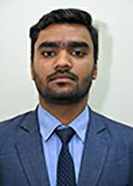
Father’s Name Roll No. |  |  |  |  | Pradeep Chatterjee  BTCS22R120
Date of Birth |  |  |  |  | 12-10-2003
Reference No. |  |  |  |  | 2025/007 | 6/13565
REGULAR SUBJECT DETAILS
Sr. No. |  | Course Code-Course Name |  | Date |  | Time |  | Invigilator Signa | ture
1 |  | PEC-CSE-AIML-701-Advanced Artificial Intelligence  PEC-CSE-AIML-702-Deep Learning  PEC-CSE-AIML-704-Bio-Inspired Computing |  | 16-09-202 | 5 | 14:00-15 | 30
2 |  |  |  | 18-09-202 | 5 | 14:00-15 | 30
3 |  |  |  | 20-09-202 | 5 | 14:00-15 | 30

Note: | Controller of Examination
1. This Admit Card is invalid without a self-attested photograph.
2. You may be denied entry into the examination hall without a valid admit card.
Print Date - 9/13/2025 11:28:22 PMPrint By - Abhishek Chatterjee Page 1 of 1

