Here’s a 10-mark summarized answeron Hebbian Learningbased on the contents of your PDF:
Hebbian Learning – 10 Marks Summary
Definition:
Hebbian Learning is a biologically inspired learning ruleproposed by Donald Hebb (1949). It
states:
“When a neuron A repeatedly helps fire neuron B, the connection between them strengthens.”
Mathematically, the change in weight is:
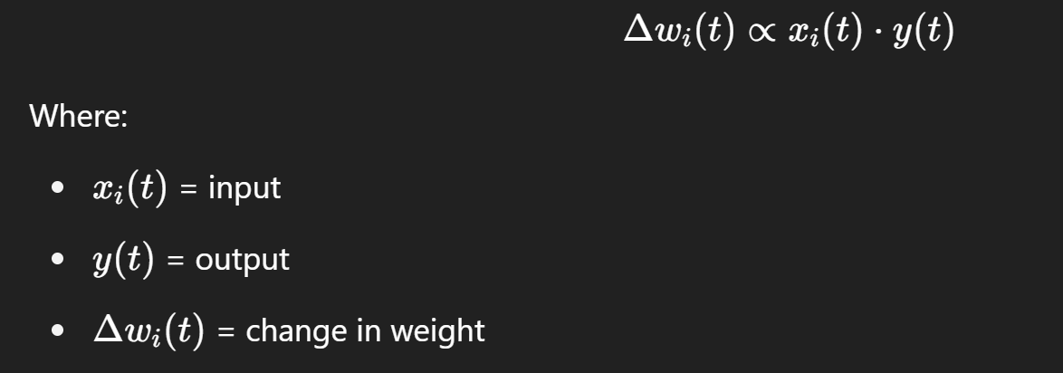
Working Principle:
•Neuronsstrengthen their connection when activated together.
•In vector form:
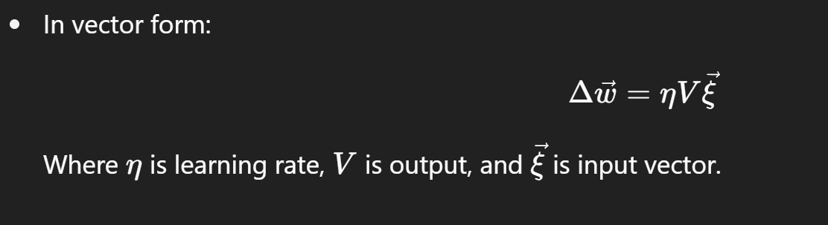
Key Properties:

1.Unsupervised learning– no need for labeled output.
2.Locality– only uses data from connected neurons.
3.Biologically plausible– aligns with observed brain behavior.
Limitation:
•Weight explosion: Weights keep growing indefinitely unless controlled.
Stabilization Techniques:
1.Weight Normalization– Normalize the weight vector after each update.
2.Oja’s Rule– Adds a decay term to prevent weight growth:
3. 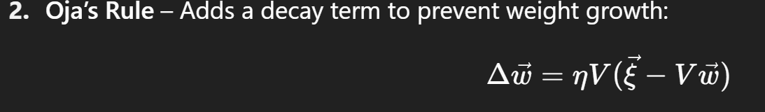
Sejnowski’s Covariance Rule– Adjusts learning by subtracting the means.
Relation to PCA:
•Hebbian learning aligns the weight vector to the direction of maximum variancein the data.
•This is the first principal componentin Principal Component Analysis (PCA).
Applications:
•Neural modeling
•Feature extraction
•Principal component learning
•Visual system simulations (e.g., Linsker’s model)

Let me know if you’d like diagrams or a handwritten-style version for class notes!
