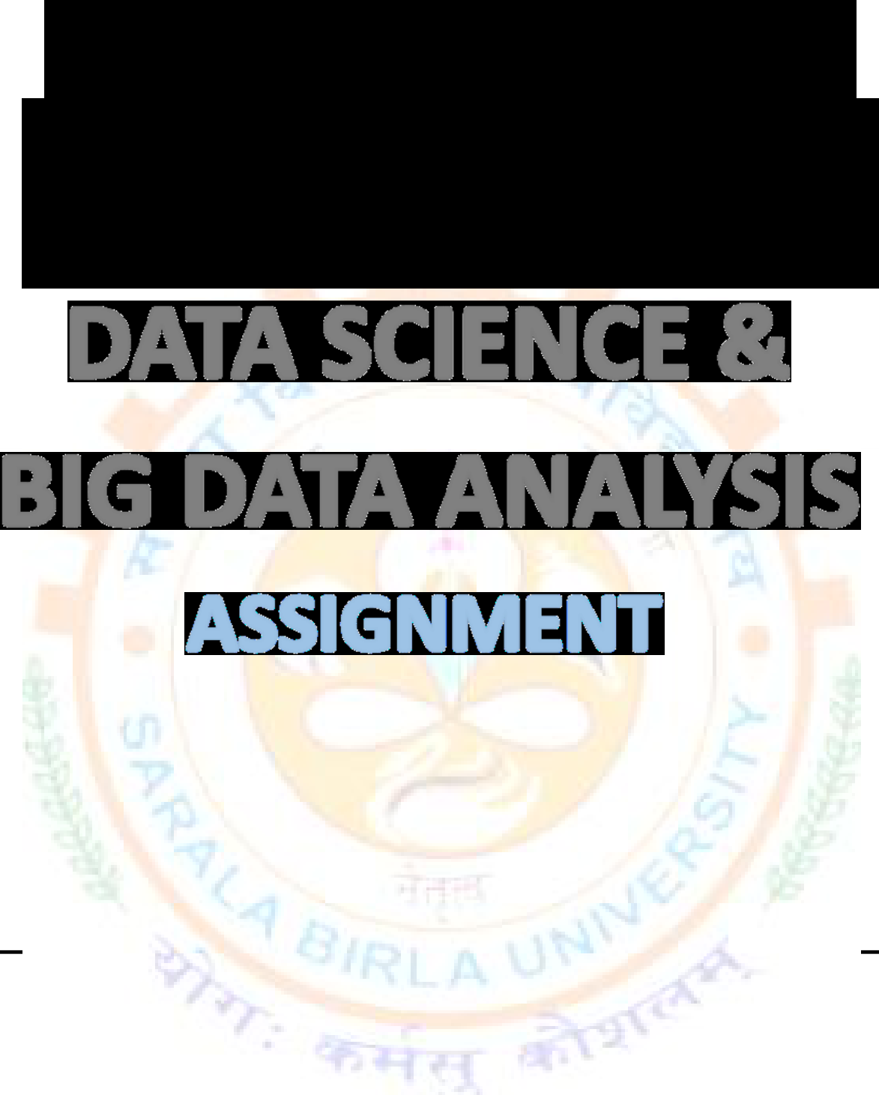

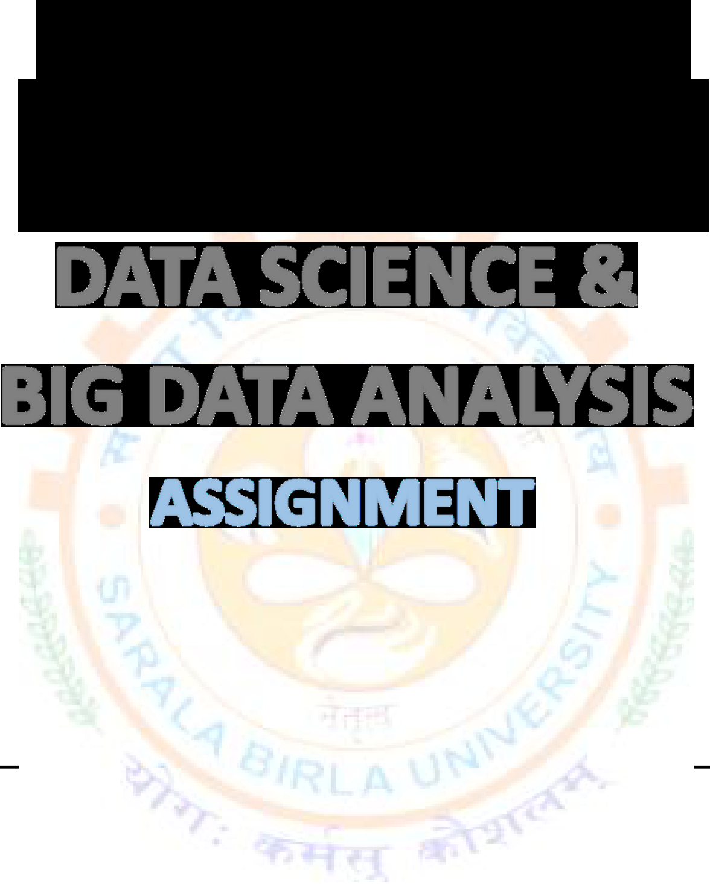





BTECH(CSE) AI&ML SESSION: 2022-2026
SUBMITTED BY:SUBMITTED TO:
NAME:Abhishek Chatterjee FACULTY NAME: REG. NO:SBU221026 Dr. Sandeep Kumar
SEMESTER:6th(Even) Singh Modak
ROLL NO:BTCS22R120
SEC: “A”

