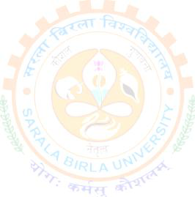





1



BTECH(CSE) AI&ML
BTECH(CSE)AIML
SESSION: 2022-2026 [COURSE CODE: PEC-CSE-AIML-702] SUBMITTED BY:
NAME: Abhishek Chatterjee
REG. NO: SBU221026
SEMESTER: 7th (Even)
ROLL NO: BTCS22R120
SEC: A
SUBMITTED TO:

FACULTY NAME: Dr. Modak

Sandip Kumar Singh

2

