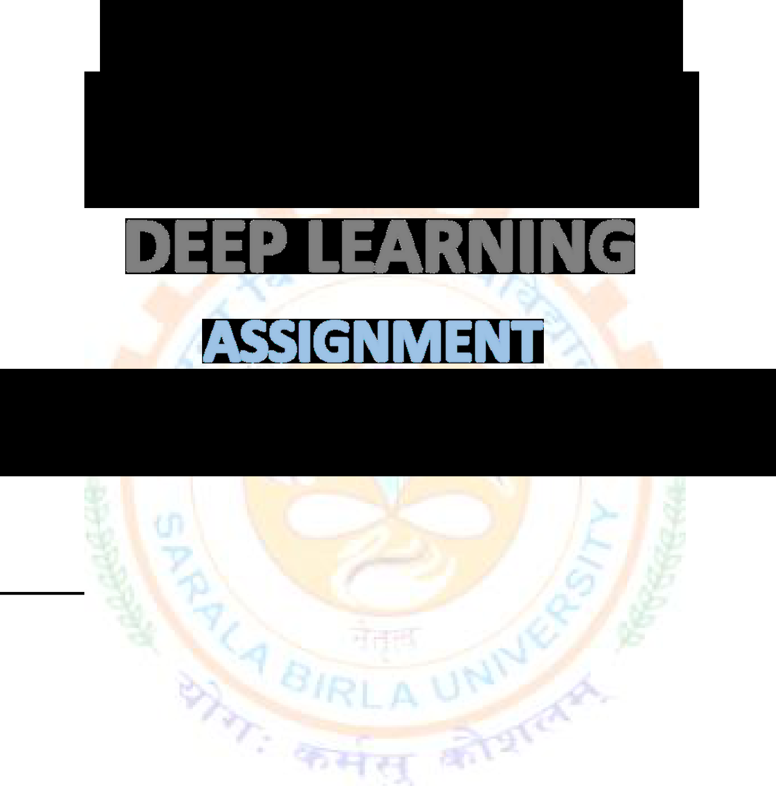


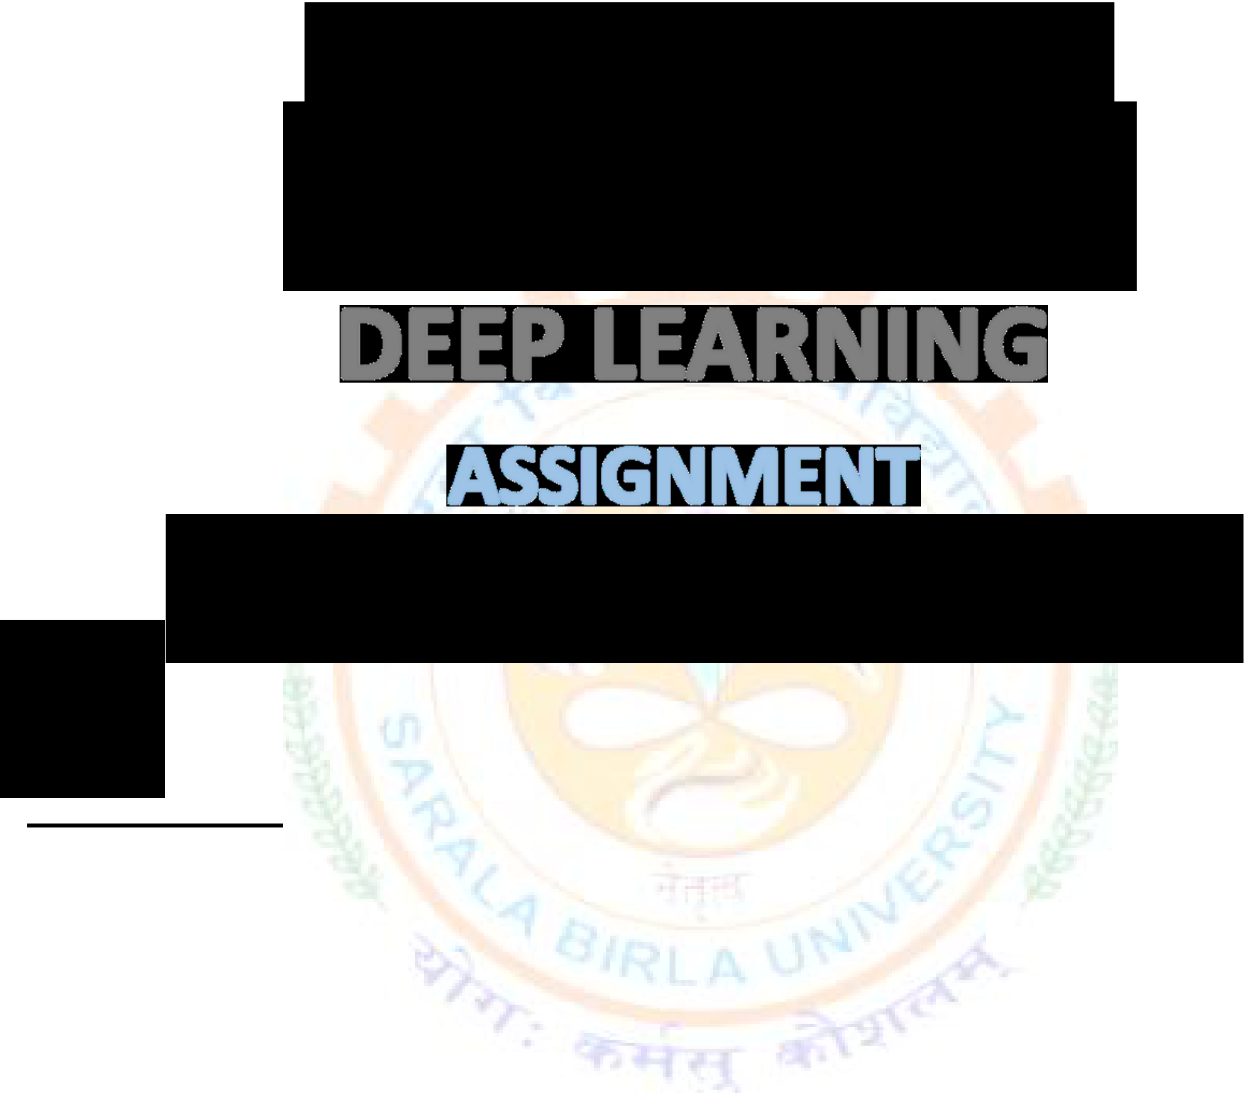


BTECH(CSE) AI&ML
SESSION: 2022-2026
[COURSE CODE: PEC-CSE-AIML-702]
SUBMITTED BY:
NAME:Abhishek Chatterjee
REG. NO:SBU221026
SEMESTER:7th(Even)
ROLL NO:BTCS22R120
SEC: “A”
SUBMITTED TO:
FACULTY NAME: Dr. Sandip Kumar Singh Modak

