INDEX
S. No. |  |  |  | Title |  |  |  |  |  | Page No.
1 |  |  |  | Cover Page |  |  |  |  |  | i
2 |  |  |  | Certificate from Organization |  |  |  |  |  | ii
3 |  |  |  | Acknowledgment |  |  |  |  |  | iii
4 |  |  |  | Abstract |  |  |  |  |  | iv
5 |  |  |  | Organization Profile |  |  |  |  |  | 1
 |  |  |  | 5.1 Overview |  |  |  |  |  | 1
 |  |  |  | 5.2 Technologies Used |  |  |  |  |  | 3
6 |  |  |  | Internship Objectives |  |  |  |  |  | 4
7 |  |  |  | Work Carried Out |  |  |  |  |  | 5
 |  |  |  | 7.1 Tools and Technologies Used |  |  |  |  |  | 7
 |  |  |  | 7.2 Engineering Methods Applied |  |  |  |  |  | 8
8 |  |  |  | Technical Learning Outcomes |  |  |  |  |  | 10
 |  |  |  | 8.1 Engineering Knowledge |  |  |  |  |  | 10
 |  |  |  | 8.2 Problem-Solving |  |  |  |  |  | 11
 |  |  |  | 8.3 Modern Tool Usage |  |  |  |  |  | 12
 |  |  |  | 8.4 Teamwork and Communication |  |  |  |  |  | 13
9 |  |  |  | Challenges Faced and Solutions |  |  |  |  |  | 14
11 |  |  |  | Conclusion |  |  |  |  |  | 18
12 |  |  |  | References |  |  |  |  |  | 19
13 |  |  |  | Appendix |  |  |  |  |  | 20
 |  |  |  | 13.1 Work Log |  |  |  |  |  | 20
 |  |  |  | 13.2 Screenshots / Designs |  |  |  |  |  | 21
14 |  |  |  | Declaration |  |  |  |  |  | 22

Internship Report
On
CinePro
Submitted in partial fulfillment of the requirements for the award of the degree Bachelor of Technology

in
Computer Science and Engineering(Cyber Security)
submitted
by
Kolluri Chaturvedhi Narsimha (24EG109A28)

DEPARTMENT OF CYBER SECURITY


ANURAG UNIVERSITY
(Approved by AICTE and NBA Accredited)
Venkatapur (V), Ghatkesar (M), Medchal-Malkjgiri (Dt),
Hyderabad, Telangana, 500088

( 2026-2027)
ANURAG UNIVERSITY
(Approved by AICTE and NBA Accredited)
Venkatapur (V), Ghatkesar (M), Medchal-Malkjgiri (Dt),
Hyderabad, Telangana, 500088
DEPARTMENT OF CYBER SECURITY


CERTIFICATE

This is to certify that the Internship report entitled “CineProo” is bonafide work done and submitted by Kolluri Chaturvedhi Narsimha 24EG109A28, in partial fulfillment of the requirements for the award of the degree of B.Tech in Cyber Security from Anurag University, Hyderabad during the academic year 2026-2027. The bonafide work has not been submitted elsewhere for the award of any other degree.

Internship Coordinator | Head of the Department
Mr. G. Sai Krishna  Assistant Professor | Dr. Niteesha Sharma

Internship Assessment Committee
DECLARATION

This is to certify that the Internship report entitled “CineProo” submitted to Anurag University in partial fulfillment of the requirements for the award of the degree of B. Tech in Information Technology is an original work carried out by Kolluri Chaturvedhi Narsimha (24EG109A28). This matter embodied in this Internship is a genuine work, done by the student and has not been submitted whether the university or to any other university/Institute for the fulfillment of the requirement of any course of study.

Kolluri Chaturvedhi Narsimha 24EG109A28

ACKNOWLEDGEMENT

I would like to express my profound sense of gratitude to all for having helped me in completing this dissertation. I would like to express my deep-felt gratitude and sincere thanks to, Dr. Niteesha Sharma, Head of the Department, Department of Information Technology, Anurag University, for her skillful guidance, timely suggestions, and encouragement in completing this project.
I would like to express my sincere thanks to Dr. K. Sudheer Reddy, Dean, Academics and Planning, Anurag University, whose motivation in the field of software development has made me overcome all hardships during the study and successful completion of the project.
I extend my sincere appreciation to Dr. V. Vijaya Kumar, Dean, School of Engineering, for his encouragement and consistent support during this endeavor.
Finally, I would like to express my heartfelt thanks to my parents, who were very supportive both financially and mentally and for their encouragement to achieve my set goals.

Kolluri Chaturvedhi Narsimha
24EG109A28

Abstract
This report describes my learning experience during the CareerX Training and Internship Program conducted by Vault of Codes. The internship was held online for one month, from 15th May to 15th June. The main aim of this internship was to gain practical knowledge in different areas of computer science and understand how different technologies work together to build software applications.
The internship was divided into four tracks: Python Programming, Java Programming, Artificial Intelligence (Prompt Engineering), and Web Development. During the program, I completed weekly assignments, reports, presentations, and final projects for each track. In Web Development, I learned HTML, CSS, JavaScript, React to build responsive web applications. In Python and Java, I learned programming basics, object-oriented programming, data structures, exception handling, file handling, and collections. In the AI track, I learned Prompt Engineering and how to use AI tools to improve programming and problem-solving.
To complete my work, I used Visual Studio Code as my code editor, GitHub for saving and managing my projects, and AI tools like Claude Sonnet and GitHub Copilot for debugging, understanding concepts, and improving my code. Around 40% of my work was supported by AI tools, while I completed the implementation and learning on my own under the guidance of my mentor.
At the end of the internship, I applied what I learned by developing CinePro, a project that combines concepts from Java, Python, and Web Development. The project includes features like animated movie tickets, QR code validation, and seat recommendation, which were inspired by modern movie booking applications. Building this project helped me understand how different programming languages and technologies can be connected to create a complete software application.
Overall, this internship improved my programming knowledge, logical thinking, and problem-solving skills. More importantly, it helped me understand how different technologies work together in software development. The experience has given me the confidence to learn new technologies on my own and build projects independently in the future.

5. Organization Profile

5.1 Overview
Vault of Codes is an EdTech company that provides training and internship programs for students. The organization is also listed on platforms such as the AICTE National Internship Portal and Internshala, and is a Google for Education Partner.
I completed the CareerX Training and Internship Program offered by Vault of Codes. The internship was conducted online for one month and covered four main tracks: Python Programming, Java Programming, Artificial Intelligence (Prompt Engineering), and Web Development. During the internship, I completed weekly assignments, technical reports, presentations, and final projects. The program provided practical exposure to software development, encouraged independent learning, and helped me improve my programming and problem-solving skills.

5.2 Technologies Used
During the CareerX Training and Internship Program, I learned and worked with different programming languages, frameworks, tools, and software commonly used in software development. The main technologies used during the internship are listed below:
- Programming Languages: Python and Java for learning programming fundamentals, object-oriented programming, exception handling.
- Front-End Web Technologies: HTML5, CSS3, and JavaScript for designing responsive web pages, creating user interfaces.
- JavaScript Frameworks: React.js for developing modern, responsive, and component-based web applications.
- Artificial Intelligence: Prompt Engineering using AI tools such as Claude Sonnet and GitHub Copilot to understand concepts, debug code, and improve development productivity.
- Development Environment: Visual Studio Code (VS Code) for writing, testing, debugging, and managing source code.
- Version Control: Git and GitHub for storing projects, tracking changes, and managing source code repositories.
- Documentation Tools: Google Docs, Google Slides, Microsoft Office, and PDF tools for preparing weekly reports, presentations, and project documentation.
6. Internship Objectives

The main objective of this internship was to gain practical knowledge and hands-on experience in different areas of software development and emerging technologies. The CareerX: All-in-One Internship Program was designed to help students improve their technical skills through assignments and project-based learning.
The objectives of the internship were:
- To learn the fundamentals of Web Development using HTML, CSS, and JavaScript.
- To understand core programming concepts using Python and Java.
- To improve logical thinking, problem-solving, and debugging skills through coding assignments.
- To gain practical experience by developing mini projects and final projects.
- To learn the basics of Artificial Intelligence and Prompt Engineering.
- To understand how effective prompts can be used to interact with AI tools and generate useful outputs.
- To improve project documentation and report-writing skills.
- To build confidence in developing applications independently and applying theoretical knowledge to practical tasks.
Overall, the internship aimed to strengthen both technical and professional skills while providing exposure to Web Development, Python Programming, Java Programming, and Artificial Intelligence & Prompt Engineering.
7. Work Carried Out

During the CareerX Training and Internship Program at Vault of Codes, I worked on four different learning tracks: Web Development, Python Programming, Java Programming, and Artificial Intelligence (Prompt Engineering). Each week, I completed coding assignments, technical reports, presentations, and practical tasks based on the topics covered during the training.
As I progressed through the internship, I applied the concepts learned in each track by developing mini projects and improving my programming skills. At the end of the internship, I integrated the knowledge gained from Web Development, Python, and Java to develop CinePro, a movie ticket booking application. The project included features such as animated movie tickets, QR code validation, and a seat recommendation system inspired by modern movie booking applications. Throughout the internship, I also prepared weekly documentation and maintained my project files using GitHub.

7.1 Tools and Technologies Used
The following tools and technologies were used during the internship:
- Programming Languages: Python and Java for learning programming fundamentals, Object-Oriented Programming (OOP), data structures, exception handling, file handling.
- Web Development: HTML5, CSS3, JavaScript, React for designing and developing responsive and interactive web applications.
- Artificial Intelligence: Prompt Engineering using AI tools such as Claude Sonnet and GitHub Copilot to understand concepts, debug code, and improve development productivity.
- Development Environment: Visual Studio Code (VS Code) for writing, testing, debugging, and managing source code.
- Version Control: Git and GitHub for maintaining project repositories and tracking code changes.
- Documentation Tools: Google Docs, Google Slides, Microsoft Office, and PDF tools for preparing weekly reports, presentations, and project documentation.

7.2 Engineering Methods Applied
During the internship, I followed a simple and organized approach while completing my assignments and projects.
- Modular Development: I divided programs into smaller and manageable sections to make coding, testing, and debugging easier.
- Project-Based Learning: Each week focused on a different topic, followed by assignments and mini projects that helped me apply the concepts learned during the training.
- Version Control: I regularly updated my projects using Git and GitHub to maintain different versions of my code and keep backups.
- Debugging and Testing: I tested my programs regularly, fixed errors, and improved the code with the help of debugging techniques and AI-assisted tools when required.
- Documentation: I prepared weekly reports, presentations, and project documentation to record my progress and explain the work completed during the internship.
8. Technical Learning Outcomes

8.1 Engineering Knowledge
- Throughout this internship, I learned different areas of software development, including Web Development, Python, Java, and Artificial Intelligence. I learned how to build web pages using HTML, CSS, and JavaScript, and how to create interactive user interfaces using React.
- In Python and Java, I learned programming fundamentals, Object-Oriented Programming (OOP) and other concepts too. The most important thing I learned during this internship was how different programming languages and technologies work together to build a complete software application instead of learning them separately.

8.2 Problem-Solving
- This internship helped me improve my logical thinking and problem-solving skills. While working on coding assignments and projects, I learned how to identify errors, understand their cause, and fix them step by step. Instead of looking for one complete solution, I learned to divide large problems into smaller tasks, which made programming easier to understand. Working on my final project also improved my debugging skills and gave me more confidence in solving technical problems independently.

8.3 Modern Tool Usage
During the internship, I learned how to use modern development tools that are commonly used by software developers. I used Visual Studio Code as my main code editor and GitHub to manage and update my projects. I also used Claude Sonnet and GitHub Copilot to understand programming concepts, fix errors, and improve my coding process. These tools helped me work more efficiently and improve my understanding of software development.
8.4 Teamwork and Communication
- Although I completed the internship individually, I worked under the guidance of a mentor throughout the program. I completed weekly assignments, reports, presentations, and final projects according to the internship schedule. Since the internship was conducted online, I learned the importance of clear communication, proper documentation, and managing my work independently. This experience helped me become more confident, responsible, and better at learning new technologies on my own.
9. Challenges Faced and Solutions

9.1 Managing Weekly Reports, Files, and Screenshots

Challenge: Throughout the internship, I was asked to write weekly assignments, technical reports, presentations, PDFs, sources and screenshots for all 4 learning tracks. It was quite hard to keep track of so many files each week, and it was sometimes complicated to organize all of them.

Solution: On a different note, to find a quick solution for my task, I created individual folders for Python, Java, Artificial Intelligence and Web Development. I also classified my work week wise to make it easier for me to search whenever I required any file. I kept backup copies of my files and screens shots of all the executed task.

9.2 Learning Multiple Technologies Simultaneously

Challenge: The internship involved Web Development, Python, Java, and Artificial intelligence in a relatively short span of time. It was a too much information to learn all the concepts of various fields at the same time and therefore at the beginning it was pretty hard and demanded good time management.

Solution: I scheduled my study timetable and gave equal time to each technology tracks. I practiced every day, submitted my weekly assignments and revisited the concepts after each practice session. This helped me grasp each technology well without lagging behind.

9.3 Debugging Programming Errors

Challenge: While working on my coding assignments and projects, I encountered syntax errors, logical errors, and abnormal program execution (in Python, Java, and Java Script).

Solution: I examined the error messages thoroughly,debugged my code one step at a time, and applied various debugger tips to find the issues. I also looked up information from documentation and AI tools such as, Claude Sonnet, and GitHub Copilot to understand complex ideas and resolve errors. This enhanced my debugging abilities and boosted my confidence.

9.4 Managing Project Versions with GitHub

Challenge: As I often worked on many different assignments and projects at once, I all too often uploaded an older version of my document or had different project folders mixed up.

Solution: I developed the habit of committing my work whenever I made a change and frequently updating my repository in GitHub as to have my projects neatly archived.
11. Conclusion
The CareerX: All-in-One Internship Program at Vault of Codes was an immense learning experience for me. It provided me with practical knowledge in Web Development, Python Programming, Java Programming, and Artificial Intelligence & Prompt Engineering. During the internship, I completed weekly assignments, technical reports, presentations, mini projects, and final projects, which helped me improve both my technical knowledge and practical skills.
By working independently under the guidance of my mentor, I improved my logical thinking, debugging skills, time management, and self-learning ability. I also gained experience using modern development tools such as Visual Studio Code, GitHub, Claude Sonnet, and GitHub Copilot.
One of the biggest lessons I learned during this internship was understanding how different programming languages and technologies work together to build a complete software application. This experience increased my confidence in learning new technologies and developing software projects independently. The knowledge and experience gained during this internship will be valuable for my future academic projects, internships, and professional career.
12. References
The following resources and repositories were referred to and used during the CareerX: All-in-One Internship Program at Vault of Codes.

- GitHub Repository – Internship Documentation
Repository containing weekly reports, presentations, PDF documents, and internship-related files.
Link: https://github.com/Chatur7x/VaultOfCodes-Internship
- GitHub Repository – Project
Repository containing source code, project files, and web development assignments completed during the internship.
Link: https://github.com/Chatur7x/CineProo
Appendix
Work Log
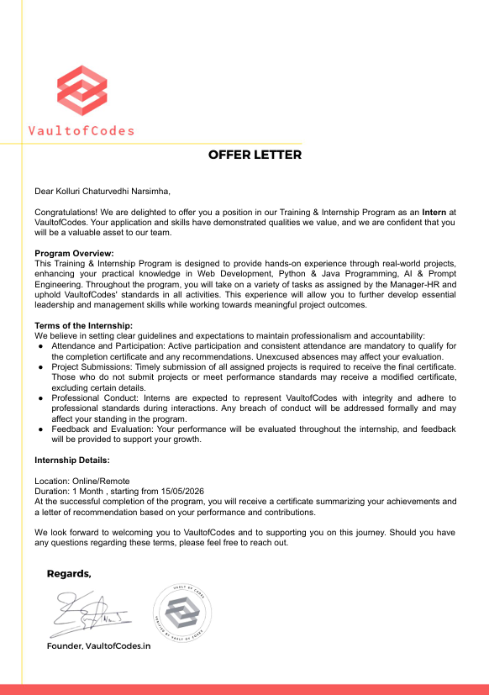
Screenshots / Designs
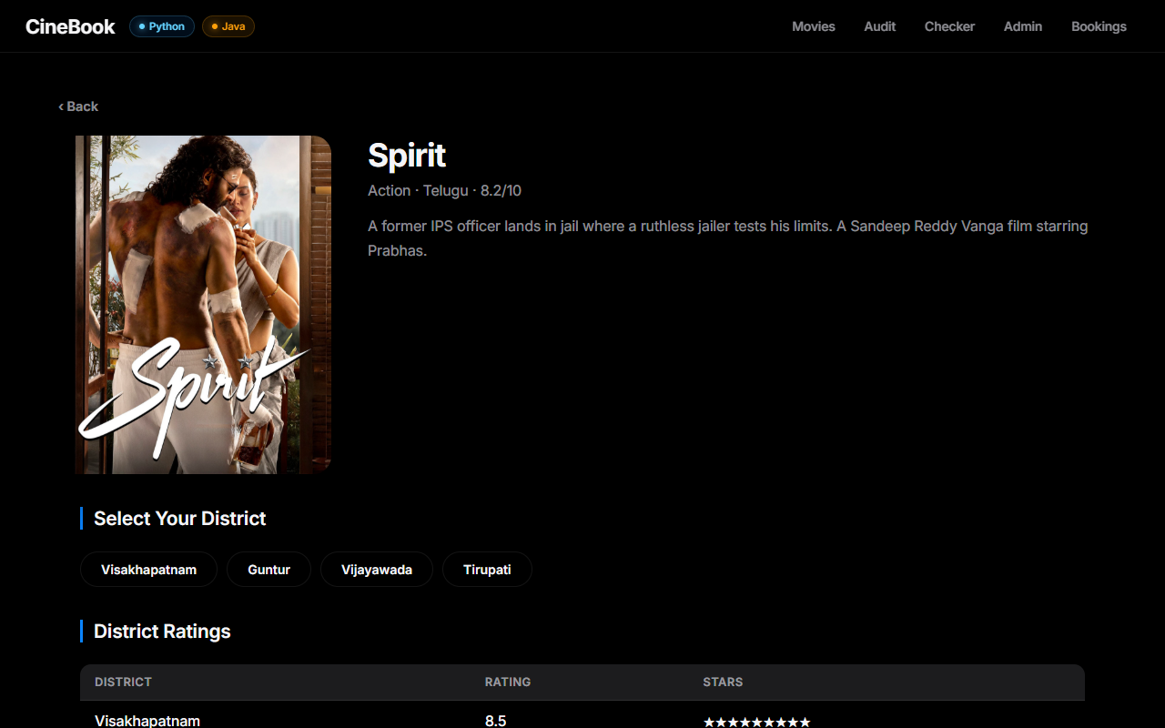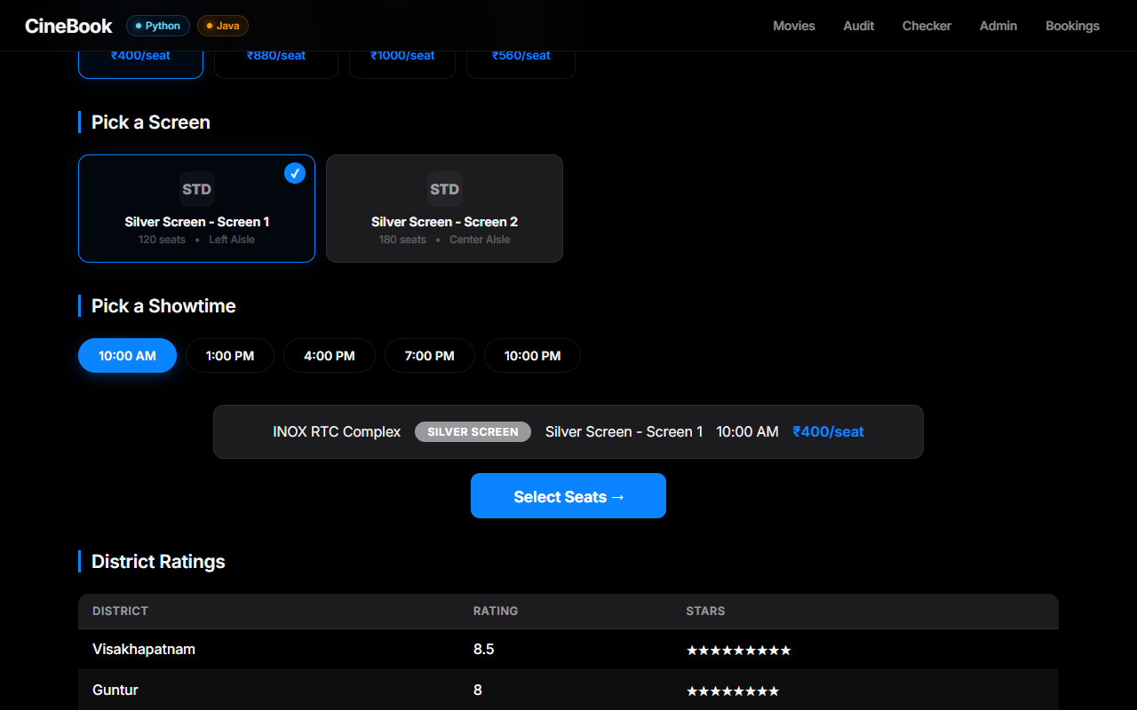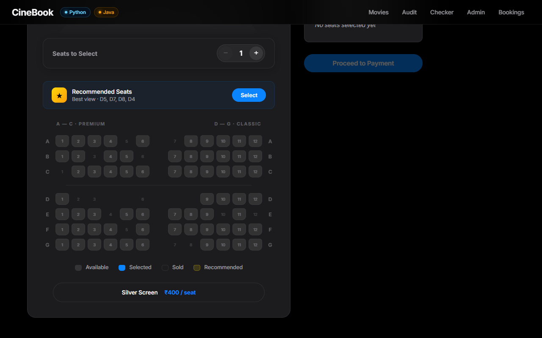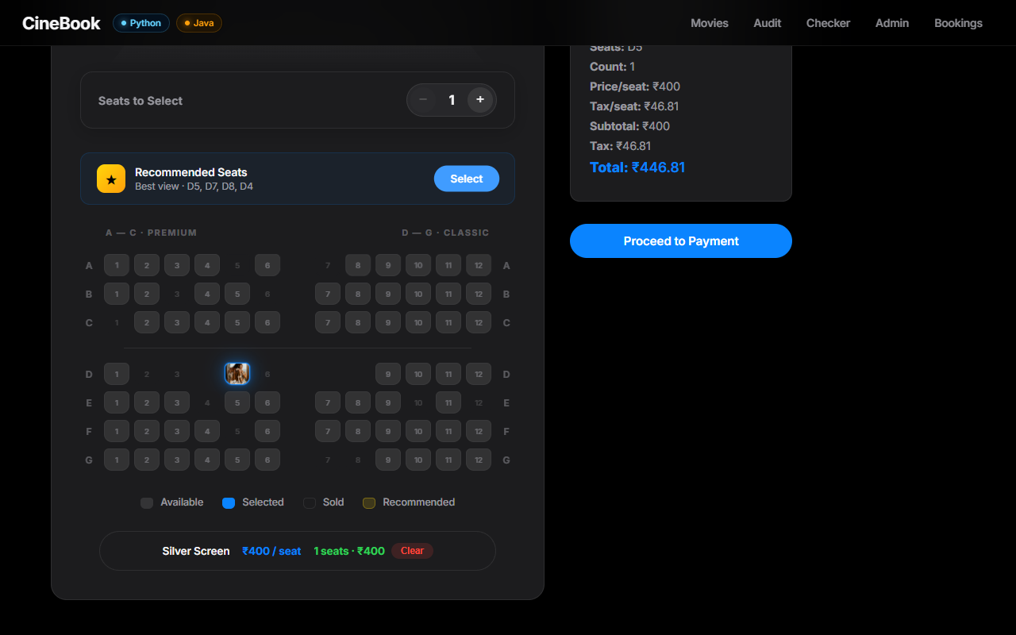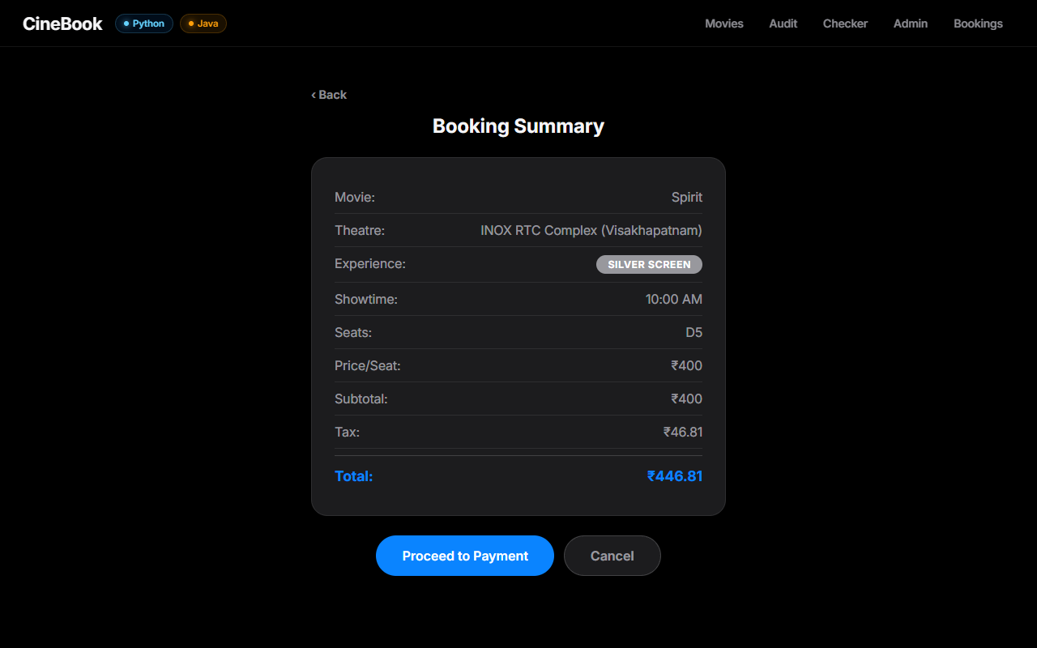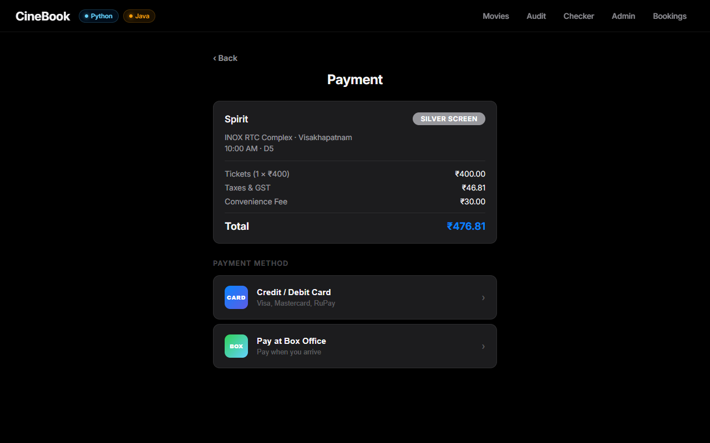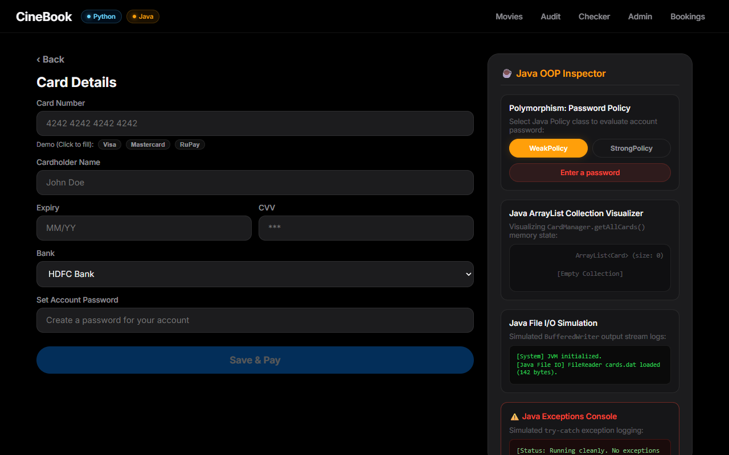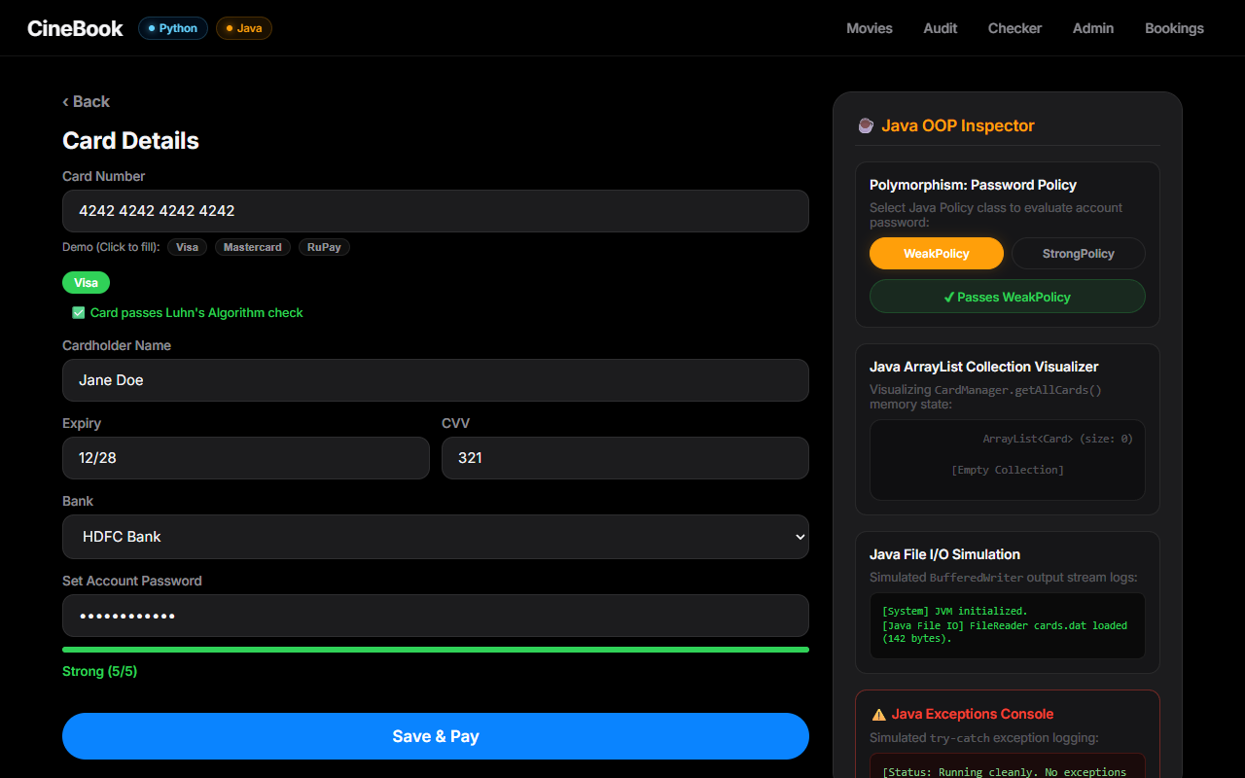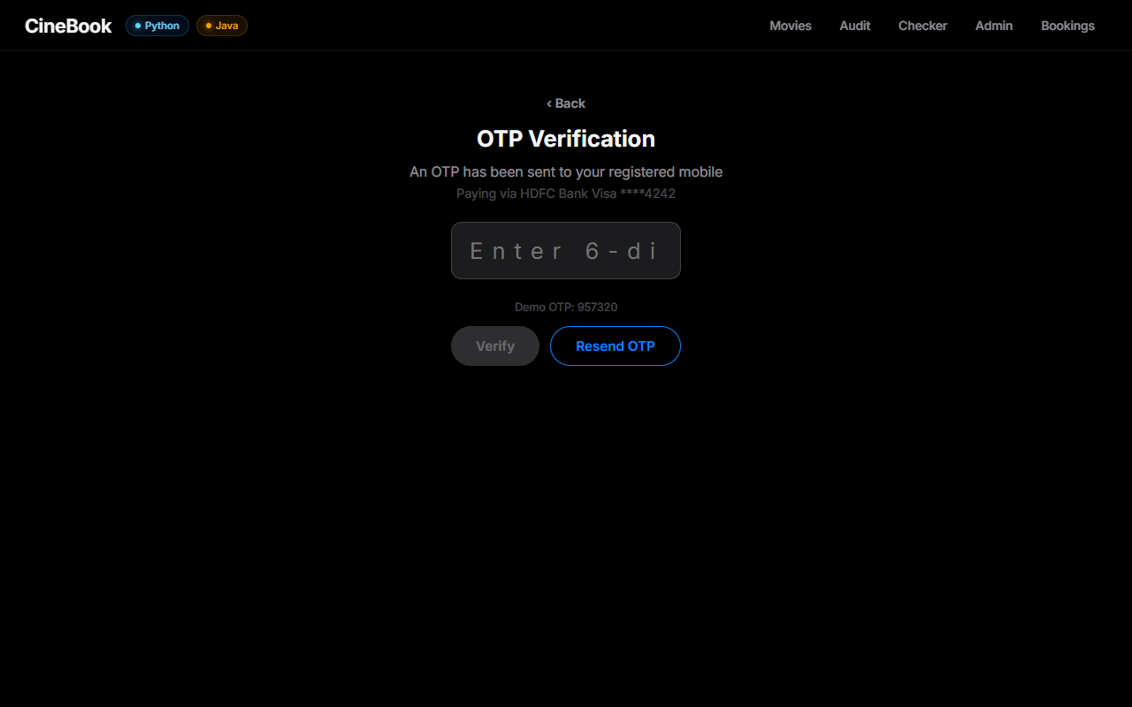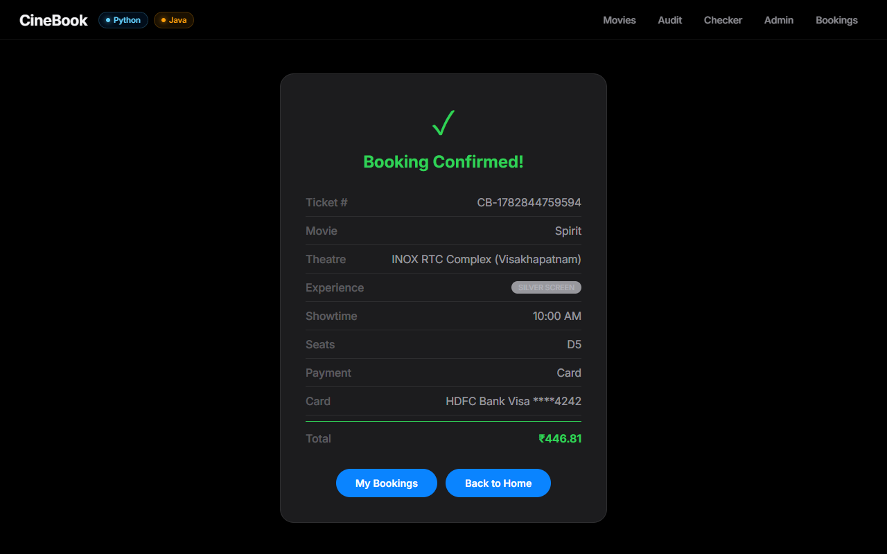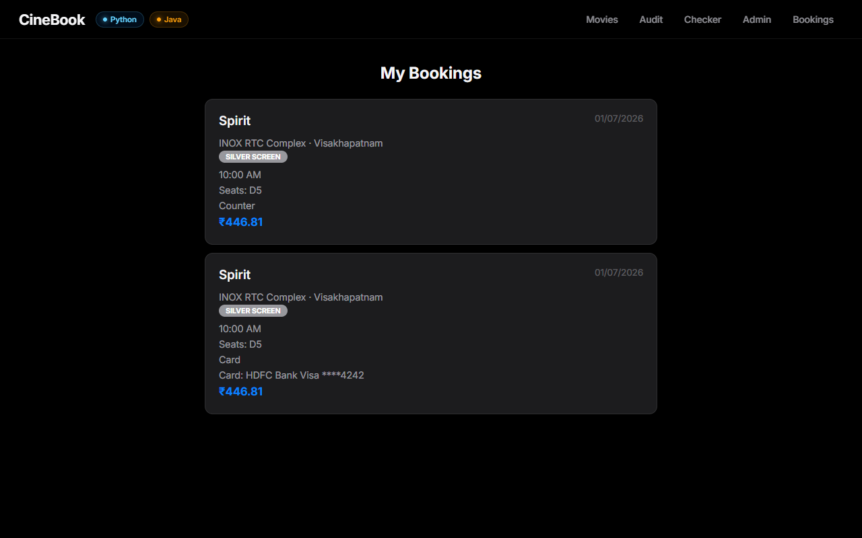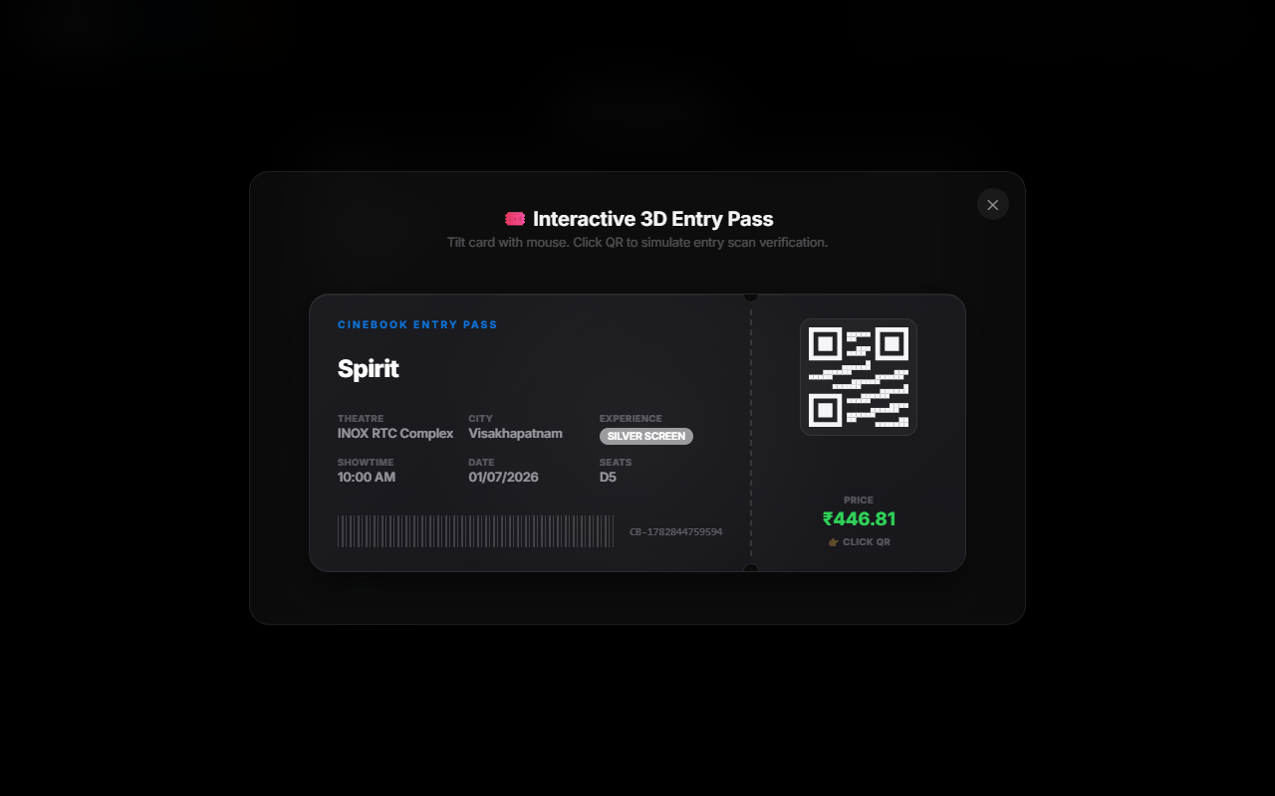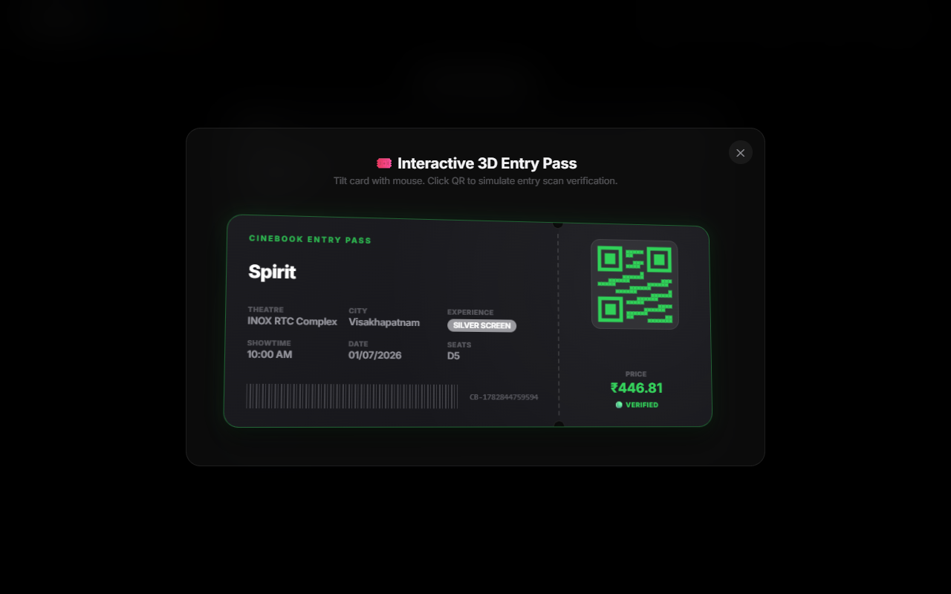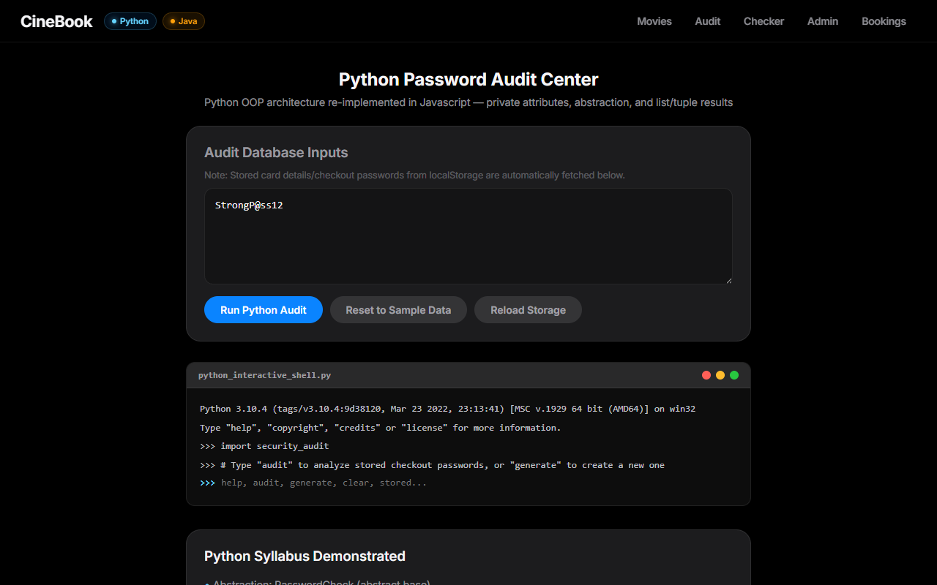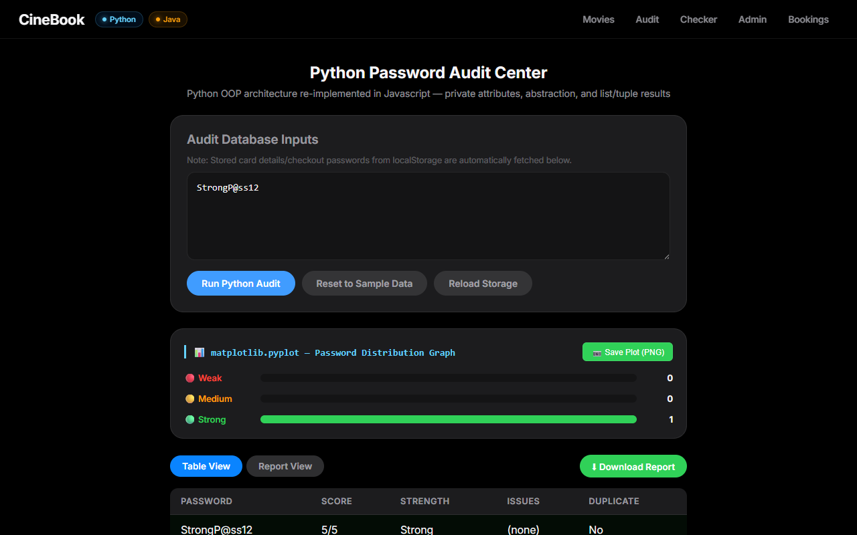
Architecture Design
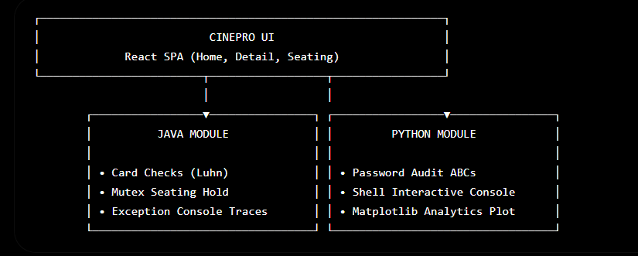
Below are the system architecture diagrams outlining the structural component interaction and transactional sequence flow of the CineBook ticketing application:
1. System Component Architecture
• React SPA Host: Serves as the primary application skeleton, executing client-side routing via a hash router and managing global movie session state using a centralized React context store.
• Vue Integration Containers: Bootstraps custom Vue.js instances (for checkout forms and password checkers) inside React container tags to support multiple framework syllabus requirements.
• Java payment security modules: Manages Card objects, validates digits using Luhn's algorithm, tracks ArrayList collection memory allocations, and records transaction logs on disk via BufferedWriter.
• Python password auditing system: Inherits validation guidelines from an abstract PasswordCheck base class, executes CLI queries inside an interactive browser emulator, and plots statistics on an HTML5 canvas.
2. End-to-End Booking Sequence Flow
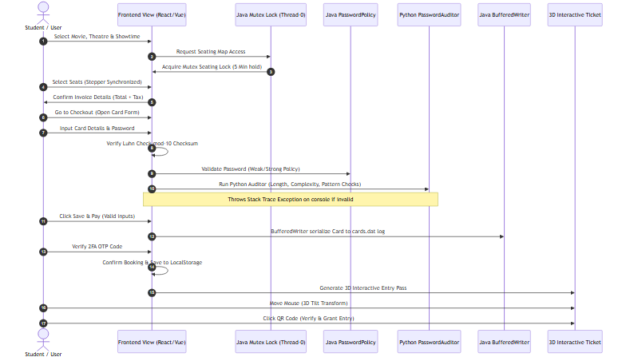
• Mutex Seating Lock: Initiates a background checkout thread (Thread-0) that locks coordinates for 5 minutes when a user clicks 'Select Seats', preventing double-bookings.
• Multi-language validations: Compares passwords against Weak/Strong guidelines in Java and evaluates duplicate/pattern metrics using Python scripts.
• JVM Exception Logging: Redirects errors and trace records to the console log stream to assist in real-time developer debugging.
• 3D Verification ticket pass: Once payments pass verification, the app generates a mouse-interactive ticket with custom QR codes that register entry scans on click.
Declaration
I hereby declare that the internship report titled “CareerX: All-in-One Internship Program” submitted by me in partial fulfillment of the requirements for the internship is an original work carried out by me during the internship period at VaultOfCodes. The information presented in this report is true to the best of my knowledge and has not been submitted elsewhere for any academic or professional purpose.

Name: Kolluri Chaturvedhi Narsimha
HTNO: 24EG109A28
Branch: Cyber Security - A
Date: ____
Signature: ____

