Personal Portfolio Website
Complete Project Documentation

Submitted by: Chaturvedhi Narsimha
Project: Personal Portfolio Website
Technologies: HTML5, CSS3, JavaScript, Python, Flask
Date: May 2026
Purpose: Web Development Internship Submission

COMPLETE CODE - index.html
<!DOCTYPE html>
<html lang="en">
<head>
<meta charset="UTF-8">
<meta name="viewport" content="width=device-width, initial-scale=1.0">
<title>John Doe | Portfolio</title>
<link rel="stylesheet" href="style.css">
<link href="https://fonts.googleapis.com/css2?family=Poppins:wght@300;400;500;600;700&display=swap" rel="stylesheet">
<link rel="stylesheet" href="https://cdnjs.cloudflare.com/ajax/libs/font-awesome/6.5.0/css/all.min.css">
</head>
<body>
<!-- ===== NAVBAR ===== -->
<nav class="navbar" id="navbar">
<div class="nav-container">
<a href="#home" class="nav-logo">JD</a>
<ul class="nav-menu" id="nav-menu">
<li><a href="#home" class="nav-link">Home</a></li>
<li><a href="#about" class="nav-link">About</a></li>
<li><a href="#skills" class="nav-link">Skills</a></li>
<li><a href="#interests" class="nav-link">Interests</a></li>
<li><a href="#projects" class="nav-link">Projects</a></li>
<li><a href="#contact" class="nav-link">Contact</a></li>
</ul>
<div class="nav-actions">
<button class="theme-toggle" id="theme-toggle" aria-label="Toggle dark mode">
<i class="fas fa-moon"></i>
</button>
<button class="hamburger" id="hamburger" aria-label="Toggle menu">
<span></span><span></span><span></span>
</button>
</div>
</div>
</nav>
<!-- ===== HERO / HOME SECTION ===== -->
<section class="hero" id="home">
<div class="hero-content">
<p class="hero-greeting">Hello, I'm</p>
<h1 class="hero-name">John Doe</h1>
<p class="hero-title">Frontend Developer | Web Development Intern</p>
<p class="hero-desc">
Passionate about building clean, responsive, and user-friendly websites.
Currently learning modern web technologies to create amazing digital experiences.
</p>
<div class="hero-btns">
<a href="#projects" class="btn btn-primary">View My Work</a>
<a href="#contact" class="btn btn-outline">Contact Me</a>
</div>
</div>
</section>
<!-- ===== ABOUT SECTION ===== -->
<section class="section" id="about">
<div class="container">
<h2 class="section-title">About Me</h2>
<div class="about-content">
<div class="about-text">
<p>
I'm an aspiring web developer exploring the world of frontend development.
I started with HTML and CSS to build static pages,
then added JavaScript to make them interactive.
I also have experience with Python and Java,
which helped me understand programming logic and problem-solving.
Recently, I've been diving into AI tools to see how
artificial intelligence can enhance web development workflows.
I enjoy learning new technologies and turning ideas into real, working projects.
</p>
</div>
</div>
</div>
</section>
<!-- ===== SKILLS SECTION ===== -->
<section class="section section-alt" id="skills">
<div class="container">
<h2 class="section-title">My Skills</h2>
<div class="skills-grid">
<div class="skill-item">
<div class="skill-info">
<span>HTML</span><span>90%</span>
</div>
<div class="skill-bar"><div class="skill-fill" style="width:90%"></div></div>
</div>
<div class="skill-item">
<div class="skill-info">
<span>CSS</span><span>85%</span>
</div>
<div class="skill-bar"><div class="skill-fill" style="width:85%"></div></div>
</div>
<div class="skill-item">
<div class="skill-info">
<span>JavaScript</span><span>75%</span>
</div>
<div class="skill-bar"><div class="skill-fill" style="width:75%"></div></div>
</div>
<div class="skill-item">
<div class="skill-info">
<span>Responsive Design</span><span>80%</span>
</div>
<div class="skill-bar"><div class="skill-fill" style="width:80%"></div></div>
</div>
<div class="skill-item">
<div class="skill-info">
<span>GitHub</span><span>70%</span>
</div>
<div class="skill-bar"><div class="skill-fill" style="width:70%"></div></div>
</div>
<div class="skill-item">
<div class="skill-info">
<span>Python</span><span>70%</span>
</div>
<div class="skill-bar"><div class="skill-fill" style="width:70%"></div></div>
</div>
<div class="skill-item">
<div class="skill-info">
<span>Java</span><span>65%</span>
</div>
<div class="skill-bar"><div class="skill-fill" style="width:65%"></div></div>
</div>
<div class="skill-item">
<div class="skill-info">
<span>AI Tools</span><span>75%</span>
</div>
<div class="skill-bar"><div class="skill-fill" style="width:75%"></div></div>
</div>
</div>
</div>
</section>
<!-- ===== INTERESTS SECTION ===== -->
<section class="section" id="interests">
<div class="container">
<h2 class="section-title">My Interests</h2>
<div class="interests-grid">
<div class="interest-card">
<i class="fas fa-code interest-icon"></i>
<h3>Web Development</h3>
<p>Building modern, responsive websites that look great on any device.</p>
</div>
<div class="interest-card">
<i class="fas fa-robot interest-icon"></i>
<h3>Artificial Intelligence</h3>
<p>Exploring AI tools and how they can improve development workflows.</p>
</div>
<div class="interest-card">
<i class="fas fa-paint-brush interest-icon"></i>
<h3>UI/UX Design</h3>
<p>Creating clean interfaces with great user experience and accessibility.</p>
</div>
<div class="interest-card">
<i class="fas fa-gamepad interest-icon"></i>
<h3>Gaming</h3>
<p>Enjoying strategy games and exploring game development concepts.</p>
</div>
</div>
</div>
</section>
<!-- ===== PROJECTS SECTION ===== -->
<section class="section section-alt" id="projects">
<div class="container">
<h2 class="section-title">My Projects</h2>
<div class="projects-grid">
<div class="project-card">
<div class="project-img">
<i class="fas fa-calculator"></i>
</div>
<div class="project-info">
<h3>Calculator App</h3>
<p>A fully functional calculator built with HTML, CSS, and JavaScript. Supports basic arithmetic operations with a clean user interface.</p>
<div class="project-btns">
<a href="#" class="btn btn-primary btn-sm">Demo</a>
<a href="#" class="btn btn-outline btn-sm">GitHub</a>
</div>
</div>
</div>
<div class="project-card">
<div class="project-img">
<i class="fas fa-list-check"></i>
</div>
<div class="project-info">
<h3>To-Do List App</h3>
<p>A task management app where users can add, complete, and delete tasks. Built using vanilla JavaScript with local storage support.</p>
<div class="project-btns">
<a href="#" class="btn btn-primary btn-sm">Demo</a>
<a href="#" class="btn btn-outline btn-sm">GitHub</a>
</div>
</div>
</div>
</div>
</div>
</section>
<!-- ===== CONTACT SECTION ===== -->
<section class="section" id="contact">
<div class="container">
<h2 class="section-title">Get In Touch</h2>
<div class="contact-content">
<div class="contact-info">
<div class="contact-item">
<i class="fas fa-envelope"></i>
<div>
<h4>Email</h4>
<p>john.doe@example.com</p>
</div>
</div>
<div class="contact-item">
<i class="fab fa-linkedin"></i>
<div>
<h4>LinkedIn</h4>
<p>linkedin.com/in/johndoe</p>
</div>
</div>
<div class="contact-item">
<i class="fab fa-github"></i>
<div>
<h4>GitHub</h4>
<p>github.com/johndoe</p>
</div>
</div>
</div>
<form class="contact-form" id="contact-form">
<input type="text" placeholder="Your Name" required>
<input type="email" placeholder="Your Email" required>
<textarea rows="5" placeholder="Your Message" required></textarea>
<button type="submit" class="btn btn-primary">Send Message</button>
</form>
</div>
</div>
</section>
<!-- ===== FOOTER ===== -->
<footer class="footer">
<div class="container">
<div class="footer-social">
<a href="#" aria-label="GitHub"><i class="fab fa-github"></i></a>
<a href="#" aria-label="LinkedIn"><i class="fab fa-linkedin"></i></a>
<a href="#" aria-label="Twitter"><i class="fab fa-twitter"></i></a>
</div>
<p>&copy; 2026 John Doe. All rights reserved.</p>
</div>
</footer>
<!-- ===== SCROLL TO TOP BUTTON ===== -->
<button class="scroll-top" id="scroll-top" aria-label="Scroll to top">
<i class="fas fa-arrow-up"></i>
</button>
<script src="script.js"></script>
</body>
</html>

COMPLETE CODE - style.css
/* ===== RESET & BASE ===== */
* {
margin: 0;
padding: 0;
box-sizing: border-box;
}
body {
font-family: 'Poppins', sans-serif;
background-color: #ffffff;
color: #1e293b;
line-height: 1.6;
}
.container {
max-width: 1100px;
margin: 0 auto;
padding: 0 20px;
}
.section {
padding: 80px 0;
}
.section-alt {
background-color: #f1f5f9;
}
.section-title {
font-size: 32px;
text-align: center;
margin-bottom: 50px;
padding-bottom: 15px;
border-bottom: 4px solid #2563eb;
display: inline-block;
width: 100%;
}
/* ===== BUTTONS ===== */
.btn {
display: inline-block;
padding: 12px 28px;
font-size: 15px;
font-weight: 500;
cursor: pointer;
text-decoration: none;
border: 2px solid transparent;
}
.btn-primary {
background: #2563eb;
color: #ffffff;
border-color: #2563eb;
}
.btn-outline {
background: transparent;
color: #2563eb;
border-color: #2563eb;
}
.btn-sm {
padding: 8px 18px;
font-size: 14px;
}
/* ===== NAVBAR ===== */
.navbar {
position: fixed;
top: 0;
left: 0;
width: 100%;
background: #ffffff;
z-index: 1000;
border-bottom: 1px solid #e2e8f0;
}
.nav-container {
max-width: 1100px;
margin: 0 auto;
padding: 0 20px;
display: flex;
justify-content: space-between;
align-items: center;
height: 70px;
}
.nav-logo {
font-size: 26px;
font-weight: 700;
color: #2563eb;
text-decoration: none;
}
.nav-menu {
display: flex;
list-style: none;
gap: 30px;
}
.nav-link {
text-decoration: none;
color: #1e293b;
font-weight: 500;
font-size: 15px;
}
.nav-actions {
display: flex;
align-items: center;
gap: 12px;
}
.theme-toggle {
background: none;
border: none;
font-size: 20px;
color: #1e293b;
cursor: pointer;
padding: 6px;
}
.hamburger {
display: none;
flex-direction: column;
gap: 5px;
background: none;
border: none;
cursor: pointer;
padding: 4px;
}
.hamburger span {
display: block;
width: 24px;
height: 2px;
background: #1e293b;
}
/* ===== HERO ===== */
.hero {
min-height: 100vh;
display: flex;
align-items: center;
justify-content: center;
text-align: center;
padding: 120px 20px 60px;
background: #f8fafc;
}
.hero-content {
max-width: 700px;
}
.hero-greeting {
font-size: 18px;
color: #2563eb;
font-weight: 500;
margin-bottom: 10px;
}
.hero-name {
font-size: 52px;
font-weight: 700;
margin-bottom: 10px;
}
.hero-title {
font-size: 20px;
color: #2563eb;
font-weight: 500;
margin-bottom: 20px;
}
.hero-desc {
font-size: 17px;
color: #64748b;
margin-bottom: 35px;
line-height: 1.7;
}
.hero-btns {
display: flex;
gap: 16px;
justify-content: center;
flex-wrap: wrap;
}
/* ===== ABOUT ===== */
.about-content {
max-width: 800px;
margin: 0 auto;
text-align: center;
}
.about-text p {
font-size: 17px;
color: #64748b;
line-height: 1.8;
}
/* ===== SKILLS ===== */
.skills-grid {
max-width: 600px;
margin: 0 auto;
display: flex;
flex-direction: column;
gap: 22px;
}
.skill-info {
display: flex;
justify-content: space-between;
margin-bottom: 6px;
font-size: 15px;
font-weight: 500;
}
.skill-bar {
height: 10px;
background: #e2e8f0;
overflow: hidden;
}
.skill-fill {
height: 100%;
background: #2563eb;
}
/* ===== INTERESTS ===== */
.interests-grid {
display: grid;
grid-template-columns: repeat(auto-fit, minmax(220px, 1fr));
gap: 24px;
}
.interest-card {
background: #ffffff;
padding: 35px 25px;
text-align: center;
box-shadow: 0 4px 20px rgba(0, 0, 0, 0.08);
}
.interest-icon {
font-size: 36px;
color: #2563eb;
margin-bottom: 18px;
}
.interest-card h3 {
font-size: 18px;
margin-bottom: 10px;
}
.interest-card p {
font-size: 15px;
color: #64748b;
}
/* ===== PROJECTS ===== */
.projects-grid {
display: grid;
grid-template-columns: repeat(auto-fit, minmax(300px, 1fr));
gap: 30px;
}
.project-card {
background: #ffffff;
overflow: hidden;
box-shadow: 0 4px 20px rgba(0, 0, 0, 0.08);
}
.project-img {
background: #2563eb;
height: 160px;
display: flex;
align-items: center;
justify-content: center;
font-size: 56px;
color: rgba(255, 255, 255, 0.85);
}
.project-info {
padding: 24px;
}
.project-info h3 {
font-size: 20px;
margin-bottom: 10px;
}
.project-info p {
font-size: 15px;
color: #64748b;
margin-bottom: 18px;
}
.project-btns {
display: flex;
gap: 10px;
flex-wrap: wrap;
}
/* ===== CONTACT ===== */
.contact-content {
display: grid;
grid-template-columns: 1fr 1.5fr;
gap: 50px;
align-items: start;
}
.contact-info {
display: flex;
flex-direction: column;
gap: 28px;
}
.contact-item {
display: flex;
align-items: center;
gap: 16px;
}
.contact-item i {
font-size: 22px;
color: #2563eb;
width: 44px;
height: 44px;
display: flex;
align-items: center;
justify-content: center;
background: #f1f5f9;
}
.contact-item h4 {
font-size: 16px;
margin-bottom: 2px;
}
.contact-item p {
font-size: 14px;
color: #64748b;
}
.contact-form {
display: flex;
flex-direction: column;
gap: 16px;
}
.contact-form input,
.contact-form textarea {
padding: 14px 18px;
border: 1px solid #e2e8f0;
background: #ffffff;
color: #1e293b;
font-family: 'Poppins', sans-serif;
font-size: 15px;
}
.contact-form input:focus,
.contact-form textarea:focus {
outline: none;
border-color: #2563eb;
}
.contact-form button {
align-self: flex-start;
border: none;
}
/* ===== FOOTER ===== */
.footer {
background: #f1f5f9;
padding: 40px 0;
text-align: center;
border-top: 1px solid #e2e8f0;
}
.footer-social {
display: flex;
justify-content: center;
gap: 20px;
margin-bottom: 16px;
}
.footer-social a {
color: #64748b;
font-size: 22px;
}
.footer p {
font-size: 14px;
color: #64748b;
}
/* ===== SCROLL TO TOP ===== */
.scroll-top {
position: fixed;
bottom: 30px;
right: 30px;
width: 44px;
height: 44px;
background: #2563eb;
color: #ffffff;
border: none;
font-size: 18px;
cursor: pointer;
opacity: 0;
visibility: hidden;
z-index: 999;
box-shadow: 0 4px 14px rgba(37, 99, 235, 0.3);
}
.scroll-top.show {
opacity: 1;
visibility: visible;
}
/* ===== DARK MODE ===== */
body.dark {
background-color: #0f172a;
color: #f1f5f9;
}
body.dark .navbar {
background: #0f172a;
border-bottom-color: #334155;
}
body.dark .nav-link {
color: #f1f5f9;
}
body.dark .theme-toggle {
color: #f1f5f9;
}
body.dark .hamburger span {
background: #f1f5f9;
}
body.dark .hero {
background: #0f172a;
}
body.dark .hero-desc {
color: #94a3b8;
}
body.dark .section-alt {
background-color: #1e293b;
}
body.dark .interest-card {
background: #1e293b;
box-shadow: 0 4px 20px rgba(0, 0, 0, 0.3);
}
body.dark .project-card {
background: #1e293b;
box-shadow: 0 4px 20px rgba(0, 0, 0, 0.3);
}
body.dark .project-info p {
color: #94a3b8;
}
body.dark .contact-item i {
background: #0f172a;
}
body.dark .contact-item p {
color: #94a3b8;
}
body.dark .contact-form input,
body.dark .contact-form textarea {
background: #1e293b;
border-color: #334155;
color: #f1f5f9;
}
body.dark .footer {
background: #1e293b;
border-top-color: #334155;
}
body.dark .footer-social a {
color: #94a3b8;
}
body.dark .footer p {
color: #94a3b8;
}
body.dark .skill-bar {
background: #334155;
}
body.dark .about-text p {
color: #94a3b8;
}
/* ===== RESPONSIVE - TABLET ===== */
@media (max-width: 768px) {
.hero-name {
font-size: 38px;
}
.section-title {
font-size: 28px;
}
.contact-content {
grid-template-columns: 1fr;
gap: 40px;
}
.projects-grid {
grid-template-columns: 1fr;
}
}
/* ===== RESPONSIVE - MOBILE ===== */
@media (max-width: 576px) {
.hamburger {
display: flex;
}
.nav-menu {
position: fixed;
top: 70px;
left: -100%;
width: 100%;
flex-direction: column;
background: #ffffff;
gap: 0;
padding: 20px 0;
border-bottom: 1px solid #e2e8f0;
text-align: center;
}
body.dark .nav-menu {
background: #0f172a;
border-bottom-color: #334155;
}
.nav-menu.active {
left: 0;
}
.nav-menu li {
width: 100%;
}
.nav-link {
display: block;
padding: 14px 20px;
}
.hero-name {
font-size: 32px;
}
.hero-title {
font-size: 16px;
}
.hero-btns {
flex-direction: column;
align-items: center;
}
.section {
padding: 60px 0;
}
.interests-grid {
grid-template-columns: 1fr;
}
.projects-grid {
grid-template-columns: 1fr;
}
.contact-form button {
width: 100%;
text-align: center;
}
.scroll-top {
bottom: 20px;
right: 20px;
}
}

COMPLETE CODE - script.js
/* ===== DARK MODE TOGGLE ===== */
const themeToggle = document.getElementById('theme-toggle');
const icon = themeToggle.querySelector('i');
// Check for saved theme preference
const savedTheme = localStorage.getItem('theme');
if (savedTheme === 'dark') {
document.body.classList.add('dark');
icon.classList.replace('fa-moon', 'fa-sun');
}
themeToggle.addEventListener('click', () => {
document.body.classList.toggle('dark');
if (document.body.classList.contains('dark')) {
icon.classList.replace('fa-moon', 'fa-sun');
localStorage.setItem('theme', 'dark');
} else {
icon.classList.replace('fa-sun', 'fa-moon');
localStorage.setItem('theme', 'light');
}
});
/* ===== MOBILE NAVBAR TOGGLE ===== */
const hamburger = document.getElementById('hamburger');
const navMenu = document.getElementById('nav-menu');
hamburger.addEventListener('click', () => {
navMenu.classList.toggle('active');
});
document.querySelectorAll('.nav-link').forEach(link => {
link.addEventListener('click', () => {
navMenu.classList.remove('active');
});
});
/* ===== SCROLL-TO-TOP BUTTON ===== */
const scrollTopBtn = document.getElementById('scroll-top');
window.addEventListener('scroll', () => {
if (window.scrollY > 400) {
scrollTopBtn.classList.add('show');
} else {
scrollTopBtn.classList.remove('show');
}
});
scrollTopBtn.addEventListener('click', () => {
window.scrollTo({ top: 0, behavior: 'smooth' });
});
/* ===== CONTACT FORM HANDLING ===== */
const contactForm = document.getElementById('contact-form');
contactForm.addEventListener('submit', (e) => {
e.preventDefault();
const formData = {
name: contactForm.querySelector('input[type="text"]').value,
email: contactForm.querySelector('input[type="email"]').value,
message: contactForm.querySelector('textarea').value
};
fetch('http://localhost:5000/contact', {
method: 'POST',
headers: {
'Content-Type': 'application/json'
},
body: JSON.stringify(formData)
})
.then(response => response.json())
.then(data => {
if (data.success) {
alert('Message sent successfully!');
contactForm.reset();
} else {
alert('Error: ' + data.message);
}
})
.catch(error => {
console.error('Error:', error);
alert('Failed to connect to backend.');
});
});
/* ===== BACKEND CONNECTION EXAMPLES ===== */
// Fetch projects from backend
/*
fetch('http://localhost:5000/projects')
.then(response => response.json())
.then(data => {
console.log('Projects:', data.projects);
});
*/
// Fetch skills from backend
/*
fetch('http://localhost:5000/skills')
.then(response => response.json())
.then(data => {
console.log('Skills:', data.skills);
});
*/

COMPLETE CODE - backend/app.py
from flask import Flask, request, jsonify
from flask_cors import CORS
from routes import contact_routes
from routes.data_routes import data_routes
app = Flask(__name__)
CORS(app)
app.register_blueprint(contact_routes)
app.register_blueprint(data_routes)
@app.route('/')
def home():
return jsonify({
"status": "running",
"message": "Portfolio Backend Running",
"version": "1.0"
})
@app.errorhandler(404)
def not_found(error):
return jsonify({
"success": False,
"error": "Route not found"
}), 404
@app.errorhandler(405)
def method_not_allowed(error):
return jsonify({
"success": False,
"error": "Method not allowed"
}), 405
@app.errorhandler(500)
def server_error(error):
return jsonify({
"success": False,
"error": "Internal server error"
}), 500
if __name__ == "__main__":
print("Starting Portfolio Backend on http://localhost:5000")
print("Press Ctrl+C to stop the server")
app.run(debug=True, port=5000)

COMPLETE CODE - backend/routes/__init__.py
from flask import Blueprint, request, jsonify
import re
contact_routes = Blueprint('contact_routes', __name__)
contact_messages = []
@contact_routes.route('/contact', methods=['POST'])
def submit_contact():
data = request.get_json()
if not data:
return jsonify({
"success": False,
"message": "No data provided"
}), 400
name = data.get('name', '').strip()
email = data.get('email', '').strip()
message = data.get('message', '').strip()
if not name:
return jsonify({
"success": False,
"message": "Name is required"
}), 400
if not email:
return jsonify({
"success": False,
"message": "Email is required"
}), 400
if not message:
return jsonify({
"success": False,
"message": "Message is required"
}), 400
email_pattern = r'^[a-zA-Z0-9._%+-]+@[a-zA-Z0-9.-]+\.[a-zA-Z]{2,}$'
if not re.match(email_pattern, email):
return jsonify({
"success": False,
"message": "Invalid email format"
}), 400
new_message = {
"id": len(contact_messages) + 1,
"name": name,
"email": email,
"message": message
}
contact_messages.append(new_message)
print(f"New contact message from {name} ({email})")
return jsonify({
"success": True,
"message": "Message received successfully",
"data": new_message
}), 200
@contact_routes.route('/contact', methods=['GET'])
def get_contacts():
return jsonify({
"success": True,
"count": len(contact_messages),
"messages": contact_messages
}), 200

COMPLETE CODE - backend/routes/data_routes.py
from flask import Blueprint, jsonify
data_routes = Blueprint('data_routes', __name__)
projects_data = [
{
"id": 1,
"title": "Calculator App",
"description": "A fully functional calculator built with HTML, CSS, and JavaScript.",
"technologies": ["HTML", "CSS", "JavaScript"],
"github_url": "#",
"demo_url": "#"
},
{
"id": 2,
"title": "To-Do List App",
"description": "A task management app where users can add, complete, and delete tasks.",
"technologies": ["HTML", "CSS", "JavaScript", "LocalStorage"],
"github_url": "#",
"demo_url": "#"
}
]
skills_data = [
{"name": "HTML", "level": 90},
{"name": "CSS", "level": 85},
{"name": "JavaScript", "level": 75},
{"name": "Responsive Design", "level": 80},
{"name": "GitHub", "level": 70},
{"name": "Python", "level": 70},
{"name": "Java", "level": 65},
{"name": "AI Tools", "level": 75}
]
about_data = {
"name": "John Doe",
"title": "Frontend Developer | Web Development Intern",
"bio": "I'm an aspiring web developer exploring the world of frontend development...",
"interests": [
{"title": "Web Development", "description": "Building modern, responsive websites"},
{"title": "Artificial Intelligence", "description": "Exploring AI tools for development"},
{"title": "UI/UX Design", "description": "Creating clean user interfaces"},
{"title": "Gaming", "description": "Strategy games and game development"}
]
}
@data_routes.route('/projects', methods=['GET'])
def get_projects():
return jsonify({
"success": True,
"count": len(projects_data),
"projects": projects_data
}), 200
@data_routes.route('/skills', methods=['GET'])
def get_skills():
return jsonify({
"success": True,
"skills": skills_data
}), 200
@data_routes.route('/about', methods=['GET'])
def get_about():
return jsonify({
"success": True,
"about": about_data
}), 200

PROJECT SCREENSHOTS

Below are actual screenshots captured from the running portfolio website.

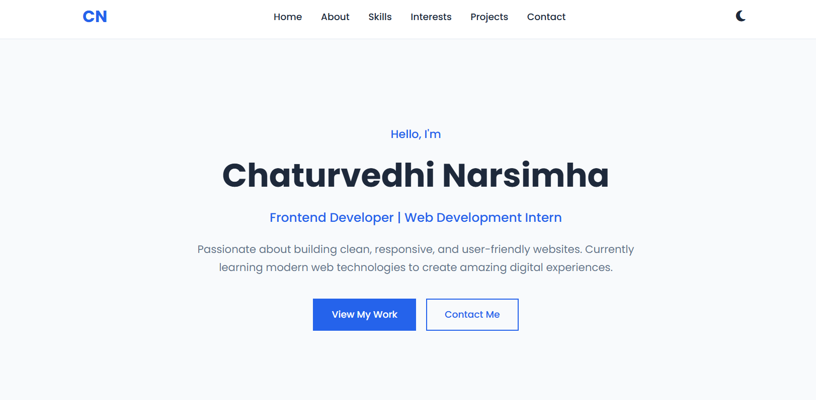
Figure 1: Home Section

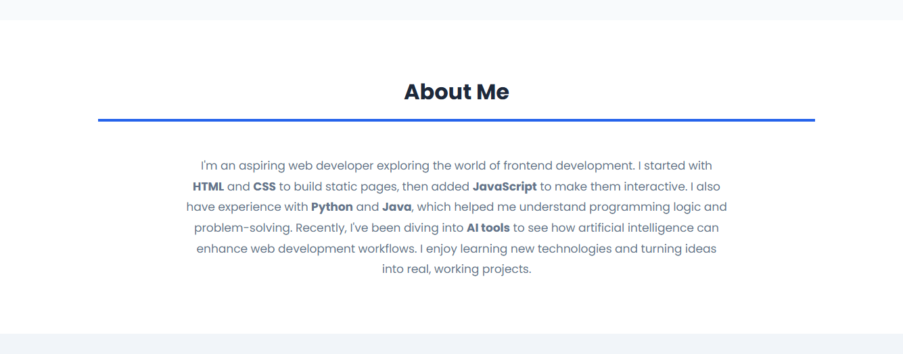
Figure 2: About Section

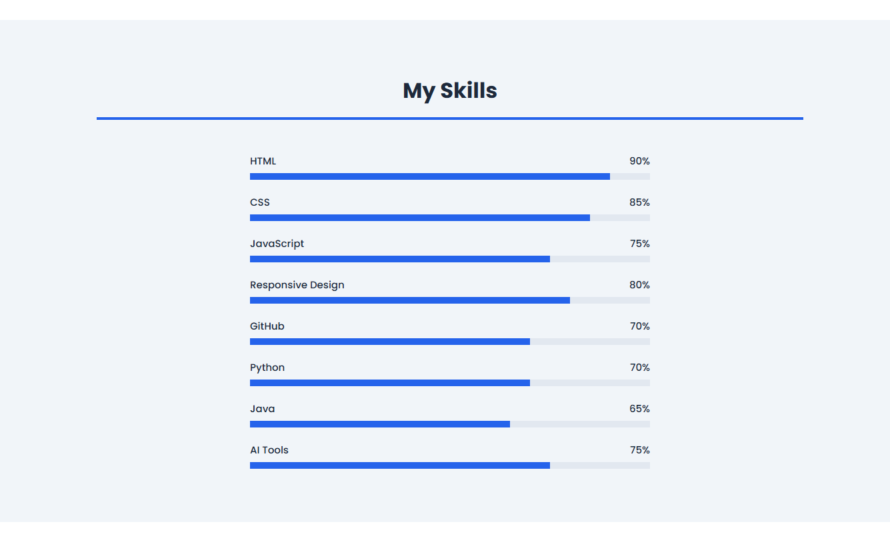
Figure 3: Skills Section

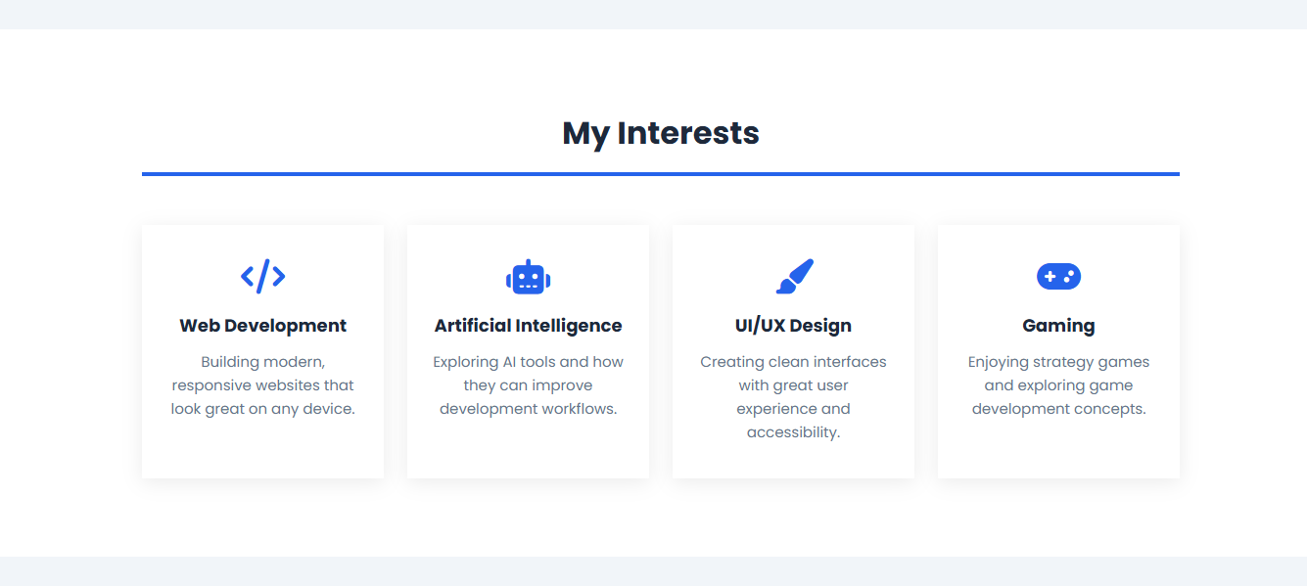
Figure 4: Interests Section

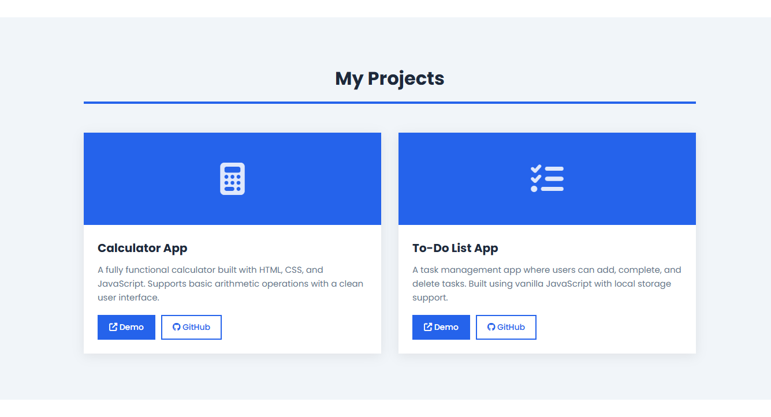
Figure 5: Projects Section

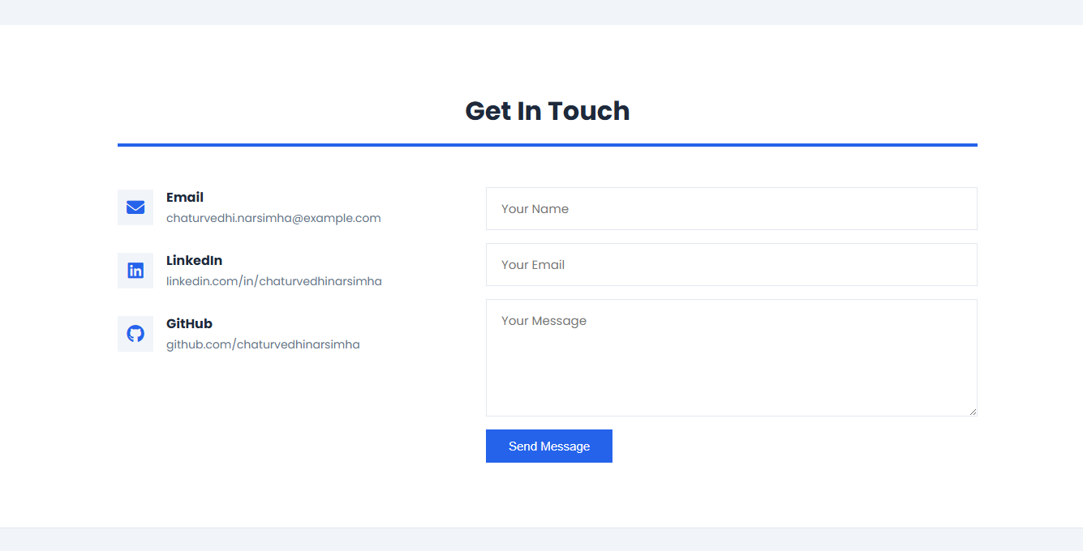
Figure 6: Contact Section

