CineBook
Movie Ticket Booking

Project Report
Pure Frontend React SPA
No Build Tools · No npm · No Server

June 2026
All code and screenshots included.

Table of Contents
1. Project Overview
2. File Structure
3. Code Listing - index.html
4. Code Listing - styles/style.css
5. Code Listing - src/data/movies.js
6. Code Listing - src/context/BookingContext.js
7. Code Listing - src/components (6 files)
8. Code Listing - src/pages (5 files)
9. Code Listing - src/App.js
10. Code Listing - src/main.js
11. Screenshots

1. Project Overview
CineBook - A pure frontend React SPA for movie ticket booking.
Loads via index.html in any browser using React 18 CDN.
No build tools, no npm, no server required.

Features: 10 Indian movies, hash-based routing (5 pages),
interactive seat map (7 rows x 12 seats), price breakdown
with subtotal/tax/total, search and genre filter,
responsive design (breakpoints at 900px and 600px).

2. File Structure
FINAL_PROJECT_WEBDEV/
index.html Entry point + CDN scripts
styles/style.css All CSS (221 lines)
src/data/movies.js Movie data + pricing
src/context/BookingContext.js Global state
src/components/ Navbar, MovieCard, Seat,
SeatMap, ShowtimeSelector,
BookingSummary
src/pages/ Home, MovieDetail, BookingPage,
ConfirmPage, MyBookings
src/App.js Hash-based router
src/main.js ReactDOM.createRoot
posters/ SPIRIT1.jpg, VARNASHI2.jpeg
output/ Generated report files

3. index.html
<!DOCTYPE html>
<html lang="en">
<head>
<meta charset="UTF-8" />
<meta name="viewport" content="width=device-width, initial-scale=1.0" />
<title>CineBook - Movie Ticket Booking</title>
<link rel="stylesheet" href="styles/style.css" />
</head>
<body>
<div id="root"></div>
<script crossorigin src="https://unpkg.com/react@18/umd/react.production.min.js"></script>
<script crossorigin src="https://unpkg.com/react-dom@18/umd/react-dom.production.min.js"></script>
<script src="src/data/movies.js"></script>
<script src="src/context/BookingContext.js"></script>
<script src="src/components/Navbar.js"></script>
<script src="src/components/MovieCard.js"></script>
<script src="src/components/Seat.js"></script>
<script src="src/components/SeatMap.js"></script>
<script src="src/components/ShowtimeSelector.js"></script>
<script src="src/components/BookingSummary.js"></script>
<script src="src/pages/Home.js"></script>
<script src="src/pages/MovieDetail.js"></script>
<script src="src/pages/BookingPage.js"></script>
<script src="src/pages/ConfirmPage.js"></script>
<script src="src/pages/MyBookings.js"></script>
<script src="src/App.js"></script>
<script src="src/main.js"></script>
</body>
</html>

4. styles/style.css
:root {
--bg: #0f0f1a;
--surface: #1a1a2e;
--surface2: #16213e;
--primary: #e94560;
--primary-hover: #ff6b81;
--accent: #0f3460;
--text: #eee;
--text-muted: #999;
--border: #2a2a4a;
--radius: 8px;
--max-width: 1200px;
}
* { margin: 0; padding: 0; box-sizing: border-box; }
body {
font-family: "Segoe UI", system-ui, -apple-system, sans-serif;
background: var(--bg);
color: var(--text);
min-height: 100vh;
}
a { text-decoration: none; color: inherit; }
.navbar {
background: var(--surface);
padding: 16px 24px;
display: flex;
justify-content: space-between;
align-items: center;
border-bottom: 1px solid var(--border);
position: sticky;
top: 0;
z-index: 100;
}
.navbar-brand { font-size: 1.5rem; font-weight: 700; color: var(--primary); cursor: pointer; }
.navbar-links { display: flex; gap: 20px; }
.navbar-links a { color: var(--text-muted); cursor: pointer; transition: color 0.2s; }
.navbar-links a:hover { color: var(--text); }
.hero { text-align: center; padding: 48px 20px 32px; }
.hero h1 { font-size: 2rem; margin-bottom: 8px; }
.hero p { color: var(--text-muted); font-size: 1.1rem; }
.filters {
display: flex; gap: 12px;
max-width: 600px; margin: 0 auto 32px; padding: 0 20px;
}
.search-input, .genre-select {
padding: 10px 16px;
border: 1px solid var(--border);
border-radius: var(--radius);
background: var(--surface);
color: var(--text);
font-size: 0.95rem;
}
.search-input:focus, .genre-select:focus { outline: none; border-color: var(--primary); }
.search-input { flex: 1; }
.genre-select { cursor: pointer; }
.movies-grid {
display: grid;
grid-template-columns: repeat(auto-fill, minmax(180px, 1fr));
gap: 16px;
max-width: var(--max-width);
margin: 0 auto;
padding: 0 20px 40px;
}
.movie-card {
background: var(--surface);
border-radius: var(--radius);
overflow: hidden;
cursor: pointer;
transition: transform 0.2s ease, box-shadow 0.2s ease;
}
.movie-card:hover {
transform: translateY(-4px);
box-shadow: 0 8px 24px rgba(233, 69, 96, 0.15);
}
.movie-card-poster img { width: 100%; aspect-ratio: 2/3; object-fit: cover; display: block; }
.movie-card-info { padding: 12px; display: flex; flex-direction: column; gap: 4px; }
.movie-card-info h3 { font-size: 0.95rem; white-space: nowrap; overflow: hidden; text-overflow: ellipsis; }
.movie-genre { color: var(--primary); font-size: 0.8rem; font-weight: 600; text-transform: uppercase; letter-spacing: 0.5px; }
.movie-rating { color: var(--text-muted); font-size: 0.8rem; }
.movie-detail {
display: flex; gap: 32px;
max-width: var(--max-width); margin: 0 auto; padding: 40px 20px;
}
.movie-detail-poster { flex-shrink: 0; width: 300px; }
.movie-detail-poster img { width: 100%; border-radius: var(--radius); }
.movie-detail-info { flex: 1; display: flex; flex-direction: column; gap: 12px; }
.movie-detail-info h1 { font-size: 2rem; }
.movie-description { color: var(--text-muted); line-height: 1.6; margin: 8px 0; }
.showtime-selector h3 { margin-bottom: 12px; font-size: 1.1rem; }
.showtime-buttons { display: flex; flex-wrap: wrap; gap: 8px; }
.showtime-btn {
padding: 8px 20px;
border: 1px solid var(--border);
border-radius: var(--radius);
background: var(--surface);
color: var(--text);
cursor: pointer;
font-size: 0.9rem;
transition: all 0.2s;
}
.showtime-btn:hover { border-color: var(--primary); color: var(--primary); }
.showtime-btn.active { background: var(--primary); border-color: var(--primary); color: #fff; }
.btn-primary {
padding: 12px 28px;
background: var(--primary);
color: #fff;
border: none;
border-radius: var(--radius);
cursor: pointer;
font-size: 1rem;
font-weight: 600;
transition: background 0.2s;
display: inline-block;
text-align: center;
}
.btn-primary:hover { background: var(--primary-hover); }
.btn-primary:disabled { opacity: 0.5; cursor: not-allowed; }
.btn-secondary {
padding: 12px 28px;
background: var(--surface);
color: var(--text);
border: 1px solid var(--border);
border-radius: var(--radius);
cursor: pointer;
font-size: 1rem;
font-weight: 600;
transition: all 0.2s;
}
.btn-secondary:hover { border-color: var(--text-muted); }
.seat-map-container {
background: var(--surface);
border-radius: var(--radius);
padding: 32px;
display: flex;
flex-direction: column;
align-items: center;
gap: 8px;
}
.screen {
background: var(--accent);
color: var(--text-muted);
text-align: center;
padding: 12px;
width: 80%;
border-radius: 4px;
margin-bottom: 24px;
font-size: 0.85rem;
text-transform: uppercase;
letter-spacing: 4px;
}
.seat-row { display: flex; align-items: center; gap: 8px; }
.row-label { width: 20px; text-align: center; color: var(--text-muted); font-size: 0.8rem; font-weight: 600; }
.seats { display: flex; gap: 6px; }
.seat {
width: 32px; height: 28px;
display: flex; align-items: center; justify-content: center;
font-size: 0.65rem; border-radius: 4px 4px 8px 8px;
cursor: pointer; user-select: none;
transition: transform 0.15s, background 0.15s;
font-weight: 600;
}
.seat:hover { transform: scale(1.1); }
.seat.available { background: #2d2d5e; color: var(--text-muted); }
.seat.available:hover { background: #3d3d7e; }
.seat.selected { background: var(--primary); color: #fff; }
.seat.booked { background: #333; color: #555; cursor: not-allowed; }
.seat-legend { display: flex; gap: 20px; margin-top: 20px; font-size: 0.8rem; color: var(--text-muted); }
.legend-box { display: inline-block; width: 16px; height: 14px; border-radius: 3px; margin-right: 6px; vertical-align: middle; }
.legend-box.available { background: #2d2d5e; }
.legend-box.selected { background: var(--primary); }
.legend-box.booked { background: #333; }
.booking-page { max-width: var(--max-width); margin: 0 auto; padding: 40px 20px; }
.booking-page h1 { margin-bottom: 16px; }
.booking-info { display: flex; gap: 24px; margin-bottom: 32px; color: var(--text-muted); }
.booking-layout { display: flex; gap: 32px; align-items: flex-start; }
.booking-sidebar { flex-shrink: 0; width: 260px; display: flex; flex-direction: column; gap: 16px; }
.booking-summary { background: var(--surface); border-radius: var(--radius); padding: 20px; }
.booking-summary h3 { margin-bottom: 12px; font-size: 1.1rem; }
.booking-summary p { margin-bottom: 8px; color: var(--text-muted); font-size: 0.9rem; }
.total-price { color: var(--primary) !important; font-size: 1.1rem !important; }
.empty-summary { color: var(--text-muted); font-style: italic; }
.confirm-page { max-width: 600px; margin: 0 auto; padding: 40px 20px; }
.confirm-page h1 { margin-bottom: 24px; }
.confirm-card { background: var(--surface); border-radius: var(--radius); padding: 32px; }
.confirm-card h2 { margin-bottom: 16px; }
.confirm-card p { margin-bottom: 8px; color: var(--text-muted); }
.confirm-card hr { border: none; border-top: 1px solid var(--border); margin: 16px 0; }
.confirm-card .total-price { font-size: 1.3rem !important; }
.confirm-actions { display: flex; gap: 12px; margin-top: 24px; }
.my-bookings-page { max-width: var(--max-width); margin: 0 auto; padding: 40px 20px; }
.my-bookings-page h1 { margin-bottom: 24px; }
.empty-state { text-align: center; padding: 60px 20px; color: var(--text-muted); }
.empty-state p { margin-bottom: 20px; font-size: 1.1rem; }
.bookings-list { display: flex; flex-direction: column; gap: 16px; }
.booking-card { background: var(--surface); border-radius: var(--radius); padding: 20px; transition: transform 0.2s; }
.booking-card:hover { transform: translateX(4px); }
.booking-card-header { display: flex; justify-content: space-between; align-items: center; margin-bottom: 12px; }
.booking-card-header h3 { color: var(--primary); }
.booking-date { color: var(--text-muted); font-size: 0.85rem; }
.booking-card p { margin-bottom: 4px; color: var(--text-muted); font-size: 0.9rem; }
.booking-total { margin-top: 8px !important; color: var(--primary) !important; font-size: 1.05rem !important; }
.not-found { text-align: center; padding: 80px 20px; }
.not-found h2 { margin-bottom: 20px; color: var(--text-muted); }
.no-results { text-align: center; padding: 40px; color: var(--text-muted); }
@media (max-width: 900px) {
.movie-detail { flex-direction: column; align-items: center; text-align: center; }
.movie-detail-poster { width: 200px; }
.showtime-buttons { justify-content: center; }
.booking-layout { flex-direction: column; align-items: center; }
.booking-sidebar { width: 100%; max-width: 400px; }
.booking-info { justify-content: center; }
}
@media (max-width: 600px) {
.hero h1 { font-size: 1.5rem; }
.filters { flex-direction: column; }
.movies-grid { grid-template-columns: repeat(2, 1fr); gap: 10px; }
.seat { width: 22px; height: 20px; font-size: 0.55rem; }
.seats { gap: 4px; }
.seat-map-container { padding: 16px; }
.confirm-actions { flex-direction: column; }
.navbar-brand { font-size: 1.2rem; }
}

5. src/data/movies.js
var MOVIES = [
{ id: 1, title: "Spirit", genre: "Action", rating: 8.2, poster: "posters/SPIRIT1.jpg", description: "A former IPS officer lands in jail where a ruthless jailer tests his limits. A Sandeep Reddy Vanga film starring Prabhas.", showtimes: ["10:00 AM","1:00 PM","4:00 PM","7:00 PM","10:00 PM"] },
{ id: 2, title: "Varanasi", genre: "Sci-Fi", rating: 8.6, poster: "posters/VARNASHI2.jpeg", description: "A Shiva devotee is sent on a mysterious mission to find an ancient cosmic artifact across continents. SS Rajamouli film starring Mahesh Babu.", showtimes: ["11:00 AM","2:00 PM","5:00 PM","8:00 PM"] },
{ id: 3, title: "Peddi", genre: "Sports", rating: 8.4, poster: "https://upload.wikimedia.org/wikipedia/en/2/26/Peddi_Poster.jpg", description: "In 1980s rural Andhra Pradesh, a spirited villager unites his community through sports to defend their pride against a powerful rival.", showtimes: ["9:00 AM","12:00 PM","3:00 PM","6:00 PM","9:00 PM"] },
{ id: 4, title: "Kantara", genre: "Thriller", rating: 8.8, poster: "https://upload.wikimedia.org/wikipedia/en/8/84/Kantara_poster.jpeg", description: "A clash between a tribal man and a landlord escalates into a battle of faith, nature, and ancient traditions in coastal Karnataka.", showtimes: ["10:30 AM","1:30 PM","4:30 PM","7:30 PM"] },
{ id: 5, title: "RRR", genre: "Action", rating: 8.9, poster: "https://upload.wikimedia.org/wikipedia/en/d/d7/RRR_Poster.jpg", description: "A fearless revolutionary and a reckless Indian policeman form an unlikely friendship in pre-independent India.", showtimes: ["10:00 AM","12:30 PM","3:00 PM","5:30 PM","8:00 PM"] },
{ id: 6, title: "Pushpa 2", genre: "Action", rating: 8.1, poster: "https://upload.wikimedia.org/wikipedia/en/1/11/Pushpa_2-_The_Rule.jpg", description: "Pushpa faces new challenges as he rises in the red sandalwood smuggling syndicate while battling enemies and personal demons.", showtimes: ["11:30 AM","2:30 PM","5:30 PM","8:30 PM"] },
{ id: 7, title: "Animal", genre: "Crime", rating: 7.8, poster: "https://upload.wikimedia.org/wikipedia/en/9/90/Animal_%282023_film%29_poster.jpg", description: "A wealthy businessman's son returns to take revenge on those who threatened his family, exploring the dark side of toxic masculinity.", showtimes: ["10:00 AM","1:00 PM","4:00 PM","7:00 PM"] },
{ id: 8, title: "Jailer", genre: "Comedy", rating: 8.0, poster: "https://upload.wikimedia.org/wikipedia/en/c/cb/Jailer_2023_Tamil_film_poster.jpg", description: "A retired jailer sets out to rescue his cop son from a ruthless gangster, uncovering a web of crime and corruption.", showtimes: ["9:30 AM","12:30 PM","3:30 PM","6:30 PM","9:30 PM"] },
{ id: 9, title: "Salaar", genre: "Action", rating: 7.9, poster: "https://upload.wikimedia.org/wikipedia/en/a/a6/Salaar_Part_1_%E2%80%93_Ceasefire.jpg", description: "A gang leader makes a promise to a dying friend and faces off against tyrants to protect the powerless in a violent land.", showtimes: ["10:00 AM","1:00 PM","4:00 PM","7:00 PM","10:00 PM"] },
{ id: 10, title: "Leo", genre: "Thriller", rating: 8.3, poster: "https://upload.wikimedia.org/wikipedia/en/7/75/Leo_%282023_Indian_film%29.jpg", description: "A mild-mannered cafe owner's past catches up when his family is threatened, forcing him to confront his violent former life.", showtimes: ["11:00 AM","2:00 PM","5:00 PM","8:00 PM"] },
];
var PRICE_PER_SEAT = 400;
var TAX_PER_SEAT = 46.81;
function generateSeats() {
var rows = ["A", "B", "C", "D", "E", "F", "G"];
var seats = [];
var booked = new Set(Array.from({ length: 15 }, function () { return Math.floor(Math.random() * 84); }));
rows.forEach(function (row, ri) {
for (var n = 1; n <= 12; n++) {
seats.push({ id: row + n, row: row, number: n, status: booked.has(ri * 12 + n - 1) ? "booked" : "available" });
}
});
return seats;
}

6. src/context/BookingContext.js
var BookingCtx = React.createContext();
function BookingProvider(props) {
var state = React.useState(null);
var selectedMovie = state[0], setSelectedMovie = state[1];
var timeState = React.useState("");
var selectedShowtime = timeState[0], setSelectedShowtime = timeState[1];
var seatsState = React.useState([]);
var selectedSeats = seatsState[0], setSelectedSeats = seatsState[1];
var bookingsState = React.useState([]);
var bookings = bookingsState[0], setBookings = bookingsState[1];
var genState = React.useState(function () { return generateSeats(); });
var seats = genState[0], setSeats = genState[1];
function confirmBooking() {
var subtotal = selectedSeats.length * PRICE_PER_SEAT;
var tax = selectedSeats.length * TAX_PER_SEAT;
var booking = {
id: Date.now(),
movie: selectedMovie,
showtime: selectedShowtime,
seats: selectedSeats.slice(),
subtotal: subtotal,
tax: tax,
total: subtotal + tax,
date: new Date().toLocaleDateString(),
};
setBookings(function (prev) { return prev.concat([booking]); });
setSeats(function (prev) {
return prev.map(function (s) {
return selectedSeats.indexOf(s.id) !== -1 ? { id: s.id, row: s.row, number: s.number, status: "booked" } : s;
});
});
setSelectedSeats([]);
setSelectedShowtime("");
}
var value = {
selectedMovie: selectedMovie, setSelectedMovie: setSelectedMovie,
selectedShowtime: selectedShowtime, setSelectedShowtime: setSelectedShowtime,
selectedSeats: selectedSeats, setSelectedSeats: setSelectedSeats,
bookings: bookings, setBookings: setBookings,
seats: seats, setSeats: setSeats,
confirmBooking: confirmBooking,
PRICE_PER_SEAT: PRICE_PER_SEAT,
TAX_PER_SEAT: TAX_PER_SEAT,
};
return React.createElement(BookingCtx.Provider, { value: value }, props.children);
}
function useBooking() {
return React.useContext(BookingCtx);
}

7. src/components (6 files)

components/Navbar.js
function Navbar() {
return React.createElement("nav", { className: "navbar" },
React.createElement("span", { className: "navbar-brand", onClick: function () { window.location.hash = "#/"; } }, "\uD83C\uDFAC CineBook"),
React.createElement("div", { className: "navbar-links" },
React.createElement("a", { onClick: function () { window.location.hash = "#/"; } }, "Movies"),
React.createElement("a", { onClick: function () { window.location.hash = "#/my-bookings"; } }, "My Bookings")
)
);
}

components/MovieCard.js
function MovieCard(props) {
var movie = props.movie;
return React.createElement("div", { className: "movie-card", onClick: function () { window.location.hash = "#/movie/" + movie.id; } },
React.createElement("div", { className: "movie-card-poster" },
React.createElement("img", { src: movie.poster, alt: movie.title })
),
React.createElement("div", { className: "movie-card-info" },
React.createElement("h3", null, movie.title),
React.createElement("span", { className: "movie-genre" }, movie.genre),
React.createElement("span", { className: "movie-rating" }, "\u2B50 " + movie.rating + "/10")
)
);
}

components/Seat.js
function Seat(props) {
var seat = props.seat;
var isSelected = props.isSelected;
var onSelect = props.onSelect;
var cls = "seat " + (seat.status === "booked" ? "booked" : isSelected ? "selected" : "available");
return React.createElement("div", {
className: cls,
onClick: function () { if (seat.status !== "booked") onSelect(seat.id); },
title: seat.id
}, seat.number);
}

components/SeatMap.js
function SeatMap() {
var ctx = useBooking();
var seats = ctx.seats;
var selectedSeats = ctx.selectedSeats;
var setSelectedSeats = ctx.setSelectedSeats;
var rows = ["A", "B", "C", "D", "E", "F", "G"];
function handleClick(id) {
if (selectedSeats.indexOf(id) !== -1) {
setSelectedSeats(selectedSeats.filter(function (s) { return s !== id; }));
} else {
setSelectedSeats(selectedSeats.concat([id]));
}
}
var children = [
React.createElement("div", { className: "screen", key: "screen" }, "Screen")
];
rows.forEach(function (row) {
var rowSeats = seats.filter(function (s) { return s.row === row; });
children.push(
React.createElement("div", { key: row, className: "seat-row" },
React.createElement("span", { className: "row-label" }, row),
React.createElement("div", { className: "seats" },
rowSeats.map(function (seat) {
return React.createElement(Seat, {
key: seat.id,
seat: seat,
isSelected: selectedSeats.indexOf(seat.id) !== -1,
onSelect: handleClick
});
})
)
)
);
});
children.push(
React.createElement("div", { className: "seat-legend", key: "legend" },
React.createElement("span", null,
React.createElement("span", { className: "legend-box available" }), " Available"
),
React.createElement("span", null,
React.createElement("span", { className: "legend-box selected" }), " Selected"
),
React.createElement("span", null,
React.createElement("span", { className: "legend-box booked" }), " Booked"
)
)
);
return React.createElement("div", { className: "seat-map-container" }, children);
}

components/ShowtimeSelector.js
function ShowtimeSelector(props) {
var ctx = useBooking();
var showtimes = props.showtimes;
return React.createElement("div", { className: "showtime-selector" },
React.createElement("h3", null, "Select Showtime"),
React.createElement("div", { className: "showtime-buttons" },
showtimes.map(function (time) {
return React.createElement("button", {
key: time,
className: "showtime-btn" + (ctx.selectedShowtime === time ? " active" : ""),
onClick: function () { ctx.setSelectedShowtime(time); }
}, time);
})
)
);
}

components/BookingSummary.js
function BookingSummary() {
var ctx = useBooking();
if (ctx.selectedSeats.length === 0) {
return React.createElement("div", { className: "booking-summary" },
React.createElement("h3", null, "Booking Summary"),
React.createElement("p", { className: "empty-summary" }, "No seats selected yet")
);
}
var count = ctx.selectedSeats.length;
var subtotal = count * PRICE_PER_SEAT;
var tax = count * TAX_PER_SEAT;
var total = subtotal + tax;
return React.createElement("div", { className: "booking-summary" },
React.createElement("h3", null, "Booking Summary"),
React.createElement("p", null, React.createElement("strong", null, "Seats:"), " ", ctx.selectedSeats.join(", ")),
React.createElement("p", null, React.createElement("strong", null, "Count:"), " ", count),
React.createElement("p", null, React.createElement("strong", null, "Price/seat:"), " \u20B9", PRICE_PER_SEAT),
React.createElement("p", null, React.createElement("strong", null, "Tax/seat:"), " \u20B9", TAX_PER_SEAT.toFixed(2)),
React.createElement("p", null, React.createElement("strong", null, "Subtotal:"), " \u20B9", subtotal),
React.createElement("p", null, React.createElement("strong", null, "Tax:"), " \u20B9", tax.toFixed(2)),
React.createElement("p", { className: "total-price" }, React.createElement("strong", null, "Total:"), " \u20B9", total.toFixed(2))
);
}

8. src/pages (5 files)

pages/Home.js
function Home() {
var searchState = React.useState("");
var search = searchState[0], setSearch = searchState[1];
var genreState = React.useState("All");
var genre = genreState[0], setGenre = genreState[1];
var genres = ["All"];
MOVIES.forEach(function (m) {
if (genres.indexOf(m.genre) === -1) genres.push(m.genre);
});
var filtered = MOVIES.filter(function (m) {
var ms = m.title.toLowerCase().indexOf(search.toLowerCase()) !== -1;
var mg = genre === "All" || m.genre === genre;
return ms && mg;
});
return React.createElement("div", { className: "home-page" },
React.createElement("div", { className: "hero" },
React.createElement("h1", null, "Book Your Movie Tickets"),
React.createElement("p", null, "Browse the latest movies and book your seats in minutes")
),
React.createElement("div", { className: "filters" },
React.createElement("input", {
className: "search-input",
placeholder: "Search movies...",
value: search,
onChange: function (e) { setSearch(e.target.value); }
}),
React.createElement("select", {
className: "genre-select",
value: genre,
onChange: function (e) { setGenre(e.target.value); }
}, genres.map(function (g) {
return React.createElement("option", { key: g, value: g }, g);
}))
),
filtered.length === 0
? React.createElement("p", { className: "no-results" }, "No movies found. Try a different search.")
: React.createElement("div", { className: "movies-grid" },
filtered.map(function (m) { return React.createElement(MovieCard, { key: m.id, movie: m }); })
)
);
}

pages/MovieDetail.js
function MovieDetail(props) {
var id = props.id;
var ctx = useBooking();
var movie = null;
for (var i = 0; i < MOVIES.length; i++) {
if (MOVIES[i].id === Number(id)) { movie = MOVIES[i]; break; }
}
if (!movie) {
return React.createElement("div", { className: "not-found" },
React.createElement("h2", null, "Movie not found"),
React.createElement("button", { className: "btn-primary", onClick: function () { window.location.hash = "#/"; } }, "Back to Home")
);
}
function handleBook() {
ctx.setSelectedMovie(movie);
window.location.hash = "#/booking";
}
return React.createElement("div", { className: "movie-detail" },
React.createElement("div", { className: "movie-detail-poster" },
React.createElement("img", { src: movie.poster, alt: movie.title })
),
React.createElement("div", { className: "movie-detail-info" },
React.createElement("h1", null, movie.title),
React.createElement("span", { className: "movie-genre" }, movie.genre),
React.createElement("span", { className: "movie-rating" }, "\u2B50 ", movie.rating, "/10"),
React.createElement("p", { className: "movie-description" }, movie.description),
React.createElement(ShowtimeSelector, { showtimes: movie.showtimes }),
React.createElement("button", {
className: "btn-primary",
disabled: !ctx.selectedShowtime,
onClick: handleBook
}, "Book Now")
)
);
}

pages/BookingPage.js
function BookingPage() {
var ctx = useBooking();
if (!ctx.selectedMovie || !ctx.selectedShowtime) {
return React.createElement("div", { className: "not-found" },
React.createElement("h2", null, "No movie or showtime selected"),
React.createElement("button", { className: "btn-primary", onClick: function () { window.location.hash = "#/"; } }, "Browse Movies")
);
}
return React.createElement("div", { className: "booking-page" },
React.createElement("h1", null, "Select Your Seats"),
React.createElement("div", { className: "booking-info" },
React.createElement("p", null, React.createElement("strong", null, "Movie:"), " ", ctx.selectedMovie.title),
React.createElement("p", null, React.createElement("strong", null, "Showtime:"), " ", ctx.selectedShowtime)
),
React.createElement("div", { className: "booking-layout" },
React.createElement(SeatMap, null),
React.createElement("div", { className: "booking-sidebar" },
React.createElement(BookingSummary, null),
React.createElement("button", {
className: "btn-primary",
disabled: ctx.selectedSeats.length === 0,
onClick: function () { window.location.hash = "#/confirm"; }
}, "Proceed to Confirm")
)
)
);
}

pages/ConfirmPage.js
function ConfirmPage() {
var ctx = useBooking();
if (!ctx.selectedMovie || ctx.selectedSeats.length === 0) {
return React.createElement("div", { className: "not-found" },
React.createElement("h2", null, "Nothing to confirm"),
React.createElement("button", { className: "btn-primary", onClick: function () { window.location.hash = "#/"; } }, "Browse Movies")
);
}
var count = ctx.selectedSeats.length;
var subtotal = count * PRICE_PER_SEAT;
var tax = count * TAX_PER_SEAT;
var total = subtotal + tax;
function handleConfirm() {
ctx.confirmBooking();
window.location.hash = "#/my-bookings";
}
return React.createElement("div", { className: "confirm-page" },
React.createElement("h1", null, "Confirm Booking"),
React.createElement("div", { className: "confirm-card" },
React.createElement("h2", null, ctx.selectedMovie.title),
React.createElement("p", null, React.createElement("strong", null, "Showtime:"), " ", ctx.selectedShowtime),
React.createElement("p", null, React.createElement("strong", null, "Seats:"), " ", ctx.selectedSeats.join(", ")),
React.createElement("p", null, React.createElement("strong", null, "Count:"), " ", count),
React.createElement("p", null, React.createElement("strong", null, "Price/seat:"), " \u20B9", PRICE_PER_SEAT),
React.createElement("p", null, React.createElement("strong", null, "Tax/seat:"), " \u20B9", TAX_PER_SEAT.toFixed(2)),
React.createElement("hr"),
React.createElement("p", null, React.createElement("strong", null, "Subtotal:"), " \u20B9", subtotal),
React.createElement("p", null, React.createElement("strong", null, "Tax:"), " \u20B9", tax.toFixed(2)),
React.createElement("p", { className: "total-price" }, React.createElement("strong", null, "Total:"), " \u20B9", total.toFixed(2)),
React.createElement("div", { className: "confirm-actions" },
React.createElement("button", { className: "btn-secondary", onClick: function () { window.location.hash = "#/booking"; } }, "Back"),
React.createElement("button", { className: "btn-primary", onClick: handleConfirm }, "Confirm Booking")
)
)
);
}

pages/MyBookings.js
function MyBookings() {
var ctx = useBooking();
if (ctx.bookings.length === 0) {
return React.createElement("div", { className: "my-bookings-page" },
React.createElement("h1", null, "My Bookings"),
React.createElement("div", { className: "empty-state" },
React.createElement("p", null, "No bookings yet."),
React.createElement("button", { className: "btn-primary", onClick: function () { window.location.hash = "#/"; } }, "Browse Movies")
)
);
}
var reversed = ctx.bookings.slice().reverse();
return React.createElement("div", { className: "my-bookings-page" },
React.createElement("h1", null, "My Bookings"),
React.createElement("div", { className: "bookings-list" },
reversed.map(function (b) {
return React.createElement("div", { key: b.id, className: "booking-card" },
React.createElement("div", { className: "booking-card-header" },
React.createElement("h3", null, b.movie.title),
React.createElement("span", { className: "booking-date" }, b.date)
),
React.createElement("p", null, React.createElement("strong", null, "Showtime:"), " ", b.showtime),
React.createElement("p", null, React.createElement("strong", null, "Seats:"), " ", b.seats.join(", ")),
React.createElement("p", { className: "booking-total" }, React.createElement("strong", null, "Total:"), " \u20B9", b.total.toFixed(2))
);
})
)
);
}

9. src/App.js
function App() {
var routeState = React.useState(window.location.hash || "#/");
var route = routeState[0], setRoute = routeState[1];
React.useEffect(function () {
function handler() { setRoute(window.location.hash || "#/"); }
window.addEventListener("hashchange", handler);
return function () { window.removeEventListener("hashchange", handler); };
}, []);
var match = route.match(/^#\/movie\/(\d+)$/);
var page;
if (route === "#/" || route === "") {
page = React.createElement(Home, null);
} else if (match) {
page = React.createElement(MovieDetail, { id: match[1] });
} else if (route === "#/booking") {
page = React.createElement(BookingPage, null);
} else if (route === "#/confirm") {
page = React.createElement(ConfirmPage, null);
} else if (route === "#/my-bookings") {
page = React.createElement(MyBookings, null);
} else {
page = React.createElement(Home, null);
}
return React.createElement(React.Fragment, null,
React.createElement(Navbar, null),
page
);
}

10. src/main.js
var root = ReactDOM.createRoot(document.getElementById("root"));
root.render(React.createElement(BookingProvider, null, React.createElement(App, null)));

11. Screenshots

Home Page
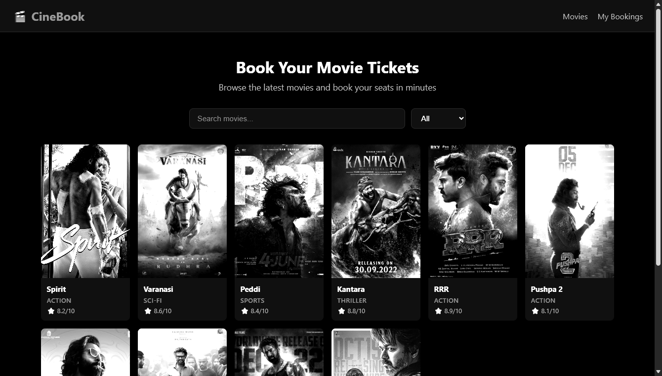

Movie Detail - Spirit
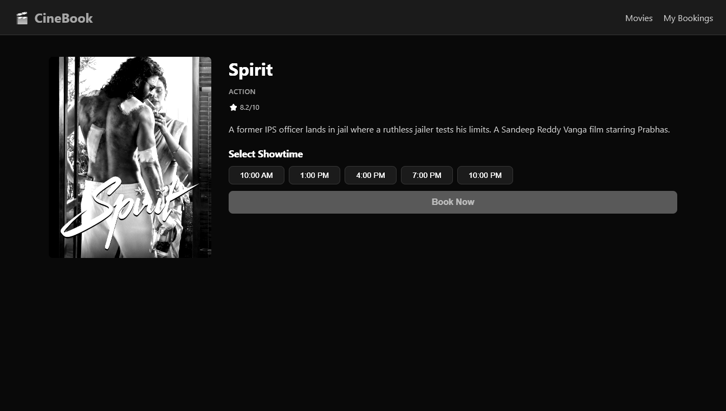

Movie Detail - Kantara
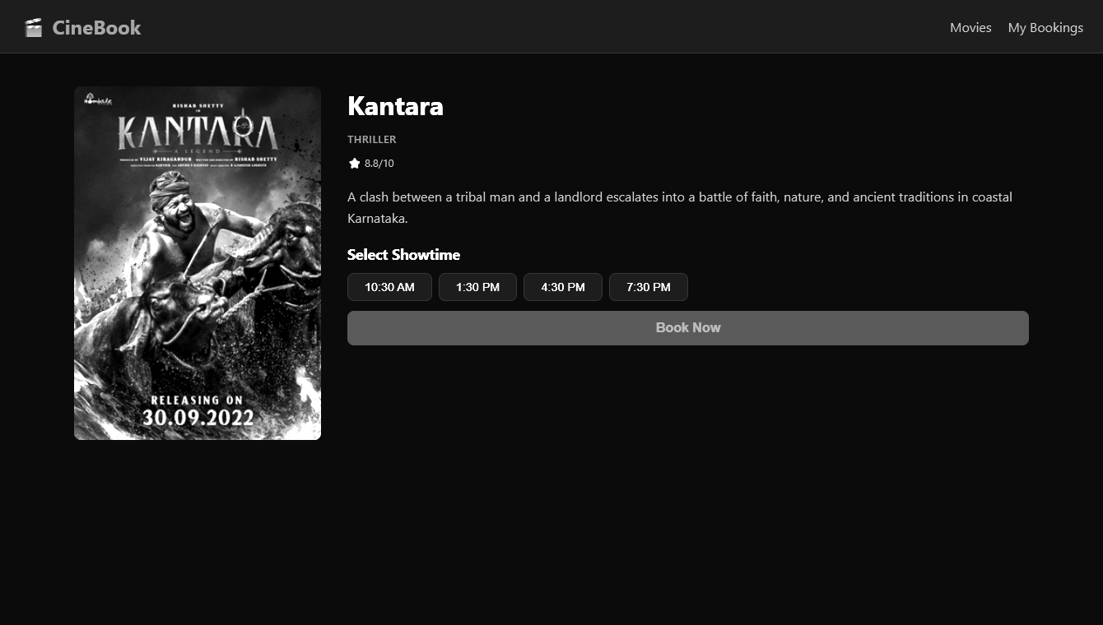

Booking Page
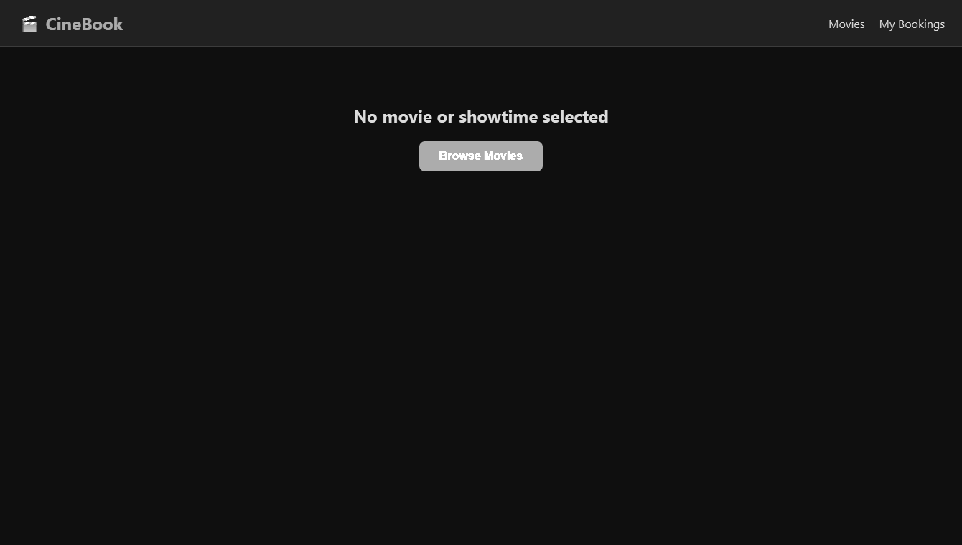

Confirm Page
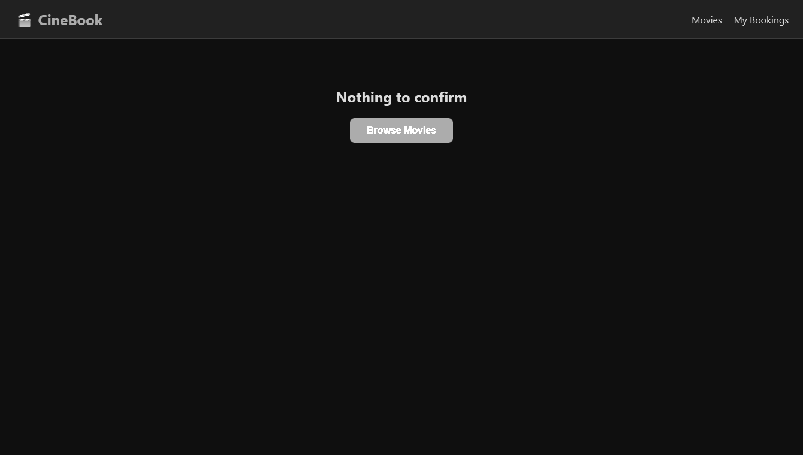

My Bookings
