ASSIGNMENT 2 - Personal Portfolio
Kolluri Chaturvedhi Narsimha
Web Development Internship

Source Code
index.html
<!DOCTYPE html>
<html lang="en">
<head>
<meta charset="UTF-8">
<meta name="viewport" content="width=device-width, initial-scale=1.0">
<title>Chaturvedhi Narsimha | Portfolio</title>
<!-- External CSS -->
<link rel="stylesheet" href="style.css">
<!-- Font Awesome for icons -->
<link rel="stylesheet" href="https://cdnjs.cloudflare.com/ajax/libs/font-awesome/6.5.0/css/all.min.css">
</head>
<body>

<!-- ===== STICKY NAVBAR ===== -->
<header class="navbar" id="navbar">
<div class="container nav-inner">
<a href="#home" class="nav-logo">CN</a>
<nav>
<ul class="nav-menu" id="navMenu">
<li><a href="#home">Home</a></li>
<li><a href="#about">About</a></li>
<li><a href="#skills">Skills</a></li>
<li><a href="#projects">Projects</a></li>
<li><a href="#contact">Contact</a></li>
</ul>
</nav>
<div class="nav-right">
<button class="dark-btn" id="darkBtn" aria-label="Dark mode">
<i class="fas fa-moon"></i>
</button>
<button class="hamburger" id="hamburger" aria-label="Menu">
<span></span><span></span><span></span>
</button>
</div>
</div>
</header>

<!-- ===== HERO SECTION ===== -->
<section class="hero" id="home">
<div class="container hero-inner">
<p class="hero-hello">Hello, I'm</p>
<h1 class="hero-name">Chaturvedhi Narsimha</h1>
<p class="hero-title"><span id="typedText"></span><span class="cursor">|</span></p>
<p class="hero-desc">
I am a web development intern passionate about building clean and responsive websites.
I enjoy learning new technologies and turning ideas into working code.
</p>
<div class="hero-btns">
<a href="#projects" class="btn fill">View My Work</a>
<a href="#" class="btn outline"><i class="fas fa-download"></i> Download Resume</a>
</div>
</div>
</section>

<!-- ===== ABOUT ME ===== -->
<section class="segment" id="about">
<div class="container">
<h2 class="seg-title">About Me</h2>
<div class="about-wrap">
<div class="about-avatar">
<i class="fas fa-user-circle"></i>
</div>
<div class="about-text">
<p>
I am an aspiring frontend developer currently exploring HTML, CSS, and JavaScript.
I also have experience with <strong>Python</strong> and <strong>Java</strong>,
and I am curious about how <strong>AI tools</strong> can be used in web development.
I love building things that look good and work well.
</p>
</div>
</div>
</div>
</section>

<!-- ===== SKILLS ===== -->
<section class="segment alt-bg" id="skills">
<div class="container">
<h2 class="seg-title">Skills</h2>
<div class="skill-grid">
<div class="skill-item">
<i class="fab fa-html5"></i>
<h3>HTML</h3>
</div>
<div class="skill-item">
<i class="fab fa-css3-alt"></i>
<h3>CSS</h3>
</div>
<div class="skill-item">
<i class="fab fa-js"></i>
<h3>JavaScript</h3>
</div>
<div class="skill-item">
<i class="fab fa-python"></i>
<h3>Python</h3>
</div>
<div class="skill-item">
<i class="fab fa-java"></i>
<h3>Java</h3>
</div>
<div class="skill-item">
<i class="fas fa-robot"></i>
<h3>AI Tools</h3>
</div>
<div class="skill-item">
<i class="fas fa-mobile-alt"></i>
<h3>Responsive Design</h3>
</div>
</div>
</div>
</section>

<!-- ===== PROJECTS ===== -->
<section class="segment" id="projects">
<div class="container">
<h2 class="seg-title">Projects</h2>
<div class="project-grid">

<article class="project-card">
<div class="project-img calc-bg">
<i class="fas fa-calculator"></i>
</div>
<div class="project-body">
<h3>Calculator App</h3>
<p>A simple calculator built with HTML, CSS, and JavaScript. It can do addition, subtraction, multiplication, and division.</p>
<div class="project-btns">
<a href="#" class="btn-sm fill"><i class="fas fa-external-link-alt"></i> Live Demo</a>
<a href="#" class="btn-sm outline"><i class="fab fa-github"></i> GitHub</a>
</div>
</div>
</article>

<article class="project-card">
<div class="project-img todo-bg">
<i class="fas fa-list-check"></i>
</div>
<div class="project-body">
<h3>To-Do App</h3>
<p>A task manager where you can add tasks, mark them as done, and delete them. Uses local storage to save your tasks.</p>
<div class="project-btns">
<a href="#" class="btn-sm fill"><i class="fas fa-external-link-alt"></i> Live Demo</a>
<a href="#" class="btn-sm outline"><i class="fab fa-github"></i> GitHub</a>
</div>
</div>
</article>

<article class="project-card">
<div class="project-img port-bg">
<i class="fas fa-globe"></i>
</div>
<div class="project-body">
<h3>Portfolio Website</h3>
<p>This responsive portfolio site you are looking at. Built with semantic HTML, CSS grid/flexbox, and vanilla JavaScript.</p>
<div class="project-btns">
<a href="#" class="btn-sm fill"><i class="fas fa-external-link-alt"></i> Live Demo</a>
<a href="#" class="btn-sm outline"><i class="fab fa-github"></i> GitHub</a>
</div>
</div>
</article>

</div>
</div>
</section>

<!-- ===== CONTACT ===== -->
<section class="segment alt-bg" id="contact">
<div class="container">
<h2 class="seg-title">Contact Me</h2>
<div class="contact-wrap">
<div class="contact-details">
<p><i class="fas fa-envelope"></i> chaturvedhi.narsimha@example.com</p>
<p><i class="fab fa-github"></i> github.com/Chatur7x</p>
<p><i class="fab fa-linkedin"></i> linkedin.com/in/chaturvedhinarsimha</p>
</div>
<form class="contact-form" id="contactForm">
<input type="text" id="name" placeholder="Your Name" required>
<input type="email" id="email" placeholder="Your Email" required>
<textarea id="message" rows="5" placeholder="Your Message" required></textarea>
<button type="submit" class="btn fill">Send Message</button>
</form>
</div>
</div>
</section>

<!-- ===== FOOTER ===== -->
<footer class="footer">
<div class="container">
<div class="footer-icons">
<a href="https://github.com/Chatur7x" target="_blank" aria-label="GitHub"><i class="fab fa-github"></i></a>
<a href="https://linkedin.com/in/chaturvedhinarsimha" target="_blank" aria-label="LinkedIn"><i class="fab fa-linkedin"></i></a>
<a href="mailto:chaturvedhi.narsimha@example.com" aria-label="Email"><i class="fas fa-envelope"></i></a>
</div>
<p class="copyright">&copy; 2026 Chaturvedhi Narsimha. All rights reserved.</p>
</div>
</footer>

<!-- ===== SCROLL TO TOP ===== -->
<button class="scroll-up" id="scrollUp"><i class="fas fa-arrow-up"></i></button>

<!-- External JavaScript -->
<script src="script.js"></script>
</body>
</html>

style.css
/* ===== RESET ===== */
* {
margin: 0;
padding: 0;
box-sizing: border-box;
}

html {
scroll-behavior: smooth;
}

body {
font-family: 'Segoe UI', Tahoma, Geneva, Verdana, sans-serif;
background: #f5f7fa;
color: #2d3748;
line-height: 1.7;
}

a {
text-decoration: none;
color: inherit;
}

ul {
list-style: none;
}

.container {
max-width: 1100px;
margin: 0 auto;
padding: 0 20px;
}

/* ===== STICKY NAVBAR ===== */
.navbar {
position: fixed;
top: 0;
left: 0;
width: 100%;
background: #fff;
box-shadow: 0 2px 8px rgba(0,0,0,0.06);
z-index: 999;
height: 60px;
}

.nav-inner {
display: flex;
justify-content: space-between;
align-items: center;
height: 60px;
}

.nav-logo {
font-size: 1.4rem;
font-weight: 700;
color: #4a6cf7;
}

.nav-menu {
display: flex;
gap: 28px;
}

.nav-menu a {
font-size: 0.92rem;
color: #555;
transition: color 0.2s;
}

.nav-menu a:hover {
color: #4a6cf7;
}

.nav-right {
display: flex;
align-items: center;
gap: 10px;
}

.dark-btn {
background: none;
border: none;
font-size: 1.1rem;
cursor: pointer;
color: #555;
padding: 6px;
border-radius: 50%;
transition: background 0.2s;
}

.dark-btn:hover {
background: #f0f0f0;
}

/* ===== HAMBURGER ===== */
.hamburger {
display: none;
flex-direction: column;
gap: 4px;
background: none;
border: none;
cursor: pointer;
padding: 4px;
}

.hamburger span {
width: 22px;
height: 2.5px;
background: #333;
border-radius: 2px;
transition: 0.3s;
}

.hamburger.active span:nth-child(1) {
transform: rotate(45deg) translate(5px, 5px);
}

.hamburger.active span:nth-child(2) {
opacity: 0;
}

.hamburger.active span:nth-child(3) {
transform: rotate(-45deg) translate(5px, -5px);
}

/* ===== HERO ===== */
.hero {
min-height: 100vh;
display: flex;
align-items: center;
justify-content: center;
text-align: center;
padding-top: 60px;
}

.hero-inner {
max-width: 650px;
}

.hero-hello {
font-size: 1.1rem;
color: #4a6cf7;
margin-bottom: 6px;
letter-spacing: 1px;
}

.hero-name {
font-size: 2.8rem;
color: #1a202c;
margin-bottom: 8px;
line-height: 1.2;
}

.hero-title {
font-size: 1.15rem;
color: #718096;
margin-bottom: 18px;
min-height: 1.8em;
}

.cursor {
color: #4a6cf7;
animation: blink 0.8s infinite;
}

@keyframes blink {
0%, 100% { opacity: 1; }
50% { opacity: 0; }
}

.hero-desc {
color: #718096;
max-width: 500px;
margin: 0 auto 28px;
font-size: 1rem;
}

.hero-btns {
display: flex;
gap: 14px;
justify-content: center;
flex-wrap: wrap;
}

/* ===== BUTTONS ===== */
.btn {
display: inline-block;
padding: 11px 28px;
border-radius: 6px;
font-size: 0.95rem;
font-weight: 500;
cursor: pointer;
transition: all 0.2s;
border: 2px solid #4a6cf7;
}

.btn.fill {
background: #4a6cf7;
color: #fff;
}

.btn.fill:hover {
background: #3b5de7;
box-shadow: 0 4px 12px rgba(74, 108, 247, 0.3);
}

.btn.outline {
background: transparent;
color: #4a6cf7;
}

.btn.outline:hover {
background: #4a6cf7;
color: #fff;
}

.btn-sm {
display: inline-block;
padding: 7px 16px;
border-radius: 5px;
font-size: 0.85rem;
font-weight: 500;
cursor: pointer;
transition: all 0.2s;
border: 1.5px solid #4a6cf7;
}

.btn-sm.fill {
background: #4a6cf7;
color: #fff;
}

.btn-sm.fill:hover {
background: #3b5de7;
}

.btn-sm.outline {
background: transparent;
color: #4a6cf7;
}

.btn-sm.outline:hover {
background: #4a6cf7;
color: #fff;
}

/* ===== SECTIONS ===== */
.segment {
padding: 80px 0;
}

.alt-bg {
background: #fff;
}

.seg-title {
text-align: center;
font-size: 1.8rem;
color: #1a202c;
margin-bottom: 40px;
position: relative;
}

.seg-title::after {
content: '';
display: block;
width: 50px;
height: 3px;
background: #4a6cf7;
margin: 10px auto 0;
border-radius: 3px;
}

/* ===== ABOUT ===== */
.about-wrap {
display: flex;
gap: 40px;
align-items: center;
max-width: 800px;
margin: 0 auto;
}

.about-avatar i {
font-size: 7rem;
color: #4a6cf7;
}

.about-text p {
color: #555;
font-size: 1.02rem;
}

/* ===== SKILLS ===== */
.skill-grid {
display: grid;
grid-template-columns: repeat(auto-fit, minmax(130px, 1fr));
gap: 20px;
}

.skill-item {
background: #f5f7fa;
border: 1px solid #e8ecf1;
border-radius: 10px;
padding: 24px 14px;
text-align: center;
transition: box-shadow 0.2s, transform 0.2s;
}

.skill-item:hover {
box-shadow: 0 4px 14px rgba(0,0,0,0.06);
transform: translateY(-3px);
}

.skill-item i {
font-size: 2rem;
color: #4a6cf7;
margin-bottom: 10px;
}

.skill-item h3 {
font-size: 0.92rem;
color: #4a5568;
font-weight: 600;
}

/* ===== PROJECTS ===== */
.project-grid {
display: grid;
grid-template-columns: repeat(auto-fit, minmax(290px, 1fr));
gap: 24px;
}

.project-card {
background: #fff;
border: 1px solid #e8ecf1;
border-radius: 12px;
overflow: hidden;
transition: box-shadow 0.2s, transform 0.2s;
}

.project-card:hover {
box-shadow: 0 6px 18px rgba(0,0,0,0.07);
transform: translateY(-4px);
}

.project-img {
height: 170px;
display: flex;
align-items: center;
justify-content: center;
font-size: 3rem;
color: rgba(255,255,255,0.85);
}

.calc-bg {
background: linear-gradient(135deg, #667eea, #764ba2);
}

.todo-bg {
background: linear-gradient(135deg, #f093fb, #f5576c);
}

.port-bg {
background: linear-gradient(135deg, #4facfe, #00f2fe);
}

.project-body {
padding: 20px;
}

.project-body h3 {
font-size: 1.1rem;
margin-bottom: 8px;
color: #1a202c;
}

.project-body p {
font-size: 0.9rem;
color: #718096;
margin-bottom: 14px;
}

.project-btns {
display: flex;
gap: 8px;
}

/* ===== CONTACT ===== */
.contact-wrap {
display: grid;
grid-template-columns: 1fr 1fr;
gap: 40px;
max-width: 800px;
margin: 0 auto;
}

.contact-details p {
margin-bottom: 14px;
color: #555;
font-size: 0.95rem;
}

.contact-details i {
width: 24px;
color: #4a6cf7;
}

.contact-form input,
.contact-form textarea {
width: 100%;
padding: 11px 14px;
border: 1.5px solid #e2e8f0;
border-radius: 6px;
font-size: 0.95rem;
margin-bottom: 14px;
font-family: inherit;
background: #f5f7fa;
transition: border 0.2s;
}

.contact-form input:focus,
.contact-form textarea:focus {
outline: none;
border-color: #4a6cf7;
}

.contact-form textarea {
resize: vertical;
}

/* ===== FOOTER ===== */
.footer {
background: #1a202c;
color: #cbd5e0;
text-align: center;
padding: 30px 0;
}

.footer-icons {
display: flex;
justify-content: center;
gap: 18px;
margin-bottom: 12px;
}

.footer-icons a {
color: #cbd5e0;
font-size: 1.2rem;
transition: color 0.2s;
}

.footer-icons a:hover {
color: #4a6cf7;
}

.copyright {
font-size: 0.85rem;
color: #718096;
}

/* ===== SCROLL TO TOP ===== */
.scroll-up {
position: fixed;
bottom: 24px;
right: 24px;
width: 40px;
height: 40px;
border-radius: 50%;
background: #4a6cf7;
color: #fff;
border: none;
font-size: 1rem;
cursor: pointer;
opacity: 0;
visibility: hidden;
transition: all 0.3s;
z-index: 99;
box-shadow: 0 3px 10px rgba(74, 108, 247, 0.3);
}

.scroll-up.show {
opacity: 1;
visibility: visible;
}

.scroll-up:hover {
background: #3b5de7;
transform: translateY(-2px);
}

/* ===== DARK MODE ===== */
body.dark {
background: #0f172a;
color: #e2e8f0;
}

body.dark .navbar {
background: #1e293b;
box-shadow: 0 2px 8px rgba(0,0,0,0.2);
}

body.dark .nav-menu a {
color: #cbd5e0;
}

body.dark .nav-menu a:hover {
color: #818cf8;
}

body.dark .dark-btn {
color: #cbd5e0;
}

body.dark .dark-btn:hover {
background: #334155;
}

body.dark .hamburger span {
background: #e2e8f0;
}

body.dark .hero-name {
color: #e2e8f0;
}

body.dark .alt-bg {
background: #1e293b;
}

body.dark .seg-title {
color: #e2e8f0;
}

body.dark .skill-item {
background: #0f172a;
border-color: #334155;
}

body.dark .skill-item h3 {
color: #cbd5e0;
}

body.dark .project-card {
background: #1e293b;
border-color: #334155;
}

body.dark .project-body h3 {
color: #e2e8f0;
}

body.dark .project-body p {
color: #94a3b8;
}

body.dark .contact-details p {
color: #cbd5e0;
}

body.dark .contact-form input,
body.dark .contact-form textarea {
background: #0f172a;
border-color: #334155;
color: #e2e8f0;
}

body.dark .nav-menu {
background: #1e293b;
}

/* ===== RESPONSIVE ===== */
@media (max-width: 768px) {
.nav-menu {
display: none;
position: fixed;
top: 60px;
left: 0;
width: 100%;
background: #fff;
flex-direction: column;
align-items: center;
padding: 24px 0;
gap: 18px;
border-bottom: 1px solid #eee;
box-shadow: 0 4px 12px rgba(0,0,0,0.06);
}

.nav-menu.active {
display: flex;
}

.hamburger {
display: flex;
}

.hero-name {
font-size: 2rem;
}

.about-wrap {
flex-direction: column;
text-align: center;
}

.contact-wrap {
grid-template-columns: 1fr;
}
}

@media (max-width: 480px) {
.hero-name {
font-size: 1.6rem;
}

.hero-btns {
flex-direction: column;
align-items: center;
}

.btn {
width: 100%;
max-width: 240px;
}

.skill-grid {
grid-template-columns: repeat(2, 1fr);
}

.project-grid {
grid-template-columns: 1fr;
}
}

script.js
/* ===== GET ELEMENTS ===== */
const navbar = document.getElementById('navbar');
const navMenu = document.getElementById('navMenu');
const hamburger = document.getElementById('hamburger');
const darkBtn = document.getElementById('darkBtn');
const scrollBtn = document.getElementById('scrollUp');
const typedEl = document.getElementById('typedText');
const contactForm = document.getElementById('contactForm');

/* ===== MOBILE MENU TOGGLE ===== */
hamburger.addEventListener('click', function() {
hamburger.classList.toggle('active');
navMenu.classList.toggle('active');
});

/* close menu when a link is clicked */
navMenu.querySelectorAll('a').forEach(function(link) {
link.addEventListener('click', function() {
hamburger.classList.remove('active');
navMenu.classList.remove('active');
});
});

/* ===== DARK MODE TOGGLE ===== */
/* check localStorage for saved theme on page load */
const savedTheme = localStorage.getItem('theme');
if (savedTheme === 'dark') {
document.body.classList.add('dark');
darkBtn.innerHTML = '<i class="fas fa-sun"></i>';
}

darkBtn.addEventListener('click', function() {
document.body.classList.toggle('dark');
const isDark = document.body.classList.contains('dark');

/* change icon based on mode */
if (isDark) {
darkBtn.innerHTML = '<i class="fas fa-sun"></i>';
} else {
darkBtn.innerHTML = '<i class="fas fa-moon"></i>';
}

/* save preference */
localStorage.setItem('theme', isDark ? 'dark' : 'light');
});

/* ===== SCROLL TO TOP ===== */
window.addEventListener('scroll', function() {
if (window.scrollY > 300) {
scrollBtn.classList.add('show');
} else {
scrollBtn.classList.remove('show');
}
});

scrollBtn.addEventListener('click', function() {
window.scrollTo({ top: 0, behavior: 'smooth' });
});

/* ===== TYPING TEXT ANIMATION ===== */
const words = ['Frontend Developer', 'Web Design Enthusiast', 'Problem Solver'];
let wordIdx = 0;
let charIdx = 0;
let deleting = false;

function typeEffect() {
const current = words[wordIdx];

if (!deleting) {
/* typing forward */
typedEl.textContent = current.substring(0, charIdx + 1);
charIdx++;
if (charIdx === current.length) {
deleting = true;
setTimeout(typeEffect, 1800);
return;
}
setTimeout(typeEffect, 90);
} else {
/* deleting backward */
typedEl.textContent = current.substring(0, charIdx);
charIdx--;
if (charIdx < 0) {
deleting = false;
charIdx = 0;
wordIdx = (wordIdx + 1) % words.length;
setTimeout(typeEffect, 400);
return;
}
setTimeout(typeEffect, 40);
}
}

/* start the typing animation */
typeEffect();

/* ===== CONTACT FORM ===== */
contactForm.addEventListener('submit', function(e) {
e.preventDefault();

const name = document.getElementById('name').value.trim();
const email = document.getElementById('email').value.trim();
const message = document.getElementById('message').value.trim();

if (name && email && message) {
alert('Thanks ' + name + '! Your message was sent successfully.');
contactForm.reset();
}
});

Screenshots
Navbar
Desktop:
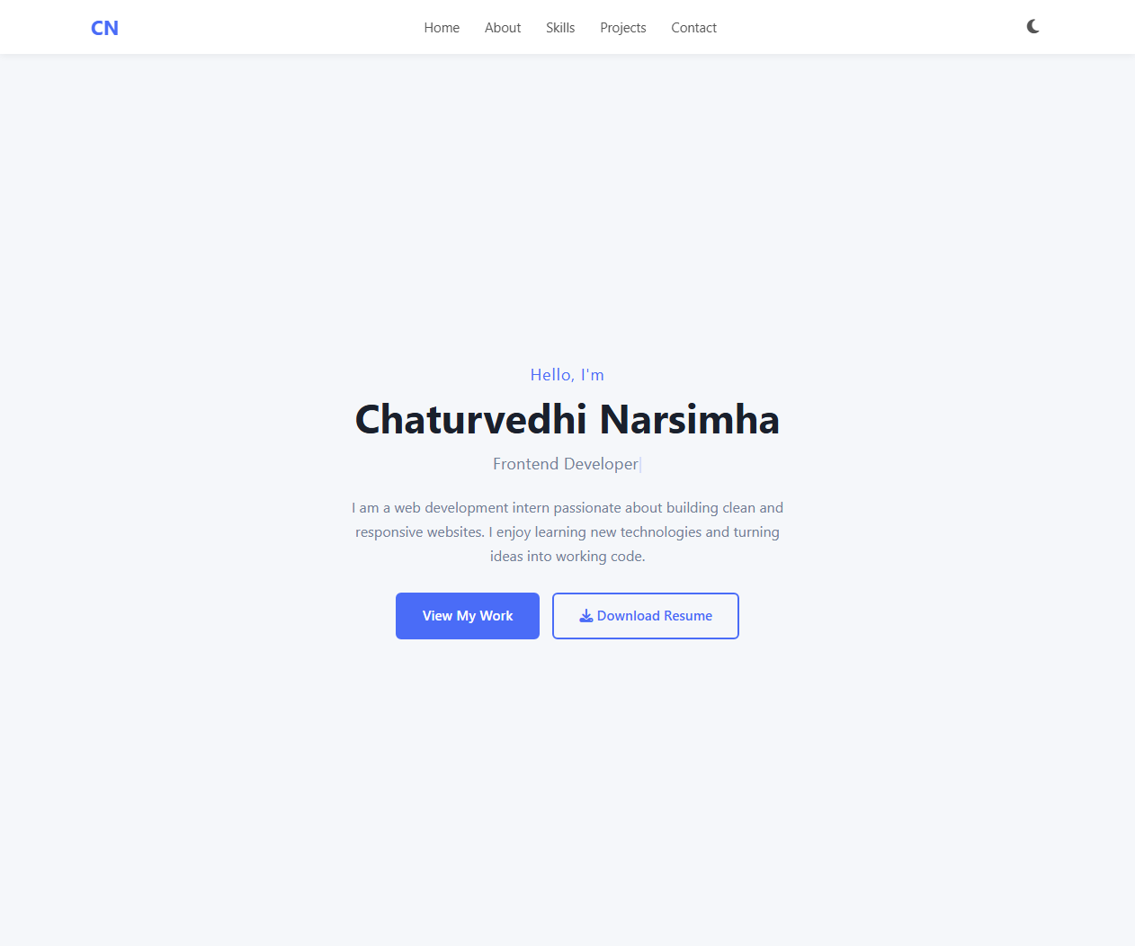

Mobile:
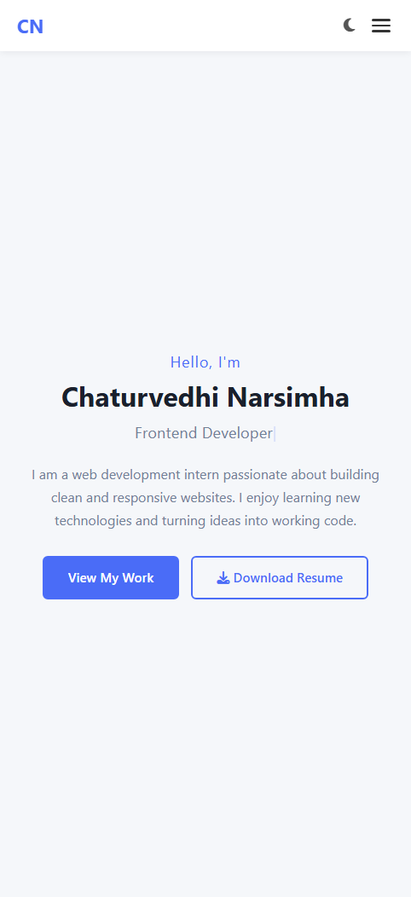

Hero Section
Desktop:
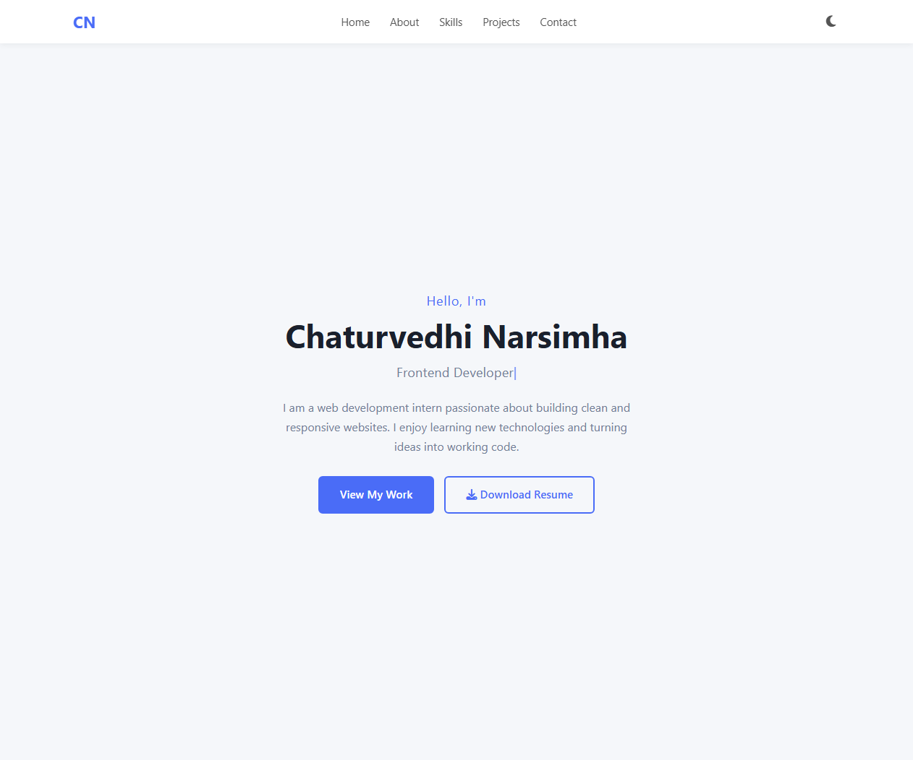

Mobile:
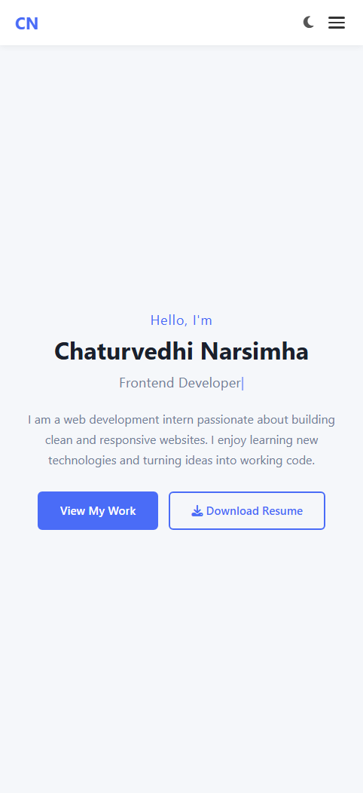

About Me
Desktop:
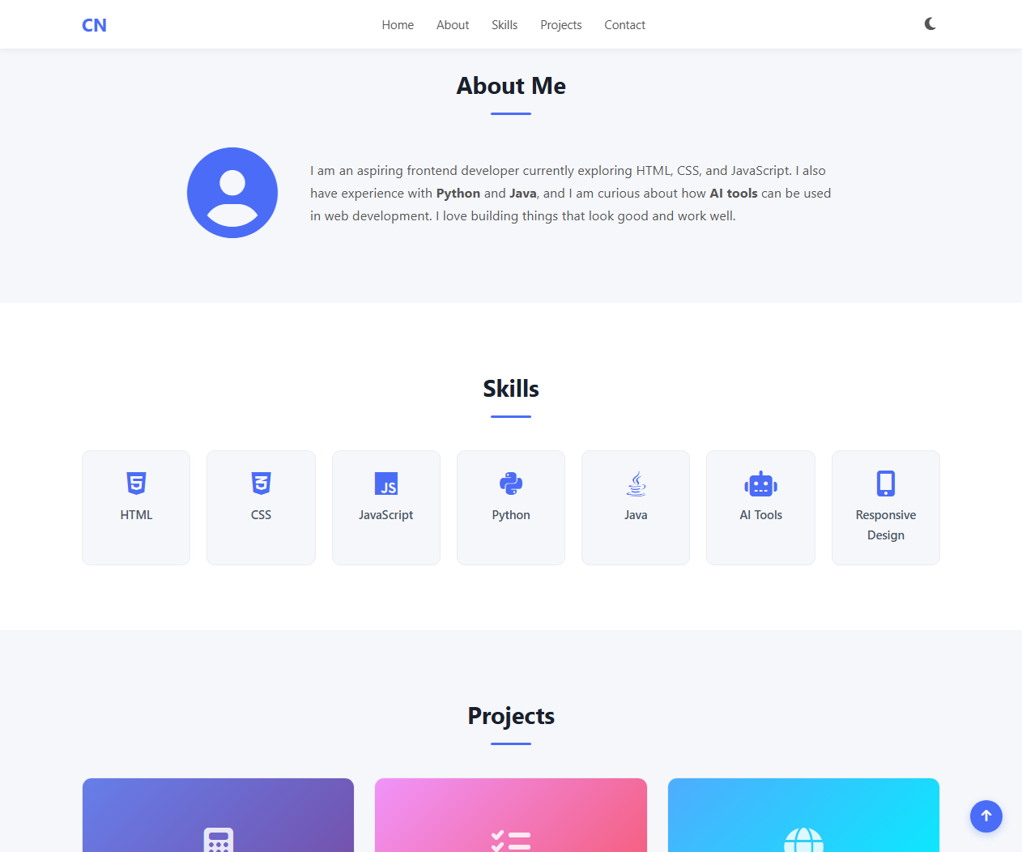

Mobile:
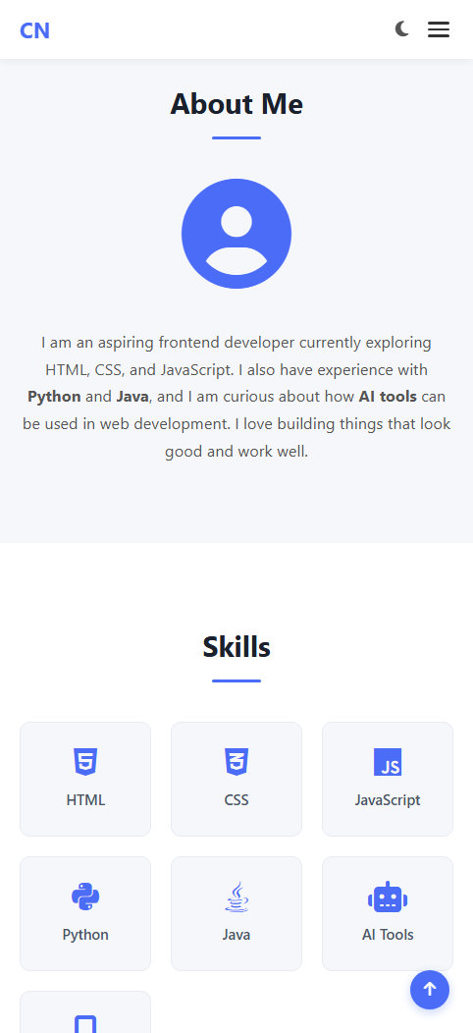

Skills
Desktop:
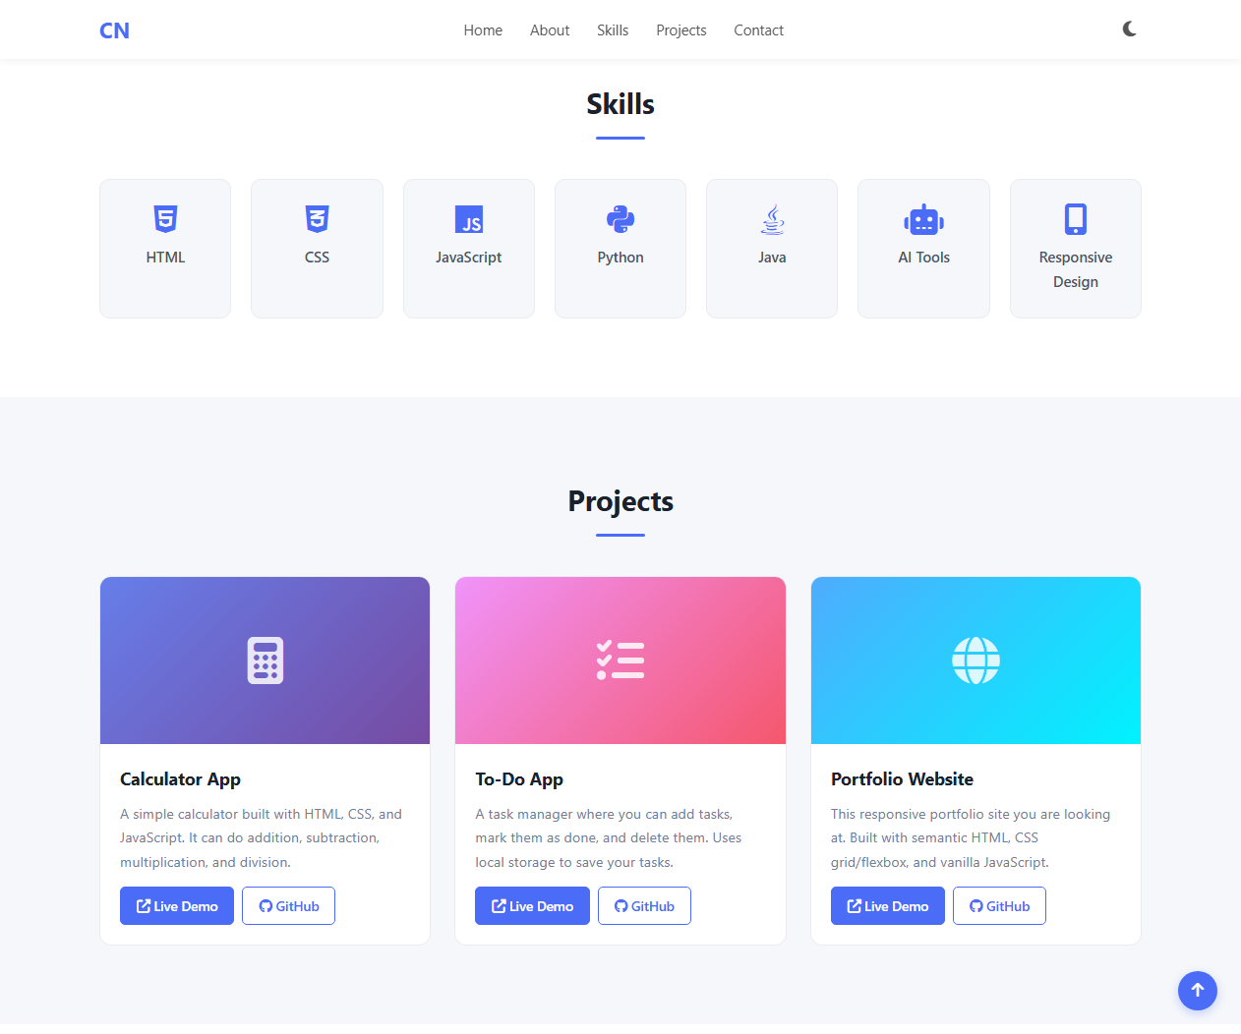

Mobile:
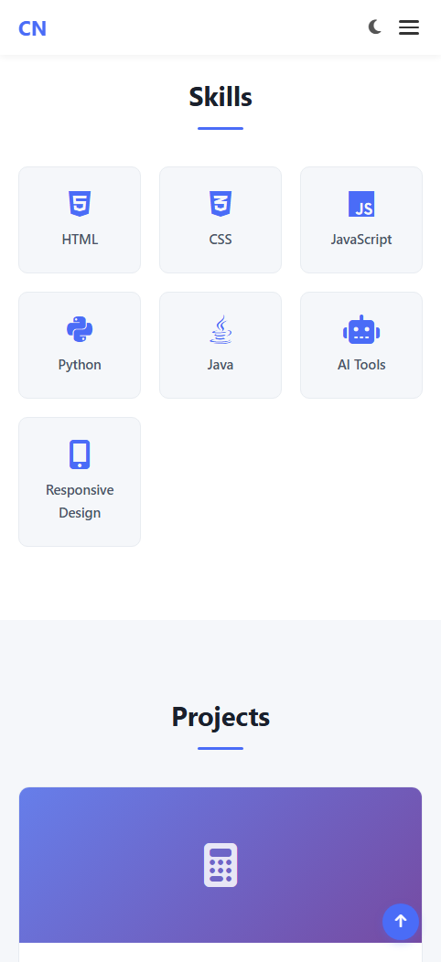

Projects
Desktop:
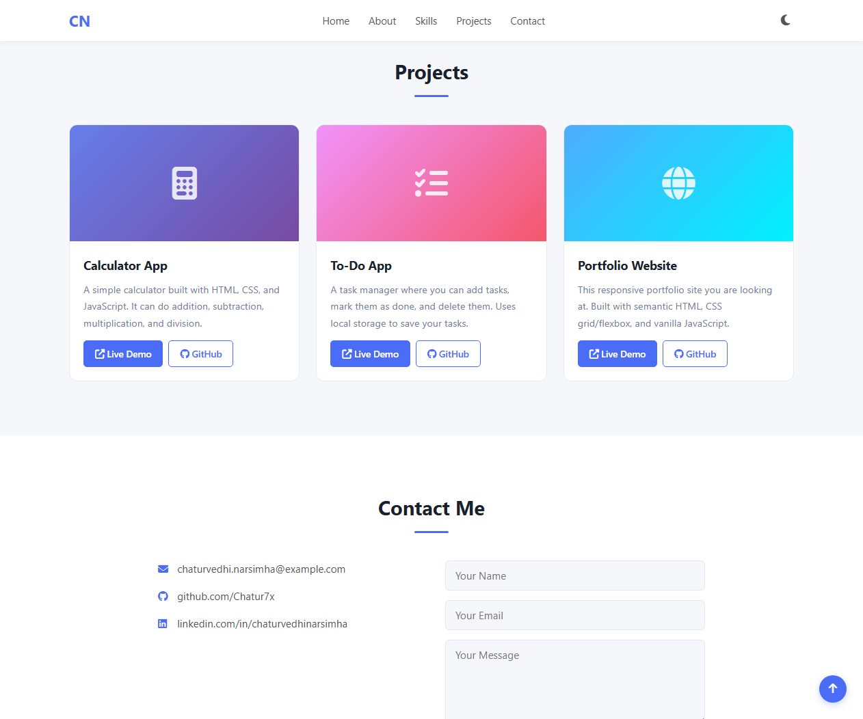

Mobile:
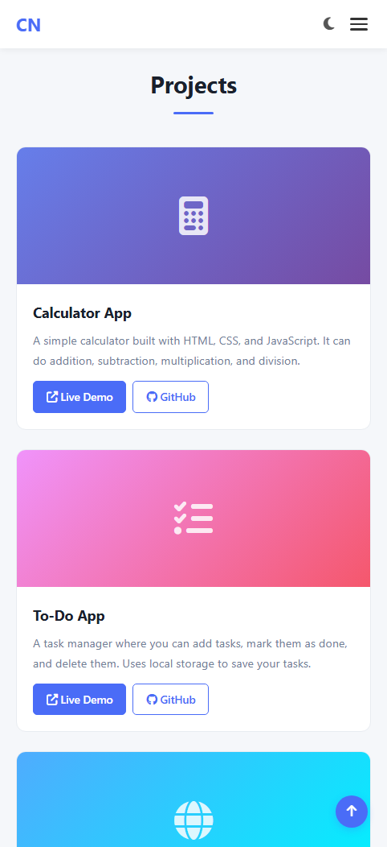

Contact Form
Desktop:
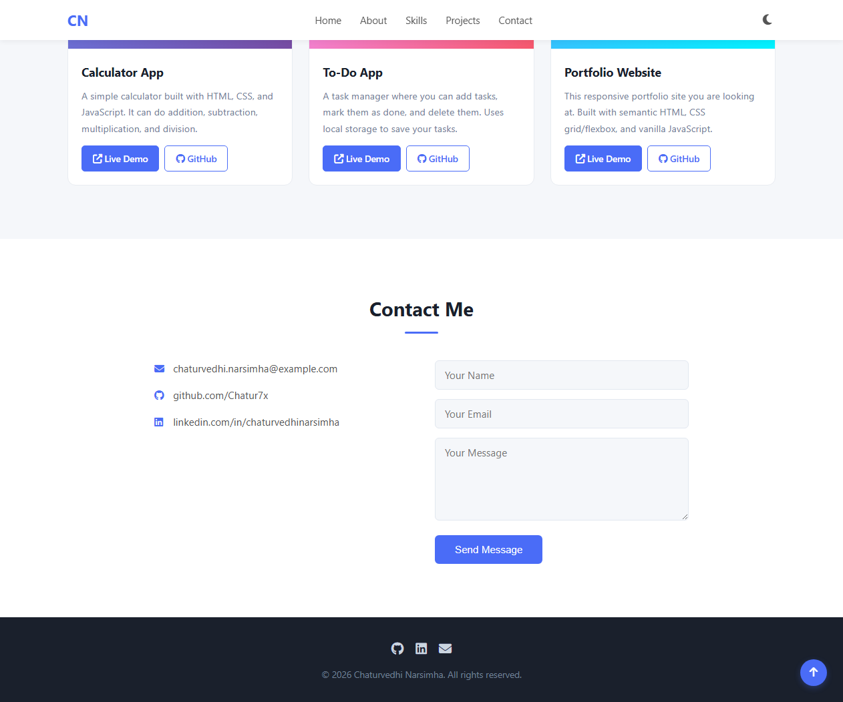

Mobile:
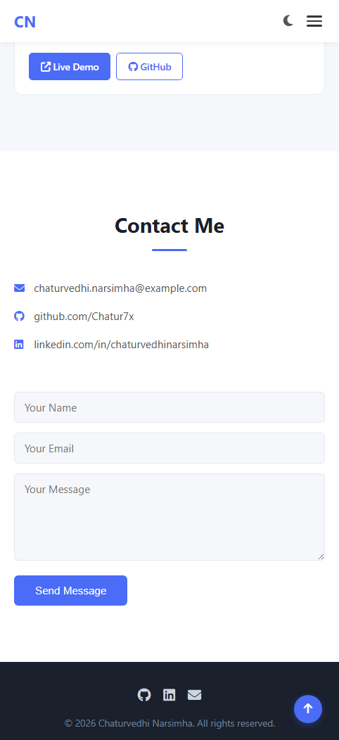

Footer
Desktop:


Mobile:


