1. **Malware Analysis**

File name – 1.pdf  
Sha 256 - [0b4e30c8a8ead0bae21046b628cdfc46e6c472e3159784deb80cf22315639e05](https://www.hybrid-analysis.com/search?query=context:0b4e30c8a8ead0bae21046b628cdfc46e6c472e3159784deb80cf22315639e05&block_redirect=1)

**Brief about sandbox analysis** : Sandbox analysis is a cybersecurity technique used to detect and analyze potential threats, such as malware and suspicious files, in a safe and isolated environment.

**no specific threat**

AV Detection: Marked as clean

**Cryptographic Related**

Sample file has high entropy (likely encrypted/compressed content)

## **Network Analysis**

## **DNS Request**

## No relevant DNS requests were made.

### **Contacted Hosts**

No relevant hosts were contacted.

### **HTTP Traffic**

No relevant HTTP requests were made.

1. **URL Analysis**

URL - http://subtitleseeker.com/  
Is it malicious - NO  
URL categories - BitDefender : Education  
First Submission - 2011-12-01 09:51:42 UTC

Last Submission - 2023-07-19 20:08:34 UTC

Last Analysis - 2023-07-19 20:08:34 UTC

**Brief about the URL**

#### Final URL

http://ww1.subtitleseeker.com/

#### Serving IP Address

[69.16.230.228](https://www.virustotal.com/gui/ip-address/69.16.230.228)

#### Meta Tags

Description:

subtitleseeker.com is your first and best source for all of the information you’re looking for. From general topics to more of what you would expect to find here, subtitleseeker.com has it all. We hope you find what you are searching for!

1. **Email Header Analysis**

**Checking header is compliant or not**

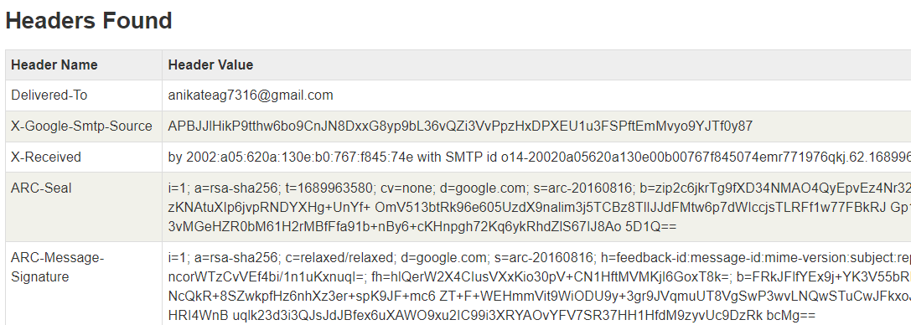

Problem Icon [DMARC Compliant](https://mxtoolbox.com/dmarc/problem/dmarc-compliance)

Problem Icon [SPF Alignment](https://mxtoolbox.com/Public/Tools/EmailHeaders.aspx?huid=34f163fe-c536-4801-a100-44e5c933d2f5)

Ok Icon [SPF Authenticated](https://mxtoolbox.com/Public/Tools/EmailHeaders.aspx?huid=34f163fe-c536-4801-a100-44e5c933d2f5)

Problem Icon [DKIM Alignment](https://mxtoolbox.com/Public/Tools/EmailHeaders.aspx?huid=34f163fe-c536-4801-a100-44e5c933d2f5)

[DKIM Authenticated](https://mxtoolbox.com/Public/Tools/EmailHeaders.aspx?huid=34f163fe-c536-4801-a100-44e5c933d2f5)



**DKIM Authentication**: DKIM (DomainKeys Identified Mail) is an email authentication method that adds a digital signature to the email header. It verifies the email's integrity and authenticity by using a private key associated with the sending domain and a public key in the domain's DNS records.

**DKIM Alignment**: DKIM alignment checks if the domain in the "From" field of an email matches the domain used in the DKIM signature. When they match, it indicates that the sender's identity is valid, increasing email trustworthiness.

**SPF Alignment**: SPF (Sender Policy Framework) alignment verifies if the domain in the "Return-Path" or "Mail From" field aligns with the domain specified in the SPF record. Alignment confirms that the email's return path is authorized by the domain's owner.

**SPF Authentication**: SPF is an email authentication protocol that specifies authorized mail servers for a domain. SPF authentication involves checking if the sender's IP address is listed as an allowed sender in the domain's SPF record. A pass result indicates a legitimate sender, while a fail result suggests potential email spoofing.

1. **Suggested security controls and how will you implement them.**

* Add a firewall to the network to prevent and block untrusted sites and packets.
* Use EDR in the end devices for detection and recovery in case of attacks.
* Enable proper patch management to keep security updated.
* Add IPS to monitor the incoming data.
* Create awareness about cybersecurity and proper ways to handle incidents of breach.
* Create a crisis recovery plan to quickly handle breach.
* Use SIEM for monitoring.
* Implement proper encryption of data and use of strong passwords.
* Enable proper and minimal Access controls.
* Do vulnerability analysis and penetration testing.