DAILY-JOURNAL

## A PROJECT REPORT

***Submitted by***

# Anikate Agrawal (201500088)

**Ishika Chaturvedi (201500306)**

***in partial fulfillment for the award of the degree of***

# BACHELOR OF TECHNOLOGY IN

## Computer Engineering and Application



**GLA University, Mathura**

APRIL 2023

# BONAFIDE CERTIFICATE

Certified that this project report **“DAILY-JOURNAL”** is the bonafide work of “**Anikate Agrawal and Ishika Chaturvedi”** who carried out the project work under my supervision.

|  |  |
| --- | --- |
| **SIGNATURE**  **Dr. Rohit Agrawal**  **HEAD OF THE DEPARTMENT**  Department of Computer Engineering & Application | **SIGNATURE**  **Ms. Neelam Soni**  **SUPERVISOR**  Technical Trainer  Training & Development Department |

Submitted for the project viva-voce examination held on

**INTERNAL EXAMINER EXTERNAL EXAMINER**

# ACKNOWLEDGEMENT

It gives us the immense pleasure to present the report of the B.Tech. Mini Project undertaken during B.Tech. 3rd Year. This project would never have seen the light of the day without the help and guidance that we have received.

Our heartiest thanks to **Ms. Neelam Soni, Technical Trainer (T&D Department)** for providing us with an encouraging platform to develop this project, which thus helped us in shaping our abilities towards a constructive goal.

We owe special debt of gratitude to **Mr. Naman Tyagi**, for his constant support and guidance throughout the course of our work. He has showered us with all his extensively experienced ideas and has also taught us about the latest industry-oriented technologies.

We also do not like to miss the opportunity to acknowledge the contribution of all faculty members of the department for their kind guidance and cooperation during the development of our project.

**Anikate Agrawal (201500088)**

**Ishika Chaturvedi (201500306)**

# TABLE OF CONTENTS

## List of Figures Abstract Graphical Abstract Abbreviations

**Chapter 1. Introduction**

* 1. Identification of relevant Contemporary issue
  2. Identification of Problem
  3. Identification of Tasks
  4. Timeline
  5. Organization of the Report

## Chapter 2. Goals and Objectives

* 1. Problem Statement
  2. Goals and Objectives

## Chapter 3. Design Flow

* 1. Hardware & Software Requirements
  2. Project Design

## Chapter 4. Implementation & Validation

4.1 Implementation

## Chapter 5. Conclusion And Future Work

* 1. Conclusion
  2. Future Work

**References**

# List of Figures

## Figure 3.1 Our Platform

**Figure 3.2 Header with Navigation bar Figure 3.3 Home**

## Figure 3.4 My Journal Figure 3.5 Compose

## Figure 3.6 About Us

**Figure 3.7 Contact Us**

**Figure 3.8 Sign up**

**Figure 3.9 Log in**

**Figure 3.10 Saved**

**Figure 3.11 Profile**

**Figure 3.12 Log out**

**Figure 3.13 Footer**

# ABSTRACT

Full Stack Development is the ability to develop websites and user-friendly web applications with fully functional backend facilities. After learning Html, CSS, Java-script, NodeJS, EJS and MongoDB we made up a fully responsive website for allowing users to post their articles. Here came the need of a website where we could display our journals and articles and make them easily available for the users. We needed a user interface through which user could easily compose and post the articles he needs so we came up with an idea of developing a **Daily-Journal App**.

**Daily Journal** will be an application where user can easily post and journal on daily basis and could get acknowledged by other users too. Saving the important articles for future references and update their profiles.

With this idea in our thoughts, we chose **Daily journal** as our mini project and hope we shall be successful in accomplishing it.

# GRAPHICAL ABSTRACT

Sign Up

E-Books

Login

**Web App**

**Store**

Games

Home

Apps

**ABBREVIATIONS**

* + 1. HTML Hyper Text Markup Language
    2. CSS Cascading Style Sheets
    3. JS JavaScript
    4. IT Information Technology
    5. UI User Interface
    6. VS Visual Studio
    7. RAM Random Access Memory
    8. EJS Embedded Java Script

# CHAPTER 1 INTRODUCTION

## Identification of relevant Contemporary issue

* + - No Platform available for displaying journals for free. There are several ways to use the website such as composing and saving an article.
    - Without a User Interface Clients will not be able to reach the applications.
    - A good website with user friendly interface leads to higher number to clients.
    - Major IT Companies have their own platform to showcase their daily achievements on an authenticated web application.

## Identification of Problem

Need For Authentic Secure Platform To display journals and articles and provide User Interface for our clients and users to access content.

## Identification of Tasks

There are several tasks that need to be performed:

* Gathering of all requirements and features required in the website
* Analyzing requirements and feasibility study
* Planning and creating appropriate model
* Making initial design of website
* Implementation of Design and Coding
* Testing of website
* Error Detection and Handling

## Timeline

April 1-10 Requirement Specification, Built up Model April 1-10 Designing of Website and User Interface April 1-10 Implementation started. Built Apps and website. April 10-22 Completed Project. Testing. User Review.

April 22-25 Project Presentation and Report Submission.

## Organization of the Report

Chapter 1 gives the introduction to the project specifying the need of the project, various problems which would be solved through the project and the various tasks required to be performed for completion of the project. It also tells the timeline of various activities performed.

Chapter 2 specifies the problem statement and the goals and objectives of the project.

Chapter 3 gives details about the model and design of the project. Various constraints are also discussed here. It gives the structure of the website. It provides all the details about each section provided in the website.

Chapter 4 talks about how the design is implemented using various technologies. Chapter 5 concludes the project and gives the future scope.

# CHAPTER 2

## GOALS AND OBJECTIVES

* 1. **Problem Statement**

A fully Responsive website having authentication, header with navigation bar, home, compose, saved, profile, contact us and footer required.

## Goals and Objectives

There are several goals:

* + 1. A Website to display the journals.
    2. A platform that works well on all devices such as mobiles, laptops etc.
    3. User Friendly User Interface.
    4. Secure Platform
    5. Ease Of User Feedback
    6. Prevention of unauthentic usage.

# CHAPTER 3 DESIGN FLOW

## Hardware & Software Requirements

* + - HTML, CSS and JAVASCRIPT
    - VS CODE
    - Google Firebase
    - NodeJS, EJS and MongoDB
    - Version Control and Hosting: GitHub
    - Processor: i5 or above
    - Minimum 4GB RAM
    - Windows Operating System

## Project Design

The website has various sections such as: -

1. Header
2. Home
3. My journals
4. Compose
5. About
6. Contact us
7. Saved
8. Profile
9. Login
10. Sign up
11. Log out
12. Footer.

The roles of the sections are as follows:

**Header:** This contains our Daily Journal Logo, Navigation Bar, and button for Home, My Journal, Compose, About us, Contact us, Login, Signup, Saved and profile.

A header is the top margin of each page, and a footer is the bottom margin of each page. Headers and footers are useful for including material that you want to appear on every page of a document such as your name, the title of the document, or page numbers.





**Fig. 3.1 Header with logo and Navigation bar**

**Home:** Home Page showcasing all the journals for the user to read and save. The home page of a journal typically serves as the main entry point for readers to access its content and information. It often features the latest articles, special issues, and announcements related to the journal, as well as information about its scope, editorial board, submission guidelines, and subscription options.

The design and layout of a journal's home page may vary depending on the publisher's preferences and the journal's audience, but most home pages prioritize ease of use, readability, and accessibility. This may involve organizing content into sections or tabs, using clear headings and labels, and providing search functions and navigation menus to help users find what they're looking for quickly.

Overall, a journal's home page serves as a key marketing tool to promote its content and attract new readers and authors. As such, publishers often invest significant resources into optimizing their home pages to make them as engaging and user-friendly as possible.

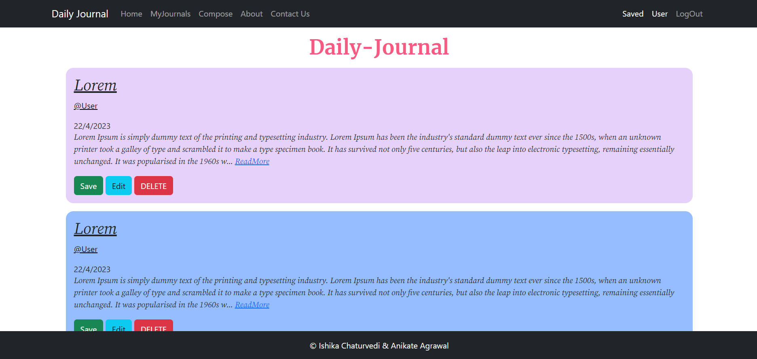

**Fig. 3.2 Home**

**My Journals:** This section has cards showcasing all your journals. As an individual, you may not have a journal page per se, but if you are referring to a personal journal or diary, its pages are where you can express your thoughts, feelings, and experiences in writing. Journaling can be a powerful tool for self-reflection, self-discovery, and personal growth, allowing you to explore your inner world, clarify your goals and values, and gain insight into your patterns of thinking and behavior. Whether you prefer to journal in a physical notebook or using a digital platform, the act of writing down your thoughts can help you process emotions, reduce stress, and enhance your overall well-being.

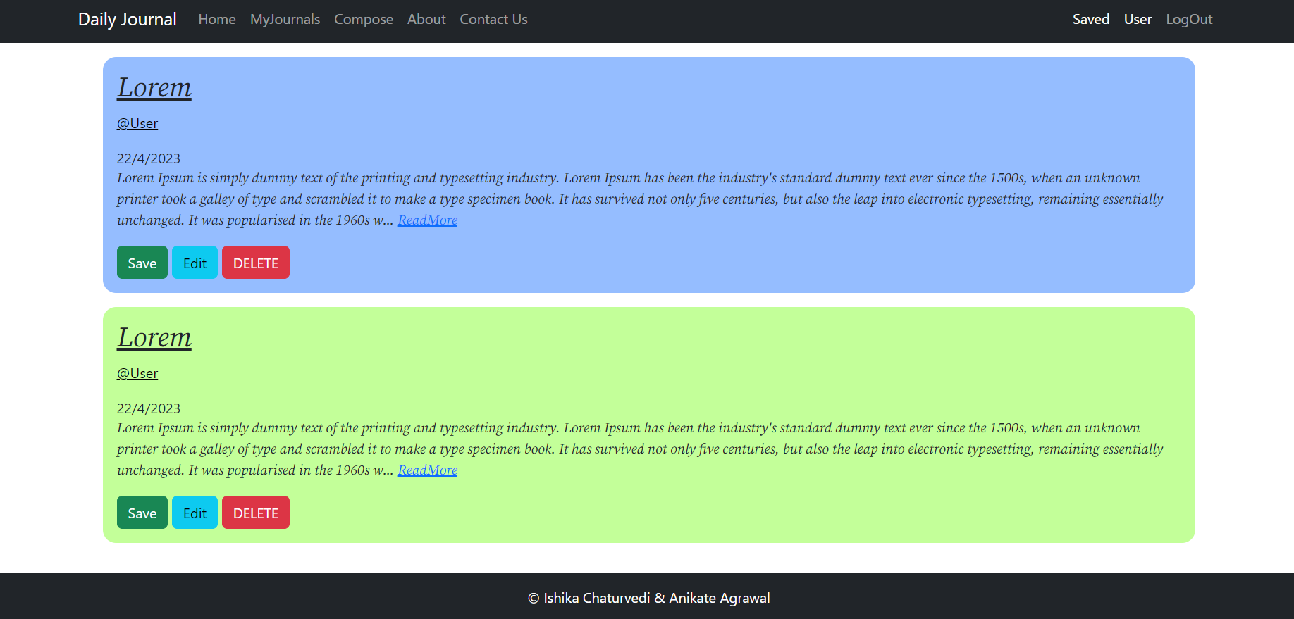

**Fig. 3.3 My Journals**

**Compose:** Form where you can compose your own journal. The compose page of a daily journal is where you can record your thoughts, experiences, and reflections on a regular basis. This can be a blank page in a physical notebook or a digital platform with a writing interface. To make the most of your journaling practice, it can be helpful to establish a consistent routine and set aside a specific time and place for writing. You can use prompts, such as gratitude lists or goal-setting exercises, to inspire your writing or simply write free-form about whatever is on your mind. The act of composing your thoughts in writing can help you clarify your ideas, track your progress, and cultivate a deeper sense of self-awareness.

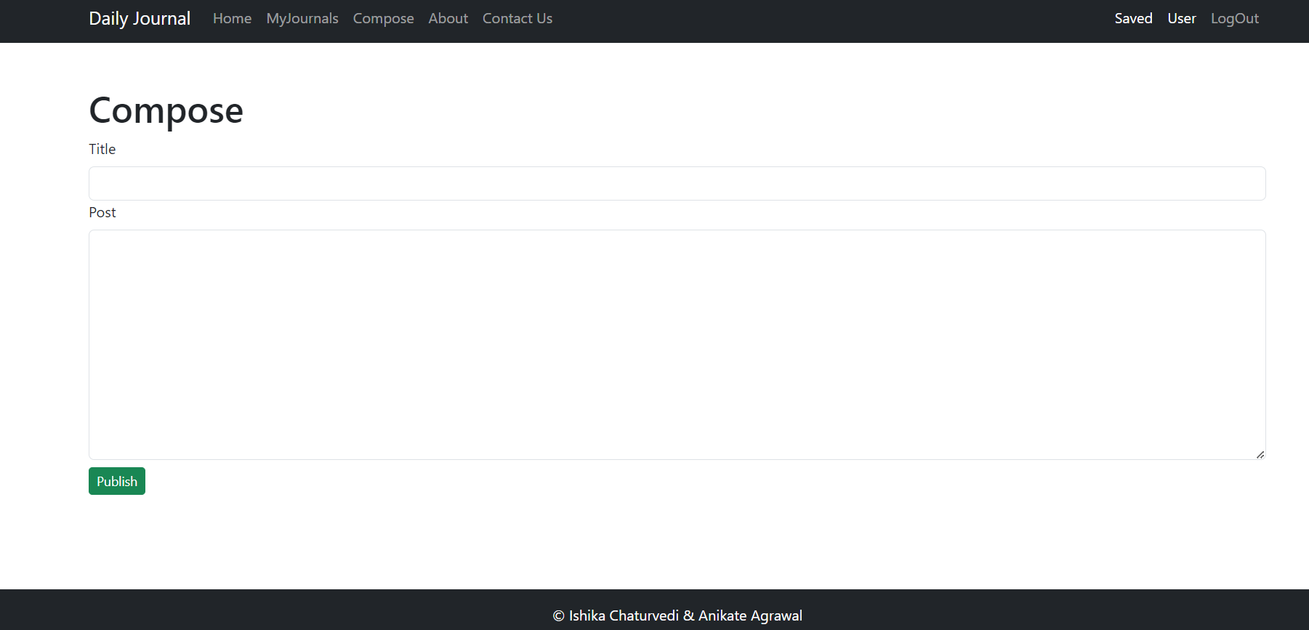

**Fig. 3.4 Compose Page**

**About Us:** An "About Us" page is a section on a website that provides information about the company or organization behind it. This page typically includes details about the company's history, mission, values, team members, and any other relevant information that can help visitors understand what the company stands for and what it offers.

An effective "About Us" page can help build trust with potential customers and establish credibility in the marketplace. It can also serve as a platform for companies to share their unique story and showcase their achievements, products, or services.

To make an "About Us" page stand out, it should be clear, concise, and engaging, and use visuals, such as photos or videos, to bring the company's story to life. Companies should also ensure that the page is easy to navigate, and that it accurately reflects their brand and voice. By creating a compelling "About Us" page, companies can strengthen their online

presence and make a lasting impression on their audience.

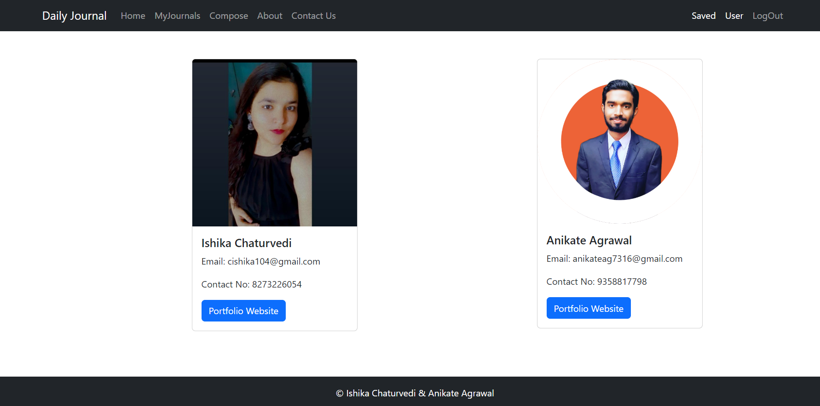

**Fig. 3.5 About us**

**Contact Us :** A "Contact Us" page is an essential component of a website that allows visitors to get in touch with the company or organization behind it. One effective way to create a contact form is by using Firebase, a cloud-based platform that offers a range of tools for web and mobile app development.

With Firebase, you can easily create a contact form that collects and stores visitor's data, such as their name, email, and message. You can also set up email notifications to alert you when someone submits a form, making it easier to respond to inquiries in a timely manner. Firebase's real-time database can store and organize your visitor's data securely, ensuring that you can access it whenever you need to follow up.

To set up a contact form using Firebase, you will need to create a Firebase project, add the Firebase SDK to your website, and use Firebase's authentication and database features to create the form. Once set up, visitors can fill out the form and send their message directly to your inbox. This can help streamline communication with potential customers and improve overall user experience on your website.

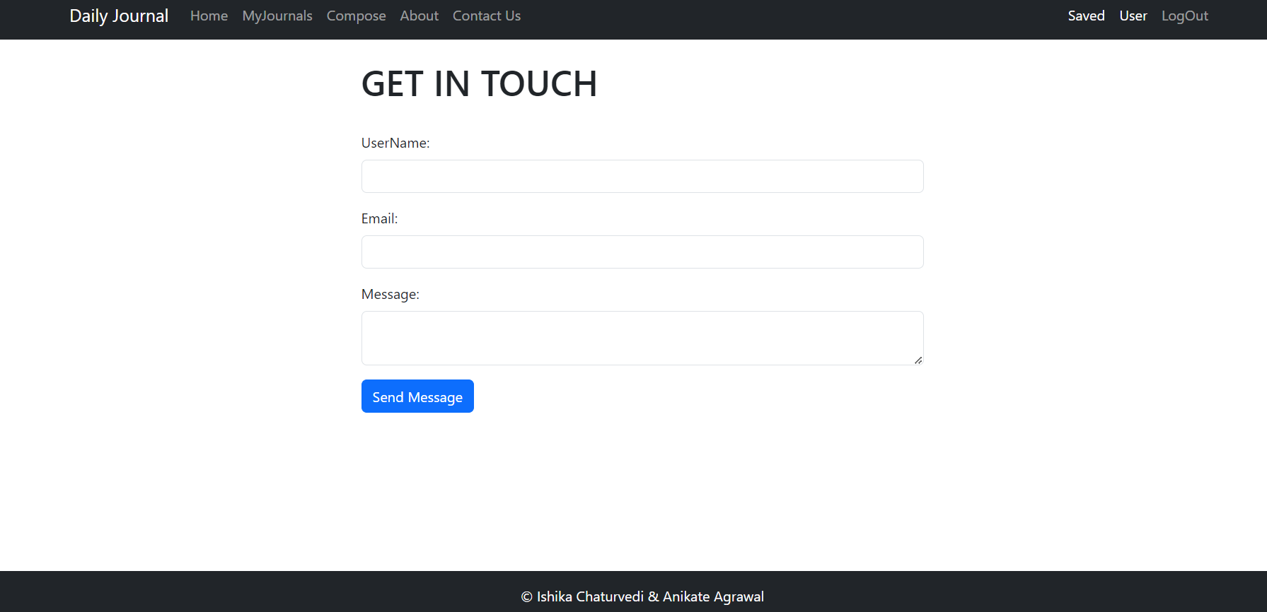

**Figure 3.6 Contact us**

**Saved:** A saved article page is a page that allows users to view and manage their saved articles or content on a website or app. This page typically displays a list of the user's saved articles, with options to view, edit, or delete each item.

Saved article pages can be a valuable feature for users, as they provide a convenient way to keep track of interesting or relevant content and revisit it later. To create a saved article page, websites or apps can use tools like local storage or databases to store user preferences and keep track of the articles that have been saved.

A well-designed saved article page can enhance the user experience and encourage users to return to your site or app. You can include features such as a search bar, sorting options, or a tagging system to help users easily find and organize their saved articles. You can also use this page to suggest related content or offer personalized recommendations based on the user's saved articles.

Overall, a saved article page can be an effective tool for increasing user engagement and retention on your site or app, providing users with a valuable and customizable feature that enhances their experience.

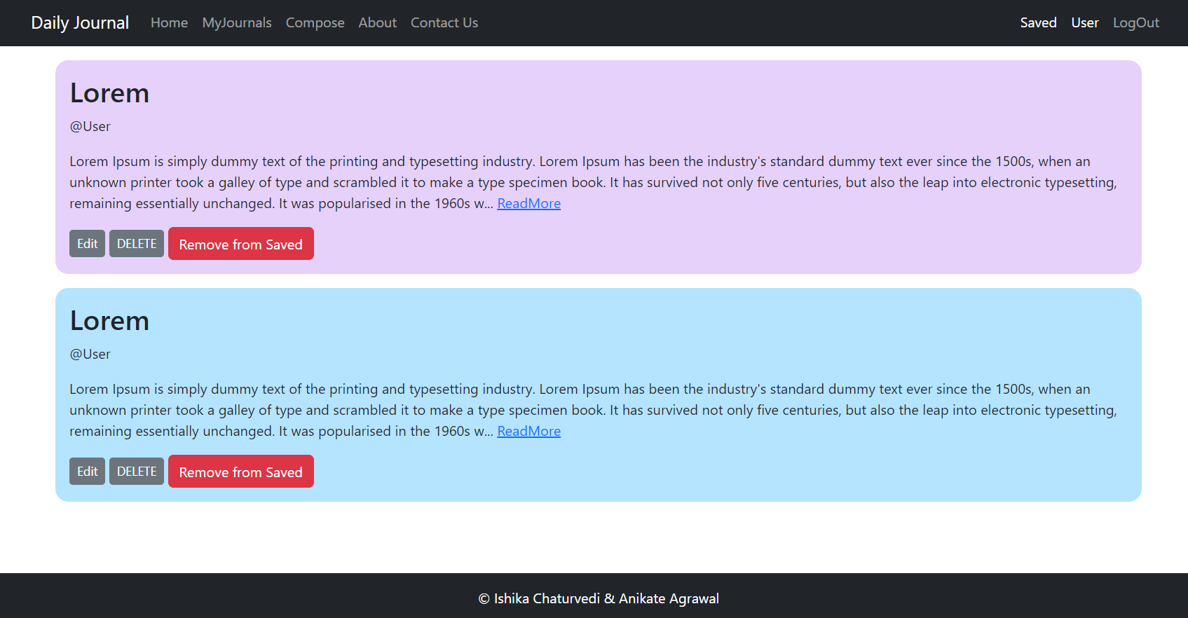

**Figure 3.7 Saved**

**Profile:** A profile page is a page on a website or app that displays information about a specific user or account. This page typically includes details such as the user's name, profile picture, bio, and any other relevant information.

Profile pages can be a valuable tool for social networking sites, online marketplaces, and other websites where users have a personal account. By allowing users to create a profile page, you can help them establish a unique identity on your platform and build connections with others.

To create an effective profile page, you can include features such as a feed of the user's activity or content, a list of their followers or connections, and options to customize their profile settings. You can also offer users the ability to add additional information or media, such as photos, videos, or links to other social media accounts.

Overall, a well-designed profile page can help users feel more engaged and connected on your platform, providing them with a space to showcase their personality and interact with others. By offering users a customized and personalized experience, you can increase user satisfaction and retention on your website or app.

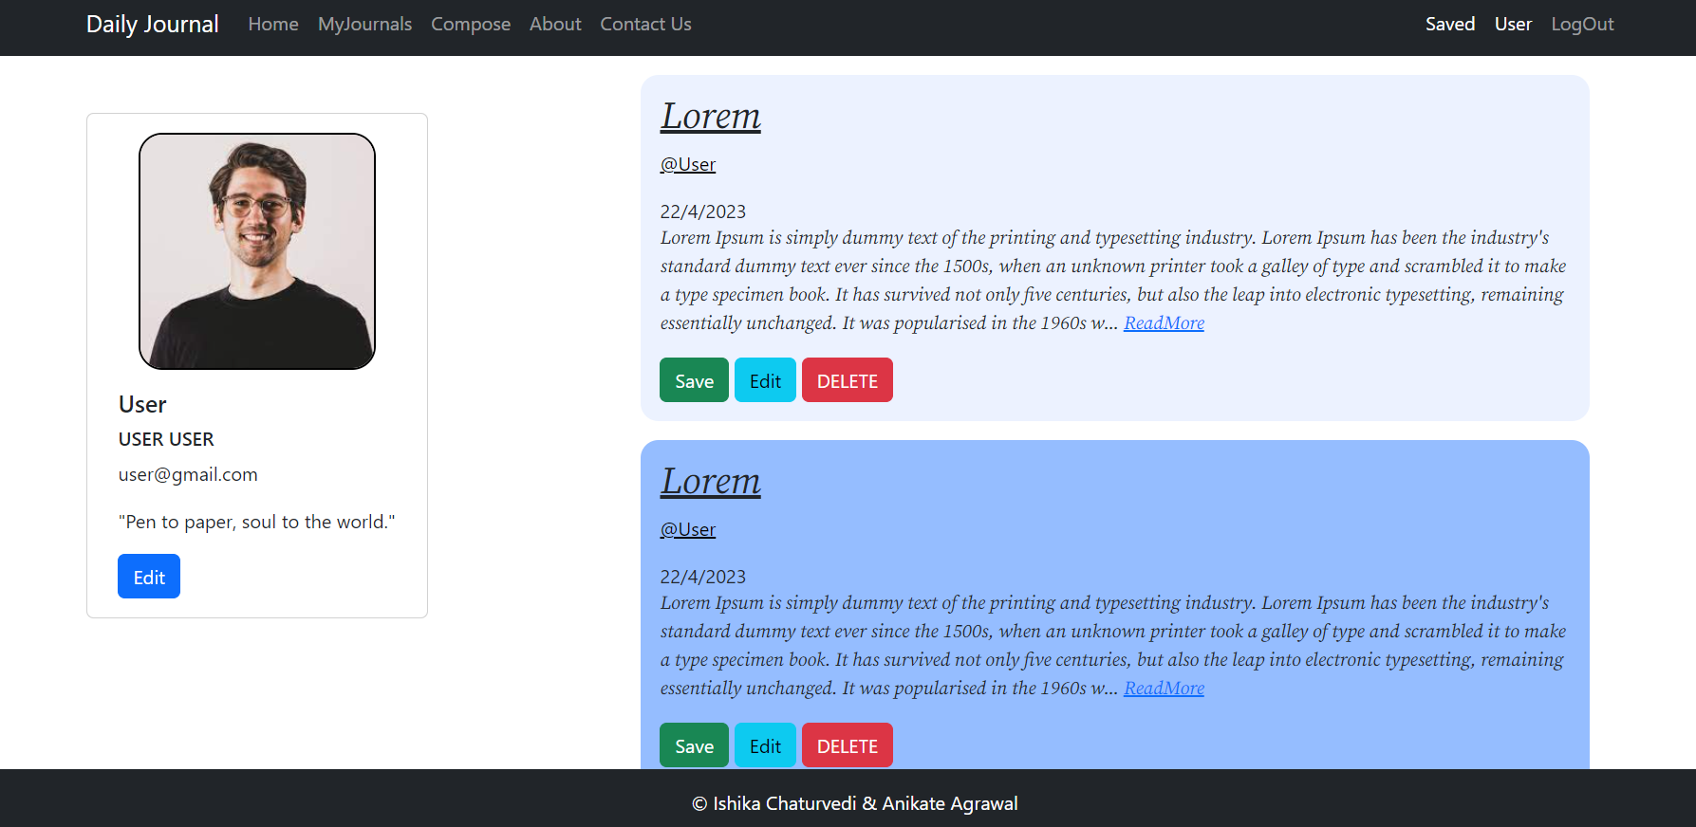

**Figure 3.8 Profile**

**Login :** A login page is a page on a website or app that requires users to enter their login credentials in order to access the site's content or features. Typically, a login page will prompt the user to enter their username or email address, followed by their password.

Creating an effective login page is important for ensuring the security of your website or app. You can use tools such as two-factor authentication or captcha to further enhance security and prevent unauthorized access.

To create a user-friendly login page, it's important to ensure that the design is clear and simple, with easy-to-follow instructions and error messages. You can also offer users the ability to reset their password or retrieve their username if they have forgotten it.

Overall, a well-designed login page can help ensure that your website or app is secure and easy to use, enhancing the user experience and encouraging users to return to your site or app. By prioritizing security and ease of use, you can create a login page that meets the needs of both you and your users.

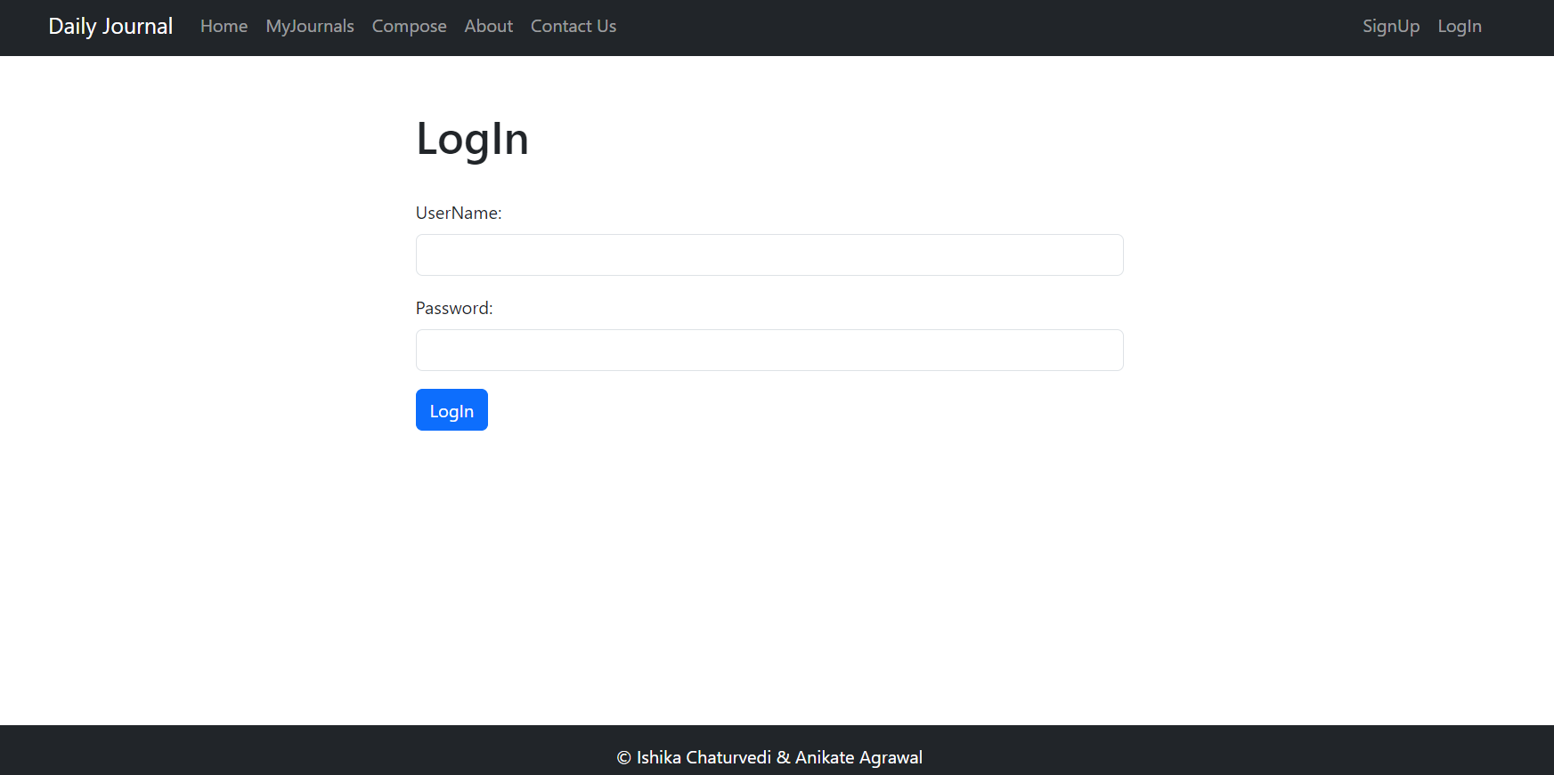

**Figure 3.9 Login**

**Sign Up:** A sign-up page is a page on a website or app that allows users to create a new account. Typically, a sign-up page will prompt the user to enter their personal information, such as their name, email address, and password, followed by any additional information that may be required for registration.

Creating an effective sign-up page is important for ensuring a smooth user experience and encouraging users to create an account. To achieve this, it's important to ensure that the sign-up page is easy to use, with clear instructions and minimal required information.

You can also use tools such as email verification or captcha to enhance security and prevent spam accounts. Additionally, you can offer users the ability to sign up using their social media accounts, making the process even more streamlined and convenient.

Overall, a well-designed sign-up page can help attract and retain users on your website or app, providing them with a simple and easy way to create an account and begin using your platform. By prioritizing user experience and security, you can create a sign-up page that meets the needs of both you and your users.

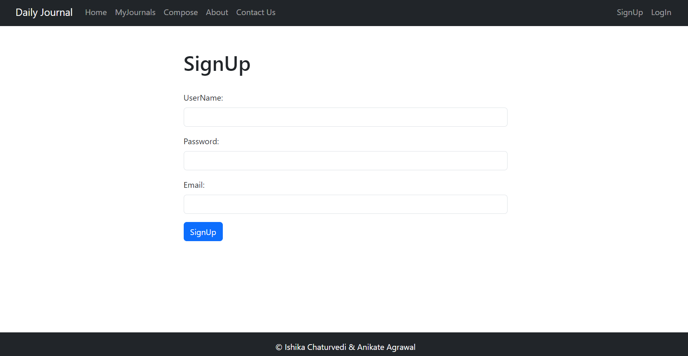 **Figure 3.10 Signup**

**Log out:** A log out button is a feature on a website or app that allows users to securely log out of their account. This button is typically located in the user interface and can be accessed from any page on the site or app.

Implementing a log out button is an important security measure, as it ensures that users can protect their personal information and prevent unauthorized access to their account. It also helps ensure that users do not accidentally leave their account open on a shared device or public computer.

To create an effective log out button, it's important to ensure that it is prominently displayed and easy to access, with clear instructions for use. You can also offer users the option to stay logged in for a certain amount of time, such as a week or month, before requiring them to log in again.

Overall, a well-designed log out button can help ensure the security of your website or app, providing users with an easy and secure way to log out of their account when they are finished using it. By prioritizing security and user experience, you can create a log out button that meets the needs of both you and your users.

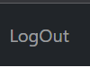 **Figure 3.11 Log out**

**Footer:** The footer of a website is an important component that is located at the bottom of the page. It typically contains information about the website, such as copyright notices, contact information, social media links, and legal information.

The footer can also be used to provide navigation links to important pages on the website, such as the About Us, Contact, and FAQ pages. This can help users easily find the information they are looking for and improve the overall user experience.

In addition to providing important information and navigation links, the footer can also be used to add a personal touch to the website. This can include a message from the website owner, testimonials from satisfied customers, or links to blog posts or other content that may be of interest to the user.

Overall, the footer of a website plays a crucial role in providing users with important information, improving the user experience, and adding a personal touch to the website. It is important to ensure that the footer is well-designed and easy to navigate to enhance the overall effectiveness of the website.

** Figure 3.12 Footer**

# CHAPTER 4 IMPLEMENTATION AND VALIDATION

## 4.1 Implementation

**Frontend**

## Front end development refers to the part of web development that deals with the user interface and user experience of a website or application. It involves the use of various programming languages, frameworks, and tools to create visually appealing and interactive interfaces that allow users to interact with the website or application.

## Front end developers are responsible for designing and developing the layout, navigation, and overall look and feel of a website or application. They use languages such as HTML, CSS, and JavaScript, as well as frameworks such as React, Angular, and Vue, to create responsive and dynamic user interfaces.

## In addition to technical skills, front end developers must also have a good understanding of user experience (UX) design principles and be able to create interfaces that are intuitive and easy to use. They must also be familiar with web standards and accessibility guidelines to ensure that their interfaces are accessible to all users.

## Overall, front end development is a critical component of web development, as it directly affects the way users interact with and perceive a website or application.

## Backend

## Backend development involves the creation of server-side applications and APIs that power the functionality of a website or application. MongoDB and Firebase are two popular backend technologies that developers can use to build robust and scalable web applications.

## MongoDB is a NoSQL database that uses a document-based model to store and retrieve data. It is known for its flexibility, scalability, and ease of use, making it a popular choice for backend development. With MongoDB, developers can store and query large amounts of data, including unstructured data such as images, videos, and audio files.

## Firebase, on the other hand, is a cloud-based platform that offers a range of backend services such as authentication, real-time database, storage, and hosting. It is a popular choice for mobile and web application development, as it provides developers with a complete backend solution that requires minimal setup and maintenance.

## When used together, MongoDB and Firebase can provide developers with a powerful and flexible backend solution that can handle complex data structures and high levels of traffic. With MongoDB handling data storage and retrieval and Firebase handling backend services, developers can focus on building their frontend applications and delivering an optimal user experience.

## HTML

HTML is a versatile language that can be used to create simple static web pages or complex dynamic web applications. It is supported by all modern web browsers and is constantly evolving to meet the needs of developers and users.

Learning HTML is essential for anyone interested in web development, as it is the foundation of all web technologies. There are many resources available online to help beginners learn HTML, including tutorials, courses, and reference guides.

In addition to learning HTML, it is important to stay up to date with best practices and web standards to ensure that your web pages are accessible, user-friendly, and compatible with different devices and browsers. Overall, HTML is a powerful and essential tool for web development, and mastering it is key to building effective and engaging web pages and applications.

## CSS

CSS, or Cascading Style Sheets, is a style sheet language used to describe the presentation and formatting of HTML documents. It is used in conjunction with HTML and JavaScript to create visually appealing and interactive web pages.

CSS allows developers to separate the content of a web page from its presentation, making it easier to maintain and update. With CSS, developers can control the layout, color, font, and other visual elements of a web page.

CSS is constantly evolving, with new features and capabilities being added regularly.

Learning CSS is essential for anyone interested in web development, as it is a crucial component of modern web design. There are many resources available online to help beginners learn CSS, including tutorials, courses, and reference guides..

## JavaScript

JavaScript is a programming language used to create dynamic and interactive web pages and applications. It is a versatile language that can be used for client-side scripting, server-side scripting, and desktop application development.

JavaScript allows developers to add interactivity to web pages, such as animations, form validation, and dynamic content loading. It is supported by all modern web browsers and is constantly evolving to meet the needs of developers and users.

Learning JavaScript is essential for anyone interested in web development, as it is a crucial component of modern web design. There are many resources available online to help beginners learn JavaScript, including tutorials, courses, and reference guides.

**Node JS**

Node.js is an open-source, cross-platform JavaScript runtime environment that allows developers to build fast and scalable network applications. It is built on the V8 JavaScript engine, which is used by Google Chrome, and provides an event-driven architecture and non-blocking I/O model that makes it ideal for building real-time, data-intensive applications.

Node.js is commonly used for building web applications, RESTful APIs, and microservices. It also provides a range of built-in modules and libraries that make it easy to implement features such as HTTP requests, file system access, and data streaming.

Node.js is constantly evolving, with new features and capabilities being added regularly. Learning Node.js is essential for anyone interested in backend web development, as it is a crucial component of modern web applications. There are many resources available online to help beginners learn Node.js, including tutorials, courses, and reference guides.

**MongoDB**

MongoDB is a popular open-source document-oriented NoSQL database system. It stores data in a flexible, JSON-like format called BSON, which allows developers to store and manipulate unstructured data with ease.

MongoDB is designed to scale horizontally, allowing applications to distribute data across

multiple servers for improved performance and scalability. It also provides a range of features and capabilities, including automatic sharding, indexing, and query optimization, that make it a popular choice for modern web applications.

Learning MongoDB is essential for anyone interested in building scalable and flexible web applications. There are many resources available online to help beginners learn MongoDB, including tutorials, courses, and reference guides.

**EJS**

EJS, or Embedded JavaScript, is a templating language used to generate HTML markup with JavaScript. It allows developers to embed JavaScript code directly into HTML templates, making it easier to generate dynamic content and customize the layout and structure of web pages.

EJS is commonly used in Node.js applications, where it can be used to generate HTML pages on the server-side. It also provides a range of features and capabilities, including conditional statements, loops, and custom tags, that make it a powerful and versatile tool for building web applications.

Learning EJS is essential for anyone interested in web development with Node.js, as it is a crucial component of server-side templating. There are many resources available online to help beginners learn EJS, including tutorials, courses, and reference guides.

## Google Firebase

Firebase is an app development platform that helps you build and grow apps and games users love. Backed by Google and trusted by millions of businesses around the world. Firebase provides detailed documentation and cross-platform SDKs to help you build and ship apps on Android, iOS, the web, C++, and Unity.

# CHAPTER 5 CONCLUSION AND FUTURE WORK

## Conclusion

The Website is successfully designed and is live on Render. It is also fully responsive to work well on all devices. Login and Sign Up are working fine. Header Section has a working navigation bar to navigate to different section.

All the Pages on the website are running nicely. They lack certain responsiveness due to lack of time. Slight Security issues possible in them as apps are on different locations from the authenticated website.

Footer Section with feedback form is fully functional.

## Future work

Apps need updates and maintenance for improvement.

# REFERENCES

* + 1. **Books:** Black Book HTML5, CSS, JS, MongoDB, EJS, NodeJS

## Websites:

* + - 1. MDN Web Docs
      2. W3Schools
      3. GeeksForGeeks
      4. Javatpoint
      5. MongoDB atlas
      6. BootStrap
    1. **Faculty:** Ms. Neelam Soni (Technical Trainer in GLA University)

**GitHub Repository link:**

<https://github.com/anikateagrawal/Daily_Journal>

<https://github.com/ChaturvediIshika/Daily_Journal>

**Live Website Link:** <https://daily-journal-ofpt.onrender.com/journal>