**HEALTH CARE SYSTEM**

***A Project Report submitted in partial fulfilment of the requirements for the award of the degree of***

**Bachelor of Technology**

**in**

**Computer Science and Engineering**

**by**

**Ishika Chaturvedi (201500306) Anikate Agrawal (201500088)**

**Anuj Verma (201500122) Pop Singh (201500475)**

**Group No.: 113**

Under the Guidance of

**Dr. Neeraj Varshney**

Department of Computer Engineering & Applications

**Institute of Engineering & Technology**

**GLA University**

**Mathura- 281406, INDIA**

**December, 20****23**

# DECLARATION

We hereby declare that the project work entitled **“HEALTH CARE SYSTEM”** submitted to the **GLA University Mathura**, is a record of an original work done by us under the guidance of Dr Neeraj Varshney, Associate Professor, Department of Computer Engineering & Application, GLA University and this project work is submitted in the partial fulfilment of the requirements for the award of the degree of Bachelor of Technology in Computer Science & Engineering. This project has not been submitted to any other University or Institute for the award of any degree or diploma.

**Anikate Agrawal (201500088) Ishika Chaturvedi (201500306)**

**Anuj Verma (201500122) Pop Singh (201500475)**

# BONAFIDE CERTIFICATE

Certified that this project report **“Health Care System”** is the bonafide work of “**Anikate Agrawal, Ishika Chaturvedi, Anuj Verma and Pop Singh”** who carried out the project work under my supervision.

|  |  |
| --- | --- |
| **SIGNATURE**  **Dr. Rohit Agrawal**  Head of the Department  Department of Computer Engineering  & Application | **SIGNATURE**  **Dr. Neeraj Varshney**  Associate Professor  Supervisor |

Submitted for the project viva-voce examination held on

**INTERNAL EXAMINER EXTERNAL EXAMINER**

# ACKNOWLEDGEMENT

It gives us the immense pleasure to present the report of the B.Tech. Major Project undertaken during B.Tech. 4th Year. This project would never have seen the light of the day without the help and guidance that we have received.

Our heartiest thanks to **Dr. Neeraj Varshney, Associate Professor** for providing us with an encouraging platform to develop this project, which thus helped us in shaping our abilities towards a constructive goal.

We owe special debt of gratitude to **Mr. Naman Tyagi**, for his constant support and guidance throughout the course of our work. He has showered us with all his extensively experienced ideas and has also taught us about the latest industry oriented technologies.

We also do not like to miss the opportunity to acknowledge the contribution of all faculty members of the department for their kind guidance and cooperation during the development of our project.

**Anikate Agrawal (201500088) Ishika Chaturvedi (201500306)**

**Anuj Verma (201500122) Pop Singh (201500475)**

**ABSTRACT**

**Why do we need a health care system?**

Healthcare is an industry tailor-made for content marketing. Customers will always have questions, and there must be someone to answer them. So, why not do it effectively — on our website? By creating an online platform, we will contribute considerably to future prosperity. This need for an online presence can be explained by a number of reasons:

* *Long lines at reception*
* *Long waits for lab results*
* *High levels of medical appointment fees*
* *Expansion of epidemic and viral diseases* due to hospital overcrowding

Evidently, overcrowding is the whole point. This issue, as distinct from healthcare pricing, is not too deeply seated and yet can be addressed. Any health facility, be it a small clinic or a large hospital, stands a chance of benefiting from going online.

A successful online platform (a website) has to connect a provider of services (a hospital) with its customers (patients.)

**Purpose of Health Care Website:**

* ***Consumer education***
* ***Disease management***
* ***Clinical decision support***
* ***Physician-consumer communication***
* ***Administrative efficiencies***

Each of these components relates to the idea of the doctor-patient relationship. At the same time, they can be associated with specific types of medical sites. Website contain useful and reliable information.

Let’s now take a closer look at the requirements of health care websites.

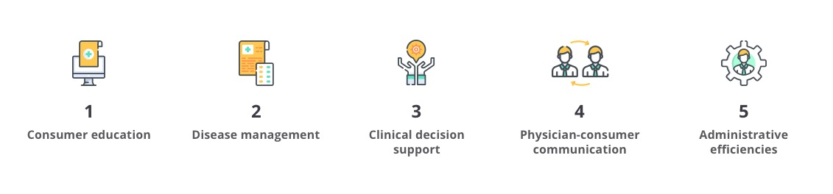

**1. Consumer education.**

Most patients are ignorant of treatment details and do not know much about their current condition. To help your patients, you can create a website that offers information about disease prevention, risk factors, and tips on how to reduce treatment costs.

**2. Disease management.**

This kind of website will be especially useful for patients suffering from chronic diseases. Due to the “Ask a physician/nurse” feature that many web-based health portals have, customers can evade visiting their physicians too often and track their medical condition by taking advantage of Internet-based technologies.

**3. Clinical decision support.**

Web-based clinical decision support systems as a means of medical error reduction can help health workers access different databases. These systems would allow finding necessary information quickly to make the problem-solving process more efficient.

**4. Physician-consumer communication.**

One of the most convenient ways to connect to your doctor is by email. This can be done through either the eHealth portal or the doctor’s own website. In both cases, patients use a Web interface to send an email and get a prompt response.

**5. Administrative efficiencies.**

Some people would say that this is the largest benefit they can derive from a medical website. Through web-enabled processes, health facilities and patients will save time, money, and even lives: filling forms online and computerized pharmacy ordering, to name a few.

**ABBREVIATIONS**

* + 1. HTML Hyper Text Markup Language
    2. CSS Cascading Style Sheets
    3. JS JavaScript
    4. IT Information Technology
    5. UI User Interface
    6. VS Visual Studio
    7. RAM Random Access Memory
    8. ML Machine Learning

**CONTENTS**

Declaration 1

Certificate 2

Acknowledgement 3

Abstract 4

Abbreviations 6

Table of Contents 7

List of figures 8

**CHAPTER 1 Introduction 9**

1.1 Overview and Motivation 9

1.2 Objective 11

1.3 Issues and Challenges 13

1.4 Contribution 15

1.5 Organization of the Project 16

**CHAPTER 2 Requirement Analysis 17**

2.1 Hardware Requirements 17

2.2 Software Requirements 17

**CHAPTER 3 System Design 18**

3.1 Client/User Interface Design 18

3.2 Machine Learning Model Design 18

3.3 Use Case Diagram 19

**CHAPTER 4 Implementation and User Interface 20**

4.1 Implementation 20

4.2 Machine Learning Algorithms Used 26

**CHAPTER 5 Conclusion 28**

**References 29**

# LIST OF FIGURES

**Figure 1 Project Organization 16**

**Figure 2 Client/User Interface Design 18**

**Figure 3 Machine Learning Model Design 18**

**Figure 4 Use Case Diagram 19**

**Figure 5 Elements of Decision Tree 26**

# CHAPTER 1

# INTRODUCTION

# OVERVIEW AND MOTIVATION

**Overview:**

**Project Title:** “Health Care System: Integrated Health Recommendation and Appointment Booking System”

**Objective:**

The primary objective of our project is to establish an online platform, Health Care System, that seamlessly integrates a symptom-based disease recommendation system with a user-friendly doctor appointment booking feature. Health Care System aims to empower users to make informed health decisions by providing accurate and personalized disease recommendations based on reported symptoms. Additionally, the platform facilitates the booking of doctor appointments directly within the same system, creating a holistic healthcare experience.

**Scope:**

Health Care System’s scope encompasses the development of a robust recommendation algorithm that analyses user-entered symptoms to suggest potential diseases. The platform will further extend its functionality to enable users to book appointments with healthcare professionals, promoting continuity of care. Initially, our focus will be on common health concerns, with plans for continuous expansion to cover a broader spectrum of medical conditions and specialties.

**Significance:**

Health Care System addresses the growing need for accessible and reliable health information. By combining a symptom-based recommendation system with appointment booking capabilities, the platform aims to bridge the gap between self-diagnosis and professional medical care. This integrated approach not only empowers users to take proactive steps toward their health but also facilitates a more efficient and streamlined healthcare journey.

**Motivation:**

**Current Challenges:**

The current healthcare landscape often leaves individuals seeking health information online, resulting in misinformation and confusion. The motivation behind Health Care System arises from the need to address this information gap by providing users with a reliable source for symptom-based disease recommendations. Additionally, the platform seeks to streamline the often-cumbersome process of finding and booking appointments with healthcare providers.

**Technological Advancements:**

Advancements in machine learning algorithms and the increasing reliance on online platforms for healthcare information have opened up new possibilities. Health Care System leverages these technological advancements to deliver a sophisticated recommendation system that continuously learns and adapts based on user interactions. The integration of appointment booking features aligns with the trend of comprehensive digital health solutions.

**Improving Patient Access:**

Health Care System is motivated by the goal of improving access to healthcare services. By offering a free and user-friendly platform, we aim to empower individuals, especially those with limited access to traditional healthcare resources, to make informed decisions about their health. The convenience of finding disease recommendations and booking appointments within the same platform enhances the overall accessibility of healthcare services.

**Enhancing Patient Engagement:**

Recognizing the importance of patient engagement in healthcare outcomes, Health Care System motivates users to take an active role in managing their health. The recommendation system encourages users to be proactive in seeking professional medical advice, while the appointment booking feature ensures a seamless transition from information gathering to direct interaction with healthcare providers.

**Stakeholder Needs:**

Our motivation is grounded in understanding the needs of both users and healthcare professionals. Health Care System strives to meet the informational needs of users while offering healthcare providers a platform to connect with individuals seeking their expertise. By facilitating this interaction, we aim to create a symbiotic relationship that benefits both parties and contributes to the overall improvement of healthcare delivery.

In summary, Health Care System represents a forward-thinking approach to healthcare, driven by a commitment to addressing current challenges, leveraging technological advancements, improving access to healthcare services, enhancing patient engagement, and meeting the diverse needs of stakeholders in the healthcare ecosystem.

# 1.2 OBJECTIVE

**Primary Goal:**

The primary aim of the Health Care System project is to create a user-centric and technologically advanced platform that addresses critical challenges in healthcare information access, patient empowerment, and seamless interaction with healthcare providers. The overarching objectives can be categorized as follows:

**Symptom-Based Disease Recommendation:**

Develop a sophisticated recommendation system capable of accurately analysing user-entered symptoms and providing personalized and reliable disease recommendations. The goal is to assist users in understanding potential health issues based on reported symptoms, fostering health literacy and informed decision-making.

**Integrated Appointment Booking:**

Implement a seamless and user-friendly appointment booking feature within the Health Care System platform. The objective is to streamline the process of connecting users with healthcare professionals, ensuring a smooth transition from self-diagnosis to professional consultation. This integration aims to bridge the gap between digital health information and personalized medical care.

**User Empowerment and Engagement:**

Empower users to take an active role in managing their health by providing them with accurate and understandable health information. Enhance user engagement through a well-designed and intuitive user interface, encouraging users to seek professional medical advice when needed and fostering a sense of responsibility for their well-being.

**Data Security and Privacy Compliance:**

Prioritize the implementation of robust data security and privacy measures to safeguard user information. Ensure compliance with relevant healthcare data protection regulations, such as HIPAA, to instil trust and confidence among users regarding the confidentiality and security of their health-related data.

**Accessibility and Inclusivity:**

Design Health Care System to be accessible and inclusive, catering to a diverse user base. Consider the needs of individuals with varying levels of technological proficiency, language preferences, and healthcare literacy. The objective is to make health information and services accessible to a broad audience, including those who may face barriers to traditional healthcare resources.

**Healthcare Professional Integration:**

Facilitate the integration of healthcare professionals into the Health Care System ecosystem. Enable seamless communication between users and healthcare providers through the platform’s appointment booking system. The goal is to create a collaborative environment that benefits both users and healthcare professionals while ensuring the highest standards of care.

**Continuous Improvement and Adaptability:**

Establish a framework for continuous improvement and adaptability, allowing the Health Care System platform to evolve in response to user feedback, technological advancements, and emerging healthcare trends. The objective is to create a dynamic and responsive system that stays aligned with the evolving needs of users and the healthcare industry.

**Measurable Impact on Healthcare Accessibility:**

Measure and assess the impact of Health Care System on healthcare accessibility, user behaviour, and patient outcomes. Through quantitative and qualitative analysis, determine the extent to which the platform contributes to improved access to healthcare services, patient empowerment, and the overall efficiency of healthcare delivery.

By pursuing these objectives, the Health Care System project aims to contribute to a paradigm shift in how individuals engage with health information, make healthcare decisions, and access professional medical care, ultimately fostering a more informed and empowered healthcare community.

# 1.3 ISSUES AND CHALLENGES

The development and implementation of the Health Care System project have been accompanied by various issues and challenges that have influenced the project’s trajectory. Understanding and addressing these challenges is crucial for improving the platform’s effectiveness and ensuring its seamless integration into the healthcare ecosystem.

**Data Quality and Variability:**

**Challenge:** The reliability of disease recommendations is directly influenced by the quality and variability of symptom data entered by users.

**Issue**: Inconsistent or inaccurate symptom reporting can lead to less precise recommendations, impacting the overall effectiveness of the recommendation system.

Algorithm Sensitivity and Specificity:

**Challenge:** Striking a balance between sensitivity (accurate detection of relevant symptoms) and specificity (reduction of false positives) is a complex challenge in developing the recommendation algorithm.

**Issue:** An overly sensitive algorithm may produce more false positives, leading to potential user anxiety, while an overly specific algorithm may miss important symptoms.

User Interface Complexity:

**Challenge:** Designing an intuitive and user-friendly interface that accommodates a wide range of users, including those with varying levels of technological literacy, presents a significant challenge.

**Issue:** A complex or confusing user interface may hinder user engagement and limit the accessibility of the platform, particularly for users with limited digital literacy.

Data Security and Privacy Concerns:

**Challenge:** Ensuring robust data security measures and compliance with healthcare privacy regulations, such as HIPAA, is a continuous challenge.

**Issue:** Users may be reluctant to input sensitive health information if they perceive potential risks to the confidentiality and security of their data.

Healthcare Professional Onboarding:

**Challenge:** Integrating healthcare professionals into the Health Care System platform requires addressing their concerns about workflow disruption and maintaining high standards of patient care.

**Issue:** Resistance from healthcare professionals or difficulties in adapting to the new system may hinder the effectiveness of the integrated appointment booking feature.

Diversity in Healthcare Practices:

**Challenge:** Accounting for the diversity in healthcare practices and procedures across different regions and specialties poses a challenge.

**Issue:** A one-size-fits-all approach may not accommodate the specific needs and practices of healthcare professionals, potentially limiting the platform’s applicability.

User Trust and Ethical Considerations:

**Challenge:** Building and maintaining user trust in the platform’s recommendations and data security is an ongoing challenge, particularly in the context of sensitive health information.

**Issue:** Ethical considerations, such as ensuring transparency in algorithmic decision-making and protecting user autonomy, are critical to addressing trust-related concerns.

Continuous Learning and Adaptation:

**Challenge:** Creating a recommendation system that continuously learns and adapts to changing healthcare knowledge and user behaviours requires a dynamic approach.

**Issue:** Balancing the need for continuous improvement with the risk of algorithmic bias or unintended consequences is a nuanced challenge.

By recognizing and addressing these issues and challenges, the Health Care System project aims to enhance its overall functionality, user satisfaction, and impact on healthcare accessibility. Ongoing monitoring, iterative improvements, and collaboration with stakeholders are key strategies in overcoming these challenges and ensuring the sustained success of the platform.

# 1.4 CONTRIBUTION

**Anikate Agrawal – Data Scientist and Backend Developer:**

Anikate Agrawal played a pivotal role in the Health Care System project, serving as both a data scientist and a backend developer. His contributions were instrumental in shaping the core functionality of the platform. Anikate led the development of the recommendation algorithm, employing machine learning models to analyse user-entered symptoms and enhance the accuracy of disease recommendations. Simultaneously, he played a key role in backend development, implementing robust data processing and storage solutions to support the seamless functioning of the recommendation system. Anikate’s dual expertise in data science and backend development significantly influenced the project’s technical foundation.

**Ishika Chaturvedi – Backend Developer:**

Ishika Chaturvedi, as a backend developer, made substantial contributions to the architecture and functionality of Health Care System. Her focus on backend development involved designing and implementing scalable and efficient server-side components. Ishika collaborated closely with the data science team to ensure the seamless integration of the recommendation algorithm with the backend infrastructure. Her expertise in backend technologies contributed to the creation of a robust and responsive system that forms the backbone of the Health Care System platform.

**Anuj Verma and Pop Singh – Frontend Developers:**

Anuj Verma and Pop Singh, as frontend developers, played key roles in shaping the user interface and overall user experience of Health Care System. Their contributions focused on translating design concepts into a visually appealing and user-friendly interface. Anuj and Pop implemented frontend components that facilitate smooth user interactions, ensuring accessibility for users with varying levels of technological literacy. Their collaborative efforts resulted in an intuitive platform that enhances user engagement and contributes to the overall success of Health Care System.

Collectively, the collaborative efforts of Anikate Agrawal, Ishika Chaturvedi, Anuj Verma, and Pop Singh reflect a synergistic approach to project development. Their expertise in data science, backend development, and frontend development has been instrumental in creating a comprehensive and effective healthcare platform that aligns with the project’s objectives of providing accurate health recommendations and seamless appointment booking.

**1.5 ORGANIZATION OF THE PROJECT**

**Health Care System – September 2023 – March 2024**

Figure 1 Project Organization

**CHAPTER 2**

**REQUIREMENT ANALYSIS**

**2.1 HARDWARE REQUIREMENTS**

* Laptop / Desktop
* Processor: i5 or above
* Minimum 4Gb RAM
* Windows Operating System
* 256Gb or more Hard-disk / SSD

**2.2 SOFTWARE REQUIREMENTS**

* VS Code
* Google Colab
* Github
* Python - Machine Learning
* MongoDB Database
* ExpressJS Server
* React Front End
* Nodejs BackEnd
* EJS
* HTML, CSS, Bootstrap
* Javascript
* MS Excell
* Chrome Browser
* Render
* PassPort

**CHAPTER 3**

**SYSTEM DESIGN**

**3.1 CLIENT / USER INTERFACE DESIGN**

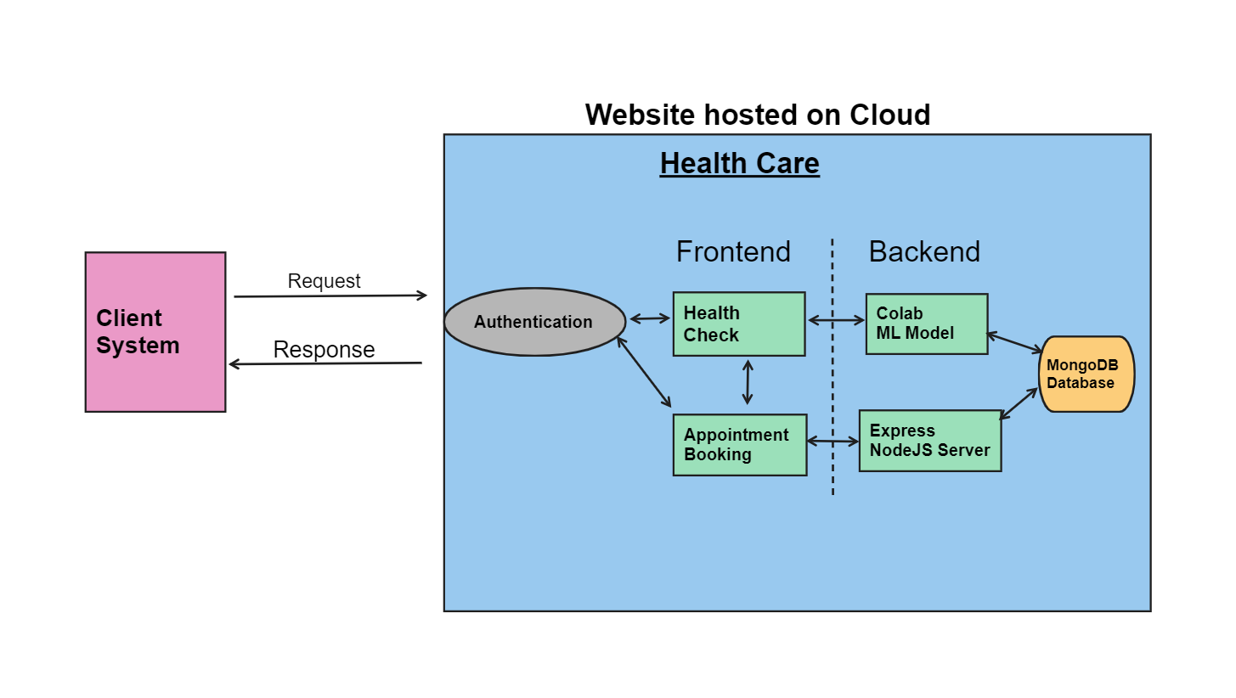

Figure 2 Client/User Interface Design

**3.2 MACHINE LEARNING MODEL DESIGN**

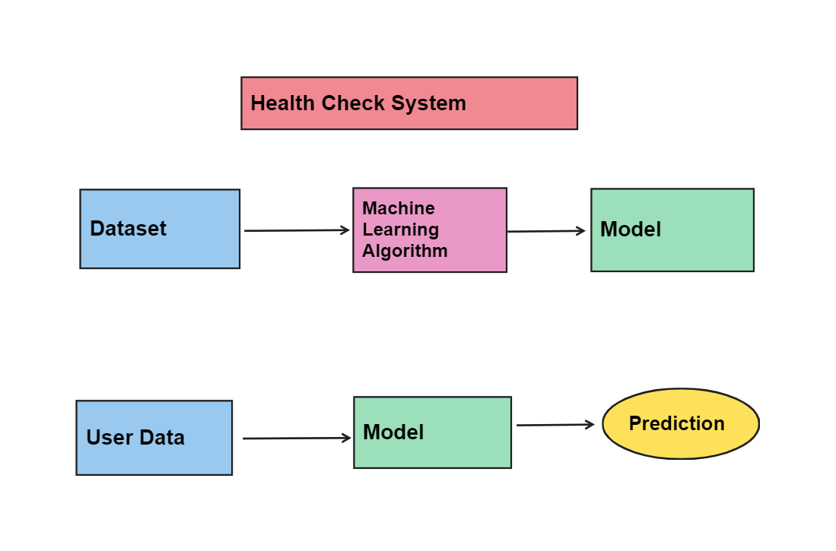

Figure 3 Machine Learning Model Design

**3.3 USE CASE DIAGRAM**

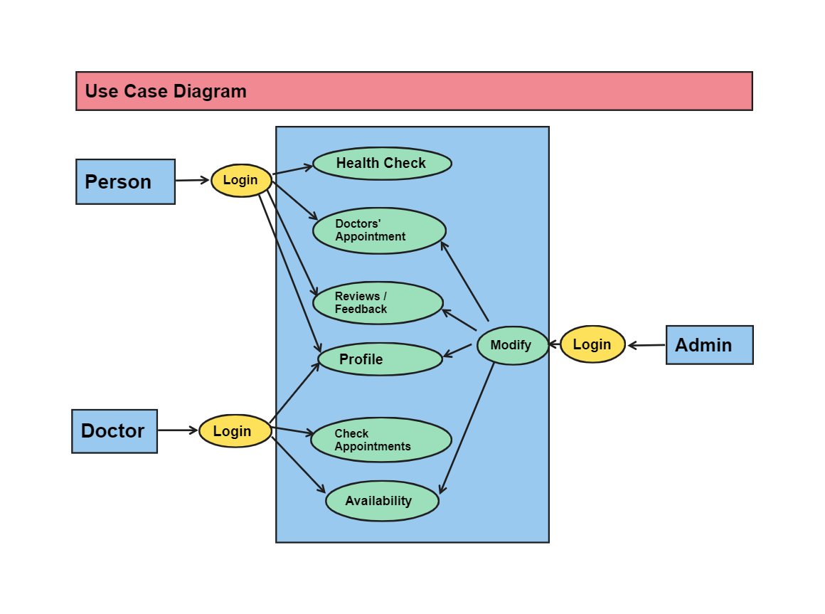

Figure 4 Use Case Diagram

# CHAPTER 4

# IMPLEMENTATION AND VALIDATION

**4.1 IMPLEMENTATION**

**Machine Learning**

Machine Learning (ML) is a subfield of artificial intelligence (AI) that focuses on the development of algorithms and models that enable computers to learn from data and make predictions or decisions without being explicitly programmed. In traditional programming, humans write explicit instructions for a computer to follow. In contrast, machine learning allows computers to learn patterns and relationships from data and generalize that knowledge to new, unseen data.

Key concepts and components of machine learning include:

1. **Types of Machine Learning:**
   * **Supervised Learning:** Involves training a model on a labeled dataset, where the algorithm learns the mapping between input and output pairs. The goal is to make predictions on new, unseen data.
   * **Unsupervised Learning:** Involves working with unlabeled data, and the algorithm tries to find patterns, structures, or relationships in the data without explicit guidance.
   * **Semi-Supervised Learning:** Combines elements of both supervised and unsupervised learning, where the model is trained on a dataset containing both labeled and unlabeled examples.
   * **Reinforcement Learning:** Involves training an agent to make sequences of decisions by providing feedback in the form of rewards or punishments.
2. **Common Machine Learning Algorithms:**
   * **Linear Regression:** Used for predicting a continuous variable based on one or more input features.
   * **Decision Trees and Random Forests:** Useful for both classification and regression tasks, based on a tree-like model of decisions.
   * **Support Vector Machines (SVM):** A supervised learning algorithm for classification and regression tasks.
   * **Neural Networks and Deep Learning:** Deep learning involves neural networks with multiple layers (deep neural networks) and is particularly powerful for tasks like image and speech recognition.
3. **Feature Engineering:** Involves selecting, transforming, or creating input features to improve the performance of machine learning models.
4. **Model Evaluation and Metrics:** Various metrics are used to assess the performance of machine learning models, such as accuracy, precision, recall, F1 score, and area under the receiver operating characteristic (ROC) curve.
5. **Training and Testing:** Datasets are typically divided into training and testing sets. The model is trained on the training set and evaluated on the testing set to assess its generalization to new data.
6. **Overfitting and Underfitting:** Overfitting occurs when a model performs well on the training data but poorly on new data, while underfitting occurs when a model is too simple to capture the underlying patterns in the data.
7. **Hyperparameter Tuning:** Adjusting the hyperparameters of a machine learning algorithm to optimize its performance on a specific task.
8. **Deployment:** Taking a trained machine learning model and integrating it into a production environment for making real-time predictions.

Machine learning applications are widespread and include areas such as natural language processing, computer vision, speech recognition, recommendation systems, fraud detection, and more. It is a dynamic field with ongoing research and advancements, and it plays a crucial role in the development of intelligent systems.

Popular machine learning libraries and frameworks include scikit-learn, TensorFlow, PyTorch, and Keras.

**Frontend**

Front end development refers to the part of web development that deals with the user interface

and user experience of a website or application. It involves the use of various programming languages, frameworks, and tools to create visually appealing and interactive interfaces that allow users to interact with the website or application.

Front end developers are responsible for designing and developing the layout, navigation, and

overall look and feel of a website or application. They use languages such as HTML, CSS, and

JavaScript, as well as frameworks such as React, Angular, and Vue, to create responsive and dynamic user interfaces.

In addition to technical skills, front end developers must also have a good understanding of user experience (UX) design principles and be able to create interfaces that are intuitive and easy to use. They must also be familiar with web standards and accessibility guidelines to ensure that their interfaces are accessible to all users.

Overall, front end development is a critical component of web development, as it directly affects the way users interact with and perceive a website or application.

**Backend**

Backend development involves the creation of server-side applications and APIs that power the functionality of a website or application. MongoDB and Firebase are two popular backend

technologies that developers can use to build robust and scalable web applications.

MongoDB is a NoSQL database that uses a document-based model to store and retrieve data. It is known for its flexibility, scalability, and ease of use, making it a popular choice for backend

development. With MongoDB, developers can store and query large amounts of data, including

unstructured data such as images, videos, and audio files.

Firebase, on the other hand, is a cloud-based platform that offers a range of backend services

such as authentication, real-time database, storage, and hosting. It is a popular choice for mobile and web application development, as it provides developers with a complete backend

solution that requires minimal setup and maintenance.

When used together, MongoDB and Firebase can provide developers with a powerful and flexible backend solution that can handle complex data structures and high levels of traffic. With MongoDB handling data storage and retrieval and Firebase handling backend services, developers can focus on building their frontend applications and delivering an optimal user experience.

**HTML**

HTML is a versatile language that can be used to create simple static web pages or complex dynamic web applications. It is supported by all modern web browsers and is constantly evolving to meet the needs of developers and users.

Learning HTML is essential for anyone interested in web development, as it is the foundation

of all web technologies. There are many resources available online to help beginners learn HTML, including tutorials, courses, and reference guides.

In addition to learning HTML, it is important to stay up to date with best practices and web standards to ensure that your web pages are accessible, user-friendly, and compatible with different devices and browsers. Overall, HTML is a powerful and essential tool for web development, and mastering it is key to building effective and engaging web pages and applications.

**CSS**

CSS, or Cascading Style Sheets, is a style sheet language used to describe the presentation and

formatting of HTML documents. It is used in conjunction with HTML and JavaScript to create

visually appealing and interactive web pages.

CSS allows developers to separate the content of a web page from its presentation, making it easier to maintain and update. With CSS, developers can control the layout, color, font, and other visual elements of a web page.

CSS is constantly evolving, with new features and capabilities being added regularly.

Learning CSS is essential for anyone interested in web development, as it is a crucial component of modern web design. There are many resources available online to help beginners

learn CSS, including tutorials, courses, and reference guides.

**JavaScript**

JavaScript is a programming language used to create dynamic and interactive web pages and applications. It is a versatile language that can be used for client-side scripting, server-side scripting, and desktop application development.

JavaScript allows developers to add interactivity to web pages, such as animations, form validation, and dynamic content loading. It is supported by all modern web browsers and is constantly evolving to meet the needs of developers and users.

Learning JavaScript is essential for anyone interested in web development, as it is a crucial component of modern web design. There are many resources available online to help beginners

learn JavaScript, including tutorials, courses, and reference guides.

**ReactJS**

ReactJS, often simply referred to as React, is an open-source JavaScript library developed and maintained by Facebook. It is used for building user interfaces, particularly for single-page applications where the user interface needs to be dynamic and interactive. React allows developers to create reusable UI components that update in response to changes in the application's state.

Here are some key features and concepts associated with React:

1. **Component-Based Architecture:** React follows a component-based architecture, where the user interface is broken down into individual, reusable components. Each component is responsible for its own logic and can be composed together to create complex UIs.
2. **Virtual DOM:** React uses a virtual DOM (Document Object Model) to optimize and efficiently update the actual DOM. Instead of directly manipulating the DOM for every change, React updates a virtual representation of the DOM and then calculates the most efficient way to update the actual DOM.
3. **Declarative Syntax:** React uses a declarative syntax, which means developers describe what the UI should look like, and React takes care of updating the DOM to match that description. This is in contrast to an imperative approach where developers would need to specify each step to achieve a particular outcome.
4. **JSX (JavaScript XML):** React uses JSX, a syntax extension for JavaScript that allows developers to write HTML code within JavaScript files. JSX makes it easier to visualize and write React components.
5. **Unidirectional Data Flow:** React follows a unidirectional data flow, meaning data flows in a single direction through the components. This helps in maintaining a clear and predictable state in the application.
6. **React Router:** For building single-page applications with multiple views, React Router is commonly used. It allows developers to define routes and navigate between different parts of the application without triggering a full page reload.

React has gained widespread adoption and is widely used in the development of modern web applications. It is often used in conjunction with other tools and libraries, such as Redux for state management and Webpack for bundling and asset management.

**Node JS**

Node.js is an open-source, cross-platform JavaScript runtime environment that allows developers to build fast and scalable network applications. It is built on the V8 JavaScript engine, which is used by Google Chrome, and provides an event-driven architecture and non- blocking I/O model that makes it ideal for building real-time, data-intensive applications.

Node.js is commonly used for building web applications, RESTful APIs, and microservices. It

also provides a range of built-in modules and libraries that make it easy to implement features

such as HTTP requests, file system access, and data streaming.

Node.js is constantly evolving, with new features and capabilities being added regularly. Learning Node.js is essential for anyone interested in backend web development, as it is a crucial component of modern web applications. There are many resources available online to help beginners learn Node.js, including tutorials, courses, and reference guides.

**MongoDB**

MongoDB is a popular open-source document-oriented NoSQL database system. It stores data

in a flexible, JSON-like format called BSON, which allows developers to store and manipulate

unstructured data with ease.

MongoDB is designed to scale horizontally, allowing applications to distribute data across multiple servers for improved performance and scalability. It also provides a range of features

and capabilities, including automatic sharding, indexing, and query optimization, that make it a popular choice for modern web applications.

Learning MongoDB is essential for anyone interested in building scalable and flexible web

applications. There are many resources available online to help beginners learn MongoDB,

including tutorials, courses, and reference guides.

**ExpressJS**

Express.js, commonly referred to as Express, is a minimal and flexible web application framework for Node.js. It is designed to provide a simple and unopinionated set of tools for building web and mobile applications. Express.js is often used to build server-side applications and APIs, and it simplifies the process of handling HTTP requests, routing, middleware, and more.

Key features and concepts associated with Express.js include:

1. Routing: Express allows developers to define routes to handle different HTTP methods (GET, POST, PUT, DELETE, etc.) and URL patterns. Routes are defined using a combination of HTTP methods and URL patterns.
2. Middleware: Express uses middleware functions to perform tasks during the request-response cycle. Middleware can be used for tasks such as logging, authentication, handling form data, and more. Middleware functions have access to the request (req) and response (res) objects.});
3. Template Engines: While Express itself is unopinionated about template engines, it provides support for using template engines like EJS, Pug (formerly Jade), Handlebars, and others to generate dynamic HTML.
4. Static Files: Express makes it easy to serve static files (like images, stylesheets, and scripts) using the express.static middleware.
5. RESTful Routing: Express is often used to build RESTful APIs, and it provides features like routing and middleware to facilitate the development of RESTful services.
6. Error Handling: Express has mechanisms for handling errors in a centralized way. You can define error-handling middleware to catch and process errors during the request-response cycle.

Express is widely used in the Node.js ecosystem and is known for its simplicity and flexibility. It is often chosen for building web applications and APIs, especially in scenarios where a lightweight framework is preferred.

**EJS**

EJS, or Embedded JavaScript, is a templating language used to generate HTML markup with JavaScript. It allows developers to embed JavaScript code directly into HTML templates, making it easier to generate dynamic content and customize the layout and structure of web pages.

EJS is commonly used in Node.js applications, where it can be used to generate HTML pages

on the server-side. It also provides a range of features and capabilities, including conditional statements, loops, and custom tags, that make it a powerful and versatile tool for building web

applications.

Learning EJS is essential for anyone interested in web development with Node.js, as it is a

crucial component of server-side templating. There are many resources available online to help

beginners learn EJS, including tutorials, courses, and reference guides.

**Google Firebase**

Firebase is an app development platform that helps you build and grow apps and games users love. Backed by Google and trusted by millions of businesses around the world. Firebase provides detailed documentation and cross-platform SDKs to help you build and ship apps on Android, iOS, the web, C++, and Unity.

**Python Flask**

Flask is a lightweight and flexible web framework for Python. It is designed to be easy to use and to give developers the freedom to choose the components they want to use while building web applications. Flask is often referred to as a micro-framework because it provides the essentials for building web applications without imposing too much structure.

**4.2 MACHINE LEARNING ALGORITHM USED**

**Decision Tree**

A decision tree is a machine learning algorithm used for both classification and regression tasks. It works by recursively partitioning the dataset into subsets based on the most significant attributes. Here's an overview of how decision trees work and some key concepts associated with them:

1. **Tree Structure:**
   * A decision tree is composed of nodes, where each node represents a decision or a test on an attribute.
   * The tree structure is hierarchical, with a root node at the top, internal nodes representing decisions, and leaf nodes representing the final outcomes or predictions.

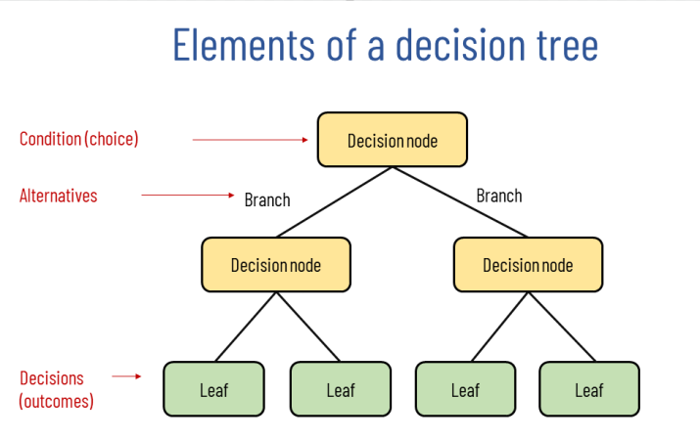

Figure 5 Elements of Decision Tree

1. **Decision Nodes:**
   * Decision nodes evaluate attributes and make decisions based on the values of those attributes.
   * Each decision node represents a test on a specific attribute, and the tree branches out based on the possible outcomes of that test.
2. **Leaf Nodes:**
   * Leaf nodes represent the final outcomes or predictions of the decision tree.
   * Once a leaf node is reached, a decision or prediction is made.
3. **Splitting Criteria:**
   * Decision trees use various criteria to determine how to split the data at each decision node. Common criteria include Gini impurity, entropy, and information gain for classification tasks, and mean squared error for regression tasks.
4. **Training Process:**
   * During the training process, the decision tree algorithm recursively selects the best attribute to split the data based on the chosen splitting criterion.
   * This process continues until a stopping condition is met, such as reaching a maximum depth or having a subset of data with uniform class labels.
5. **Pruning:**
   * Decision trees can be prone to overfitting, capturing noise in the training data. Pruning is a technique used to trim the tree by removing branches that do not significantly contribute to improving predictive performance on unseen data.
6. **Prediction:**
   * To make predictions on new data, you traverse the tree from the root node to a leaf node, following the decisions based on the attribute values of the data.
7. **Advantages:**
   * Decision trees are interpretable and easy to visualize, making them useful for understanding the decision-making process.
   * They can handle both numerical and categorical data.
   * Decision trees implicitly perform feature selection by giving more importance to important features in the tree structure.
8. **Disadvantages:**
   * Decision trees can be sensitive to small variations in the data.
   * They might create biased trees if some classes dominate.
9. **Ensemble Methods:**
   * Decision trees can be part of ensemble methods like Random Forests or Gradient Boosting, where multiple trees are combined to improve predictive performance and robustness.

Decision trees are widely used in various domains due to their simplicity, interpretability, and effectiveness in capturing complex decision boundaries. However, careful consideration of hyperparameters, data quality, and potential overfitting is crucial for obtaining reliable and accurate models.

**CHAPTER 5**

**CONCLUSION**

**5.1 CONCLUSION**

In conclusion, the Healthcare System Project has provided valuable insights into the current state of our healthcare system and offered innovative solutions to address the challenges faced by both healthcare providers and patients. Through extensive research, analysis, and collaboration, we have identified key areas for improvement and implemented strategic interventions to enhance the overall effectiveness and efficiency of our healthcare delivery.

One of the major achievements of this project is the successful implementation of disease prediction system, which has significantly contributed to ease of user to get quick health check. This includes helping them save time and money and making them aware about several possible diseases.

Our comprehensive assessment of healthcare policies, technologies, and patient experiences has highlighted the importance of e.g., preventive care, telemedicine, data security. These findings underscore the need for ongoing efforts to recommendations for future initiatives, e.g., policy adjustments, technology upgrades, training programs.

Furthermore, the collaborative nature of this project has fostered stronger partnerships between healthcare stakeholders, paving the way for continued innovation and collaboration in the pursuit of a more patient-centric and sustainable healthcare system. The insights gained from this project will serve as a valuable resource for policymakers, healthcare professionals, and researchers as they work towards building a resilient and responsive healthcare ecosystem.

As we conclude this project, it is crucial to acknowledge the dedication and expertise of all those involved, from project team members to healthcare professionals and administrators. Their commitment has been instrumental in the success of this endeavour, and their passion for improving healthcare will undoubtedly have a lasting impact on the well-being of our community.

In the ever-evolving landscape of healthcare, the lessons learned and accomplishments achieved through this project will guide us towards a future where access to quality healthcare is universal, and the well-being of individuals and communities remains at the forefront of our collective efforts. The journey does not end here; instead, it marks the beginning of a continuous commitment to advancing the health and wellness of our society.

**REFERENCES**

1. S. Grampurohit and C. Sagarnal, "Disease Prediction using Machine Learning Algorithms," 2020 International Conference for Emerging Technology (INCET), Belgaum, India, 2020, pp. 1-7, doi: 10.1109/INCET49848.2020.9154130.
2. Bhanuteja Talasila, Saipoornachand Kolli, Kilaru Venkata Narendra Kumar and Poonati Anudeep, "Symptoms Based multiple Disease Prediction Model using Machine Learning Approach", International Journal of Innovative Technology and Exploring Engineering, August 2021.
3. P. Hema, N. Sunny, R. Venkata Naganjani and A. Darbha, "Disease Prediction using Symptoms based on Machine Learning Algorithms," 2022 International Conference on Breakthrough in Heuristics And Reciprocation of Advanced Technologies (BHARAT), Visakhapatnam, India, 2022, pp. 49-54, doi: 10.1109/BHARAT53139.2022.00021.
4. Nishant Yede, Ritik Koul, Chetn Harde, Kumar Gaurav and Prof. C.S. Pagar, "General Disease Prediction Based On Symptoms Provided By Patient", Open Access International Journal Of Science & Engineering (OAIJSE), June 2021.
5. Ibrahim Mahmood and Adnan Moshin Abdulazeez, "The Role of Machine Learning Algorithms for Diagnosing Diseases", Journal of Applied Science and Technology Trends (JASTT), March 2021.
6. P. Hamsagayathri and S. Vigneshwaran, "Symptoms Based Disease Prediction Using Machine Learning Techniques", IEEE Third International Conference on Intelligent Communication Technologies and Virtual Mobile Networks (ICICV), March 2021.

**Books:** Black Book HTML5, CSS, JS

## **Websites:** MDN Web Docs, W3Schools, GeeksForGeeks, Javatpoint

**Github Repositories:**

[**https://github.com/ChaturvediIshika/Health_Care_Website**](https://github.com/ChaturvediIshika/Health_Care_Website)

[**https://github.com/anikateagrawal/health_check**](https://github.com/anikateagrawal/health_check)

[**https://github.com/anikateagrawal/Major-Project**](https://github.com/anikateagrawal/Major-Project)

**Live Link:** [**https://health-care-3q5v.onrender.com/**](https://health-care-3q5v.onrender.com/)