
Submitted by
Thukivakam Chaturya
Registration No: 2411021240045
BCA — Batch 2024|
Alliance School of Computer Applications
Course: Deep Learning
Faculty : Nagasri P

Introduction
Deep learning has produced a range of neural network architectures, each designed around the structure of the data it is meant to process. This report studies three foundational architectures — the Feedforward Neural Network (FNN), the Convolutional Neural Network (CNN), and the Recurrent Neural Network (RNN) — and compares them in terms of their internal structure, the type of input data they are best suited for, and their common real-world applications.
Task 1: Basic Architecture of Each Network
  - Feedforward Neural Network (FNN)
A Feedforward Neural Network is the simplest form of artificial neural network. Information moves in a single direction — from the input layer, through one or more hidden layers, to the output layer — with no cycles or loops feeding information backward.
- Input Layer: Receives the raw features of the data, one node per feature
- Hidden Layer(s): Fully connected layers that apply weights, biases, and an activation function (e.g., ReLU, sigmoid) to learn patterns
- Output Layer: Produces the final prediction, such as a class label or a numeric value
- Learning: Trained using backpropagation and gradient descent to minimise a loss function
Because every neuron in one layer connects to every neuron in the next (a “dense” or “fully connected” structure), FNNs have no built-in way to exploit spatial or sequential relationships in the data.
|
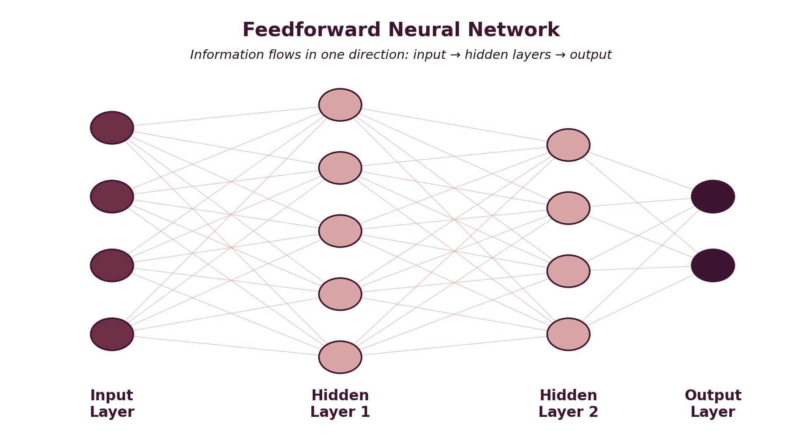
Figure 1: Fully connected layers of a Feedforward Neural Network
1.2 Convolutional Neural Network (CNN)
A CNN is designed specifically to process grid-like data such as images. Instead of connecting every input to every neuron, it uses small filters that slide across the input to detect local patterns.
- Convolutional Layer: Applies learnable filters/kernels across the input to detect features such as edges, textures, and shapes.
- Activation Function: Typically ReLU, applied after each convolution to introduce non-linearity
- Pooling Layer: Downsamples feature maps (e.g., max pooling) to reduce dimensionality while retaining important features.
- Fully Connected Layer: One or more dense layers near the end that combine extracted features to make a final prediction.
- Parameter Sharing: The same filter is reused across the entire image, greatly reducing the number of parameters compared to an FNN.
- This layered approach allows CNNs to learn a hierarchy of features — simple edges in early layers, and increasingly complex shapes and objects in deeper layers.
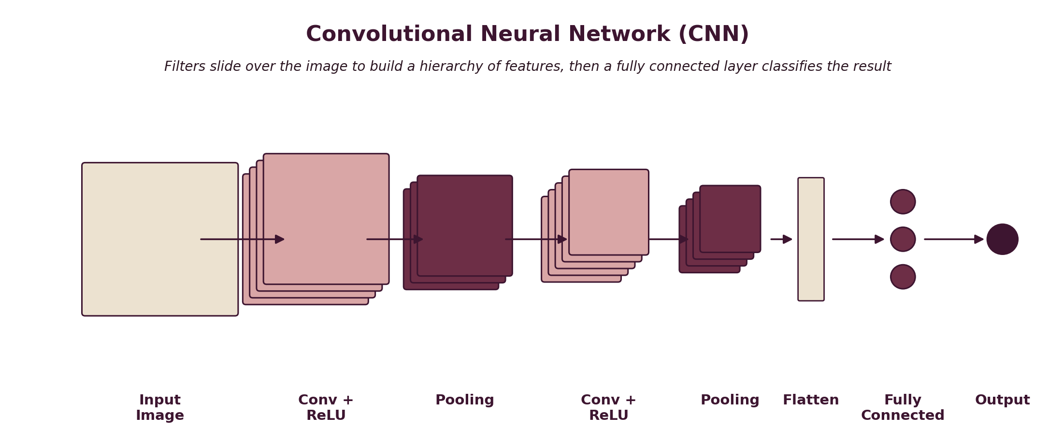
Figure 2: Convolution and pooling stages feeding into a fully connected classifier
1.3 Recurrent Neural Network (RNN)
An RNN is built to handle sequential data, where the order of inputs carries meaning. Unlike FNNs and CNNs, an RNN has connections that loop back on themselves, allowing information from earlier steps to influence later ones.
- Input Sequence: Data fed into the network one time step at a time (e.g., one word, one time-series value).
- Hidden State: A memory vector that is updated at every time step and passed forward to the next step.
- Recurrent Connection: The loop that feeds the hidden state back into the network, giving it context from previous inputs.
- Output: Produced at each time step, or only at the final step, depending on the task.
- Variants: LSTM and GRU are enhanced versions of the basic RNN designed to better retain long-term dependencies
Because the same weights are applied at every time step, RNNs can process sequences of varying length, but they can struggle to retain information across very long sequences (the vanishing gradient problem).
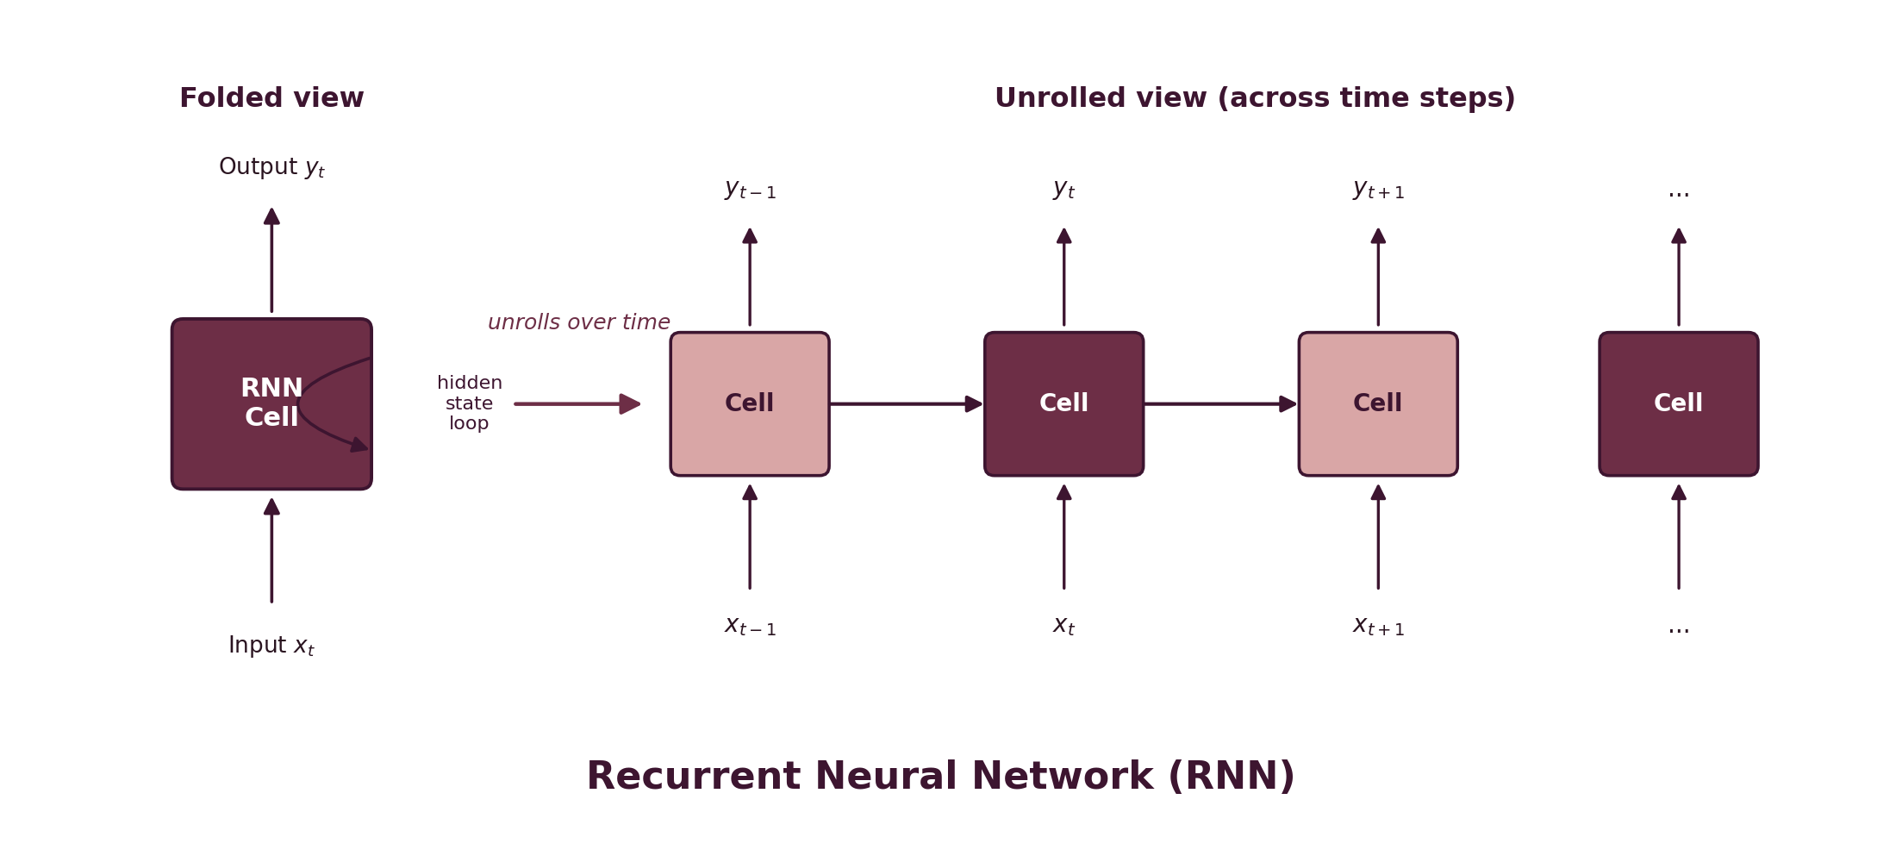
Figure 3: RNN cell shown folded (left) and unrolled across time steps (right)
Task 2: Suitable Applications for Each Architecture
2.1 Applications of Feedforward Neural Networks
- Credit scoring and loan default prediction using structured/tabular financial data.
- House price or sales forecasting based on numeric features
- Basic classification tasks such as spam detection using engi.neered features
- Customer churn prediction in tabular business datasets.
2.2 Applications of Convolutional Neural Networks
- Image classification (e.g., identifying objects, animals, handwritten digits)
- Object detection and facial recognition in security and surveillance systems
- Medical image analysis, such as detecting tumours in X-rays or MRI scans
- Self-driving car perception systems (lane detection, obstacle recognition)
2.3 Applications of Recurrent Neural Networks
- Natural language processing tasks such as language modelling and text generation
- Machine translation, converting text from one language to another
- Speech recognition, converting audio signals into text
- Time-series forecasting, such as predicting stock prices or weather patterns
Task 3: Comparison of Architectures
The table below summarises how the three architectures differ in terms of structure, the type of input data they handle, and the applications they are best suited for.

Aspect | Feedforward Neural Network (FNN) | Convolutional Neural Network (CNN) | Recurrent Neural Network (RNN)
Structure | Fully connected layers arranged in one direction, input to output; no loops, no memory of previous inputs | Convolutional layers with filters/kernels, pooling layers, followed by fully connected layers | Loops that feed the hidden state back into the network, giving it a memory of previous time steps
Input Data | Fixed-size, structured/tabular data (numbers, encoded categories) | Grid-like data such as images (2D pixel grids) or video frames | Sequential data such as text, time series, audio, or speech
Data Dependency | Treats each input independently; no notion of order or time | Assumes spatial locality; nearby pixels are related | Assumes temporal/sequential dependency; order of inputs matters
Parameter Sharing | None; every connection has its own weight | Yes; the same filter/kernel is reused across the image | Yes; the same weights are reused at every time step
Key Strength | Simplicity; good baseline for structured/tabular problems | Excellent at detecting spatial patterns and hierarchical features | Excellent at capturing context and order in sequences
Key Limitation | Cannot capture spatial or sequential patterns | Not naturally suited to sequential/time-based data | Struggles with very long sequences (vanishing gradients); slower to train (sequential computation)
Typical Applications | Credit scoring, price prediction, basic classification/regression on tabular data | Image classification, object detection, facial recognition, medical image analysis | Language modelling, machine translation, speech recognition, stock price prediction

Conclusion
Feedforward Neural Networks, CNNs, and RNNs each address a different kind of data problem. FNNs work well for straightforward, structured data where order and spatial position do not matter. CNNs are built to exploit spatial patterns and are the architecture of choice for image and visual data. RNNs are designed for sequential data, where the order of inputs carries essential context, such as language, speech, and time series. Recognising which architecture matches which data type is the first step in designing an effective deep learning solution.

