Project 4
Ethical Considerations in Deep Learning
Deep Learning is no longer confined to research papers and lab demos. Neural networks now decide who gets shortlisted for a job, who qualifies for a loan, what a doctor sees first on a scan, and what shows up in a person's feed every morning. This is genuinely useful, but it also means that a mistake buried inside a model doesn't stay small. A biased pattern learned from data can end up shaping thousands of real decisions before anyone notices something is wrong.
What makes Deep Learning different from ordinary software is that nobody writes down the rules it follows. It figures out patterns on its own by studying past data, so its behaviour is really a reflection of that data and the choices made while building it. That's exactly where the ethical questions in this report come from. Task 1 looks at three issues that come up again and again in Deep Learning systems, Task 2 walks through a real case where one of these issues caused actual harm, and Task 3 lays out steps that can be taken to keep it from happening again.

Task 1: Three Ethical Issues in Deep Learning

1. Bias and Discrimination
A Deep Learning model is only ever as good as the data it's trained on, and it has no way of knowing whether a pattern in that data is fair or not — it just knows the pattern predicts the outcome well. So if the historical data carries old biases, like hiring records that mostly favoured one gender, or policing data shaped by uneven enforcement in certain neighbourhoods, the model happily picks that up and, in many cases, makes it worse.
The problem is that these predictions don't stay theoretical. They get used to actually decide who gets hired, who gets a loan, or who gets flagged as high-risk by the justice system. A resume-screening model might quietly rank two equally qualified candidates differently because of their gender. A lending algorithm might reject applicants from certain postal codes more often, echoing old redlining practices. And because the decision now comes from a machine, it often gets treated as more "objective" than a human judgement would have been — even though the same human bias is sitting right there inside it.

2. Privacy Violation
Facial recognition, voice assistants, recommendation engines, health-prediction tools — almost all of them need huge amounts of personal data to work well. And that data is often sensitive: someone's face, their voice, where they've been, what they buy, what's in their medical file.
The privacy problem shows up in more than one way. Sometimes the data is scraped from the internet without the people in it ever knowing. Sometimes data collected for one purpose quietly gets reused for another, like a health app selling usage data to advertisers. And there's a subtler issue too — trained models can sometimes be prompted to leak fragments of the exact data they learned from, something researchers call model memorization. That means deleting the original dataset afterwards doesn't necessarily make the risk go away.

3. Lack of Transparency (The Black-Box Problem)
Deep neural networks can have millions of internal parameters, and even the people who built the model often can't point to exactly why it produced one particular output. It might correctly flag a loan applicant as risky or a scan as abnormal, but "why" isn't something it can explain in plain language.
That's a real problem when the decision affects someone's life. If a person is turned down for a job or a loan, they reasonably want to know why, and in many places they have a legal right to challenge that decision. A black-box system makes that difficult for everyone involved, including the organization that deployed it. It also means bias or errors can hide inside the model for a long time, sometimes only coming to light after an outside audit, or worse, after the harm has already happened.
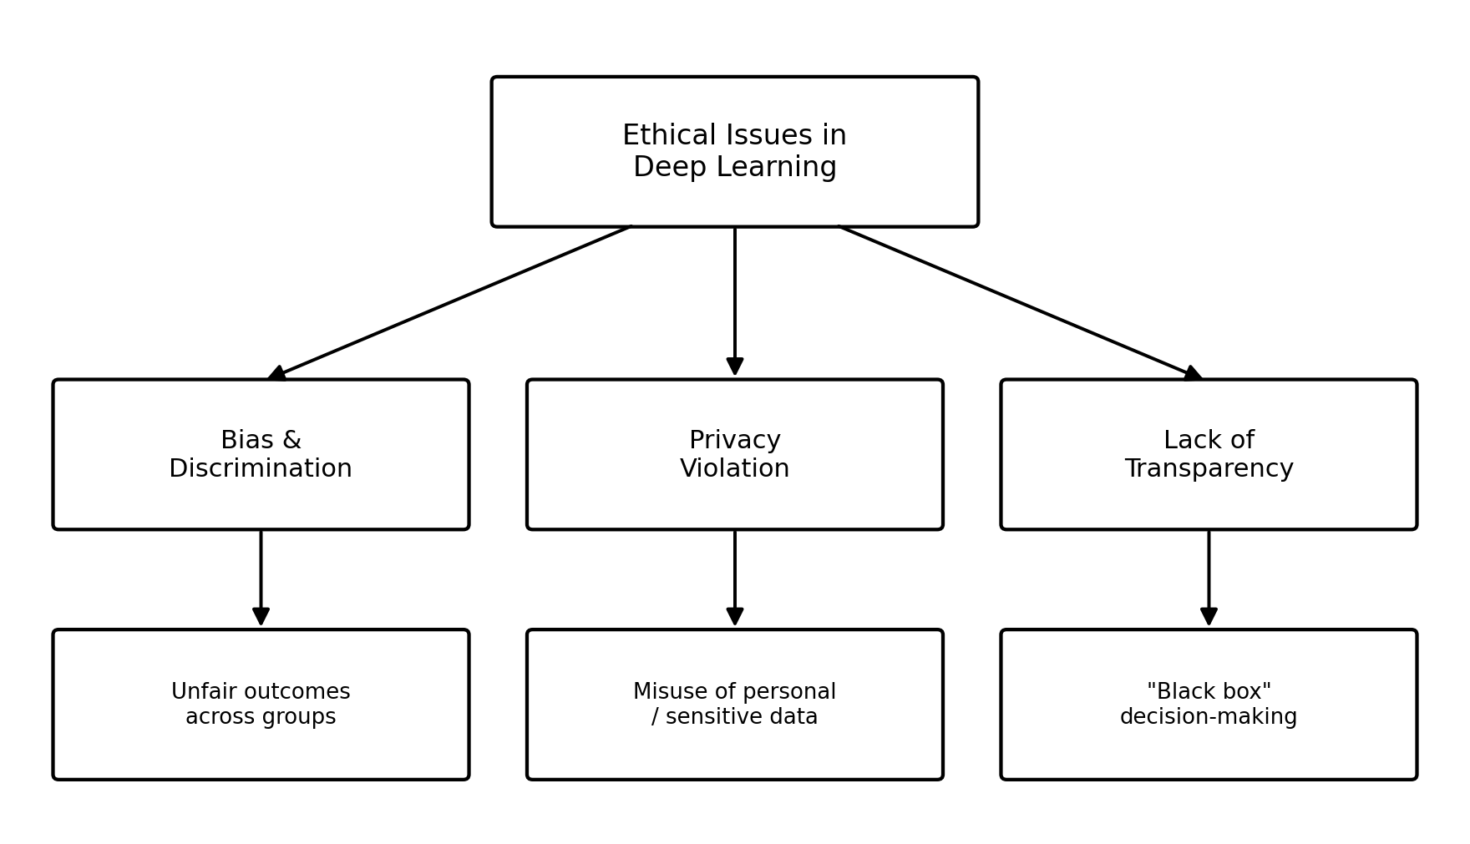
Figure 1: Three key ethical issues in Deep Learning and their impact

Task 2: Real-World Example — AI Recruiting Tool Bias

Background
One of the most cited real-world cases of this kind of harm is Amazon's internal resume-screening tool, developed between 2014 and 2017. The idea was straightforward: feed the system resumes and have it rate candidates automatically, similar to a star-rating system, to speed up hiring for technical roles.

What Went Wrong
The model was trained on ten years of resumes submitted to the company, and because the tech industry — and Amazon's applicant pool along with it — had been overwhelmingly male during that period, the training data reflected that imbalance heavily. The model concluded, based purely on the patterns it saw, that male candidates were the safer bet for technical positions.
In practice this meant resumes were penalized for containing the word "women's," as in "women's chess club captain," and graduates of two all-women's colleges were downgraded, none of which had anything to do with actual job performance. Engineers tried patching the specific terms the model was penalizing, but there was no real guarantee it wasn't finding other, less obvious ways to encode the same bias elsewhere in a resume's wording.

Impact and Response
Amazon eventually lost confidence that the tool could be made neutral and shut the project down before it was used to make live hiring calls. There's no public evidence any real candidate was rejected because of it, since it reportedly wasn't relied on for final decisions — but the case still became a go-to example of how algorithmic bias creeps into hiring tools, and it pushed a lot of companies to start auditing their own recruitment AI more seriously.
What this case really shows is that bias baked into historical data can turn into discrimination even when nobody intended it. Nobody set out to build a system that penalized women — it just learned to from the data it was given. That's exactly why testing a model's fairness across different groups, not just checking its overall accuracy, has to be part of evaluating any system that will affect real people.
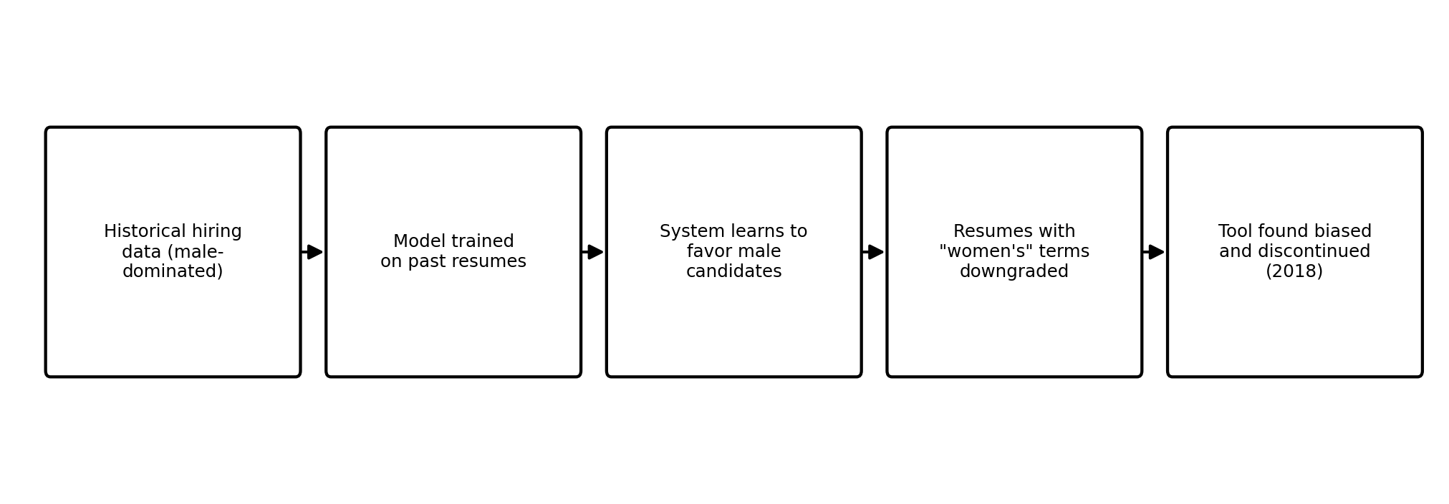
Figure 2: How historical data bias led to a discriminatory outcome

Task 3: Measures to Address the Issue
The Amazon case, and others like it, all point to the same lesson: these risks need to be handled at every stage of a system's life, not patched in after something goes wrong. A few practical steps go a long way.

1. Diverse and Representative Training Data
Before training even starts, datasets should be checked for historical imbalance. Where that imbalance can't be avoided outright, re-sampling, re-weighting, or generating synthetic examples can help the model learn from a more balanced picture of the population it will eventually affect.

2. Explainable AI (XAI) Techniques
Tools like feature-attribution methods and simplified surrogate models let a system's predictions be explained in terms a person can actually follow. Building this in from the start, rather than bolting it on later, is what actually chips away at the black-box problem described earlier.

3. Regular Bias Audits and Fairness Testing
Outputs should be checked across different demographic groups, not just judged on overall accuracy, and this needs to happen both before launch and on an ongoing basis afterward. An outside audit often catches patterns a team too close to the project might miss.

4. Human Oversight and Accountability
For decisions that really matter — hiring, lending, medical diagnosis — a qualified person should stay in the loop rather than letting the model be the final word. It also needs to be clear who is accountable when something goes wrong; "the algorithm did it" isn't an acceptable answer.

5. Privacy-Preserving Methods
Approaches like data anonymization, differential privacy, and federated learning let models be trained while limiting how much of any one person's raw data is actually exposed, which directly addresses the privacy concerns raised earlier.

6. Clear Policies and Regulation
Development should follow established ethical guidelines and data-protection laws such as the GDPR, along with newer AI-specific governance frameworks as they emerge. Internal good intentions only go so far; external regulation sets a floor that has to be met regardless.
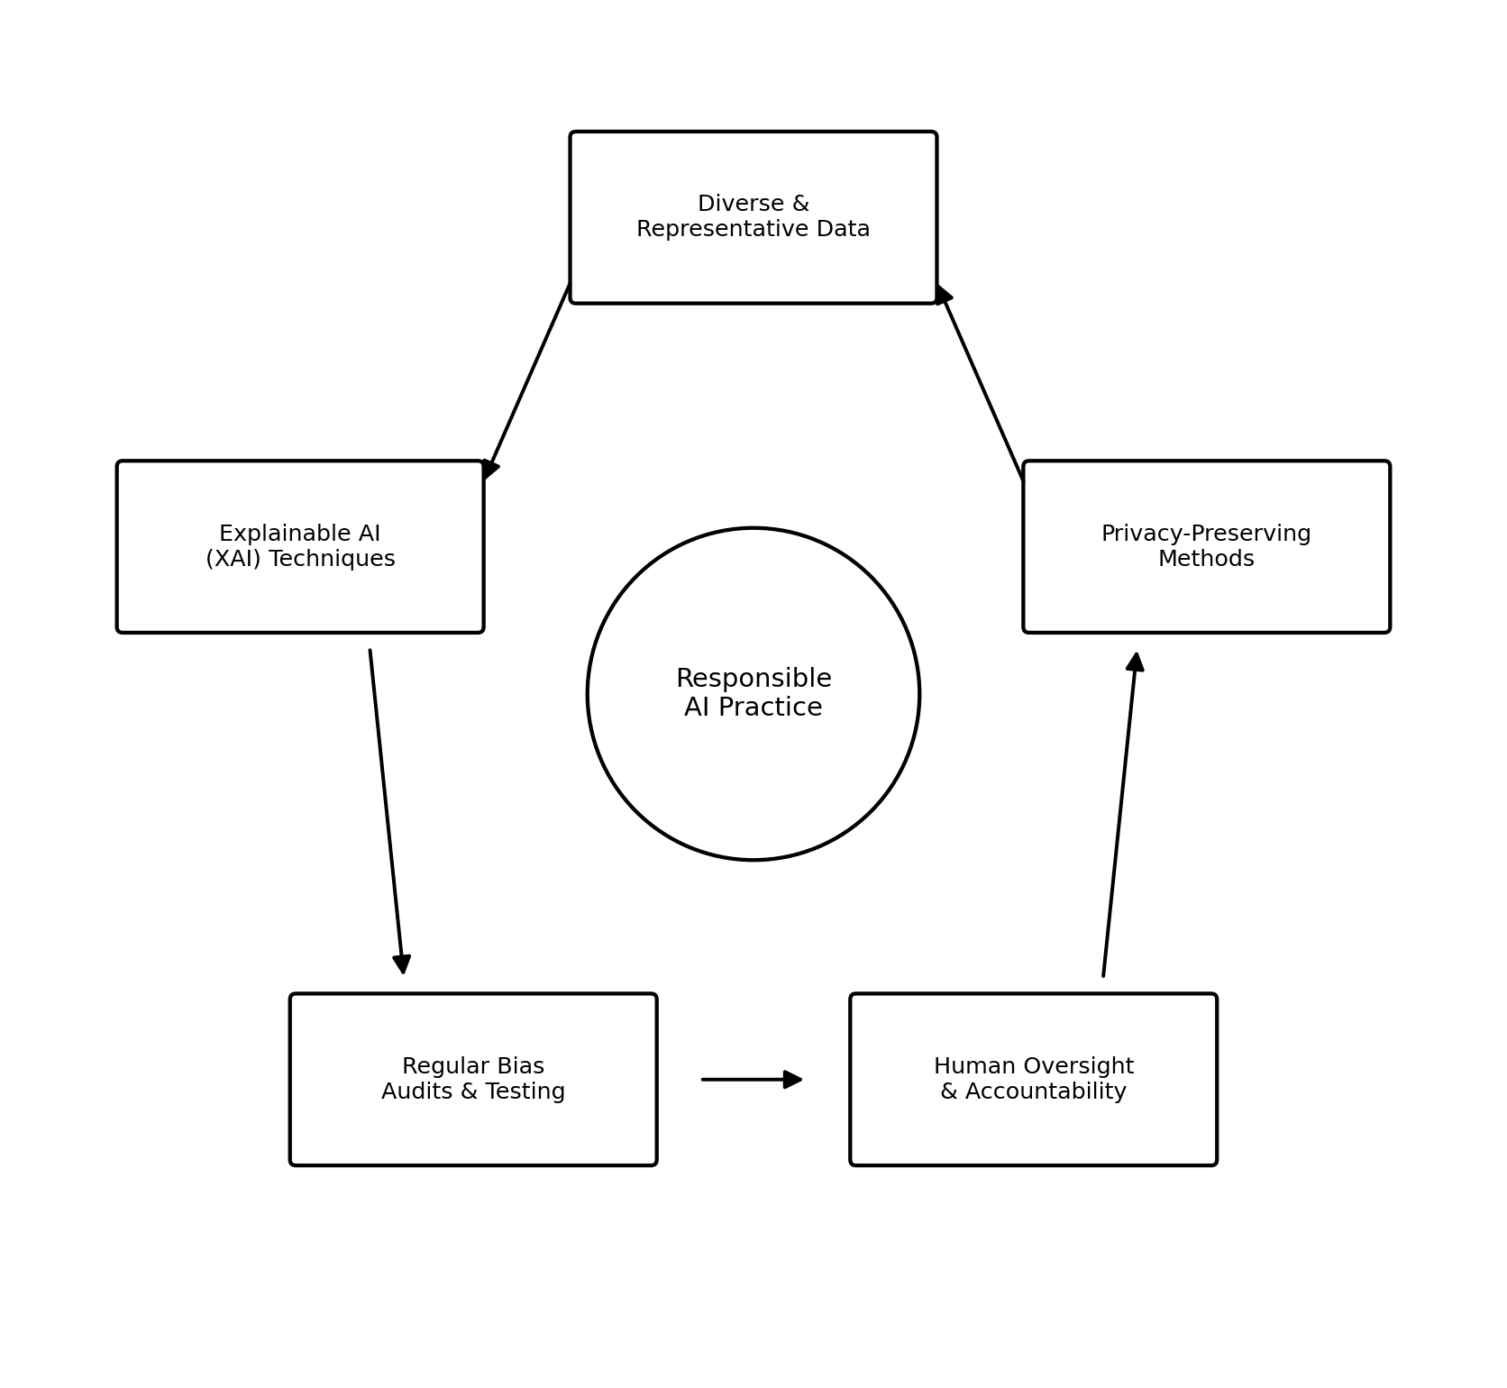
Figure 3: A responsible AI practice cycle for addressing ethical issues

Conclusion
Bias, privacy violations, and lack of transparency aren't accidents that happen to otherwise-neutral Deep Learning systems — they come directly from the data these systems are trained on and the goals they're optimized for. The Amazon case is a good reminder of how fast a training-data imbalance can turn into real discrimination, and how expensive it is to find that out only after the system has already been built.
Dealing with these risks means paying attention through the whole lifecycle of a system: choosing representative data, designing for explainability from the outset, auditing regularly for fairness, keeping a human accountable for high-stakes calls, protecting personal data properly, and following the regulations that exist to enforce all of this. None of these steps alone solves the problem, but together they make it realistic to deploy Deep Learning responsibly rather than just quickly.

References
- Dastin, J. (2018). Amazon scraps secret AI recruiting tool that showed bias against women. Reuters.
- Angwin, J., Larson, J., Mattu, S., & Kirchner, L. (2016). Machine Bias. ProPublica.
- General Data Protection Regulation (GDPR), Regulation (EU) 2016/679.
- Course materials — Deep Learning, Alliance School of Computer Applications.

