#### Notification services

For supporting notifications using Google Cloud Messaging services we have created projects and server keys for the projects on the Google platform using the link <https://console.developers.google.com>: for the iManageMyHealth and for the iSupportMyPatients apps.

The project numbers needs to be entered to the ‘*res/values/strings.xml*’ files of the both apps, e.g.

C:\Users\Gabriele\AppData\Local\Microsoft\Windows\Temporary Internet Files\Content.Word\gsm.png

Figure 1: res/values/strings.xml’ file of the app with project number.

The corresponding server keys need to be entered in the configuration of the Care Flow Engine.

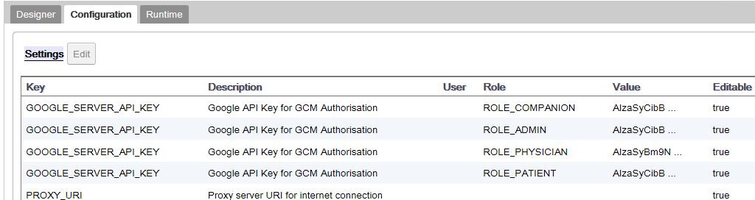

Figure 2: Configuration in the Care Flow Engine where Google API keys are entered by apps.

For creating the server keys for the iManageMyHealth and for the iSupportMyPatients apps we have selected “Activate APIs and manage” and then “Access data” in the Google project view. We have selected the option “API Key” in the drop down menu “Select credentials” and then selected the option “Server key” in the shown dialog “Create a new key”. In the next view, we have entered a key name (any text) and pressed the “Create” button.

In the following step, we need to activate the keys. For this we have to select the “Overview” option in the navigation menu and select the “Google Cloud Messaging” option in the “Mobile Apps” section.

The diagram below shows how the notification service is working for the Care Flow Engine and for the apps.

The communication is implemented as REST clients for the Google Cloud Messaging (GCM) REST server services. If an app is configured correctly, the app sends a sender_id value to the GCM and gets a token (a text sequence) back that needs to be sent to the Care Flow Engine using the REST call of the Care Flow Engine API: *POST notifications/register/gcm*. The Care Flow Engine stores the tokens for the apps together with the user (patients and physicians) iManageCancer identifiers (e-mail addresses) and can send notifications to the mobile devices of the users.

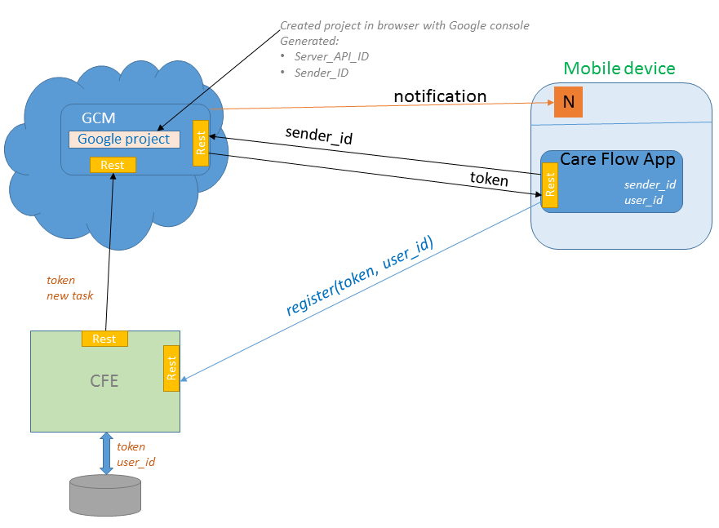

Figure 3: Use of Google Cloud Messaging in Care Flow Engine and corresponding apps.