**1150080044 – Ngô Ngọc Bảo Châu**

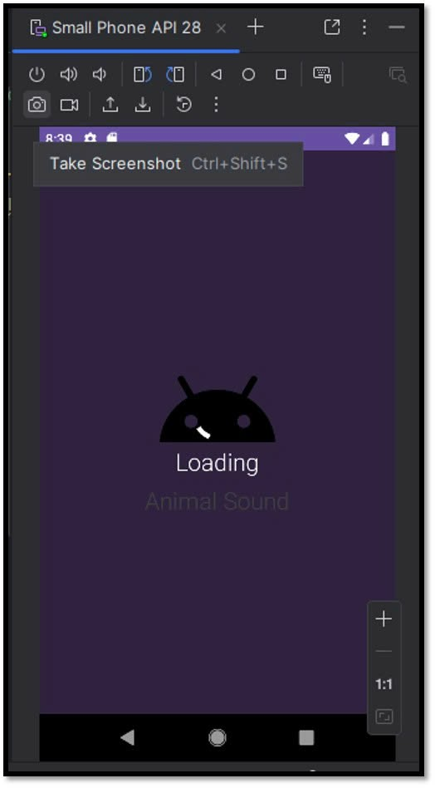**lab8**

**Các icon được chèn trong bài**   
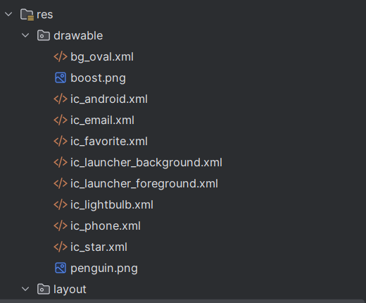

**MainActivity.java**

package com.example.bai8;

import androidx.appcompat.app.AppCompatActivity;

import androidx.core.content.ContextCompat;

import android.os.Bundle;

import android.widget.Button;

import android.widget.ImageView;

import java.util.Random;

public class MainActivity extends AppCompatActivity {

private ImageView backgroundImageView, iconImageView;

private Button btnChange;

private Random random = new Random();

@Override

protected void onCreate(Bundle savedInstanceState) {

super.onCreate(savedInstanceState);

setContentView(R.layout.activity_main);

backgroundImageView = findViewById(R.id.backgroundImageView);

iconImageView = findViewById(R.id.iconImageView);

btnChange = findViewById(R.id.btnChange);

// Gọi hàm hiển thị ngẫu nhiên khi khởi động

updateRandomDisplay();

// Bấm nút để đổi màu và icon

btnChange.setOnClickListener(v -> updateRandomDisplay());

}

// Hàm hiển thị ngẫu nhiên màu và icon

private void updateRandomDisplay() {

int[] colorArray = {

R.color.random_color_1,

R.color.random_color_2,

R.color.random_color_3,

R.color.random_color_4,

R.color.random_color_5

};

int[] iconArray = {

R.drawable.ic_star,

R.drawable.ic_favorite,

R.drawable.ic_android,

R.drawable.ic_lightbulb

};

int colorId = colorArray[random.nextInt(colorArray.length)];

int iconId = iconArray[random.nextInt(iconArray.length)];

int color = ContextCompat.getColor(this, colorId);

backgroundImageView.setBackgroundColor(color);

iconImageView.setImageResource(iconId);

// Thêm một chút hiệu ứng mờ cho icon

iconImageView.setAlpha(0.9f);

}

}

**colors.xml**

<?xml version="1.0" encoding="utf-8"?>  
<resources>  
 <color name="purple_200">#FFBB86FC</color>  
 <color name="purple_500">#FF6200EE</color>  
 <color name="purple_700">#FF3700B3</color>  
 <color name="teal_200">#FF03DAC5</color>  
 <color name="teal_700">#FF018786</color>  
 <color name="black">#FF000000</color>  
 <color name="white">#FFFFFFFF</color>  
  
 <color name="gray_light">#FAFAFA</color>  
 <color name="gray_dark">#535353</color>  
 <color name="gray_mid">#9D9797</color>  
 <color name="indigo">#424FB7</color>  
 <color name="random_color_1">#E57373</color> <!-- Red -->  
 <color name="random_color_2">#81C784</color> <!-- Green -->  
 <color name="random_color_3">#64B5F6</color> <!-- Blue -->  
 <color name="random_color_4">#FFD54F</color> <!-- Amber -->  
 <color name="random_color_5">#BA68C8</color> <!-- Purple -->  
</resources>

**Strings.xml**

<resources>  
 <string name="app_name">Bai8</string>  
 <string name="txt_name">Chau</string>  
 <string name="txt_email">Chau@example.com</string>  
 <string name="txt_phone1">(650) 555-1234</string>  
 <string name="txt_title_mobile">Mobile</string>  
 <string name="txt_phone2">(323) 555-6789</string>  
</resources>

**Activity_main.xml**

<?xml version="1.0" encoding="utf-8"?>  
<LinearLayout xmlns:android="http://schemas.android.com/apk/res/android"  
 xmlns:app="http://schemas.android.com/apk/res-auto"  
 xmlns:tools="http://schemas.android.com/tools"  
 android:id="@+id/main"  
 android:layout_width="match_parent"  
 android:layout_height="match_parent"  
 android:background="@color/gray_light"  
 android:orientation="vertical"  
 tools:context=".MainActivity">  
  
   
 <FrameLayout  
 android:layout_width="match_parent"  
 android:layout_height="350dp">  
  
 <ImageView  
 android:id="@+id/backgroundImageView"  
 android:layout_width="match_parent"  
 android:layout_height="300dp"  
 android:scaleType="centerCrop"  
 android:src="@drawable/penguin"  
 tools:ignore="ContentDescription" />  
  
 <TextView  
 android:layout_width="wrap_content"  
 android:layout_height="wrap_content"  
 android:layout_gravity="bottom"  
 android:layout_marginStart="70dp"  
 android:layout_marginBottom="90dp"  
 android:fontFamily="sans-serif"  
 android:text="@string/txt_name"  
 android:textColor="@color/white"  
 android:textSize="40sp" />  
  
 <ImageView  
 android:layout_width="80dp"  
 android:layout_height="80dp"  
 android:layout_gravity="end|bottom"  
 android:layout_marginEnd="20dp"  
 android:layout_marginBottom="10dp"  
 android:background="@drawable/bg_oval"  
 android:padding="20dp"  
 android:src="@drawable/boost"  
 app:tint="@color/indigo"  
 tools:ignore="ContentDescription" />  
  
  
 <ImageView  
 android:id="@+id/iconImageView"  
 android:layout_width="80dp"  
 android:layout_height="80dp"  
 android:layout_gravity="end|bottom"  
 android:layout_marginEnd="20dp"  
 android:layout_marginBottom="10dp"  
 android:background="@drawable/bg_oval"  
 android:padding="20dp"  
 android:src="@drawable/ic_star"  
 app:tint="@color/indigo"  
 tools:ignore="ContentDescription" />  
 </FrameLayout>  
  
  
 <!-- Phần thông tin -->  
 <TableRow  
 android:layout_width="match_parent"  
 android:layout_height="wrap_content"  
 android:padding="20dp">  
  
 <ImageView  
 android:layout_width="60dp"  
 android:layout_height="60dp"  
 android:padding="10dp"  
 android:src="@drawable/ic_email"  
 app:tint="@color/indigo"  
 tools:ignore="ContentDescription" />  
  
 <LinearLayout  
 android:layout_width="match_parent"  
 android:layout_height="match_parent"  
 android:layout_marginStart="30dp"  
 android:orientation="vertical">  
  
 <TextView  
 android:layout_width="match_parent"  
 android:layout_height="wrap_content"  
 android:text="@string/txt_email"  
 android:textColor="@color/gray_dark"  
 android:textSize="20sp" />  
  
 <TextView  
 android:layout_width="match_parent"  
 android:layout_height="wrap_content"  
 android:layout_marginTop="5dp"  
 android:text="Email"  
 android:textColor="@color/gray_mid"  
 android:textSize="18sp" />  
 </LinearLayout>  
 </TableRow>  
  
 <View  
 android:layout_width="match_parent"  
 android:layout_height="0.5dp"  
 android:layout_marginTop="30dp"  
 android:background="@color/gray_mid" />  
  
   
 <TableRow  
 android:layout_width="match_parent"  
 android:layout_height="wrap_content"  
 android:padding="20dp">  
  
 <ImageView  
 android:layout_width="60dp"  
 android:layout_height="60dp"  
 android:padding="10dp"  
 android:src="@drawable/ic_phone"  
 app:tint="@color/indigo"  
 tools:ignore="ContentDescription" />  
  
 <LinearLayout  
 android:layout_width="match_parent"  
 android:layout_height="match_parent"  
 android:layout_marginStart="30dp"  
 android:orientation="vertical">  
  
 <TextView  
 android:layout_width="match_parent"  
 android:layout_height="wrap_content"  
 android:text="@string/txt_phone1"  
 android:textColor="@color/gray_dark"  
 android:textSize="20sp" />  
  
 <TextView  
 android:layout_width="match_parent"  
 android:layout_height="wrap_content"  
 android:layout_marginTop="5dp"  
 android:text="@string/txt_title_mobile"  
 android:textColor="@color/gray_mid"  
 android:textSize="18sp" />  
  
 <TextView  
 android:layout_width="match_parent"  
 android:layout_height="wrap_content"  
 android:layout_marginTop="30dp"  
 android:text="@string/txt_phone2"  
 android:textColor="@color/gray_dark"  
 android:textSize="20sp" />  
  
 <TextView  
 android:layout_width="match_parent"  
 android:layout_height="wrap_content"  
 android:layout_marginTop="5dp"  
 android:text="@string/txt_title_mobile"  
 android:textColor="@color/gray_mid"  
 android:textSize="18sp" />  
 </LinearLayout>  
 </TableRow>  
  
</LinearLayout>