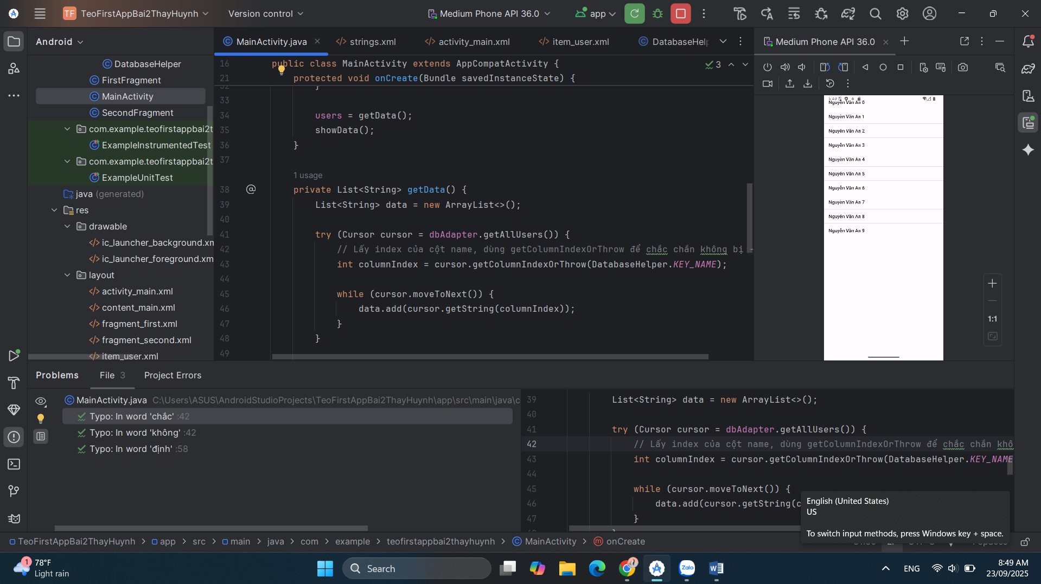

**Mainactivity.java:**

package com.example.teofirstappbai2thayhuynh;

import android.database.Cursor;

import android.os.Bundle;

import android.widget.ArrayAdapter;

import android.widget.ListView;

import androidx.appcompat.app.AppCompatActivity;

import com.example.teofirstappbai2thayhuynh.Adapter.DbAdapter;

import com.example.teofirstappbai2thayhuynh.Helper.DatabaseHelper;

import java.util.ArrayList;

import java.util.List;

public class MainActivity extends AppCompatActivity {

private DbAdapter dbAdapter;

private List<String> users;

@Override

protected void onCreate(Bundle savedInstanceState) {

super.onCreate(savedInstanceState);

setContentView(R.layout.activity_main);

dbAdapter = new DbAdapter(this);

dbAdapter.open();

dbAdapter.deleteAllUsers();

// Thêm dữ liệu mẫu

for (int i = 0; i < 10; i++) {

dbAdapter.createUser(" Nguyễn Văn An " + i);

}

users = getData();

showData();

}

private List<String> getData() {

List<String> data = new ArrayList<>();

try (Cursor cursor = dbAdapter.getAllUsers()) {

// Lấy index của cột name, dùng getColumnIndexOrThrow để chắc chắn không bị -1

int columnIndex = cursor.getColumnIndexOrThrow(DatabaseHelper.KEY_NAME);

while (cursor.moveToNext()) {

data.add(cursor.getString(columnIndex));

}

}

return data;

}

private void showData() {

ListView lvUser = findViewById(R.id.lv_user);

ArrayAdapter<String> userAdapter = new ArrayAdapter<>(

this,

android.R.layout.simple_list_item_1, // layout mặc định

users

);

lvUser.setAdapter(userAdapter);

}

@Override

protected void onDestroy() {

super.onDestroy();

if (dbAdapter != null) {

dbAdapter.close();

}

}

}

DatabaseHelper

package com.example.teofirstappbai2thayhuynh.Helper;

import android.content.Context;

import android.database.sqlite.SQLiteDatabase;

import android.database.sqlite.SQLiteOpenHelper;

public class DatabaseHelper extends SQLiteOpenHelper {

// Thông tin DB

private static final String DATABASE_NAME = "Database_Demo.db";

private static final int DATABASE_VERSION = 2;

// Thông tin bảng + cột

public static final String TABLE_USERS = "users";

public static final String KEY_ID = "_id";

public static final String KEY_NAME = "name";

// Câu lệnh tạo bảng

private static final String DATABASE_CREATE =

"CREATE TABLE " + TABLE_USERS + " (" +

KEY_ID + " INTEGER PRIMARY KEY AUTOINCREMENT, " +

KEY_NAME + " TEXT NOT NULL);";

public DatabaseHelper(Context context) {

super(context, DATABASE_NAME, null, DATABASE_VERSION);

}

@Override

public void onCreate(SQLiteDatabase db) {

// Tạo bảng khi DB mới

db.execSQL(DATABASE_CREATE);

}

@Override

public void onUpgrade(SQLiteDatabase db, int oldVersion, int newVersion) {

// Xoá bảng cũ nếu tồn tại

db.execSQL("DROP TABLE IF EXISTS " + TABLE_USERS);

// Tạo lại bảng mới

onCreate(db);

}

}

Adapter

package com.example.teofirstappbai2thayhuynh.Adapter;

import android.content.ContentValues;

import android.content.Context;

import android.database.Cursor;

import android.database.sqlite.SQLiteDatabase;

import com.example.teofirstappbai2thayhuynh.Helper.DatabaseHelper;

public class DbAdapter {

private DatabaseHelper dbHelper;

private SQLiteDatabase sqLiteDatabase;

private final Context context;

public DbAdapter(Context ctx) {

this.context = ctx;

}

public DbAdapter open() {

dbHelper = new DatabaseHelper(context);

sqLiteDatabase = dbHelper.getWritableDatabase();

return this;

}

public void close() {

if (dbHelper != null) {

dbHelper.close();

}

}

// Thêm user

public long createUser(String name) {

ContentValues inititalValues = new ContentValues();

inititalValues.put(DatabaseHelper.KEY_NAME, name);

return sqLiteDatabase.insert(DatabaseHelper.TABLE_USERS, null, inititalValues);

}

// Xóa user theo ID

public boolean deleteUser(long rowId) {

return sqLiteDatabase.delete(

DatabaseHelper.TABLE_USERS,

DatabaseHelper.KEY_ID + "=" + rowId,

null

) > 0;

}

// Xóa tất cả user

public boolean deleteAllUsers() {

return sqLiteDatabase.delete(DatabaseHelper.TABLE_USERS, null, null) > 0;

}

// Lấy toàn bộ user

public Cursor getAllUsers() {

return sqLiteDatabase.query(

DatabaseHelper.TABLE_USERS,

new String[]{DatabaseHelper.KEY_ID, DatabaseHelper.KEY_NAME},

null, null, null, null, null

);

}

}