Ngô Ngọc Bảo Châu - 1150080044
Lab 1:
Bài 1
package com.example.lab1
import android.app.Activity
import android.content.Intent
import android.graphics.Bitmap
import android.os.Bundle
import android.provider.MediaStore
import android.widget.Button
import android.widget.EditText
import android.widget.ImageView
import android.widget.TextView
import androidx.appcompat.app.AppCompatActivity
class MainActivity : AppCompatActivity() {
private lateinit var edtA: EditText
private lateinit var edtB: EditText
private lateinit var txtResult: TextView
private lateinit var btnAdd: Button
private lateinit var btnSub: Button
private lateinit var btnMul: Button
private lateinit var btnDiv: Button
private lateinit var btnMod: Button
private lateinit var btnCamera: Button
private lateinit var imgPhoto: ImageView
private val REQUEST_IMAGE_CAPTURE = 1
override fun onCreate(savedInstanceState: Bundle?) {
super.onCreate(savedInstanceState)
setContentView(R.layout.activity_main)
initControls()
initEvents()
}
private fun initControls() {
edtA = findViewById(R.id.edtA)
edtB = findViewById(R.id.edtB)
txtResult = findViewById(R.id.txtResult)
btnAdd = findViewById(R.id.btnAdd)
btnSub = findViewById(R.id.btnSub)
btnMul = findViewById(R.id.btnMul)
btnDiv = findViewById(R.id.btnDiv)
btnMod = findViewById(R.id.btnMod)
btnCamera = findViewById(R.id.btnCamera)
imgPhoto = findViewById(R.id.imgPhoto)
}
private fun initEvents() {
btnAdd.setOnClickListener { calculate('+') }
btnSub.setOnClickListener { calculate('-') }
btnMul.setOnClickListener { calculate('*') }
btnDiv.setOnClickListener { calculate('/') }
btnMod.setOnClickListener { calculate('%') }
btnCamera.setOnClickListener {
val intent = Intent(MediaStore.ACTION_IMAGE_CAPTURE)
startActivityForResult(intent, REQUEST_IMAGE_CAPTURE)
}
}
private fun calculate(op: Char) {
val a = edtA.text.toString().toDoubleOrNull()
val b = edtB.text.toString().toDoubleOrNull()
if (a == null || b == null) {
txtResult.text = "Nhập giá trị hợp lệ!"
return
}
val result = when (op) {
'+' -> a + b
'-' -> a - b
'*' -> a * b
'/' -> if (b != 0.0) a / b else Double.NaN
'%' -> a % b
else -> 0.0
}
txtResult.text = "Kết quả: $result"
}
override fun onActivityResult(requestCode: Int, resultCode: Int, data: Intent?) {
super.onActivityResult(requestCode, resultCode, data)
if (requestCode == REQUEST_IMAGE_CAPTURE && resultCode == Activity.RESULT_OK) {
val imageBitmap = data?.extras?.get("data") as Bitmap
imgPhoto.setImageBitmap(imageBitmap)
}
}
}

layout_activity_main.xml
<?xml version="1.0" encoding="utf-8"?>
<ScrollView xmlns:android="http://schemas.android.com/apk/res/android"
android:layout_width="match_parent"
android:layout_height="match_parent">
<LinearLayout
android:orientation="vertical"
android:padding="16dp"
android:layout_width="match_parent"
android:layout_height="wrap_content">
<!-- Ô nhập số A -->
<EditText
android:id="@+id/edtA"
android:hint="Nhập số A"
android:inputType="numberDecimal"
android:layout_width="match_parent"
android:layout_height="wrap_content"
android:layout_marginBottom="8dp" />
<!-- Ô nhập số B -->
<EditText
android:id="@+id/edtB"
android:hint="Nhập số B"
android:inputType="numberDecimal"
android:layout_width="match_parent"
android:layout_height="wrap_content"
android:layout_marginBottom="8dp" />
<!-- TextView hiển thị kết quả -->
<TextView
android:id="@+id/txtResult"
android:text="Kết quả:"
android:textSize="20sp"
android:textStyle="bold"
android:gravity="center"
android:layout_width="match_parent"
android:layout_height="wrap_content"
android:layout_marginTop="8dp"
android:layout_marginBottom="8dp" />
<!-- Dòng chứa các nút phép toán -->
<LinearLayout
android:orientation="horizontal"
android:gravity="center"
android:layout_width="match_parent"
android:layout_height="wrap_content"
android:layout_marginBottom="8dp">
<Button
android:id="@+id/btnAdd"
android:text="+"
android:layout_width="wrap_content"
android:layout_height="wrap_content"
android:layout_margin="4dp" />
<Button
android:id="@+id/btnSub"
android:text="-"
android:layout_width="wrap_content"
android:layout_height="wrap_content"
android:layout_margin="4dp" />
<Button
android:id="@+id/btnMul"
android:text="×"
android:layout_width="wrap_content"
android:layout_height="wrap_content"
android:layout_margin="4dp" />
<Button
android:id="@+id/btnDiv"
android:text="÷"
android:layout_width="wrap_content"
android:layout_height="wrap_content"
android:layout_margin="4dp" />
<Button
android:id="@+id/btnMod"
android:text="%"
android:layout_width="wrap_content"
android:layout_height="wrap_content"
android:layout_margin="4dp" />
</LinearLayout>
<!-- Nút mở Camera -->
<Button
android:id="@+id/btnCamera"
android:text="Chụp ảnh"
android:layout_width="wrap_content"
android:layout_height="wrap_content"
android:layout_gravity="center"
android:layout_marginTop="8dp"
android:layout_marginBottom="8dp" />
<!-- ImageView hiển thị ảnh chụp -->
<ImageView
android:id="@+id/imgPhoto"
android:layout_width="200dp"
android:layout_height="200dp"
android:layout_gravity="center"
android:layout_marginTop="8dp"
android:layout_marginBottom="16dp"
android:contentDescription="Ảnh chụp"
android:background="#EEEEEE" />
</LinearLayout>
</ScrollView>

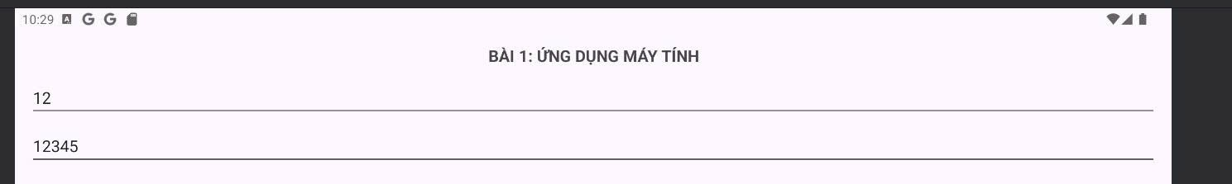
Phép nhân

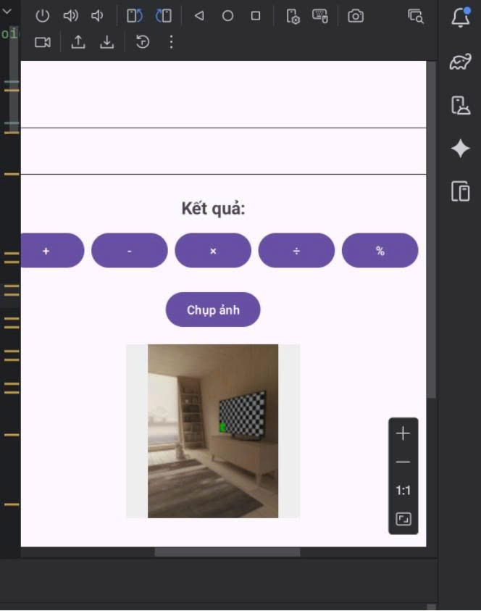
Chụp ảnh

Bài 2: bài xúc xắc
Thêm layout xúc xắc
activity_main.xml
<!-- -------- BÀI 2: XÚC XẮC NGẪU NHIÊN -------- -->
<TextView
android:id="@+id/txtRandom"
android:text="Kết quả ngẫu nhiên: "
android:textSize="18sp"
android:gravity="center"
android:layout_width="match_parent"
android:layout_height="wrap_content"
android:layout_marginTop="20dp" />

<Button
android:id="@+id/btnRandom"
android:text="Sinh số ngẫu nhiên"
android:layout_width="wrap_content"
android:layout_height="wrap_content"
android:layout_gravity="center"
android:layout_marginTop="8dp" />

<ImageView
android:id="@+id/imgDice"
android:layout_width="150dp"
android:layout_height="150dp"
android:layout_gravity="center"
android:layout_marginTop="10dp"
android:contentDescription="Xúc xắc"
android:background="#EEEEEE" />

Cập nhật MainActivity
import java.util.Random

class MainActivity : AppCompatActivity() {

// ... các biến khác
private lateinit var btnRandom: Button
private lateinit var txtRandom: TextView
private lateinit var imgDice: ImageView

// ... trong initControls()
private fun initControls() {
// (các dòng trước giữ nguyên)
btnRandom = findViewById(R.id.btnRandom)
txtRandom = findViewById(R.id.txtRandom)
imgDice = findViewById(R.id.imgDice)
}

// ... trong initEvents()
private fun initEvents() {
// (các sự kiện trước giữ nguyên)
btnRandom.setOnClickListener {
val rd = Random()
val num = rd.nextInt(6) + 1 // số từ 1 đến 6
txtRandom.text = "Kết quả ngẫu nhiên: $num"

// Đổi hình xúc xắc
val diceRes = when (num) {
1 -> R.drawable.dice1
2 -> R.drawable.dice2
3 -> R.drawable.dice3
4 -> R.drawable.dice4
5 -> R.drawable.dice5
else -> R.drawable.dice6
}
imgDice.setImageResource(diceRes)
}
}
}

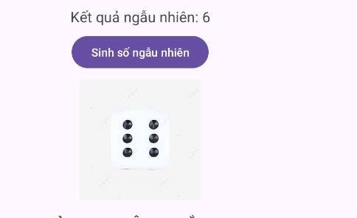
nó sinh số ngẫu nhiên

Bài 3:
Cập nhật layout
<!-- ===== BÀI 3: GỌI ĐIỆN / NHẮN TIN ===== -->
<TextView
android:text="BÀI 3: GỌI ĐIỆN & NHẮN TIN"
android:textStyle="bold"
android:textSize="18sp"
android:gravity="center"
android:layout_width="match_parent"
android:layout_height="wrap_content"
android:layout_marginTop="16dp"
android:layout_marginBottom="8dp" />

<EditText
android:id="@+id/edtPhone"
android:hint="Nhập số điện thoại"
android:inputType="phone"
android:layout_width="match_parent"
android:layout_height="wrap_content"
android:layout_marginBottom="8dp" />

<LinearLayout
android:orientation="horizontal"
android:gravity="center"
android:layout_width="match_parent"
android:layout_height="wrap_content">

<Button
android:id="@+id/btnCall"
android:text="Gọi điện"
android:layout_width="wrap_content"
android:layout_height="wrap_content"
android:layout_margin="8dp" />

<Button
android:id="@+id/btnSMS"
android:text="Nhắn tin"
android:layout_width="wrap_content"
android:layout_height="wrap_content"
android:layout_margin="8dp" />
</LinearLayout>

Cập nhật MainActivity:
// Bài 3
private lateinit var edtPhone: EditText
private lateinit var btnCall: Button
private lateinit var btnSMS: Button

// Bài 3
edtPhone = findViewById(R.id.edtPhone)
btnCall = findViewById(R.id.btnCall)
btnSMS = findViewById(R.id.btnSMS)
// Bài 3: Gọi điện & Nhắn tin
btnCall.setOnClickListener {
val phone = edtPhone.text.toString()
if (phone.isNotEmpty()) {
val intent = Intent(Intent.ACTION_DIAL)
intent.data = Uri.parse("tel:$phone")
startActivity(intent)
} else {
Toast.makeText(this, "Vui lòng nhập số điện thoại", Toast.LENGTH_SHORT).show()
}
}

btnSMS.setOnClickListener {
val phone = edtPhone.text.toString()
if (phone.isNotEmpty()) {
val intent = Intent(Intent.ACTION_VIEW)
intent.data = Uri.parse("sms:$phone")
intent.putExtra("sms_body", "Xin chào, đây là tin nhắn mẫu!")
startActivity(intent)
} else {
Toast.makeText(this, "Vui lòng nhập số điện thoại", Toast.LENGTH_SHORT).show()
}
}
}

private fun calculate(op: Char) {
val a = edtA.text.toString().toDoubleOrNull()
val b = edtB.text.toString().toDoubleOrNull()
if (a == null || b == null) {
txtResult.text = "Nhập giá trị hợp lệ!"
return
}

val result = when (op) {
'+' -> a + b
'-' -> a - b
'*' -> a * b
'/' -> if (b != 0.0) a / b else Double.NaN
'%' -> a % b
else -> 0.0
}
txtResult.text = "Kết quả: $result"
}

override fun onActivityResult(requestCode: Int, resultCode: Int, data: Intent?) {
super.onActivityResult(requestCode, resultCode, data)
if (requestCode == REQUEST_IMAGE_CAPTURE && resultCode == Activity.RESULT_OK) {
val imageBitmap = data?.extras?.get("data") as Bitmap
imgPhoto.setImageBitmap(imageBitmap)
}

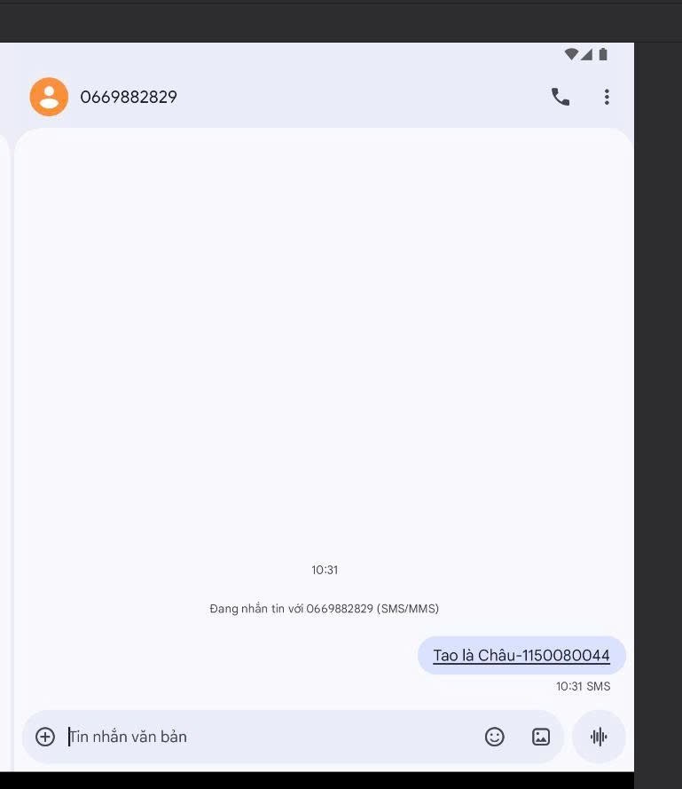
Tin nhắn

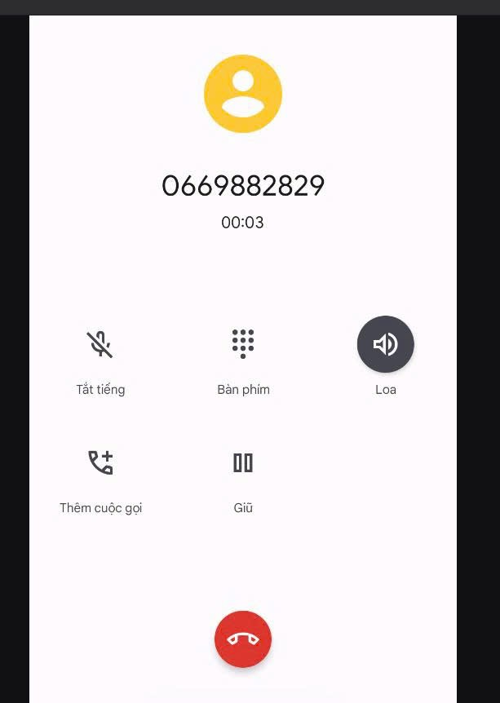
cuộc gọi

LAB 3
Bài 1:
AndroidManifest
<activity
android:name=".M000ActSplash"
android:noHistory="true"
android:exported="true"
android:theme="@style/Full_Screen">
<intent-filter>
<action android:name="android.intent.action.MAIN" />
<category android:name="android.intent.category.LAUNCHER" />
</intent-filter>
</activity>

<activity android:name=".M001ActMain" />

layout_activity_main:
<?xml version="1.0" encoding="utf-8"?>
<LinearLayout xmlns:android="http://schemas.android.com/apk/res/android"
xmlns:tools="http://schemas.android.com/tools"
android:layout_width="match_parent"
android:layout_height="match_parent"
android:background="@color/purple_700"
android:gravity="center"
android:orientation="vertical">
<ImageView
android:layout_width="128dp"
android:layout_height="128dp"
android:src="@drawable/ic_penguin"
tools:ignore="ContentDescription" />
<TextView
android:layout_width="wrap_content"
android:layout_height="wrap_content"
android:layout_marginTop="10dp"
android:fontFamily="sans-serif-light"
android:text="@string/app_name"
android:textColor="@color/white"
android:textSize="24sp" />
</LinearLayout>

M001ActMain:
package com.example.lab2

import android.os.Bundle
import androidx.appcompat.app.AppCompatActivity

class M001ActMain : AppCompatActivity() {
override fun onCreate(savedInstanceState: Bundle?) {
super.onCreate(savedInstanceState)
setContentView(R.layout.activity_main)
}
}

M000ActSplash:
package com.example.lab2
import android.content.Intent
import android.os.Bundle
import android.os.Handler
import android.os.Looper
import androidx.appcompat.app.AppCompatActivity
class M000ActSplash : AppCompatActivity() {
override fun onCreate(savedInstanceState: Bundle?) {
super.onCreate(savedInstanceState)
// Gán layout giao diện splash
setContentView(R.layout.m000_act_splash)
// Giữ màn hình splash 3 giây, sau đó chuyển sang màn hình chính
Handler(Looper.getMainLooper()).postDelayed({
val intent = Intent(this, M001ActMain::class.java)
startActivity(intent)
finish()
}, 3000) // 3000 = 3 giây
}
}

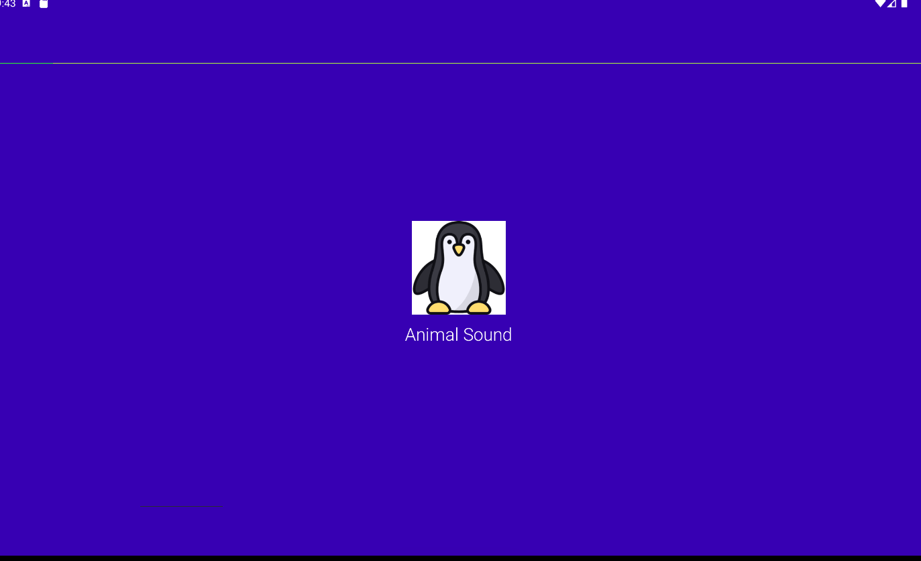

Bài 2:
Thêm vào moo_act_splash
<!-- Include phần loading -->
<include layout="@layout/item_loading" />

item_loading.xml:
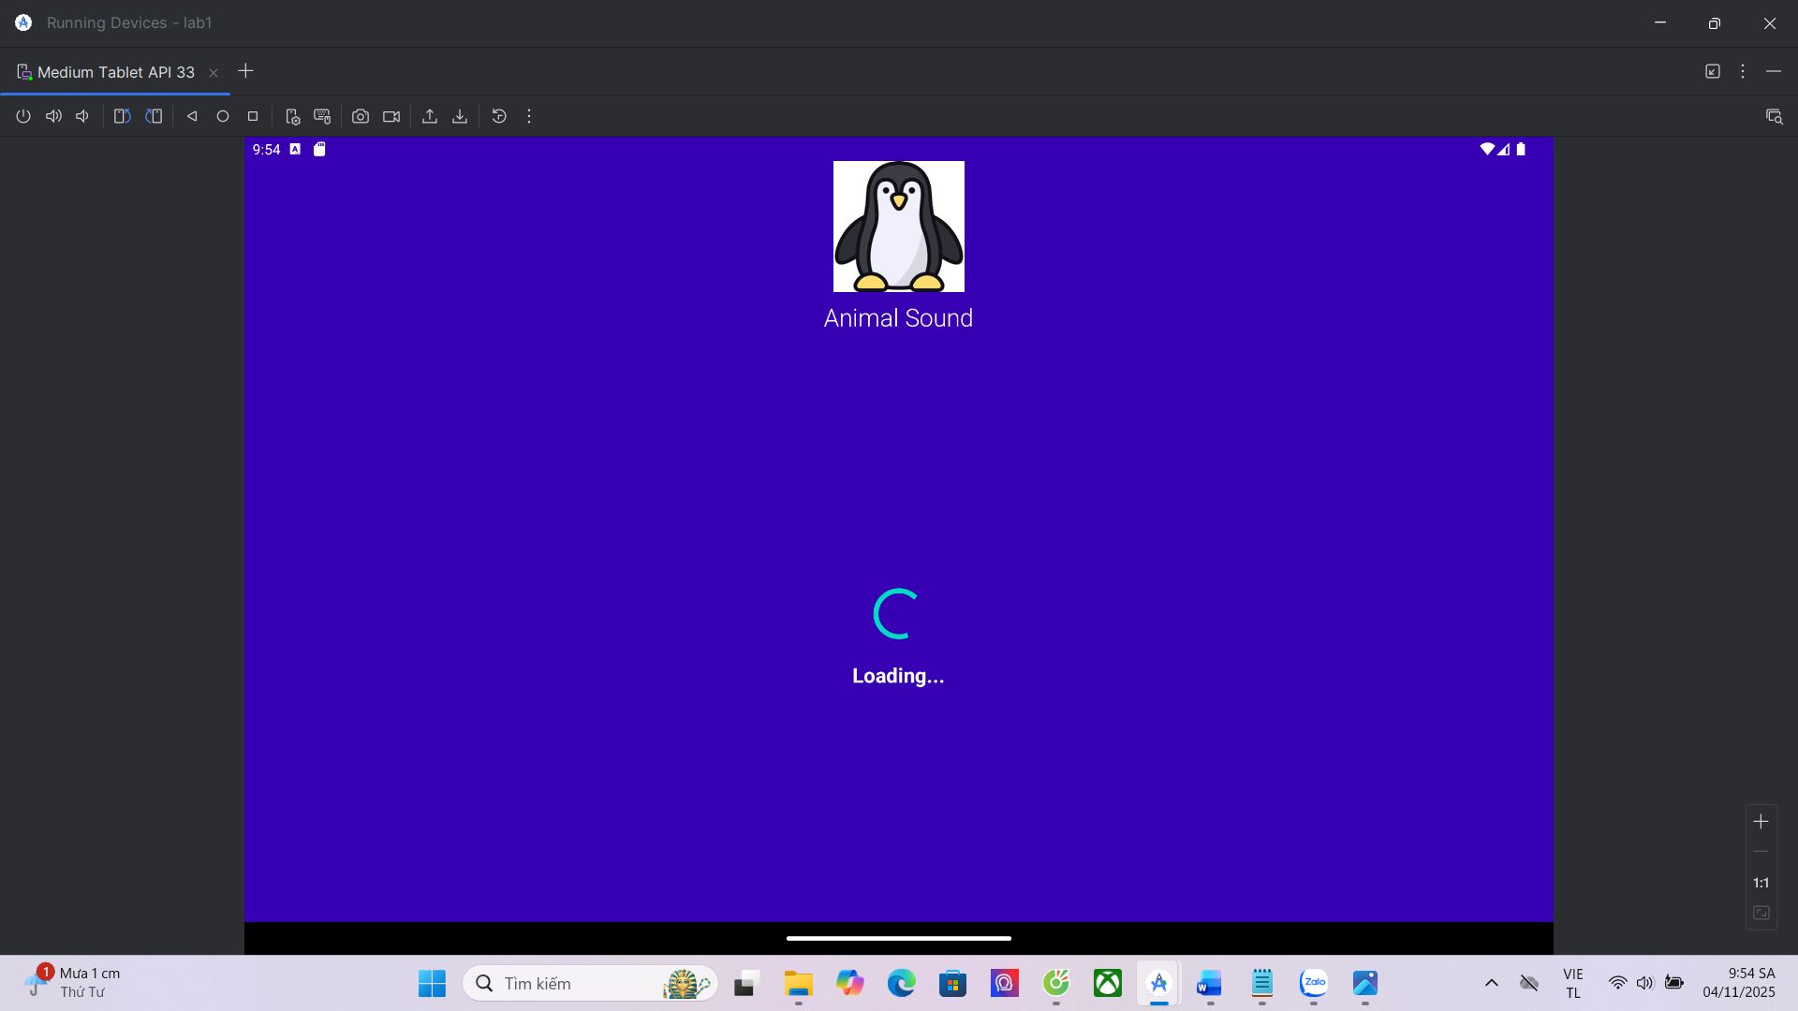

Bài 3:
M001ActMain:
package com.example.lab2

import android.os.Bundle
import androidx.appcompat.app.AppCompatActivity

class M001ActMain : AppCompatActivity() {
override fun onCreate(savedInstanceState: Bundle?) {
super.onCreate(savedInstanceState)
setContentView(R.layout.m001_act_main)
}
}

m001_act_main.xml
<?xml version="1.0" encoding="utf-8"?>
<LinearLayout xmlns:android="http://schemas.android.com/apk/res/android"
xmlns:tools="http://schemas.android.com/tools"
android:layout_width="match_parent"
android:layout_height="match_parent"
android:background="@color/purple_700"
android:gravity="center"
android:orientation="vertical"
tools:context=".M001ActMain">

<!-- Tiêu đề -->
<TextView
android:text="MAIN MENU"
android:textColor="@color/white"
android:textStyle="bold"
android:textSize="24sp"
android:layout_marginBottom="24dp"
android:layout_width="wrap_content"
android:layout_height="wrap_content" />

<!-- Hàng chứa các nút -->
<LinearLayout
android:orientation="horizontal"
android:gravity="center"
android:layout_width="wrap_content"
android:layout_height="wrap_content">

<!-- Nút Animal -->
<LinearLayout
android:id="@+id/btnAnimal"
android:orientation="vertical"
android:gravity="center"
android:layout_margin="12dp"
android:layout_width="100dp"
android:layout_height="120dp"
android:background="@drawable/bg_button">

<ImageView
android:layout_width="60dp"
android:layout_height="60dp"
android:src="@drawable/ic_animal"
android:layout_marginBottom="8dp"
tools:ignore="ContentDescription" />

<TextView
android:text="Animal"
android:textColor="@color/white"
android:textSize="16sp"
android:layout_width="wrap_content"
android:layout_height="wrap_content" />
</LinearLayout>

<!-- Nút Setting -->
<LinearLayout
android:id="@+id/btnSetting"
android:orientation="vertical"
android:gravity="center"
android:layout_margin="12dp"
android:layout_width="100dp"
android:layout_height="120dp"
android:background="@drawable/bg_button">

<ImageView
android:layout_width="60dp"
android:layout_height="60dp"
android:src="@drawable/ic_setting"
android:layout_marginBottom="8dp"
tools:ignore="ContentDescription" />

<TextView
android:text="Setting"
android:textColor="@color/white"
android:textSize="16sp"
android:layout_width="wrap_content"
android:layout_height="wrap_content" />
</LinearLayout>

<!-- Nút About -->
<LinearLayout
android:id="@+id/btnAbout"
android:orientation="vertical"
android:gravity="center"
android:layout_margin="12dp"
android:layout_width="100dp"
android:layout_height="120dp"
android:background="@drawable/bg_button">

<ImageView
android:layout_width="60dp"
android:layout_height="60dp"
android:src="@drawable/ic_about"
android:layout_marginBottom="8dp"
tools:ignore="ContentDescription" />

<TextView
android:text="About"
android:textColor="@color/white"
android:textSize="16sp"
android:layout_width="wrap_content"
android:layout_height="wrap_content" />
</LinearLayout>
</LinearLayout>

</LinearLayout>

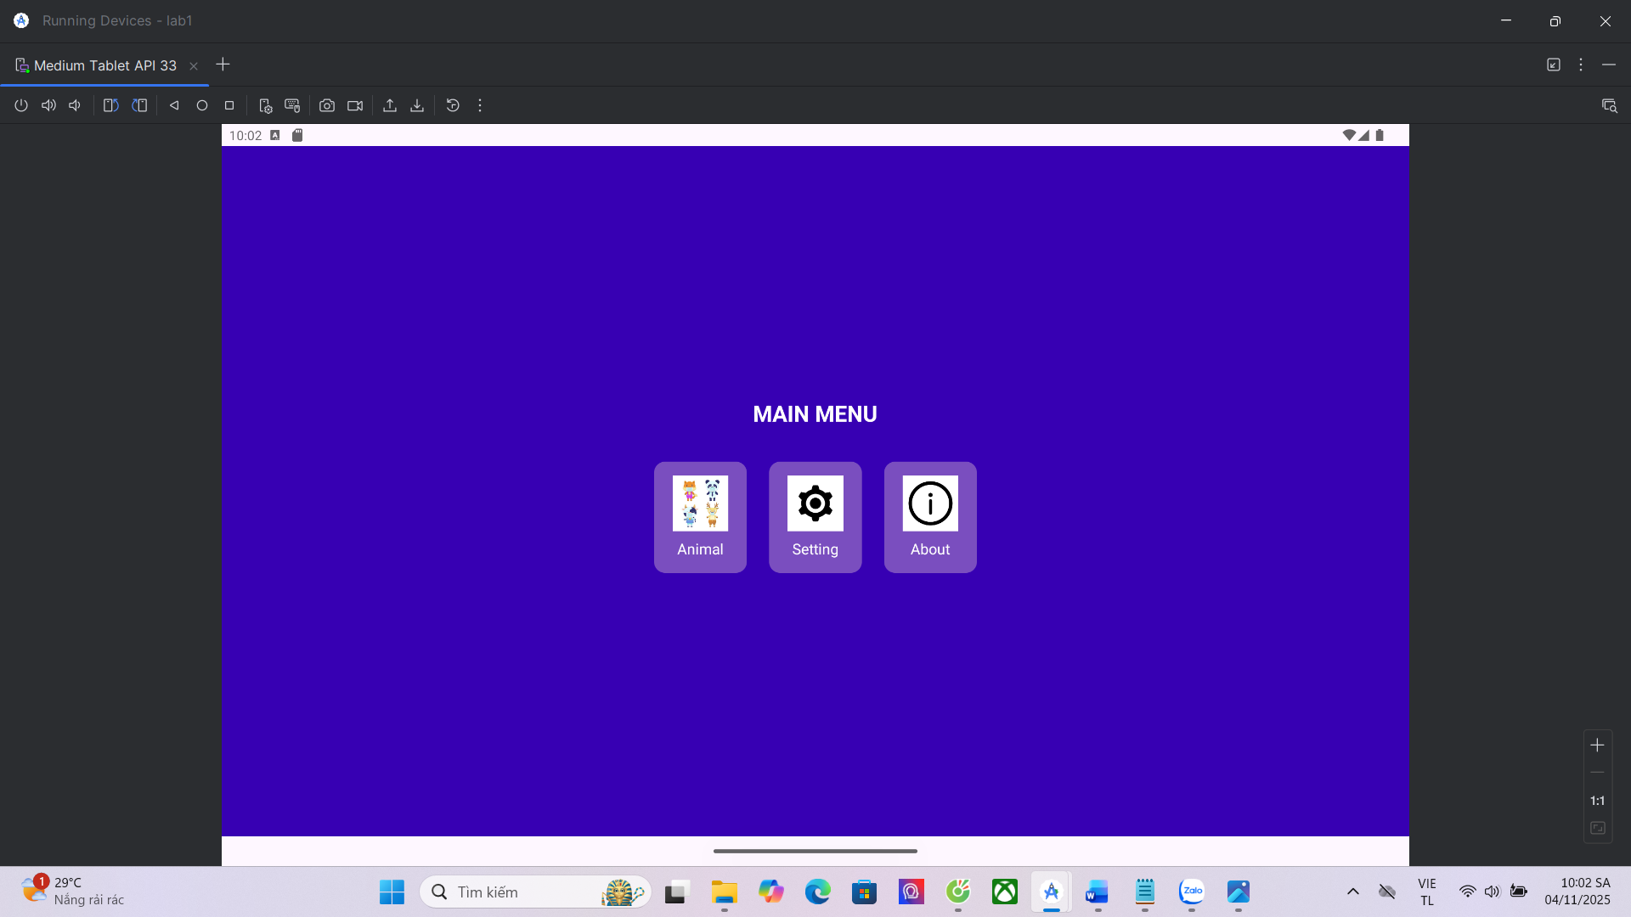

BÀI 4: BẮT SỰ KIỆN CLICK CÁC NÚT

M001ActMain:
package com.example.lab2

import android.content.Intent
import android.os.Bundle
import android.widget.LinearLayout
import androidx.appcompat.app.AppCompatActivity

class M001ActMain : AppCompatActivity() {

private lateinit var btnAnimal: LinearLayout
private lateinit var btnSetting: LinearLayout
private lateinit var btnAbout: LinearLayout

override fun onCreate(savedInstanceState: Bundle?) {
super.onCreate(savedInstanceState)
setContentView(R.layout.m001_act_main)

// Ánh xạ view
btnAnimal = findViewById(R.id.btnAnimal)
btnSetting = findViewById(R.id.btnSetting)
btnAbout = findViewById(R.id.btnAbout)

// Gán sự kiện click cho từng nút
btnAnimal.setOnClickListener {
val intent = Intent(this, M002ActAnimal::class.java)
startActivity(intent)
}

btnSetting.setOnClickListener {
val intent = Intent(this, M003ActSetting::class.java)
startActivity(intent)
}

btnAbout.setOnClickListener {
val intent = Intent(this, M004ActAbout::class.java)
startActivity(intent)
}
}
}

M002ActAnimal:
package com.example.lab2

import android.os.Bundle
import androidx.appcompat.app.AppCompatActivity

class M002ActAnimal : AppCompatActivity() {
override fun onCreate(savedInstanceState: Bundle?) {
super.onCreate(savedInstanceState)
setContentView(R.layout.m002_act_animal)
}
}

m002_act_animal
<?xml version="1.0" encoding="utf-8"?>
<LinearLayout xmlns:android="http://schemas.android.com/apk/res/android"
android:orientation="vertical"
android:gravity="center"
android:layout_width="match_parent"
android:layout_height="match_parent"
android:background="@color/purple_700">

<TextView
android:text="This is Animal Screen"
android:textColor="@color/white"
android:textSize="22sp"
android:textStyle="bold"
android:layout_width="wrap_content"
android:layout_height="wrap_content" />
</LinearLayout>

M003ActSetting:
package com.example.lab2

import android.os.Bundle
import androidx.appcompat.app.AppCompatActivity

class M003ActSetting : AppCompatActivity() {
override fun onCreate(savedInstanceState: Bundle?) {
super.onCreate(savedInstanceState)
setContentView(R.layout.m003_act_setting)
}
}

m003_act_setting:
<?xml version="1.0" encoding="utf-8"?>
<LinearLayout xmlns:android="http://schemas.android.com/apk/res/android"
android:orientation="vertical"
android:gravity="center"
android:layout_width="match_parent"
android:layout_height="match_parent"
android:background="@color/purple_700">

<TextView
android:text="This is Setting Screen"
android:textColor="@color/white"
android:textSize="22sp"
android:textStyle="bold"
android:layout_width="wrap_content"
android:layout_height="wrap_content" />
</LinearLayout>

M004ActAbout:
package com.example.lab2

import android.os.Bundle
import androidx.appcompat.app.AppCompatActivity

class M004ActAbout : AppCompatActivity() {
override fun onCreate(savedInstanceState: Bundle?) {
super.onCreate(savedInstanceState)
setContentView(R.layout.m004_act_about)
}
}

m004_act_about:
<?xml version="1.0" encoding="utf-8"?>
<LinearLayout xmlns:android="http://schemas.android.com/apk/res/android"
android:orientation="vertical"
android:gravity="center"
android:layout_width="match_parent"
android:layout_height="match_parent"
android:background="@color/purple_700">

<TextView
android:text="This is About Screen"
android:textColor="@color/white"
android:textSize="22sp"
android:textStyle="bold"
android:layout_width="wrap_content"
android:layout_height="wrap_content" />
</LinearLayout>

AndroidManifest
<activity android:name=".M002ActAnimal" />
<activity android:name=".M003ActSetting" />
<activity android:name=".M004ActAbout" />

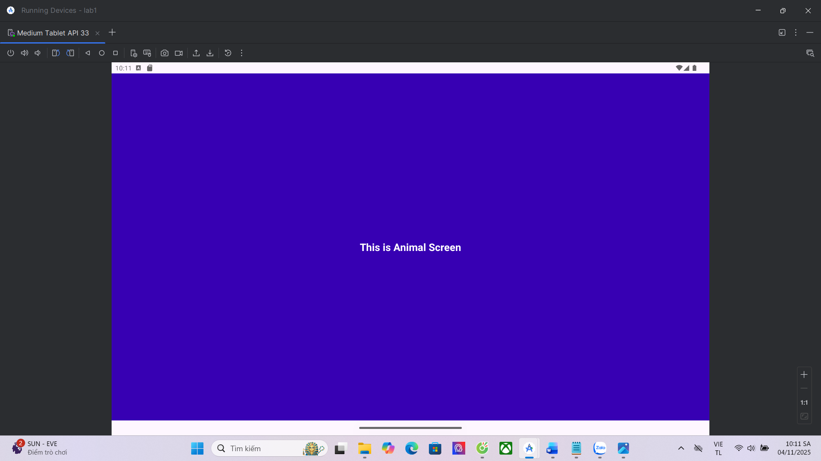
Nút Animal

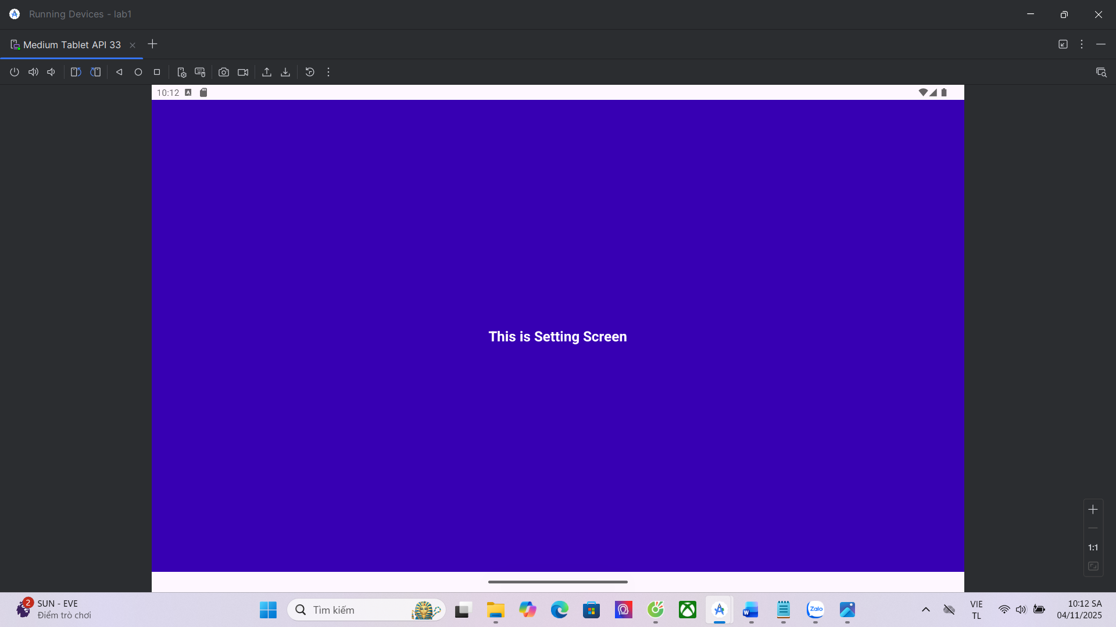
Nút Setting
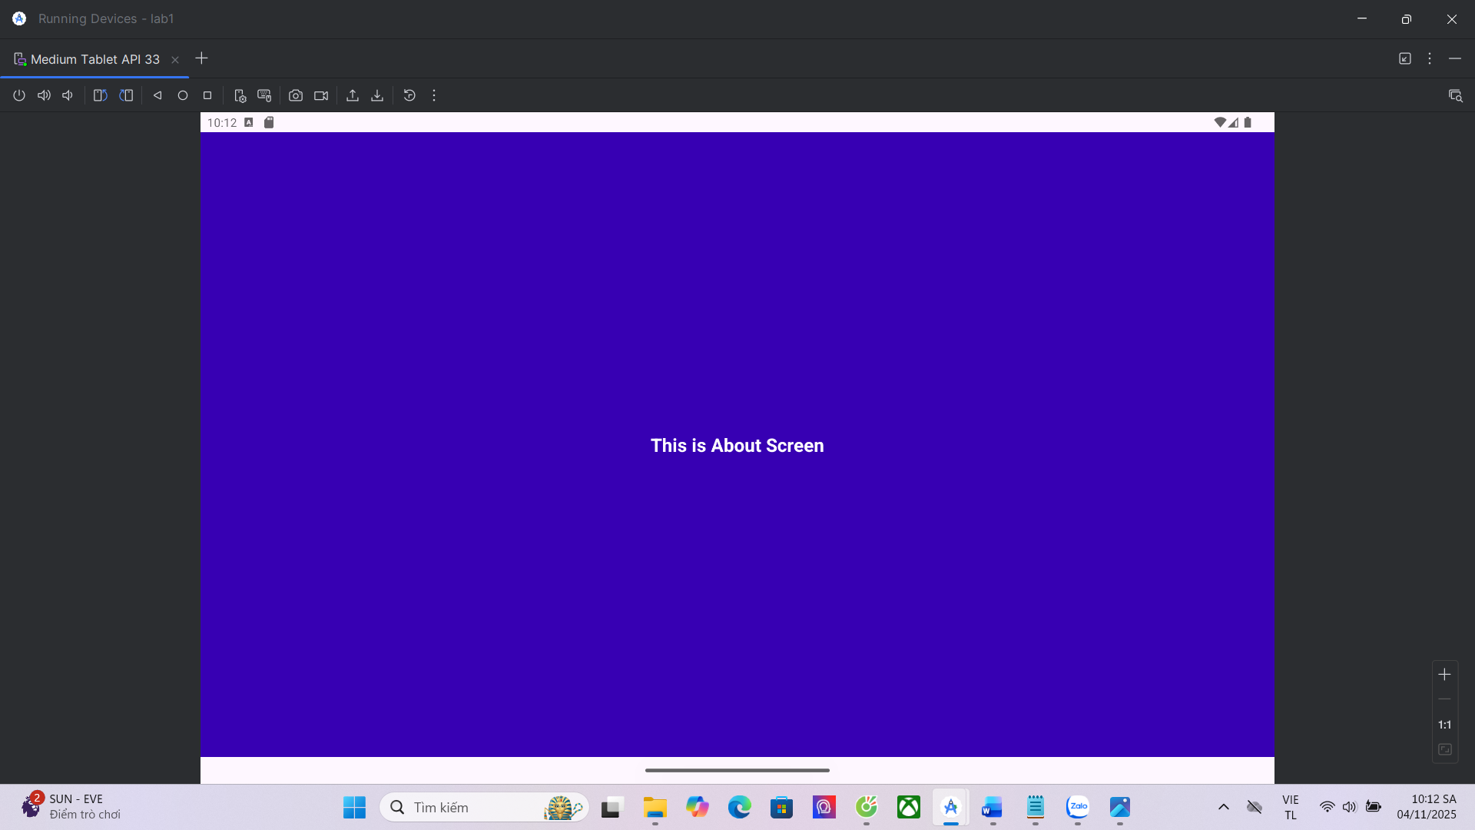
Nút About

Bài 5: Truyền dữ liệu cho animal
Cập nhật M001ActMain cho nút Animal
btnAnimal.setOnClickListener {
val intent = Intent(this, M002ActAnimal::class.java)
intent.putExtra("animal_name", "Dog")
intent.putExtra("animal_sound", "Gâu gâu!")
startActivity(intent)
}

Cập nhật M002ActAnimal
package com.example.lab2

import android.os.Bundle
import android.widget.TextView
import androidx.appcompat.app.AppCompatActivity

class M002ActAnimal : AppCompatActivity() {

private lateinit var txtAnimal: TextView

override fun onCreate(savedInstanceState: Bundle?) {
super.onCreate(savedInstanceState)
setContentView(R.layout.m002_act_animal)

txtAnimal = findViewById(R.id.txtAnimal)

// Nhận dữ liệu từ Intent
val name = intent.getStringExtra("animal_name")
val sound = intent.getStringExtra("animal_sound")

// Hiển thị lên màn hình
txtAnimal.text = "You selected: $name\nSound: $sound"
}
}

m002_act_animal:
<?xml version="1.0" encoding="utf-8"?>
<LinearLayout xmlns:android="http://schemas.android.com/apk/res/android"
android:orientation="vertical"
android:gravity="center"
android:background="@color/purple_700"
android:layout_width="match_parent"
android:layout_height="match_parent">

<TextView
android:id="@+id/txtAnimal"
android:text="You selected: ... "
android:textColor="@color/white"
android:textSize="22sp"
android:textStyle="bold"
android:gravity="center"
android:layout_width="wrap_content"
android:layout_height="wrap_content" />

</LinearLayout>

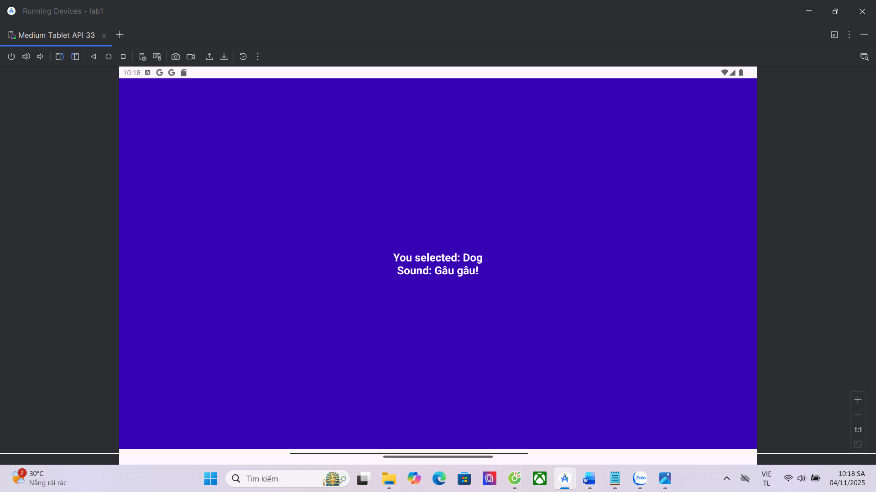
Trang sự kiện của animal

