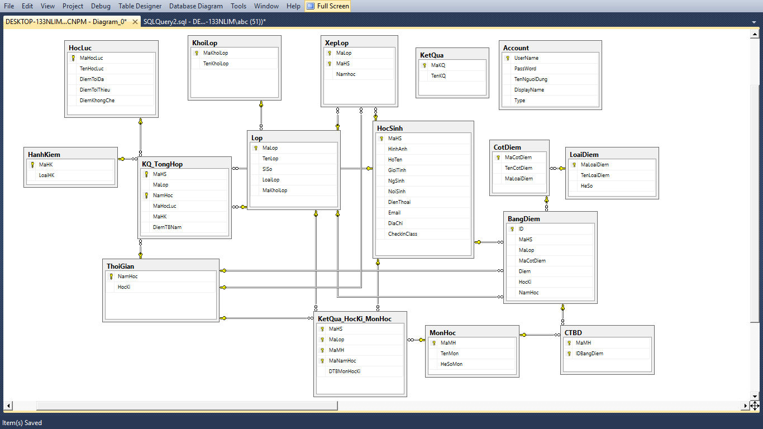

1. Mô hình hóa dữ liệu (ERD Model)

HocSinh(MaHS,HinhAnh,HoTen,GioiTinh,NgSinh,NoiSinh,DienThoai,Email,DiaChi,CheckInClass)

Lop(MaLop,TenLop,SiSo,LoaiLop,MaKhoiLop)

BangDiem(ID,MaHS,MaLop,MaCotDiem,Diem,HocKi,NamHoc)

HocLuc(MaHocLuc,TenHocLuc,DiemToiDa,DiemToiThieu,DiemKhongChe)

HanhKiem(MaHK,LoaiHK)

KQ_TongHop(MaHS,MaLop,NamHoc,MaHocLuc,MaHK,DiemTBNam)

KetQua_HocKi_MonHoc(MaHS,MaLop,MaMH,MaNamHoc,DTBMonHocKi)

KhoiLop(MaKhoiLop,TenKhoiLop)

XepLop(MaLop,MaHS,NamHoc)

KetQua(MaKQ,TenKQ)

Account(Username,Password,TenNguoiDung,DisplayName,Type)

CotDiem(MaCotDiem,TenCotDiem,MaLoaiDiem)

LoaiDiem(MaLoaiDiem,TenLoaiDiem,HeSo)

ThoiGian(NamHoc,HocKi)

CTBD(MaMH,IDBangDiem)

MonHoc(MaMH,TenMon,HeSoMon)