TESTA
AI-Powered Autonomous Web Testing Platform

PROBLEM STATEMENT
- Manual test authoring requires specialist knowledge and weeks of setup per project
- Test scripts grow stale — diverging from live application behaviour, creating false CI confidence
- No immediate root-cause visibility when CI pipelines fail; engineers spend hours reading stack traces
- Junior engineers cannot contribute meaningful test coverage — high skill barrier blocks participation
• QA bottlenecks force coverage cuts under delivery pressure, increasing production defect risk
SOLUTION APPROACH
TESTA is a fully autonomous AI testing agent. Provide a URL — the entire pipeline runs without human intervention, streaming live progress to the browser.
01  CRAWL  Playwright BFS  Discovers pages,  forms & inputs | → | 02  GENERATE  Azure GPT-5.1  Writes complete  .spec.ts file | → | 03  EXECUTE  Playwright Runner  Runs all tests &  captures screenshots | → | 04  ANALYZE  GPT-5.1 Diagnosis  Plain-English fix  per failure
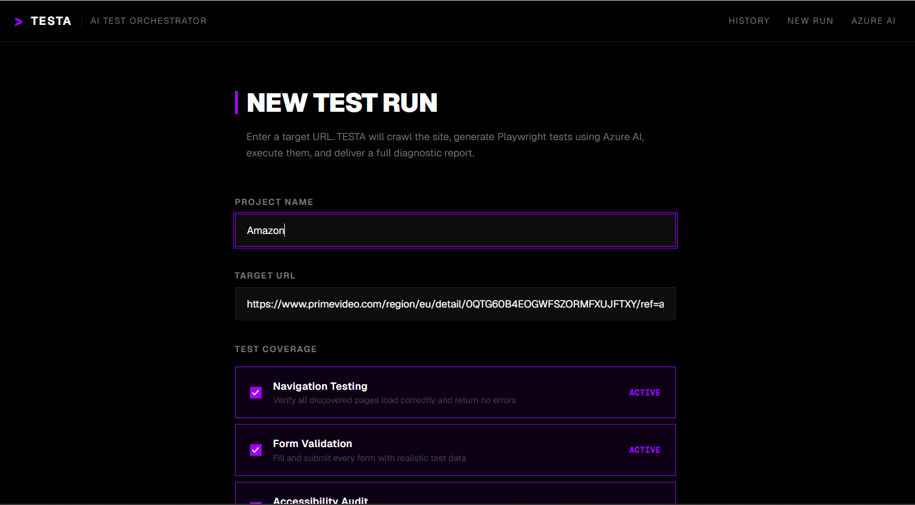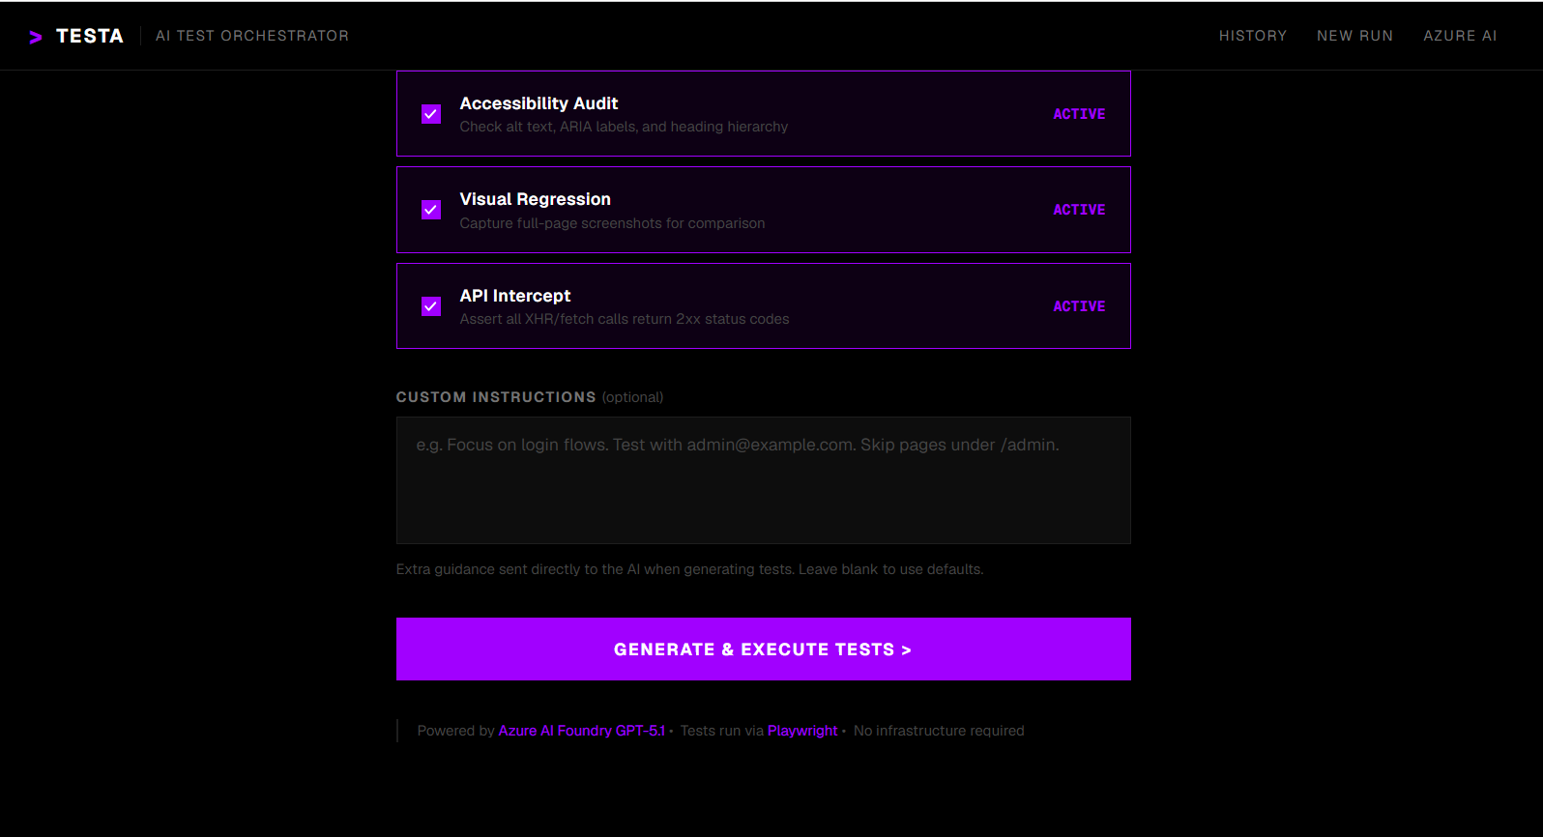
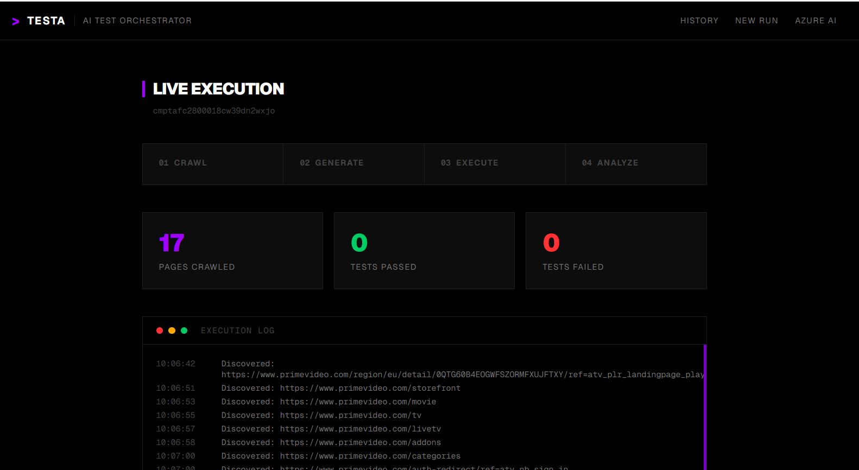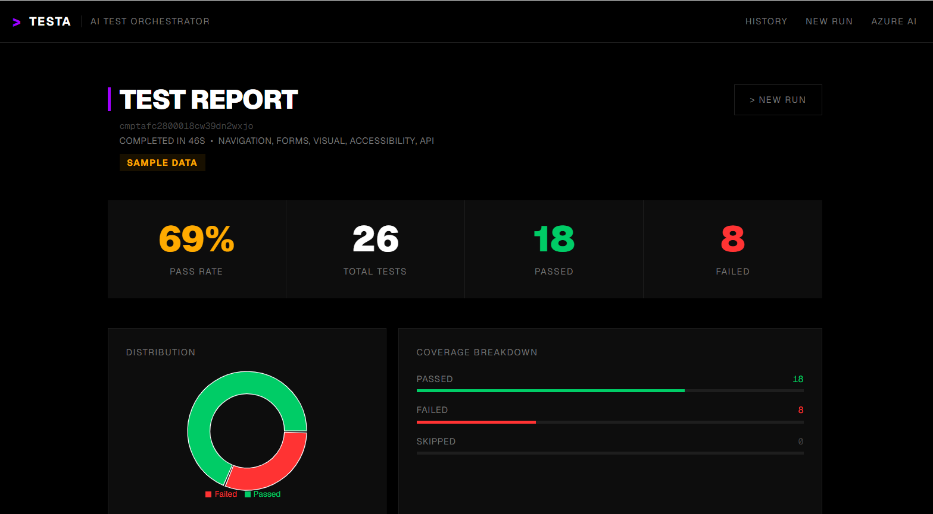
TECH STACK
LAYER | TECHNOLOGY
Frontend | Next.js 16 (App Router) · React 19 · TypeScript · Tailwind CSS v4 · Recharts
Backend | NestJS 11 · TypeScript · Prisma v7 · SQLite (zero-server, libSQL adapter)
AI Engine | Azure AI Foundry · GPT-5.1 via @azure-rest/ai-inference SDK
Browser Engine | Playwright 1.60 · Chromium · used for both crawling and test execution
Real-time | Server-Sent Events · NestJS @Sse() · RxJS Subjects · no polling
Monorepo | npm workspaces · apps/api (NestJS) · apps/web (Next.js) · packages/shared
BUSINESS IMPACT
Test Setup  Time  16 hrs  0 hrs  −100% | Test  Coverage  40%  90%  +125% | Defect  Detection  55%  88%  +60% | Manual QA  Effort  24 hrs  <2 hrs  −92% | Time to  Report  60 min  <3 min  −95%
SCALABILITY ROADMAP
NEAR-TERM (1–2 sprints)  • CI/CD integration — GitHub Actions / Jenkins plugin  • BullMQ job queue — concurrent multi-user execution  • Self-healing selectors — GPT-5.1 auto-repairs broken CSS selectors | MEDIUM-TERM (1 quarter)  • Natural language test commands ("Test the checkout flow")  • Multi-browser execution — Firefox, WebKit  • Scheduled runs with email / Slack notifications | LONG-TERM (scale)  • Accenture myWizard integration — surface reports in delivery dashboards  • Cross-project trend analysis and quality benchmarking  • Export reports as PDF / HTML for client-facing QA gates

