Ubaid Ullah, Muhammad Ahmad, Azeem Tanoli

Automatic Text Summarization with Hybrid Extractive-Abstractive Methods

Natural Language processing
Assignment 2

Automatic Text Summarization with Hybrid Extractive-Abstractive Methods

1. Problem Definition & Objective
Research Problem: Traditional text summarization systems rely on either purely extractive methods (selecting existing sentences) or abstractive methods (generating new text), each with distinct limitations. Extractive methods produce coherent but sometimes redundant summaries, while abstractive methods can generate fluent text but risk factual inconsistencies and hallucinations. Current hybrid approaches lack systematic integration strategies that leverage the complementary strengths of both paradigms for domain-specific documents.
Research Questions/Gaps:
- RQ1: How can extractive sentence selection be optimally combined with abstractive refinement to improve summary quality and factual accuracy?
- RQ2: What fusion strategies best balance informativeness, coherence, and faithfulness in hybrid summarization?
- Gap: Limited research on trainable hybrid architectures that can adaptively weigh extractive vs. abstractive components based on document characteristics and domain requirements.
Measurable Objective: Develop a hybrid extractive-abstractive text summarization system that achieves ROUGE-1 F1 >42%, ROUGE-2 F1 >20%, and ROUGE-L F1 >38% on the CNN/DailyMail dataset, while maintaining factual consistency scores (BERTScore) >85% compared to reference summaries. The system should outperform standalone extractive and abstractive baselines by at least 3% on average ROUGE scores.
2. Data Collection / Sources
Data Sources:
- Primary Dataset: CNN/DailyMail news summarization dataset (Hermann et al., 2015)
  - Articles: 287,113 training, 13,368 validation, 11,490 test
  - Highlights (reference summaries): 3-4 sentences per article
- Secondary Dataset: XSum (Extreme Summarization) for cross-domain evaluation
  - Articles: 204,045 training, 11,332 validation, 11,334 test
Format & Size:
- Input format: Plain text articles (JSON format)
- Average article length: 750-800 tokens
- Average summary length: 55-60 tokens
- Total storage: ~8GB compressed
- Character encoding: UTF-8
Sampling Strategy: Use full training set with stratified sampling by article length categories (short: <400 tokens, medium: 400-800, long: >800) for validation experiments. Random 5% subset (14,356 articles) for rapid prototyping and hyperparameter tuning.
3. Data Preprocessing & Augmentation
Preprocessing Pipeline:
- Text Cleaning: Remove HTML tags, special characters, and URLs using BeautifulSoup and regex; normalize whitespace and Unicode characters
- Sentence Segmentation: Apply NLTK sentence tokenizer for extractive component; validate with SpaCy for boundary detection accuracy
- Tokenization: Use pre-trained BART tokenizer (byte-level BPE) with vocabulary size 50,265 for consistency with abstractive model
- Length Filtering: Remove articles <100 tokens or >1024 tokens (BART max length constraint); filter summaries <10 tokens or >150 tokens
- Truncation Strategy: For articles >1024 tokens, use lead bias (first 1024 tokens) as news articles front-load key information
Data Augmentation (Training Only):
- Sentence Shuffling: Randomly shuffle 20% of middle sentences (preserving lead and tail) to reduce position bias, p=0.15
- Entity Replacement: Replace named entities with same-type entities from knowledge base (5% probability) to improve generalization
- Paraphrasing: Use back-translation (English→German→English) for 10% of training samples to increase lexical diversity
- Rationale: Augmentation reduces overfitting to article structure patterns and improves model robustness to phrasing variations, critical for abstractive component quality
4. Feature Extraction / Representation
Approach: Hybrid feature extraction combining learned embeddings for abstractive component and hand-crafted features for extractive component
Learned Features (Abstractive Component):
- Architecture Family: Transformer-based encoder-decoder (BART-large)
- Pretrained Model: BART-large (406M parameters) pretrained on large-scale text corpus with denoising objectives
- Contextual Embeddings: 1024-dimensional contextualized token representations from encoder final layer
- Rationale: BART has demonstrated state-of-the-art performance on abstractive summarization through its denoising pretraining, making it ideal for generating fluent, coherent summaries
Hand-Crafted Features (Extractive Component):
- Position Features: Sentence position index normalized by document length (exploits lead bias in news)
- TF-IDF Scores: Term frequency-inverse document frequency for content importance measurement
- Sentence Length: Normalized token count (filters too-short/too-long sentences)
- Named Entity Density: Count of named entities per sentence (indicates factual content)
- Similarity Features: Cosine similarity to document centroid using Sentence-BERT embeddings
- Cue Phrase Indicators: Binary features for presence of discourse markers ("however", "in summary", etc.)
- Rationale: Hand-crafted features capture document structure and importance signals that complement neural representations
5. Model Architecture & Training Plan
Model Topology:
Extractive Module:
- Input: Document sentences (variable count, max 50 sentences)
- Encoder: Sentence-BERT (all-MiniLM-L6-v2) → 384-d sentence embeddings
- Feature Fusion: Concatenate learned embeddings (384-d) + hand-crafted features (20-d) → 404-d
- Scoring Network:
  - BiLSTM (404 → 256 → 256, 2 layers) captures inter-sentence context
  - Attention mechanism over BiLSTM outputs
  - Feed-forward scoring layer (256 → 1) + sigmoid activation
- Output: Sentence-level extraction probabilities; select top-k sentences (k=3-5 based on compression ratio)
Abstractive Module:
- Input: Concatenated extracted sentences (from extractive module)
- Backbone: BART-large encoder-decoder
- Architecture:
  - Encoder: 12 layers, 1024 hidden dim, 16 attention heads
  - Decoder: 12 layers, 1024 hidden dim, 16 attention heads
- Fine-tuning Strategy: Unfreeze all parameters; lower learning rate for encoder (1e-5) vs. decoder (3e-5) for stability
- Output: Generated abstractive summary (max length: 140 tokens)
Fusion Strategy:
- Two-Stage Pipeline: Extractive module identifies salient content → feeds to abstractive module for refinement
- Loss Weighting: Combined loss = λ₁ × L_extractive + λ₂ × L_abstractive (λ₁=0.3, λ₂=0.7 based on validation tuning)
Training Configuration:
- Loss Functions:
  - Extractive: Binary cross-entropy with label smoothing (ε=0.1) for sentence selection
  - Abstractive: Cross-entropy loss for sequence generation with label smoothing
- Optimizer: AdamW (β₁=0.9, β₂=0.999, ε=1e-8, weight decay=0.01)
- Learning Rate Schedule:
  - Warmup: Linear warmup over 1,000 steps
  - Decay: Polynomial decay with power=1.0 over 30,000 steps
  - Peak LR: Extractive=5e-5, Abstractive=3e-5
- Batch Size:
  - Extractive: 32 documents
  - Abstractive: 8 documents (gradient accumulation over 4 steps for effective batch size 32)
- Epochs: 5 epochs (~45,000 update steps)
- Mixed Precision: FP16 training using automatic mixed precision for memory efficiency
Regularization:
- Dropout: 0.1 in all transformer layers, 0.3 in extractive LSTM
- Gradient Clipping: Max norm 1.0 to prevent exploding gradients
- Label Smoothing: ε=0.1 reduces overconfidence
- Weight Decay: 0.01 for L2 regularization
- Rationale: Transformer models with large parameter counts are prone to overfitting on summarization tasks; multiple regularization techniques ensure generalization
6. Validation & Evaluation
Data Split Strategy:
- Training Set: 287,113 articles (CNN/DailyMail training split)
- Validation Set: 13,368 articles (CNN/DailyMail validation split)
- Test Set: 11,490 articles (CNN/DailyMail test split, held out until final evaluation)
- No document-level leakage between splits (verified by URL uniqueness)
Cross-Validation: Not applicable due to dataset size and computational cost; single fixed split following standard benchmark protocol
Evaluation Metrics:
Primary Metrics (Automatic):
- ROUGE Scores (F1):
  - ROUGE-1 (unigram overlap) - Target: >42%
  - ROUGE-2 (bigram overlap) - Target: >20%
  - ROUGE-L (longest common subsequence) - Target: >38%
- BERTScore: Semantic similarity using contextual embeddings - Target: >85%
- Rationale: ROUGE measures n-gram overlap with reference summaries (standard benchmark); BERTScore captures semantic similarity beyond lexical overlap
Secondary Metrics:
- Factual Consistency: FactCC (learned factual consistency classifier) - Target: >75% factual samples
- Abstractiveness: Novel n-gram ratio (percentage of bigrams not in source) - Target: >30%
- Compression Ratio: Summary length / Article length - Target: 0.05-0.08
- BLEU-4: Precision-oriented metric for fluency assessment
Human Evaluation (Subset of 100 samples):
- Informativeness: 1-5 scale (coverage of key information)
- Coherence: 1-5 scale (logical flow and readability)
- Faithfulness: 1-5 scale (factual accuracy to source)
- Inter-annotator agreement measured via Fleiss' Kappa
Acceptance Threshold: Model accepted if ROUGE-1 ≥42%, ROUGE-2 ≥20%, ROUGE-L ≥38%, AND BERTScore ≥85% on test set, with factual consistency ≥75%
Statistical Analysis: Bootstrap resampling (10,000 iterations) for 95% confidence intervals on ROUGE scores; statistical significance testing via paired t-test comparing to baselines (p<0.05)
7. Error Analysis & Interpretability
Failure Analysis:
- ROUGE Score Distribution: Analyze low-scoring samples (bottom 10%) to identify systematic failures (e.g., handling of technical jargon, multi-topic articles)
- Factual Consistency Errors: Manual review of FactCC false positives/negatives to identify hallucination patterns (entity errors, relation errors, temporal inconsistencies)
- Extractive Component Analysis: Examine cases where low-importance sentences are selected; evaluate feature contribution via ablation studies
- Length Analysis: Stratify errors by article/summary length to identify length-dependent performance degradation
Interpretability Techniques:
- Attention Visualization:
  - Extractive: Visualize sentence-level attention scores to verify important content identification
  - Abstractive: Plot encoder-decoder attention heatmaps to show source-summary token alignments
- Feature Importance: SHAP values for hand-crafted features in extractive module to determine which features drive sentence selection
- Ablation Studies:
  - Remove extractive component (pure abstractive baseline)
  - Remove abstractive component (pure extractive baseline)
  - Ablate individual feature groups to quantify contribution
- Saliency Maps: Token-level gradient-based saliency for generated summaries to identify influential input tokens
Qualitative Analysis:
- Compare extractive-only, abstractive-only, and hybrid outputs side-by-side for 50 examples across difficulty levels
- Identify cases where hybrid approach successfully combines strengths vs. cases where cascading errors occur
Iterative Improvement: Insights inform (1) feature engineering refinements for extractive module, (2) loss function reweighting, (3) potential addition of coverage mechanisms to reduce redundancy
9. Timeline & Milestones
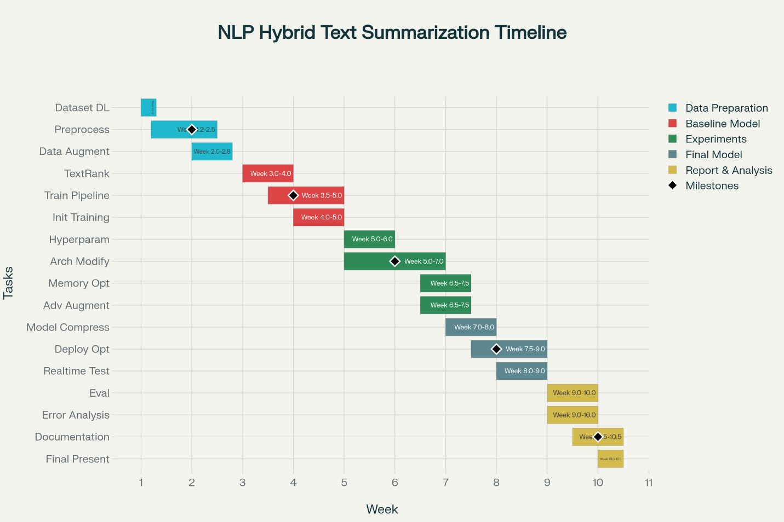

10. Risks & Mitigations
Risk | Impact | Likelihood | Mitigation Strategy
Factual Hallucinations | Abstractive model generates factually incorrect summaries, undermining trust | High | 1. Implement FactCC consistency scoring with threshold filtering  2. Add copy mechanism to encourage copying from extractive output  3. Post-processing entity verification against source
Extractive Component Failures | Poor sentence selection leads to information loss before abstractive stage | Medium | 1. Extensive feature engineering and ablation studies  2. Ensemble multiple extractive strategies (TF-IDF, TextRank, LSTM  3. Human-in-the-loop validation for feature design
Computational Constraints | Insufficient GPU resources for BART fine-tuning (>40 hours on single GPU) | Medium | 1. Use gradient accumulation for larger effective batch sizes  2. Mixed precision (FP16) training to reduce memory  3. Rent cloud GPUs (AWS p3 instances) if local resources insufficient  4. Distillation to smaller model (DistilBART) if needed
Domain Shift | Model trained on news fails on scientific/legal documents | High | 1. Fine-tune on domain-specific data if available  2. Domain adaptation techniques (adversarial training)  3. Evaluate on XSum for cross-domain robustness  4. Make extractive features domain-agnostic
Length Bias | Model struggles with very short (<300 tokens) or very long (>1000 tokens) articles | Medium | 1. Stratified sampling by length during training  2. Adaptive compression ratios based on article length  3. Sliding window approach for long documents  4. Length-penalty in beam search decoding
Evaluation Metric Limitations | ROUGE scores don't capture semantic quality; high ROUGE but low human satisfaction | High | 1. Mandatory human evaluation on test subset (n=100)  2. Use BERTScore and FactCC to complement ROUGE  3. Qualitative analysis of model outputs  4. A/B testing with baseline summaries
Reproducibility Issues | Non-deterministic GPU operations cause result variance | Low | 1. Set random seeds (Python, NumPy, PyTorch)  2. Use deterministic CUDA operations (slower but reproducible)<  3. Document exact library versions in requirements.txt  4. Report mean and std over 3 runs
Cascading Errors | Errors from extractive stage amplify in abstractive stage | Medium | 1. End-to-end joint training with shared loss  2. Error analysis to identify failure handoff points  3. Oracle experiments (use gold-standard extractive sentences) to isolate issues  4. Confidence-based gating (skip abstractive if extractive confidence low)

