

ASSIGNMENT 02 web

[Document subtitle]



[Date]

[Company name]

[Company address]

**Task 01**

<!DOCTYPE html>

<html lang="en">

<head>

    <meta charset="UTF-8">

    <meta name="viewport" content="width=device-width, initial-scale=1.0">

    <title>Button</title>

    <link rel="stylesheet" href="style.css">

</head>

<body class="bodi">

    <h1 class="H">Start CSS Exercise</h1>

    <p class="pra">Good Luck</p>

    <button class="but"  >Start CSS Exercise ></button>

</body>

</html>

**CSS**

.but{

    background-color: green;

    height: 50px;

    width: 180px;

}

.bodi{

    background-color: black;

}

.pra{

    color: wheat;

}

.H{

    color: antiquewhite;

    text-size-adjust: 40%;

}

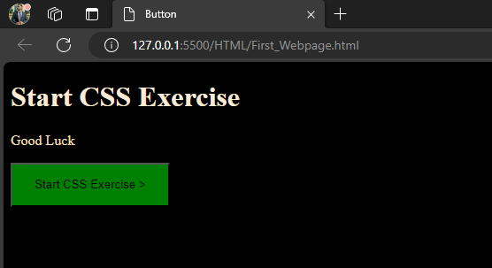

**Task 2**

<!DOCTYPE html>

<html lang="en">

<head>

    <meta charset="UTF-8">

    <meta name="viewport" content="width=device-width, initial-scale=1.0">

    <title>Form</title>

    <link rel="stylesheet" href="style.css">

</head>

<body>

    <div class="container" >

        <form action="/submit-form" method="POST" >

            <div class="form-group">

                <input type="text" id="name" placeholder="Name" >

            </div>

            <div class="form-group">

                <input type="text" id="username" placeholder="username" >

            </div>

            <div class="form-group">

                <input type="email" id="email" placeholder="email" >

            </div>

            <div class="form-group">

                <input type="email" id="email" placeholder="email" >

            </div>

            <div class="form-group">

                <input type="password" id="password" placeholder="Telephone" >

            </div>

            <button class="but" type="submit">Register</button>

        </form>

    </div>

    </body>

</html>

**Css**

body {

    font-family: Arial, sans-serif;

    background-color: #f0f0f0;

    margin: 0;

    padding: 0;

    display: flex;

    justify-content: center;

    align-items: center;

    height: 100vh;

}

.container {

    width: 300px;

    background-color: #4512a3;

    padding: 20px;

    border-radius: 8px;

    box-shadow: 0 0 10px rgba(0, 0, 0, 0.1);

}

.form-group {

    margin-bottom: 15px;

}

label {

    display: block;

    margin-bottom: 5px;

}

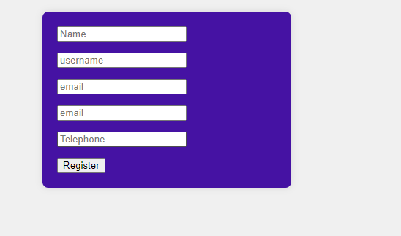

**Task 3**

<!DOCTYPE html>

<html lang="en">

<head>

    <meta charset="UTF-8">

    <meta name="viewport" content="width=device-width, initial-scale=1.0">

    <title>img</title>

    <link rel="stylesheet" href="style.css">

</head>

<body>

    <div class="card">

        <img src="Fast_logo.png" alt="Avatar" style="width:100%">

        <div class="container">

          <h4><b>Usman Saleem</b></h4>

          <p>WEB Developer</p>

        </div>

      </div>

</body>

</html>

**Css**

.card {

    width: 500px;

  box-shadow: 0 4px 8px 0 rgba(0,0,0,0.2);

  transition: 0.3s;

}

.card:hover {

  box-shadow: 0 8px 16px 0 rgba(0,0,0,0.2);

}

.container {

  padding: 2x 16px;

  text-align: center;

}



**Task 4**

**Html same code of above task 3**

.card {

    width: 500px;

  box-shadow: 0 4px 8px 0 rgba(0,0,0,0.2);

  transition: 0.3s;

  animation: 5s leftToright;

}

@keyframes  leftToright {

    50% {transform: translate(500px);}

}

.card:hover {

  box-shadow: 0 8px 16px 0 rgba(0,0,0,0.2);

}

.container {

  padding: 2x 16px;

  text-align: center;

}

