

HTML

[Document subtitle]



**Name : Usman Saleem**

**Roll No : 21F-9277**

**Tsak 1**

<!DOCTYPE html>

<html lang="en">

<head>

    <meta charset="UTF-8">

    <meta name="viewport" content="width=device-width, initial-scale=1.0">

    <title>Student Info</title>

</head>

<body>

    <h1>About Me</h1>

    <div>Name : Usman Saleem </div>

    <div>Roll No : 21F-9277 </div>

    <p>

        My name is Usman Saleem . i am Student . i am from Gujranwala .

    </p>

</body>

</html>

**Task 2**

<!DOCTYPE html>

<html lang="en">

<head>

    <meta charset="UTF-8">

    <meta name="viewport" content="width=device-width, initial-scale=1.0">

    <title>Student Info</title>

</head>

<style>

  #myText {

    font-size: 30px;

  }

  .its-italic{

    font-style: italic;

    font-size: 30px;

  }

.emphasized{

    font-size: 30px;

}

.c_output{

    font-size: 30px;

}

.sub_sup{

    font-size: 30px;

}

</style>

<body>

    <h1>This text is Bold</h1>

    <h1>This text is strong </h1>

    <p id="myText">This text is big</p>

    <p class ="its-italic">this text is italic</p>

    <em><p class = "emphasized">This text is emphasized</p></em>

    <p class="c_output" >This is computer output</p>

    <p class ="sub_sup">This is <sub>subscript</sub> and <sup>superscript</sup></p>

</body>

</html>

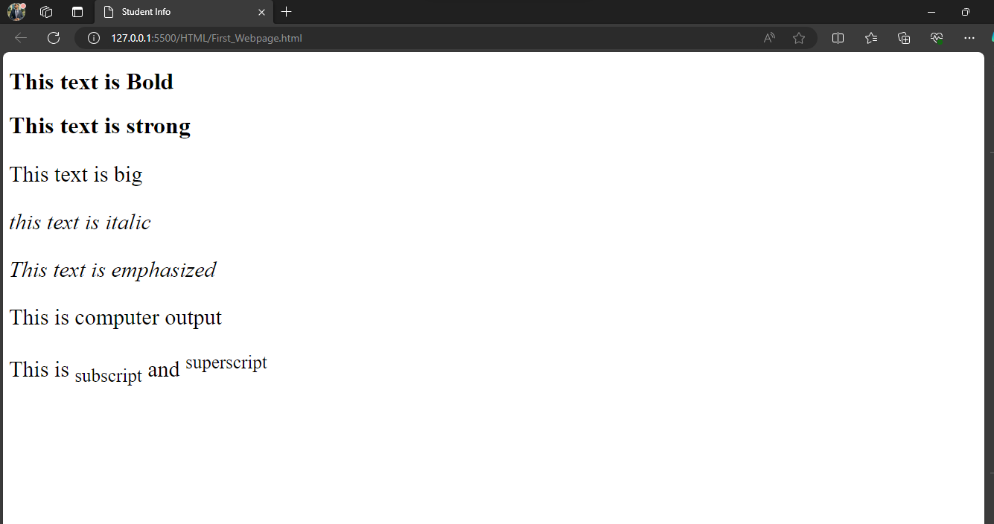

**Task 3**

<!DOCTYPE html>

<html lang="en">

<head>

    <meta charset="UTF-8">

    <meta name="viewport" content="width=device-width, initial-scale=1.0">

    <title>Student Info</title>

</head>

<style>

</style>

<body>

   <img src="Fast_logo.png"  width="1000" height="1000">

</body>

</html>



**Task 4**

<!DOCTYPE html>

<html lang="en">

<head>

    <meta charset="UTF-8">

    <meta name="viewport" content="width=device-width, initial-scale=1.0">

    <title>Student Info</title>

</head>

<style>

</style>

<body>

    <a href="https://www.nu.edu.pk/" target="_blank">

        <img src="Fast_logo.png"  width="1000" height="1000">

    </a>

</body>

</html>



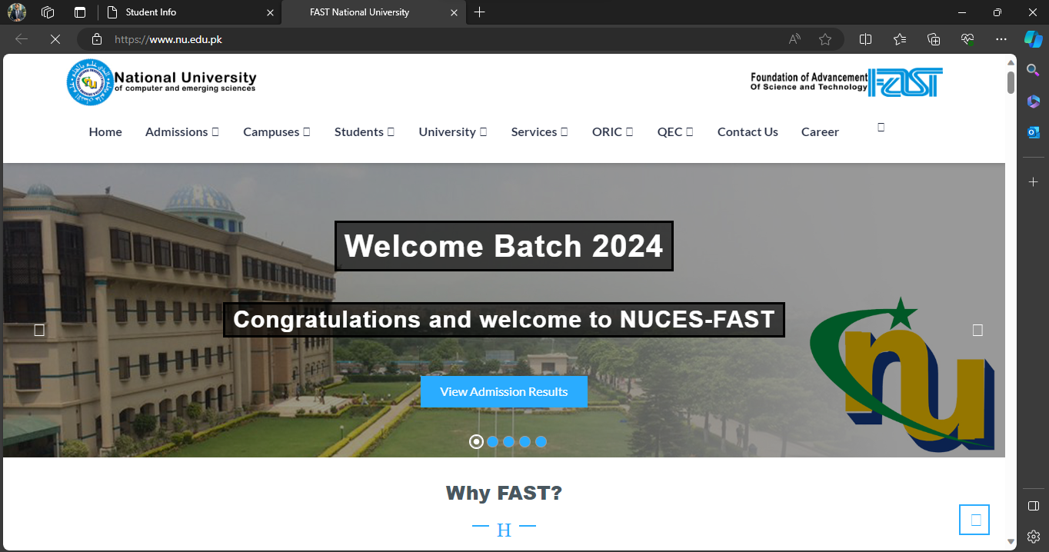

**Task 5**

<!DOCTYPE html>

<html lang="en">

<head>

    <meta charset="UTF-8">

    <meta name="viewport" content="width=device-width, initial-scale=1.0">

    <title>Student Info</title>

</head>

<body>

    <h1>HTML List</h1>

    <h2>Unordered List</h2>

    <ul>

        <li>Oracal</li>

        <li>Java</li>

        <li>HTML</li>

        <li>CSS</li>

    </ul>

    <h2>Ordererd List</h2>

    <p>Following these steps to Install Java </p>

    <ol>

        <li>Download the Softwere</li>

        <li>Extract to the Folder</li>

        <li>Double Click the executable to run</li>

    </ol>

</body>

</html>

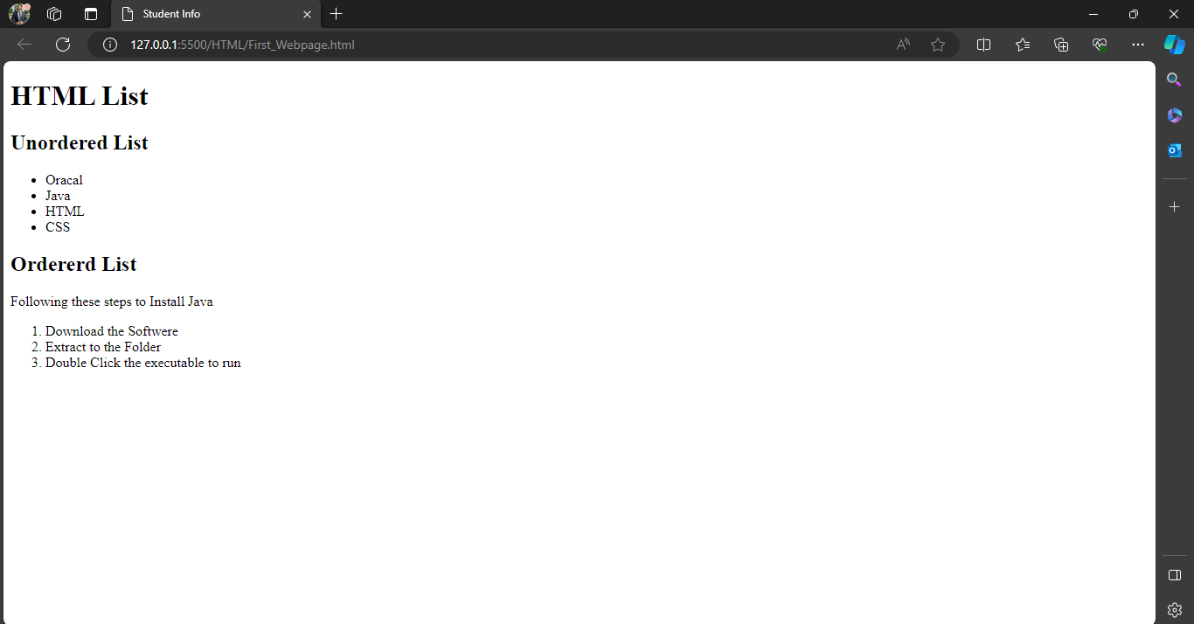

**Task 6**

<!DOCTYPE html>

<html lang="en">

<head>

    <meta charset="UTF-8">

    <meta name="viewport" content="width=device-width, initial-scale=1.0">

    <title>Student Info</title>

</head>

<style>

    table{

        border-collapse: collapse;

        width: 300px;

    }

    th ,td{

        border: 1px solid #ddd;

        padding: 10px;

        text-align: center;

    }

</style>

<body >

    <table border="2px">

        <tr>

            <td rowspan="3" >April</td>

            <td></td>

            <td></td>

        </tr>

        <tr>

            <td></td>

            <td></td>

        </tr>

        <tr>

            <td></td>

            <td></td>

        </tr>

        <tr>

            <td></td>

            <td></td>

            <td></td>

          </tr>

        <tr>

            <td></td>

            <td></td>

            <td></td>

        </tr>

</body>

</html>

