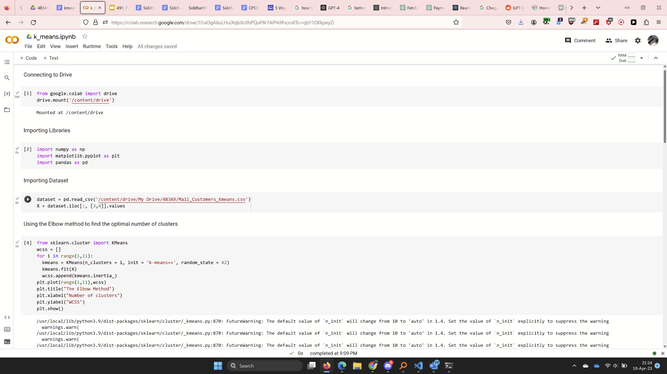

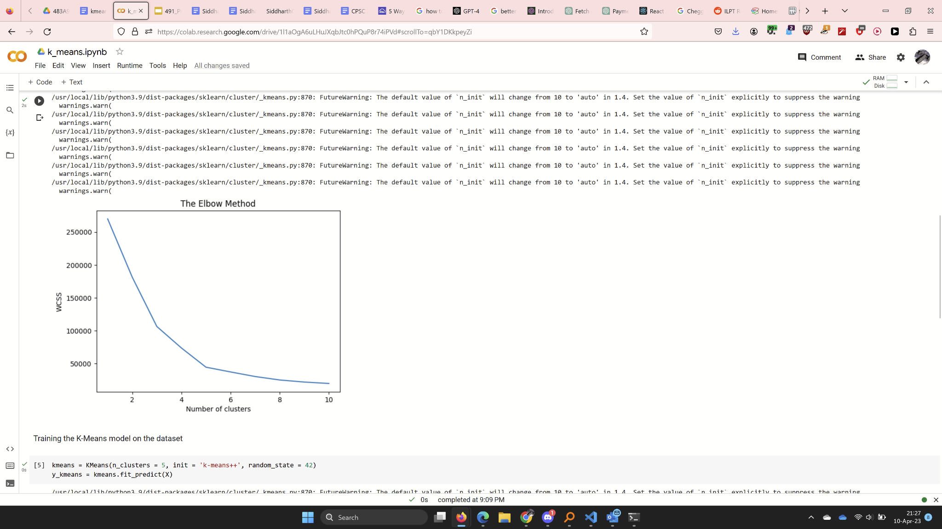

* Connecting file to google drive
* Importing necessary libraries
* Importing dataset file from Mall_Customers_Kmeans.csv
* Using elbow method to find optimal number of clusters

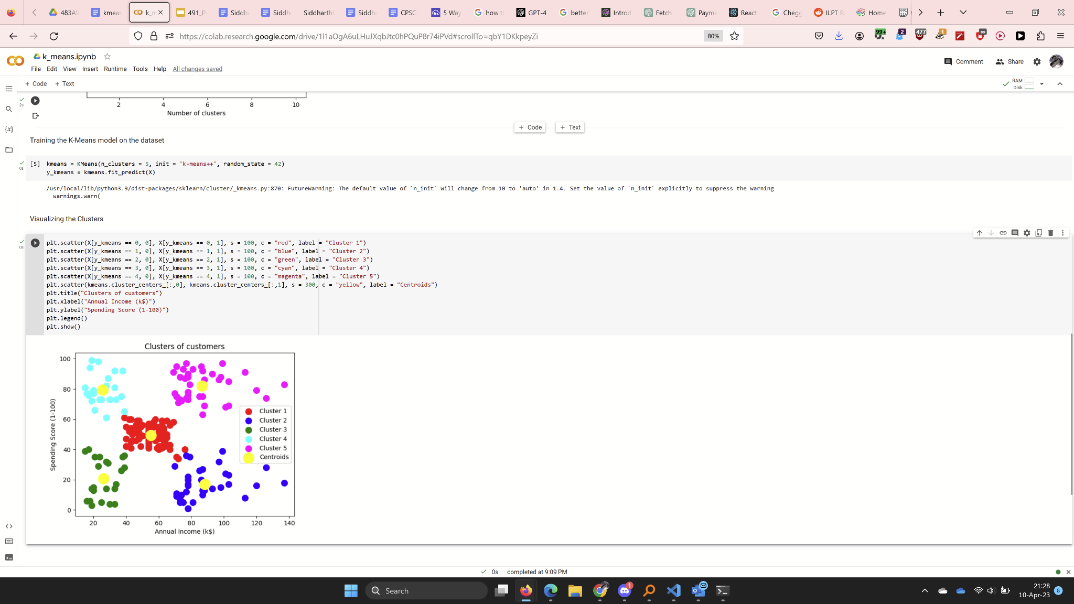

* Training k_means on dataset
* Visualizing clusters