**A REPORT OF MINOR PROJECT**

SUBMITTED IN PARTIAL FULFILLMENT OF THE REQUIREMENT FOR THE AWARD

OF THE DEGREE OF

**BACHELOR OF TECHNOLOGY**

(Computer Science & Engineering)



**SUBMITTED TO: SUBMITTED BY:**

Mr. DEVENDRA DAILA ABHINAV CHAUHAN

ASSISTANT PROFESSOR (CSE Dept.) 15ECTCS005

**UNIVERSITY COLLEGE OF ENGINEERING AND TECHNOLOGY, BIKANER**

(FORMERLY COLLEGE OF ENGINEERING AND TECHNOLOGY)

DEPARTMENT OF COMPUTER SCIENCE & ENGINEERING

**RAJASTHAN TECHNICAL UNIVERSITY, KOTA**

**DECLARATION**

I declare

GEOFENCING – Angular JS and Node JS

GEOX is basically an automated attendance system that is being created to ease the paperwork and maintain a attendance database of the student in institutes.

(a)That the work presented for assessment in this Project Report is my own, that it has not previously been presented for another assessment and that my debts (for words, data, arguments and ideas) have been appropriately acknowledged

(b)That the work conforms to the guidelines for presentation and style set out in the relevant documentation.

Date: 3 Nov 2018 Abhinav Chauhan

15ECTCS005

CSE (A1)

**ACKNOWLEDGEMENT**

I would like to express my special thanks of gratitude to my teacher Mr. Devendra Daila as well as our principal Dr. S K Bansal who gave me the golden opportunity to do this wonderful project on the topic Geo fencing, which also helped me in doing a lot of Research and I came to know about so many new things I am really thankful to them.

Secondly I would also like to thank my parents and friends who helped me in finalizing this project within the limited time frame.

With Regards

Abhinav Chauhan

**TABLE OF CONTENTS**

Chapter 1: Introduction to Angular JS and Node JS………………………………………..

1.1 What is Angular JS…….…………………………….………………………….

1.2 What is Node JS ………………………………………..………………………

Chapter 2: Geo fencing……..………………………………………………………………

2.1 What is geo fencing …………………………………………………………….

2.2 How it is work…………………………………………………………………...

Chapter 3: GEOX……..…………………………………………………………………….

3.1 Why GEOX ……………………………………………………………………..

3.2 What is GEOX…………………………………………………………………..

3.3 Problem’s Solution by GEOX…………………………………………………..

3.4 Flow charts of Projects …………………………………………………………

3.5 Screenshots of Projects………………………………………………………….

Chapter 4: Future Scope & References ……………………………………….……….......

**CHAPTER 1: INTRODUCTION TO ANGULAR AND NODE**

JavaScript has evolved far beyond a simple client-side scripting language into an incredibly powerful programming language which can also be used to create server-side applications in addition to the traditional client-side applications.

AngularJS framework and Node JS platform can be quite useful for making powerful client-side and server-side for developing interactive and feature rich cross-platform web applications in JavaScript language.

Angular and node are Both the open-source tools as node.js is mainly used to build server-side applications, whereas AngularJS is suited for building single-page client-side web applications both can be combined to create isomorphic web applications, i.e. applications that are built with the same language on the back and front-ends, but they are quite different in their architecture and working. If you go a little further and use MongoDB as your data store, you can build your entire infrastructure using JavaScript favoured tools.

**1.1 What is ANGULAR JS**

AngularJS is a JavaScript framework. It is open source web application framework mainly maintained by Google. AngularJS can be added to a HTML page with a <script> tag. It extends HTML attributes with Directives and binds data to HTML with Expressions.

It helps the user in adding dynamic views in their web application and is integrated with Model-View-Whatever (MVW) architecture and components, with the help of which, it has gained the position of the most preferred framework for the creation of data-driven apps and interactive web applications.

**1.1.1 Features of Angular JS**

**MVC Framework**

AngularJS provides with a smooth Model View Control Architecture which is also very dynamic in nature.

As we know any application is build up from combining different modules together. These modules work with different logics. These are initialized differently from each other. But still, these modules are connected with each other by some logic. The developers have to build all the components separately and then have to combine them together with some code and applied logic to fix them in a single application. This, of course, is an overhead for the developers while using an MVC Framework.

MVC makes it easier for developers to build the client side web application. All the MVC elements which are developed separately are combined automatically using AngularJS Framework. There is no need for developers to write extra code to fit all the elements together. It allows you to put MVC element separately and automatically sets them together accordingly.

**Easy to use**

Decouples DOM manipulation from any application logic, and that makes it an easy to use framework, it is a panacea for single-page applications (SPA). Comes with many useful features like directives, filters, and automatic data bindings, by which developers do not need to write complex codes for simple features. So, the codes become more optimize.

**AngularJS Architecture**

It is blessed with an MVW (Model-View-Whatever) architecture and is capable of supporting other patterns too like Model-View-Controller or Model-View-View Mode. The view modifies and manipulates the DOM to update the data and the behavior. But with the use of AngularJS development, the DOM manipulation is the task of the directives and not the view.

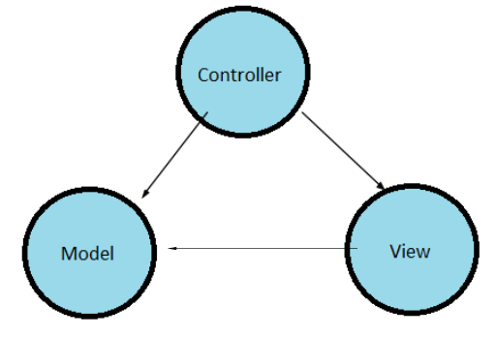

**1.1.2 Benefits of Angular JS**

1. AngularJS provides capability to create Single Page Application in a very clean and maintainable way.
2. AngularJS provides data binding capability to HTML thus giving user a rich and responsive experience.
3. AngularJS code is unit testable.
4. AngularJS uses dependency injection and make use of separation of concerns.
5. AngularJS provides reusable components.
6. In AngularJS, views are pure html pages, and controllers written in JavaScript do the business processing.

**1.2 What is NODE JS**

Node.js is an open-source, cross-platform runtime environment for developing server-side and networking applications. Node.js applications are written in JavaScript and can be run within the Node.js runtime. It also provides a rich library of various JavaScript modules which simplifies the development of web applications to a great extent.

Node.js is a platform built on Chrome's JavaScript runtime for easily building fast and scalable network applications. Node.js uses an event-driven, non-blocking I/O model that makes it lightweight and efficient, perfect for data-intensive real-time applications that run across distributed devices.

**1.2.1 Features of Node.js**

Following are some of the important features that make Node.js the first choice of software architects.

**Asynchronous and Event Driven**

All APIs of Node.js library are asynchronous, that is, non-blocking. It essentially means a Node.js based server never waits for an API to return data. The server moves to the next API after calling it and a notification mechanism of Events of Node.js helps the server to get a response from the previous API call.

**Very Fast**

Being built on Google Chrome's V8 JavaScript Engine, Node.js library is very fast in code execution.

**Single Threaded but Highly Scalable**

Node.js uses a single threaded model with event looping. Event mechanism helps the server to respond in a non-blocking way and makes the server highly scalable as opposed to traditional servers which create limited threads to handle requests. Node.js uses a single threaded program and the same program can provide service to a much larger number of requests than traditional servers like Apache HTTP Server.

**No Buffering**

Node.js applications never buffer any data. These applications simply output the data in chunks.

**CHAPTER 2: GEOFENCING**

**2.1 How Geo fencing Works**

Geo fencing is a location-based service in which an app or other software uses GPS, Wi-Fi or cellular data to trigger a pre-programmed action when a mobile device or tag enters or exits a virtual boundary set up around a geographical location, known as a geo fence.

Depending on how a geo fence is configured it can prompt mobile push notifications, trigger text messages or alerts, send targeted advertisements on social media, allow tracking on vehicle fleets, disable certain technology or deliver location-based marketing data.

Some geo fences are set up to monitor activity in secure areas, allowing management to see alerts when anyone enters or leaves a specific area. Businesses can also use geo fencing to monitor employees in the field, automate time cards and keep track of company property.

**2.2 How Geo fencing Works**

To make use of geo fencing, an administrator or developer must first establish a virtual boundary around a specified location in GPS- or RFID-enabled software. This can be as simple as a circle drawn 100 feet around a location on Google Maps, as specified using APIs when developing a mobile app. This virtual geo fence will then trigger a response when an authorized device enters or exits that area, as specified by the administrator or developer.

A geo fence is most commonly defined within the code of a mobile application, especially since users need to opt-in to location services for the geo fence to work. If you go to a concert venue, they might have an app you can download that will deliver information about the event. Or, a retailer might draw a geo fence around its outlets to trigger mobile alerts for customers who have downloaded the retailer’s mobile app. In these cases, a geo fence that is managed by the retailer is programmed into the app, and users can opt to decline location access for the app.

A geo fence can also be set up by end-users using geo fencing capabilities in their mobile apps. These apps, such as iOS Reminders, allow you to choose an address or location where you want to trigger a specific alert or push notification. This is called an “if this, then that” command, where an app is programmed to trigger an action based off another action. For example, “If I’m five feet from my front door, turn on my lights.” Or you might ask a reminder app to send you an alert once you reach a specific location.

Geo fencing isn’t just for mobile apps – it’s used to control and track vehicles in the shipping industry, cattle in agriculture industry and – you’ll see this topic pop up in drone discussions. Nearly every drone is pre-programmed to accommodate geo fencing, which are usually set up around airports, open-air venues and even the White House. The FAA can set up these drone-resistant geo fences upon request – some barriers will stop a drone in mid-air, while others will trigger a warning message to the user. Some drone geo fences will ask for a users’ authorization – a process that ties the user’s identity to their drone – so that law enforcement can keep track on unmanned drones.

**CHAPTER 3: GEOX**

**3.1 Why GEOX**

**3.1.1 Problems of traditional attendance systems**

**Manual creation of database**

Previously there was no automated attendance systems. Due to this there is lots of paper works doing in every organization attendance is made on papers due to this we are not able to maintain it for long this and paper works increases the time.

**Lots of paper works**

Due to lots of paper work the organization does not able to maintain the record for long time and sometimes due to this he attendance track record get lost and sometimes fire catches it.

**Checking the attendance manually**

When checking the attendance for any query we have to filter a long paper work. this takes a lot of time and increases the chances of error in our calculations. In an organization where lots of people are working in together calculating the attendance of each student takes a lot of time.

**Time Consuming**

In paper attendance system due to lots of paperwork. It increases the time to manage these paper attendances and requires a lot of work force.

**No system for self-checking the attendance**

There is no facility for student to check its attendance, this can only be done by contacting the admin department of the organization.

**3.2 WHAT IS GEOX**

**3.2.1 Literature survey**

Geo-fencing is a feature in a software program that uses the global positioning system (GPS) to define geographical boundaries.

Geo-fencing allows an administrator to set up triggers so when a device enters (or exits) the boundaries defined by the administrator, an alert is issued.

**3.2.2 GEOX**

GEOX is basically an automated attendance system that is being created to ease the paperwork and maintain an attendance database of the student in institutes. We are using geo fence as the main pillar to fix this problem and a database mongo DB for storing students information.

**3.3 Problem’s solutions by GEOX**

1. **Eco Friendly**

In most of the organizations employees use paper based attendance systems for signing in the log in and log out times in organizations. Mass production of paper and ink consumes a lot of energy and utilization of resources. With the world becoming aware about global warming, everyone wants to cut down on waste of such resources. Using fingerprint attendance can help in making a small but significant contribution to help save the planet. It also saves users from the hassle of carrying an ID card with them all the time.

1. **Identity Management and Security**

Every person has a unique set of fingerprints, so faking identity on a fingerprint scanner is totally impossible. Keeping an attendance register at the entry for visitors can give access to unauthorized people. Using fingerprint access control systems such as a biometric door

lock at the entry point will help in keeping an organization’s premises secure as people cannot have access to the organization without a proper authorization.

1. **Eliminates Buddy Punching**

Employers face huge payroll losses when the absenteeism of an employee is covered up through buddy punching by another co-worker. By using a fingerprint attendance system, company’s can cut down on such losses. With the option of buddy punching being unavailable, employees are encouraged to work, thus increasing the efficiency and performance of the company.

1. **Track Movements**

In schools, installing fingerprint access control can help the administration track the students’ movements who attend school at unusual hours for after-hours classes. Some schools that have implemented this system are Singleton High and Cessnock High in Australia. It helps the staff to monitor the students’ attendance and tardiness.

1. **Accounting working hours**

Companies can use attendance systems for project management too. Using a biometric door lock for attendance instead of pen and paper can help the company efficiently monitor and record the hours put in by each employee and the number of tasks completed. These systems can also help the project managers to identify the free-riders in the team and acknowledge diligent workers**.**

**3.3 Flow Charts**

1. **Flow chart of user :-**

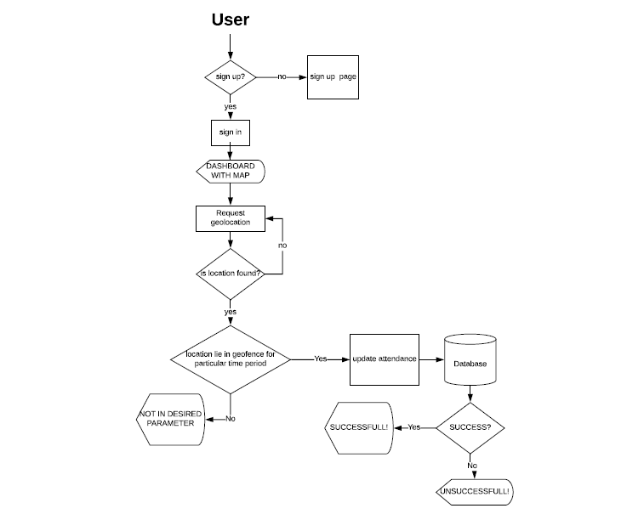

**Fig. User Interaction Flowchart**

1. **Flow chart of admin :-**

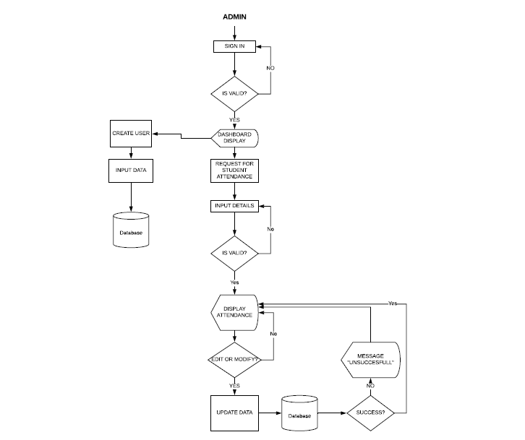

**Fig: Admin Interaction Flowchart**

**3.4 Screenshots of projects**

1. **Login Page**

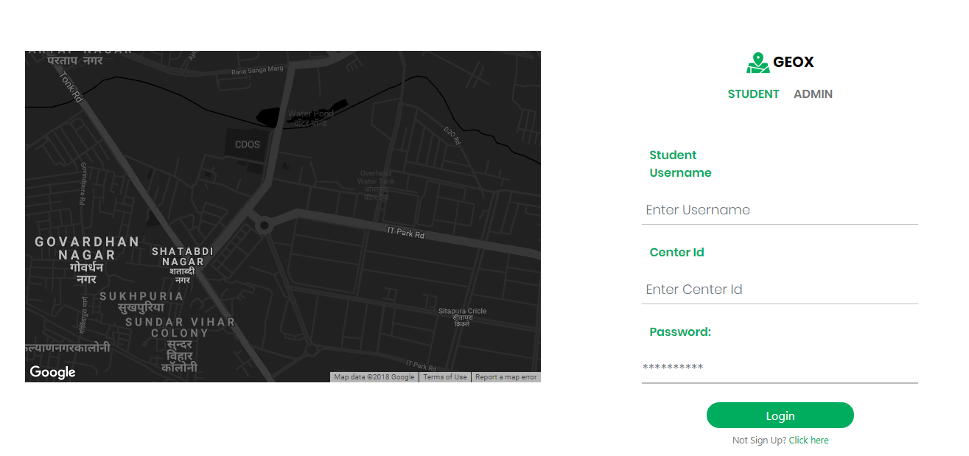

1. **Sign up Page**

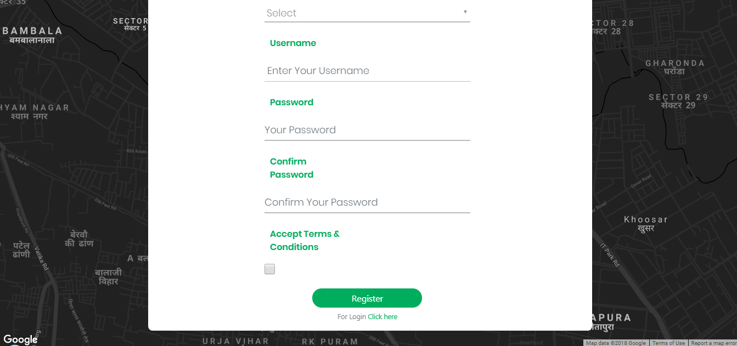

1. **Dashboard**

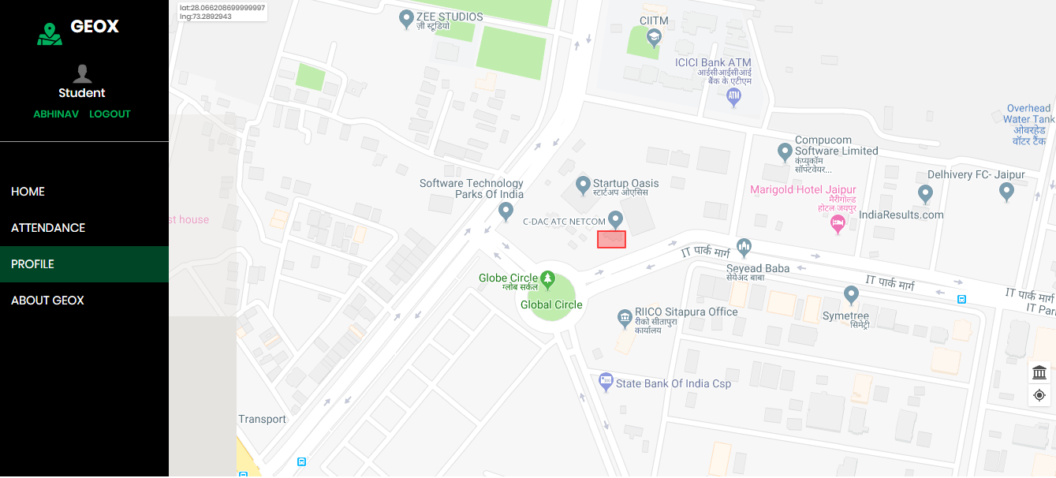

**CHAPTER 4: FUTURE SCOPE AND REFERENCES**

**4.1 Future scope**

1. Real time monitoring of users by admin.

2. Advertisement and marketing by push notification when the user enters the geo fence.

3. Traffic monitoring

**4.2 References**

[***https://fencer.io/***](https://fencer.io/)

[***https://developers.google.com/maps/documentation/javascript/tutorial***](https://developers.google.com/maps/documentation/javascript/tutorial)

[***https://whatis.techtarget.com/definition/geofencing***](https://whatis.techtarget.com/definition/geofencing)