ASSIGNMENT 1
Introduction to Web Development
Name: Dev Singh Chauhan
Section : 3SB
Class Roll.no: 15
Roll no: 2415000502

Q1.
Frontend is the part of a website that we can see and use — like buttons, colours, text, images, and menus. It runs inside the browser. It is made using HTML, CSS, and JavaScript. Example: The Instagram screen where you scroll photos and tap the like button is frontend.
Backend is the part that works behind the scenes. We cannot see it. It handles the logic, saves data, and talks to the database. It uses languages like Node.js, Python, PHP, or Java. Example: When you like a photo on Instagram, the backend saves that like in the database.
Full-Stack development means a person can do both frontend and backend work. A full-stack developer can build the full website from start to end. Example: One developer builds the Instagram screen (frontend) and also builds the system that stores photos (backend).

Q2.Client-Server Model Diagram
The client (your browser) and the server (a computer that stores the website) talk to each other. The client sends a request, and the server sends back a response. This is called the request-response cycle.

1.The client (browser) sends a request to the server, for example "give me the Google home page".
2. The server receives the request and finds the correct files.
3.The server sends back a response with the web page.
4.The browser shows the page to the user.
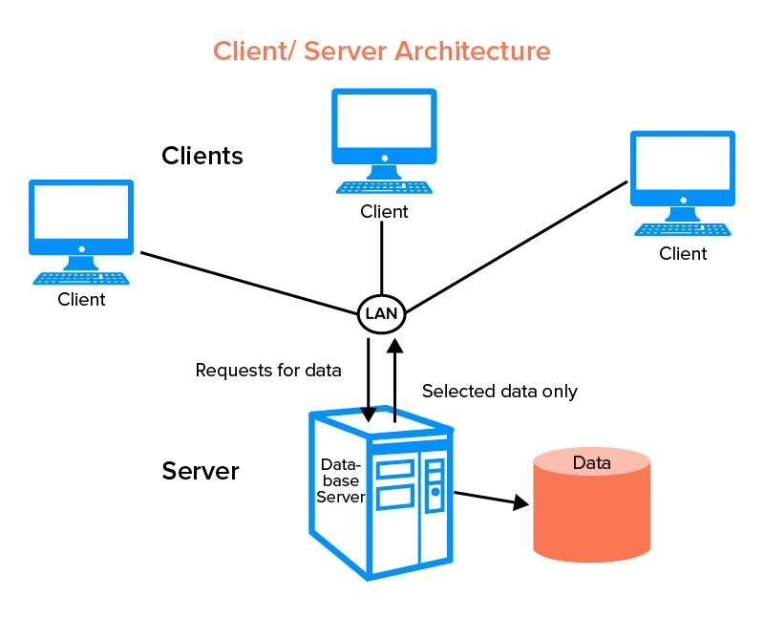

Q.3
- User enters a website address in the browser.
- Browser sends a request to the web server.
- Server finds the required files.
- Server sends HTML, CSS, and JavaScript files back.
- Browser reads these files.
- Browser displays the webpage to the user.
Example:
Opening www.google.com loads the Google homepage from Google's server.

Q4.
Ans:
VS CODE: Code editor for writing programs
Web Browser : Testing website
HTML: Creates webpage structure
CSS: Designs webpage appearance
JAVAScript: Adds functionality
Database: Stores website data
Q5.
A web server is a computer or software that stores website files and delivers them to users when requested.
Commonly used web servers:
- Apache – One of the most popular and free web servers. Works on many systems.
- Nginx – Very fast and can handle a large number of users at the same time.
- Microsoft IIS – Made by Microsoft, mostly used on Windows servers.
- LiteSpeed – Known for high speed and good performance.
Q6.
Roles in a Web Project
1. Frontend Developer
Creates website design.
Builds user interface.
Uses HTML, CSS, JavaScript.
2. Backend Developer
Creates server-side logic.
Develops APIs.
Handles authentication and data processing.
3. Database Administrator (DBA)
Manages databases.
Maintains data security.
Creates backups and improves database performance.
Q7.Install VS Code and Configure for HTML, CSS, and JavaScript
1. Visit https://code.visualstudio.com and download VS Code.
2. Install and open VS Code.
3. Go to Extensions and install:
Live Server – Runs website live in browser.
HTML CSS Support – Provides coding suggestions.
JavaScript (ES6) Snippets – Provides JavaScript shortcuts.
4. Create a file named index.html and start coding.
5. Right-click the file and select "Open with Live Server" to view the webpage.
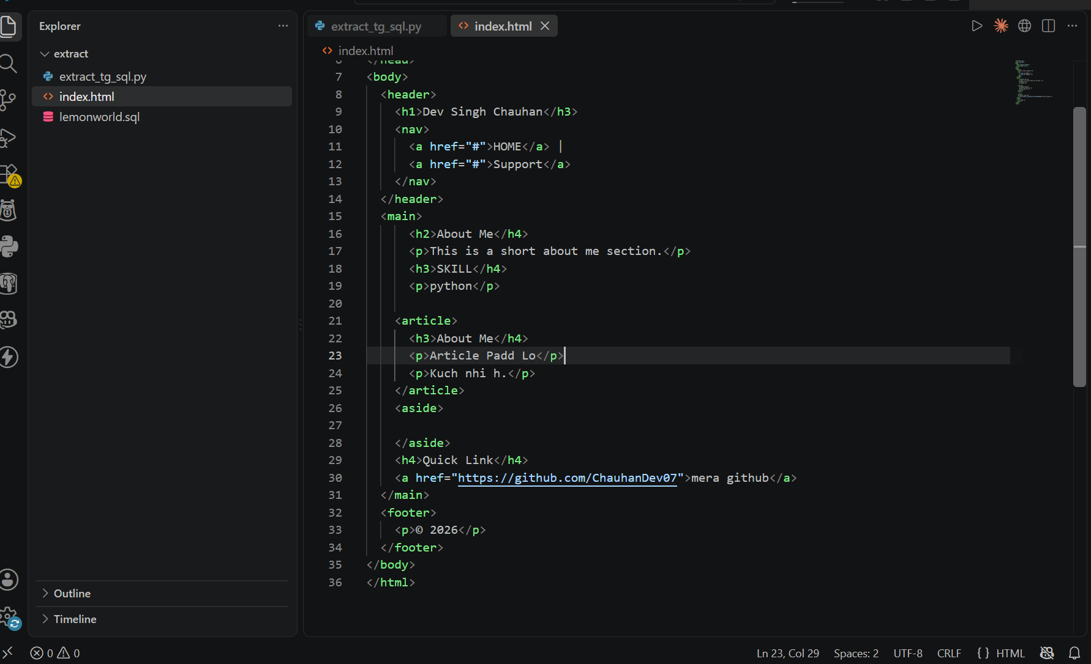
Q8
Static Website
A static website shows the same content to every visitor.
The content does not change automatically.
Changes must be made by the developer by editing the code.
It is simple and uses HTML and CSS.
Example:
Personal portfolio website, college information page, or simple "About Us" page.
Dynamic Website
A dynamic website shows different content for different users.
The content can change automatically based on users, time, or data.
It uses backend code and a database along with HTML, CSS, and JavaScript.
Example:
Facebook, Amazon, or YouTube, where users see different posts, products, and videos

Q9.
A web browser is a software used to open and view websites. A rendering engine is the part inside the browser that reads the HTML, CSS, and JavaScript code and turns it into the page we see on the screen.
Browser - Rendering Engine
Google Chrome - Blink
Mozilla Firefox - Gecko
Apple Safari - WebKit
Microsoft Edge - Blink
Opera – Blink
Rendering engines convert HTML, CSS, and JavaScript into a visual webpage.
- Blink: Used by Chrome, Edge, Opera. Fast and widely used.
- Gecko: Used by Firefox, focuses on standards and privacy.
- WebKit: Used by Safari, optimized for Apple devices.

Q.10.
Basic Web Architecture Diagram
