Linux_Assement_1:

1. Creating and Renaming Files/Directories
Create a directory named test_dir using mkdir.
Inside test_dir, create an empty file called example.txt.
Rename example.txt to renamed_example.txt using mv
Answer:
1. mkdir test_dir
2. touch test_dir/example.txt
3. mv test_dir/example.txt test_dir/renamed_example.txt
4. ls test_dir
5. renamed_example.txt

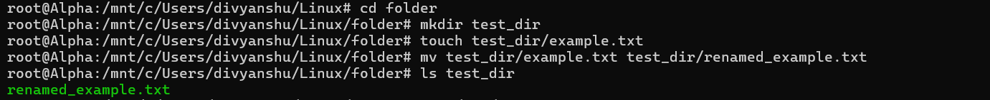

2. Viewing File Contents
Use cat to display the contents of /etc/passwd.
Display only the first 5 lines of /etc/passwd using head.
Display only the last 5 lines of /etc/passwd using tail.
Answer:
1. cat /etc/passwd
2. head -n 5 /etc/passwd
3. tail -n 5 /etc/passwd

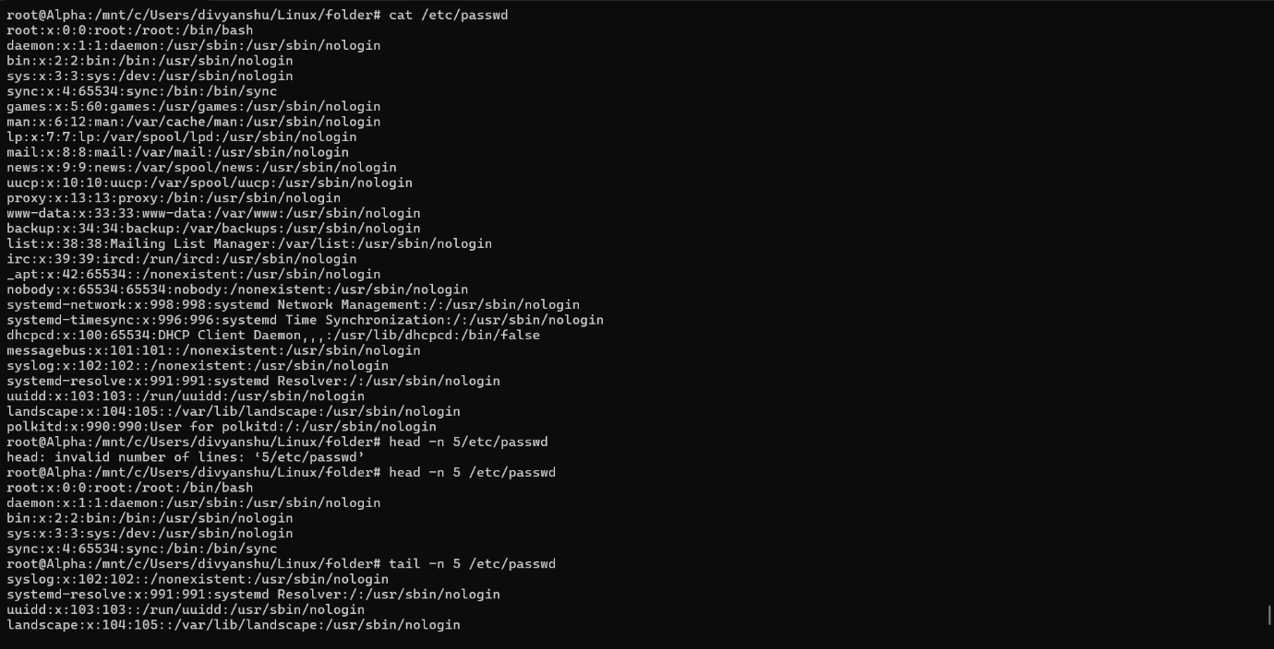

3.Searching for Patterns
Use grep to find all lines containing the word "root" in /etc/passwd.
Answer:
1. grep "root" /etc/passwd

4. Zipping and Unzipping
Compress the test_dir directory into a file named test_dir.zip using zip.
Unzip test_dir.zip into a new directory named unzipped_dir.
Answer:
1. zip -r test_dir.zip test_dir
2. unzip test_dir.zip -d unzipped_dir

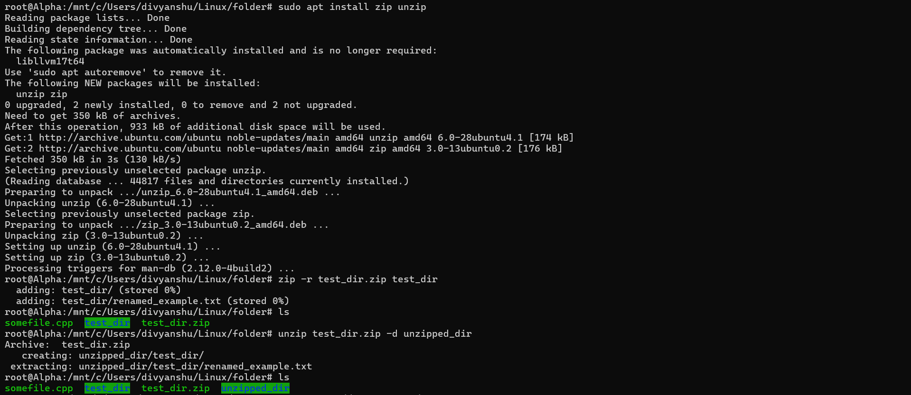

5. Downloading Files
Use wget to download a file from a URL (e.g., https://example.com/sample.txt).
Answer:
1. wget https://example.com/sample.txt

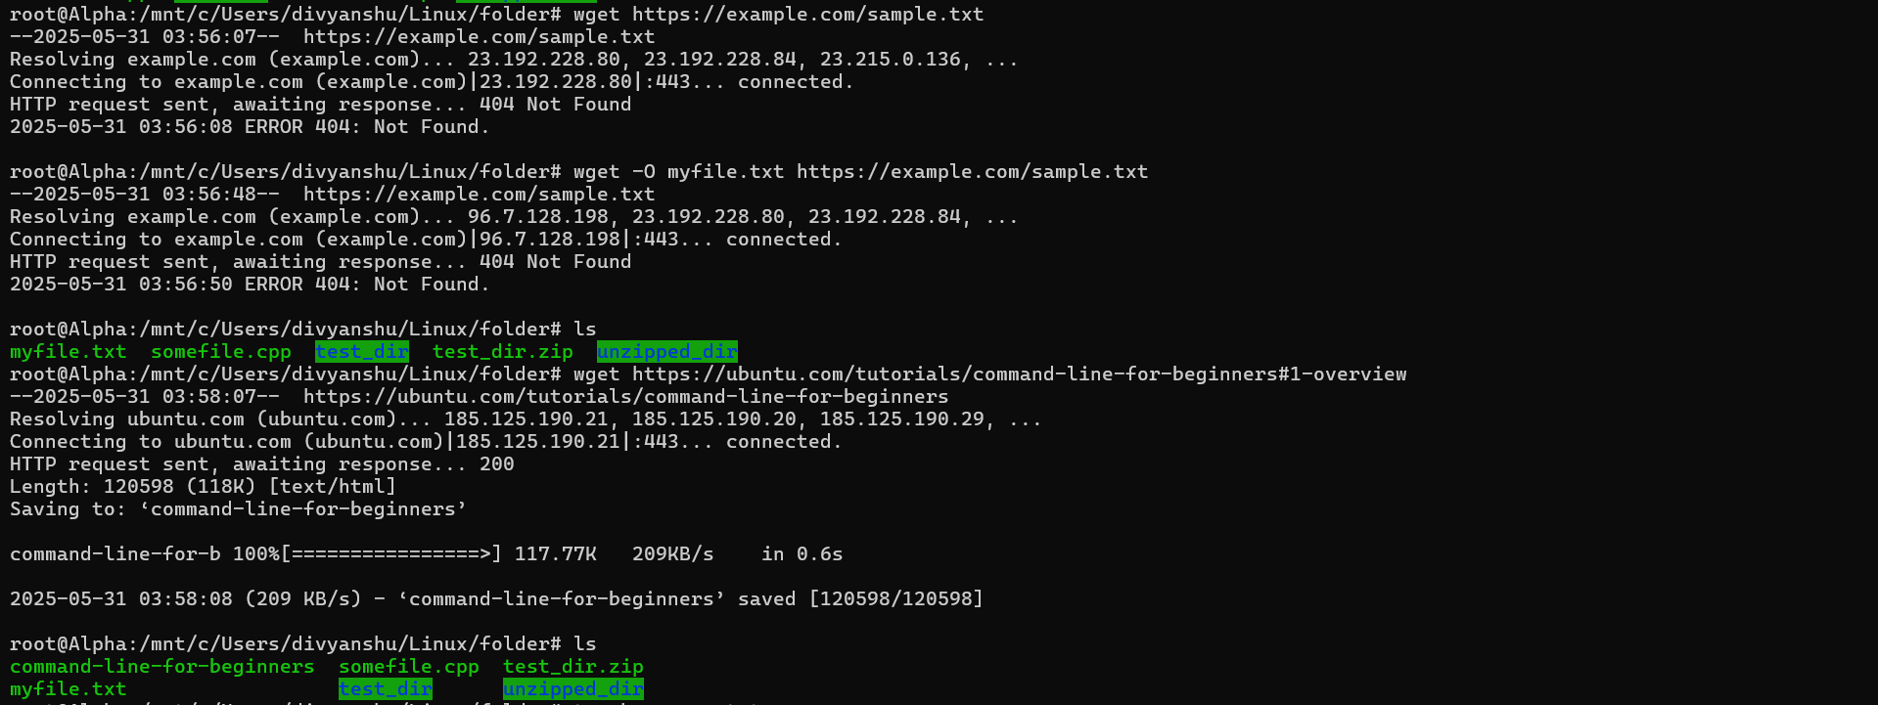

6. Changing Permissions
Create a file named secure.txt and change its permissions to read-only for everyone using chmod.
Answer:
1. touch secure.txt
2. chmod 444 secure.txt
3. ls -l secure.txt
4. -r-xr-xr-x 1 root root 0 May 31 04:01 secure.txt

7. Working with Environment Variables
Use export to set a new environment variable called MY_VAR with the value "Hello, Linux!".
Answer:
1. export MY_VAR="Hello, Linux!"
2. echo $MY_VAR
3. Hello, Linux!

Assement_DevOps:
https://github.com/ChauhanDivyanshu/Linux_Assement_1/blob/25824641028dc28978d99db0de8e5e32adc5315e/Assement_DevOps

